October 2012
Encourage older staff to keep working.
At last! More businesses are starting to understand that retaining older workers makes good business sense. Congratulations from the Equal Employment Opportunities Trust to organisations that are putting in a bit of extra effort to keep experienced and capable employees on board. With the ageing population and a drought of young qualified people coming up through the ranks a shortage of skilled staff is predicted. Hence the obvious solution is to ensure employees who are nearing retirement age feel valued and choose to remain in their job rather than rely solely on superannuation.
Basically the fact we have an ageing population is unavoidable, but a decline in work productivity isn’t. Employers should be looking at the tasks these older staff do and if they are finding them difficult - make some changes. For example how about giving them a chair to sit on rather than standing all the time? These more experienced staff can mentor some of the younger workers and they can also job share when it comes to heavy lifting duties. Research shows the outcome of such initiatives results in a more motivated workforce, better job satisfaction and an increase in production.
The first of October was International Day of Older Persons and the Minister for Senior Citizens, Jo Goodhew, said this year’s theme was ‘Longevity: Shaping the Future.’ “New Zealanders are living longer and healthier and it is important for individuals, employers, service providers and the Government to think about the implications and opportunities increased longevity brings.” Ms Goodhew says attitudes about ageing need to change. “By valuing and using the skills, knowledge and experience of older people, by caring for those who need it in a respectful manner, we will continue to build a great country to live in.”
Some Entries in this year’s ANZ New Zealand and EEO Trust Work and Life Awards showcased that many private and public organisations are doing just this by working with a wide range of employees of all ages. This year saw a record number of entries. More than 60 organisations put their workplace initiatives forward and they ranged from mentoring staff to fitness initiatives. For more information go to www.eeotrust.org.nz The following examples are a couple of successful programmes put in place to retain experienced employees.
Waikato District Health Board runs a range of initiatives to help keep its ageing workforce healthy and motivated.
Health has one of most rapidly-ageing workforces in New Zealand – and with staff shortages looming, the 6,000-strong Waikato DHB has been taking action since mid-2010. The board’s primary aim is to help workers aged over 55 remain capable – in order to retain them.
“Like most other DHBs, we are going to run into issues as our workforce ages, along with the population, and there is a greater need for healthcare due to growing chronic disease,” says Ruth Ross, co-coordinator of workforce planning and development. “We decided to put a number of strategies into place so that we are prepared for the future.”
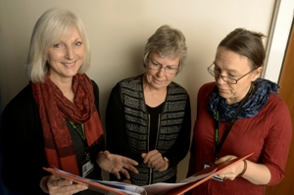
Photo: Waikato DHB staff discuss their own health needs at work.
One of the first steps was to respond early to employee reports of pain and injury. The DHB self-insures under the Accident Compensation Corporation’s partnership programme. It also subscribes to its Stay At Work early intervention programme that focuses on controlling non-accident-related musculoskeletal pain. Staff suffering non-acute pain, that wouldn’t be covered by ACC, are supported by the DHB to manage their situation.
Ensuring fitness for work
The DHB’s health and safety service uses the Work Ability Index (WAI), an increasingly popular tool overseas, to assess employee fitness for work. WAI is a questionnaire administered by a health professional that helps explore relationships between worker health, competence and motivation, work content, and leadership and organisation.
The results are seen as valid and reliable, says Ruth, and can predict the risk of early or premature retirement as well as predicted long-term work disability, helping employers determine what extra support an employee may need to stay in the job.

In 2011, the WAI was trialed on 47 staff working in district nursing and a care facility; more than 73% of them were over 46 years old, and the results showed 24% had a poor likelihood of still being in work by 65. Says Ruth: “Our health and safety service is now working with seven staff on an individual improvement plan including weight management, chronic condition management, improving fitness and more regular GP checks.”
The investment in the WAI tool is worthwhile, says Ruth: It costs the DHB about $42 per completed survey and any necessary follow-up; the average cost to the DHB of an employee sick day is about $260.
Pre-employment health checks
The DHB needs to ensure prospective employees are fit for the job and carries out pre-employment health screening. The screening helps manage personal and organisational risks by ensuring staff are physically capable, pose no risks to patients and the work is suitable and safe for them.
“We need to make sure the staff we employ are fit for the job,” says Ruth, “but it’s also as a strategy to increase the proportion of people who are fit for work as older employees leave.” Most new employees don’t need any accommodations made, “but those who are turned down, as they aren’t fit for work, are told that they can re-apply.” They are also referred to appropriate health professionals as part of the DHB’s duty of care.
Managing sick leave
For the last two years, the DHB has developed support plans for staff that take regular bursts of sick leave or are on long-term leave for health reasons. This is about ensuring that returning employees receive any necessary support they might need and also to ensure continuity of care for patients.
The positive result of this, says Ruth, is that the number of sick leave days being taken by DHB staff is dropping. Nursing-staff turnover per year has dropped from 25 % to 11%, and anecdotal evidence so far points to fewer people retiring early, or leaving, due to an untreated health problem.
------------------------------------------------
Electrix developed a fitness programme to help reduce injury to its ‘lineys’ – and has seen greater staff engagement, energy and co-operation ever since.
This programme won the ANZ New Zealand and EEO Trust’s 2012 Work & Life Award.
In 2009 and 2010, Albany-based Electrix saw a rise in the number of musculoskeletal injuries to linesmen, caused by the awkward positions they tend to adopt above and below ground as they fix power problems. The shoulders, knees and spinal areas were most commonly affected.
Until then, says Graeme Johnson, technical manager for the company’s Distribution Services Division, ‘lineys’ were sent to a GP for assessment and put on sick leave, or light duties, for three days while they recovered.
It was a no-questions-asked, re-active approach typical of the industry. But it didn’t help productivity, he says, and probably wasn’t the best way to help them heal. Although the company had been spending more than $4 million year maintaining equipment and about the same on training and compliance, Graeme says very little had been dedicated to employee health and wellness.
There was another issue causing concern: Although new employees had medical checks on eyesight, hearing, lung function, drug use and the likes, there was nothing to confirm they could cope with the physical demands of the work. This meant the company discovered too late that some new staff weren’t able to do the work without risking injury.
Finding solutions
Enter Productive Biomechanics director and chiropractor Keith Hammond, who visited sites to observe linesmen and also explain spinal biomechanics to them. Those injured were sent to Keith for assessment and from this, he developed an injury severity matrix to help guide rehabilitation decisions.
Keith also reported that some of those assessed needed core strength conditioning – that is, improving the strength and flexibility of back and abdominal muscles. His trawl of overseas research showed a correlation between poor aerobic fitness and work-related injuries.
It became clear, says Graeme, that a preventative wellness programme was needed to reduce injury, help recovery and provide a way to screen potential employees. Staff were filmed undertaking a variety of line-related tasks both above and below ground and, with the help of a personal trainer; a strength-conditioning programme was developed to strengthen areas where linesmen are susceptible to injury.
A 60sqm gym was set up in a corner of the Electrix warehouse, and Graeme was one of 18 guinea pigs who tested out the activities using free weights, filled bags and Swiss balls. As a result, two programmes were developed, with both implemented in 2010.
Every candidate for a linesman’s job now takes a pre-employment physical assessment (PEPA). Carried out by Productive Biomechanics in the Electrix gym, they involve timed events or exercises to failure – until no more repetitions can be done.
Candidates also undergo spinal x-rays and a full musculoskeletal exam, which leads to a recommendation whether to employ. Some candidates may be offered work on the condition they attend the second programme developed, lineFIT, which is available to all staff.
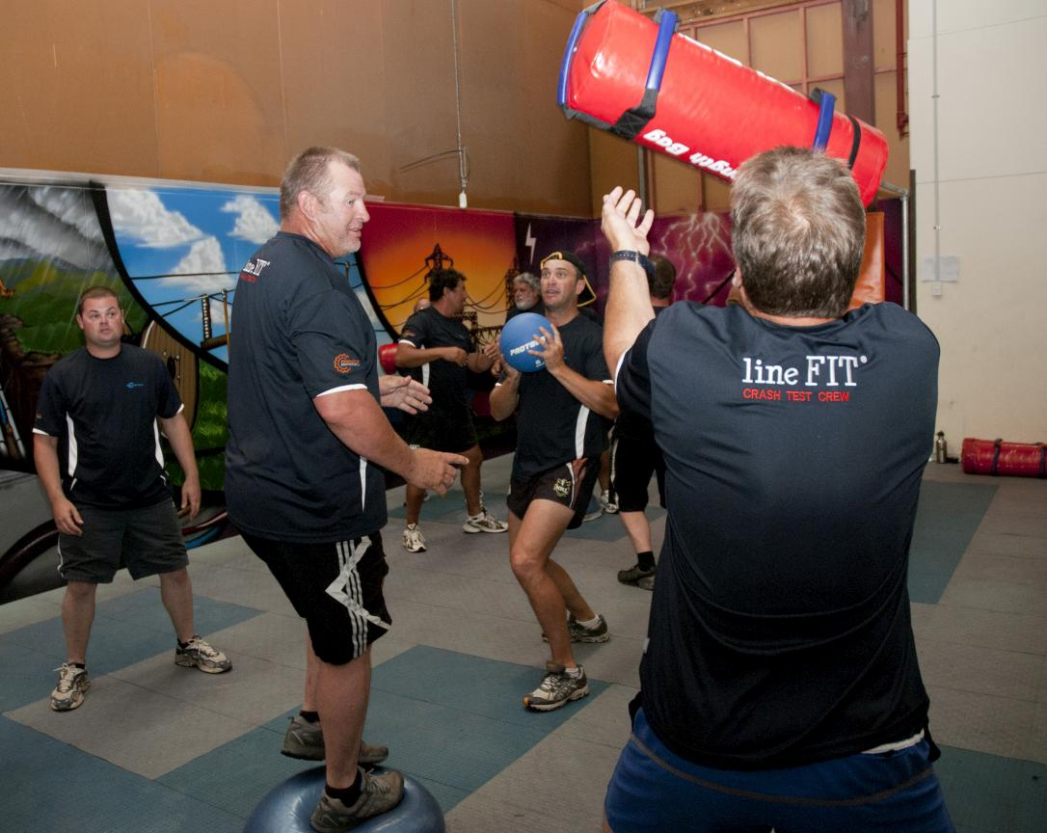
Photo: LineFIT programme in action.
LineFIT is a voluntary, 12-week challenge that builds in intensity. It’s delivered by a trainer to groups of six to 12 people. It starts with a Saturday-morning session outside work hours to bond the group and set expectations.
The other sessions also take place outside normal work hours, with many staff coming in early for workouts. Nutrition and health advice is also on offer.
“A lot of the guys haven’t done significant exercise for number of years,” says Graeme, “so the programme is designed to ease people into exercise – weeks eight to 12 are fairly intense.”
Some employees were initially skeptical about the programme, says Graeme – before they started seeing the benefits enjoyed by their fitter, newly glowing colleagues. “It’s the group dynamic that gets people through” says Graeme.
Says participant Grant Robinson: “I get there in the morning at 5.30 and I don’t wanna be there, but at the end of it I quite enjoy it ... and I’m determined after it is all over [the lineFIT course], I’m going to carry on. I feel a lot better in myself. I wondered if the ladder was getting lighter, but it’s not, it’s just me getting stronger, I think.”
The results
So far, more than 72 field staff have competed or are taking part in lineFIT, and the company now has a defined pathway to help rehabilitate those injured.
Electrix says it has saved more than 60 lost-time injury days so far, and those with back injuries are now getting tailored treatment to help strengthen problem areas and develop core strength.
An unexpected but welcome side-effect has been a positive culture change. Says Electrix general manager Robert Ferris: “Sure, individuals have lost weight, they’ve improved their strength, wellness and nutrition on an individual basis, but what I see is that the team, and particularly the greater group within the distribution area, there’s a whole change, there’s a greater level of energy, positiveness and cooperation.”

