TŪRANGAWAEWAE
Human Rights Commission News
In this issue:

Work, mental health and discrimination
Campaign for a day of remembrance
State of Care Report 2015
Attitude Awards
Dr Gill Hicks
Born Free and Equal
New video from Enquiries and Complaints
Invitation to forum

Contact us

september
Tūrangawaewae

Tenā koutou katoa

This week is Islam Awareness week. It is a good week to take advantage of the many opportunities to learn about the lives of Muslim New Zealanders.

This year's sold out Diversity Forum's theme, ‘Empathy in the Face of Diversity’, was a particularly poignant message for the 400 migrant, refugee and human rights advocates who took part in the gathering at Auckland University of Technology. Keynote speaker Dr Gill Hicks survived the London terrorist bombings and is now a global peace advocate. She spoke of empathy, humanity and how we must make a difference and make Peace a verb. There is an article about her work in this newsletter.

The Ministry of Justice has just held two open forums for comment on how the government is progressing recommendations accepted during its second Universal Periodic Review (UPR). This will assist the government to prepare its UPR mid-term report.
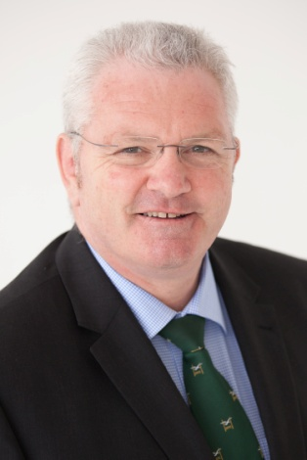
The Government’s current actions to address UPR recommendations are set out in New Zealand’s National Plan of Action for the protection and promotion of Human Rights 2015 – 2019 (NPA).
Meetings are being held next week in Wellington and Auckland on the draft State Report on the Convention on the Elimination of Racial Discrimination (CERD). An invitation to these meetings is in the newsletter.
Chief Human Rights Commissioner, David Rutherford

Ka kite anō

One in five

Recent research suggests one in five New Zealanders will experience some form of mental illness this year alone, but in contrast, Equal Employment Commissioner, Dr Jackie Blue says the workplace is often not accommodating this disability well.
Dr Blue explains that mental illness falls into the disability category of the Human Rights Act and it is therefore a breach of the Act to discriminate against people with a mental illness. This category is also included in the Convention on the Rights of Persons with Disabilities that NZ is a party to.
The Convention requires employers to ensure that ‘reasonable accommodation’ is provided to persons with disabilities for them to continue in the workplace
The Human Rights Commission (HRC) often receives complaints of discrimination from people with a mental illnessand the Commissioner’s concern is that this is just the tip of the iceberg because people are too scared to complain.
An HRC case study of a worker who told her employer (during an investigation into absenteeism), that she suffered from depression from time to time is an example of what can sometimes happen when a staff member discloses their illness:
The disclosure led to her being given a warning for failing to disclose a health condition – and then she suffered from being the butt of jokes and derogatory comments from her colleagues. Her health began to fail because of her colleagues’ conduct and she resigned. Later she took the matter to the Human Rights Commission, eventually settling by mediation and being awarded $3000 for the stress and humiliation experienced.
Dr Blue says that as there are actually so many employees that are going to experience mental health issues or are coping with mental illness that it is in the employer’s interest to work out how to accommodate a person who may need a bit more support. She says that to go further and actually encourage an understanding culture about this disability will lead to greater productivity in the workplace in the long run.
“A person is more likely to disclose a problem when they don’t fear losing their job, this means solutions can be found more quickly in a better and fairer way for everyone involved,” Dr Blue said.
Recent research from PriceWaterhouseCoopers Australia suggests that, for every dollar spent on implementing successful mental health strategies, businesses receive over $2 in return – and in Australian workplaces the cost of untreated mental health conditions is approximately $11 billion a year.

“We need to encourage a work environment that has peer support, collaborative relapse prevention and programmes at work to support staff to get well. Employment has been identified as an important factor in the recovery of people with mental illness and is generally associated with better mental health,” she says.

“The objective is to ensure people with mental health and addiction disorders retain their jobs and work productively.”

Whether to disclose or not to experience of mental illness was a vexed issue. The employee does have a responsibility to disclose a disability that may affect their ability to do the job but an employer has a responsibility to accommodate this as much as they reasonably can.

“There’s the myth that if you’ve got a mental illness you’re actually not employable. You can’t handle stress, you’re potentially dangerous to yourself and to others, you are a lot of extra work, you’re unreliable, you will take lots of time off, and so on.

“Often accommodating a person with a mental health issue involves of a bit of give and take, flexibility offered by the employer and the vision to help the staff member get well.

“I encourage people considering disclosing a mental health issue to their employer, but are unclear on their own obligations or that of their employer, to contact the Commission Infoline for advice,” Dr Blue suggests.

Dr Blue is a supporter of the Step Forward campaign: http://stepforwardnz.co.nz/

He Petihana kia Whakamaumaharatia ngā Pakanga Whenua o Aotearoa (For an English translation, click here)
He kōrero nā Leah Bell, he tauira ki te Kura Tuarua o Ōtorohanga
KahuamaitewhakaarokitetukupetihanakiteWharePārematakiawhakamaumaharatiangāPakanga Whenua o Aotearoakitētahirāwhakamaumaharaitehaerenga o ngātauira, ngākaiako me ngākaumātua o te Kura Tuarua o Ōtorohanga, hui katoatōmātautokomaha he 186, kiŌrākau me RangiaowhiaiteMaehe o 2014.
Kāoreitetinomōhiotiatetokomaha, engaritērārākotōnaāhua 500 ngāhōiaPākehā, me ngākūpapa e 250, me ngā Māori e 2,000 iwhawhaikiteKaraunai mate kirotoingāpakanganei. Kei teāhuakotahimirionaheketeaterahi o te whenua iraupatutiaingā Māori iwhawhaikiteKarauna.
He hanga aroha ngāPakanga Whenua o Aotearoa, he nuitewāhikingāpakanganeiheiwhakamāramakowaimātātau, he pēheaneitōtātauāhua, ā, nāte aha ipēneiaitātau. E maharaanaahaukoineitepūtake o ngāmomoraruraru e whakararui a mātau, itehungarangatahi. Kawhakamāramatiangānawetukuiho me ngāwhakataungakerēme e rongoneimātau.
I kī a Matua Rāhui, “keiwareware, me maumaharatātou”.Nā Matua Nick Tūwhāngaiikī, “kuawhakapaukahangākaumātuakiawhakamaumaharatiangāPakanga Whenua o Aotearoatonunei”.Nākonei, he tokomahatonumātauiwhaiwhakaaro me kakamatōmātaukōkirikiawhakamaumaharatiangāpakanganei.
Nōmurimaiitēneiakorangakitepaetonu o teriri, kuahuamai he kaupapakirotoitōmātau Kura Tuaruakāoreipakumaharatiaimua, kāoreiwhakaarotia, kāoreiwhakaponotiatērākataea.
Kāoretētahi o mātauitetinomōhioipēheaneitehuamai o tewhakaarokitetukupetihanakiteWharePārematamōtētahirāwhakamaumahara, arānōwaitewhakaaro, engariiarā, itērārākiŌrākau, kawhakaohoamātaukitekōkiri.
Kuamōhiomātauināianei he huarahipaitepetihana e tāhurimaiaingāMinita o teKaraunakitewhakarongokite iwi e tautokoneiitekaupapakiawhakamaumaharatiangāpakangakitōtātaumotutonunei: arā, kianuiakengāmahi e maumaharatiaaingātāngataihingaingāpakanganei, ngātāngataitakahuritia ō rātauao me ō rātauurianō, me tepāngamai o ngāpakanganeikitōtātaumotuitēneirangitonunei.
Kuakohikohimātauingāwaitohu o tehungatautokoingāhuarahi, ingāahureipēneiiteKawhia Kai, itePolyfest, iteMatatini, iteKoroneihanakiTūrangawaewae me ngāhuihuinga Waka Amahoki.KuatukukōreromātaukiteKāhuiRangatira ā-Iwi, kuaraputautokoiētahirōpū ā-motunei, ā-rohenei, ingākura me ngāhaporihoki.

Kuawhakapautāimamātaukatoaiwhaiwāhikitēneikaupapa, kuawhaiwhakaaro, kuaako, kuamanawanuihoki. Kuaakomātaukingāāhuatanga o temahirangatira e kaweaaitēneiwhakaaronuiirungaitetautokomai a te iwi.
Kuakohikohimātauingāwaitohu a-tuhituhitonunei, me tekaha o tetautokomai. E ruahokingāpaetukutukumōtēneikaupapa. Nātētahi, kakohikohiamaingāwaitohu e 865. Kei tehaeretonu a Petitionbuzz.
Kahopotemanawaitekitengaatu o tetūmanakokeitekanohi o tetangata, iterangonaatuki ā rātaukuputautokomōtēneikaupapanuitehua.
Tinoitineitehungaitūkinomaikitāmātaupetihana, engaritērāanōānakōrerowhakakatakata. I tenuinga o tewāihainaaitetangataitepetihana, katakipātaimaii ā rātaupātai, kakōrerohokimō ō rātauwhakaaromōngākōrerotukuiho e pāanakingāpakanga whenua.
Kiteaanaingā 10,000 waitohuikohikohia, he mana nuiinākatautokonamaitētahipetihana. Kuakīmaite iwi neiki a mātau me kōkiritonutēneikaupapaahakoaanōngātaiapakeimuaitehuarahi.
Kei tewhawhaimātaumōtetika. Kāore e tinokiteaitekaupapanei, engari he nuitonutemamae me tepōurimōngākōrerotukuiho o ngāpakanga whenua neikāoreitekōrerotia. Kuariromaimāmātaurangatahineimātauanō e whakaakokitēneikaupapa. E whakaponoanamātaukatīmatatēneikiterāwhakamaumaharaiia tau. Ākuanei pea katīmatangākaiako, ngāwhānau, ngāhōtaka o tepouakawhakaata me te reo irirangikitekōreromōtēneikaupapa. Kanohomaitehanga aroha o ngā tau e 150 kimuriki a tātaumōaketonuatu, engarimātemahinei e tīmataai he ānamatawhaiwhakaarokingākōrerotukuiho.
“Me MaumaharaTātou……”
Leah Bell

State of Care 2015

The State of Care 2015 report was released 27 August and is the first annual summary from Children’s Commission independent monitoring of Child, Youth and Family’s policies, practices and services. It includes feedback from children and young people about their experiences in the system.

While the 2015 report found pockets of excellent practice within Child, Youth and Family (CYF), it also highlights inconsistencies in the care and services provided to children. It also reveals a lack of accessible information about how well children are doing while in care and their outcomes once they have left the system.

“When children are in care, Child, Youth and Family is effectively their parent. That is a significant responsibility. These children should come out of the system in a better place and with the prospect of better future lives. Unfortunately we can’t say they are,” Children’s Commissioner, Dr Russell Wills.
The report aggregates the findings of the monitoring reports completed for a sample of sites and residences between January 2014 and June 2015, and summarises the voices of children in care who shared their views with the Commission during that time.

It looks at how well children in care are doing according to available data on measures of wellbeing, including health, education and justice outcomes, and draws on what the Commission learned from our engagement with stakeholders and wider child advocacy work in the period.
On the basis of these findings, it makes recommendations to improve CYF’s performance.
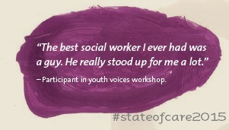

Summary
- Issues of workforce capacity and capability mean practice is not consistent
- Child, Youth and Family is not sufficiently child-centred
- Child Youth and Family do not know if children are better off as a result of their intervention as they are not measuring outcomes reliably, and
- Alongside children’s immediate safety, CYF needs to focus on improving their outcomes.
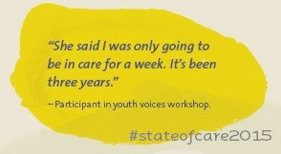
What needs to change - summary
- Set clear expectations about CYF’s core purpose and the outcomes it needs to achieve;
- Ensure CYF is fully child-centred in all its activities;
- Invest more in on-going support for children in all types of care placements;
- Address capacity and capability issues across the CYF workforce;
- Improve cultural capability across the organisation;
- Collect and analyse relevant data to drive improved outcomes for children; and
- Set clear expectations for other state agencies responsible for improving the outcomes of children in care.

Response from Human Rights Commission and Judge Becroft

“We welcome the release of this report and urge government and communities to work together to safeguard the future and protect the fundamental human rights of our most vulnerable New Zealanders,” said Mr Rutherford.

“There are 5000 children and young people in care at any given time and more than 2500 are mokopuna Maori. This is a crisis within a crisis. We must work to make certain all our children are better off as a result of state intervention.”
David Rutherford
Principal Youth Court Judge Andrew Becroft said the report was a vital piece of work and shows that the care and protection record with CYF needs to get better.

He said the Youth Court dealt with the most damaged, dysfunctional and disordered young people in New Zealand, and the overwhelming majority of them had a care and protection background.

"We know that, as night follows day, the inevitable path of those for whom care and protection is not done well is the Youth Court," Judge Becroft said.

"So that we're not left, for instance, with, as I understand it, 83 percent of prison inmates under 20 have a care and protection record with Child, Youth and Family.”

Campaign to raise cut-off age for state care

The initiative called We Don't Stop Caring, was started by Lifewise, Dingwall Trust, Youthline, Child Poverty Action Group, Wesley Community Action, Christchurch Methodist Mission and Action Station.The group’s aim is to raise the age so every young person in the country had the right to support and a home-base.

Child Poverty Action Group spokesperson Associate Professor Michael O'Brien said under the current law, children lost the protection of Child Youth and Family when they turned 17, but did not get adult support like student allowances until they were 18.

"It is unrealistic to expect 17-year-olds to exit the foster care system and become completely independent," he said.

"Transitioning to life as an independent adult is difficult and it only gets harder when a young person already has a disrupted life. Raising the age for support would give young people the right to support and a stable home through this important stage of their lives."

"The Government is currently reviewing Child Youth and Family Services, including whether the age of foster care should be reviewed... this is the ideal opportunity to fix a flawed policy and make a real difference for our most vulnerable youth," he said.

Social Development Minister Anne Tolley said the cut-off age for state care was being considered.

Source: RNZ

Attitude Awards
Voting for the ‘People’s Choice’ Attitude Award starts in November.
First held in 2008, the Attitude Awards are national awards that celebrate the achievements of people who live with disability. The aim of the event is to shine a spotlight on the disability sector, and draw attention to the one in four New Zealanders who live with disability. The event is run by the Attitude Trust.

Twenty-one finalists from all over New Zealand have been chosen for the award categories of Art, Courage in Sport, Making A Difference, Spirit of Attitude, Junior, Youth and Employer - with 3 more to come for the Sport Performer award.

The Trust also pays tribute to the employers who work alongside people with disabilities to ensure they are able to contribute their skills to society and live full and satisfying lives.

http://attitudelive.com/information-and-resources/attitude-awards

Deed of Settlement signed with Taranaki Iwi
The Crown has signed a deed of settlement with Taranaki Iwi settling all their outstanding historical Treaty claims at Pukeiti Gardens, Taranaki, Treaty of Waitangi Negotiations Minister Christopher Finlayson has announced.
Taranaki Iwi is one of eight iwi of the Taranaki region. The Waitangi Tribunal has described Taranaki claims as some of the most significant in the country. Crown breaches of the Treaty of Waitangi in Taranaki included warfare that involved loss of life, scorched earth tactics, imprisonment, raupatu, disempowerment and the Crown’s unprecedented actions at Parihaka.
The settlement includes financial redress of $70 million, along with the vesting of 29 sites of cultural significance to be vested in Taranaki Iwi. This includes a joint vesting of Ngā Motu/Sugar Loaf Islands with TeĀtiawa. Taranaki Iwi also has deferred right of selection for two years over 29 commercial properties, and a right of first refusal over Crown-owned land in their rohe.
“We can never fully compensate for the past wrongs the people of Taranaki endured,” Mr Finlayson said. “However, this settlement provides the basis for Taranaki Iwi to develop a much stronger future, and for a new relationship with the Crown based on genuine partnership.”

7/7/2005 – 10 years on
“What unites us is greater than what divides,” Dr Gill Hicks.
Ten years after the London Bombings, Dr Gill Hicks walks for peace and encourages conversations about how to get peace on earth but actually, she has a right to be very angry.
On the morning of Thursday, 7 July 2005, four Islamistextremists separately detonated three bombs in quick succession aboard London Underground trains across the city and, later, a fourth on a double-decker bus in Tavistock Square. Fifty-two people were killed and over 700 more were injured in the attacks.
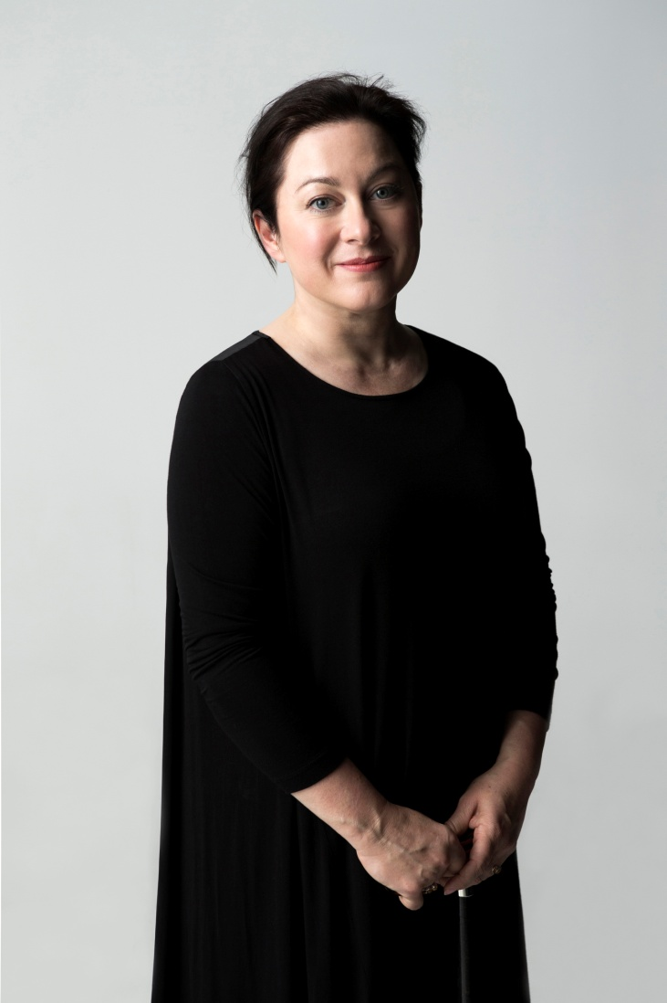
The 7 July attacks happened the day after London had won its bid to host the 2012 Olympic Games, which had highlighted the city's multicultural reputation.
That morning Gill travelled on the Piccadilly Line and she was on the train standing next to Jermaine Lindsay who was carrying a bomb in his backpack. The explosion meant she lost both her legs and nearly died from blood loss. Her lungs had collapsed and she had a perforated ear drum.
Today Gill has become close friends with the many police officers and medical staff who saved her life. She says the love she received from complete strangers is much more important to her than the hateful attack on her and her fellow passengers.
Dr Gill Hicks
“The man next to me saved my life. He then lost his life and left behind two little children. In his last moments he saved my life,” Gill Hicks says, telling her story on ABC radio.

7/7/2005 – 10 years on cont...

“I now believe there is so much more to the dimension and fullness of our lives. I signed a new contract with life,” she said.
“I am now determined to do all I can to deter anyone from following a path of violent action.”
With that vision, in 2007 Gill founded the not-for-profit organisation M.A.D. for Peace, a platform that connects people globally.It invites people all over the world to look for peace in their own lives. To this end Gill has also held television discussions with panellists that have been members of gangs or extreme militant groups but now are reverted to peace as she pushes on with the conversation about how to achieve peace and stop extremism.
“I believe everyone can make a personal difference to create a confident global community and a sustainable peace.”
Gill is asking people to come out and walk and talk with people that appear very different from themselves and she guarantees each person will find things in common with that person.
Gill took a very long and painful walk as a statement for peace from Liverpool where the families of the suicide bombers lived, to London. She recalls a Muslim man and an English woman who lived across the road from each for 10 years but had never spoken began talking within 10 minutes. But both had held the wrong idea about the other for 10 years.
“Most people have very similar concerns and fears and hopes.”
Dr Hicks was the key note speaker at the Human Rights Commission Diversity Forum 9 September at the Auckland University of Technology. The forum is a platform that brings together individuals and organisations to share ideas and good practice on cultural diversity and positive race relations.
Tūrangawaewae asked Gill what she thought New Zealanders could do to help bridge the gap between fear and tolerance and to build acceptance of cultures and people new to us here:

“The greatest antidote to fear is confidence. Working to co-create Confident and Empathetic Societies is one of the greatest areas of value in our increasingly culturally diverse communities,” Dr Gill Hicks, New Zealand 2015.

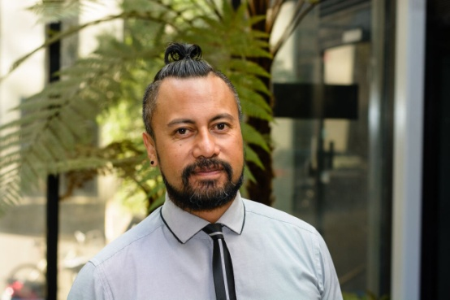
Moana Eruera represented NZ at the launch of ‘Free and Equal Pacific Region’

Human Rights specialist, Moana Eruera says he felt proud and privileged to witness the launch of the Pacific region Free and Equal campaign in Fiji last month.
The UN campaign aims to start conversations across the Pacific to encourage respect for LGBTI people, building on the shifting attitudes of governments and societies across the region, and on the important advocacy of civil society organisations.
Moana Eruera
The campaign has a simple message: human rights are for everyone, no matter whom you are or whom you love.
Human rights are universal. Everyone is entitled to the same rights. Violence and discrimination against LGBTI people is illegal under international human rights law.

Moana was invited to speak at the launch and mentioned some ‘wins’ the Commission had influenced to move LGBTI rights forward but also of the problem of bullying of GLBTI people in our society and in particular at school.

“The Commission still receives complaints about discrimination on the grounds of sexual orientation and gender identity or gender expression. Discrimination, harassment and violence are all breaches of fundamental human rights,” Moana explained.
The Pacific is the home of longstanding traditions of diversity and tolerance towards local cultures that allow persons assigned male sex at birth to identify and live as women, such as the fa'fafine of Samoa and the leiti of Tonga.

“These diverse gender identities are important parts of the cultural treasures of the Pacific,” Moana said.

Like in New Zealand, Fiji has a constitutional ban against discrimination based on sexual orientation and gender identity. Samoa prohibits discrimination in employment because of a person's sexual orientation.

The president of Fiji, RatuEpeliNailatikau, said in the Pacific UN Free & Equal campaign video that premiered at the campaign launch: "Laws alone are not enough. I ask everyone in the Pacific to take action for equality. Together we can stop bullying, violence and other forms of discrimination against people simply because of who they are or whom they love."

Born Free and Equal cont…

Mr Nailatikau also appealed to States across the Pacific to join the fight for LGBTI equality, “We all need to examine what we can do better, how we can take further steps, what practical measures can be adopted, to protect the human rights of lesbian, gay, bisexual, transgender and intersex people.”

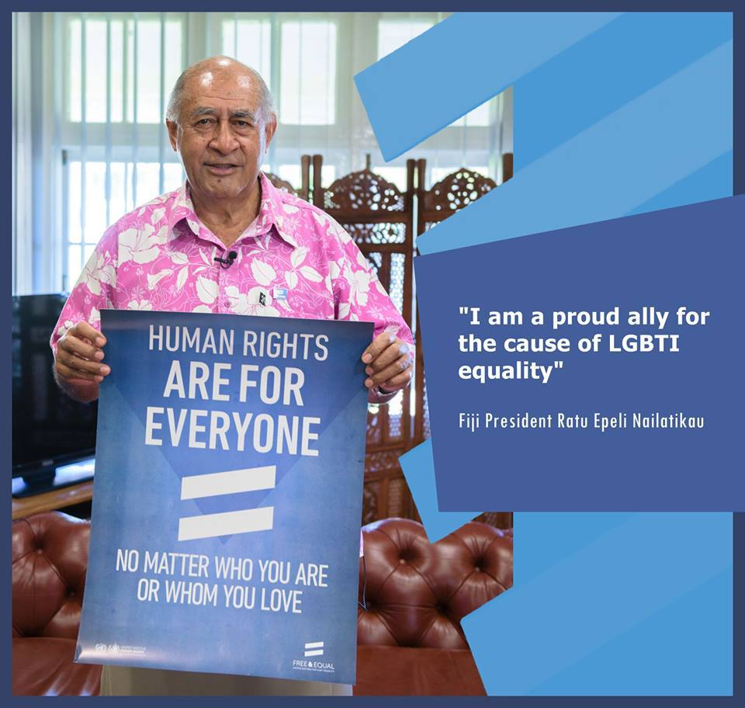

President of Fiji, Ratu Epeli Nailatikau

Moana says the event also featured mesmerizing performances, including by KitiNiumataiwalu, the Voice of Fiji, and the Rainbow Pacific Free & Equal Choir, created specifically for the campaign launch.

“There was an overwhelming sense of strength and pride within the Pacific LGBTi community at the event,” he said.

Two new campaign videos – “I’m a Proud Pacific Islander” and “For a Free & Equal Pacific” – were screened at the launch, as well as a video by UNAIDS on sexuality and gender identity in Papua New Guinea. The videos feature the faces and voices of LGBTI people and their allies from across the Pacific and can be viewed here:

‘For a Free & Equal Pacific’: https://youtu.be/fjrlX-AEQG8
‘I’m a Proud Pacific Islander’: https://youtu.be/QX9gyAokQWw
‘I am proud of who I am’: https://vimeo.com/100000779

New case study video on line

TeRito it e whakaahua illustrates in video format a real example of changes in individual and organisation behaviour and practice as a result of the dispute resolution process.

The video explains the Commission dispute resolution process and possible outcomes.
Discrimination can be destructive and is unlawful; the dispute resolution process empowers people to take action against discrimination and create change.

The Commission and the dispute resolution process is “user friendly”, free confidential and accessible to all.

Public Meeting: New Zealand’s report under the International Convention on the Elimination of All Forms of Racial Discrimination
The Ministry of Justice together with the New Zealand Human Rights Commission invites you to attend a public meeting to discuss New Zealand’s draft report to the United Nations under the International Convention on the Elimination of All Forms of Racial Discrimination.
The Convention commits New Zealand to the elimination of racial discrimination, affirms the necessity to adopting national measures to secure the effective recognition and observance of the principles set out in this international human rights treaty. The draft report responds to specific issues raised by the Committee following the review of the previous report submitted in 2012, and outlines significant developments in recent years related to the elimination of racial discrimination in New Zealand.
Based on the draft report, the meeting will be an open forum for discussion. Feedback received during the consultation process lasting from 25 August to 28 September 2015 will be considered before the report is finalised and submitted to the United Nations Committee in December 2015.

Auckland
Date and Time: Monday 14 September 2015, 5.00 – 7.00pm
Venue: New Zealand Human Rights Commission, Level 3, 21 Queen Street
Wellington
Date and Time: Thursday 17 September 2015, 5.30 – 7.30pm
Venue: New Zealand Human Rights Commission, The Vector Building, Level 8,44 The Terrace

RSVP: michaelw@hrc.co.nz

Please send us your event notices and news.

Email: karen.c@hrc.co.nz
To unsubscribe
Email: as above.
To Contact the Commission

InfoLine 0800 496 877 (toll free)
Fax: 09 377 3593 (Attn: InfoLine)
Email: infoline@hrc.co.nz (for general enquiries) TXT 0210 236 4253
Ph: 03 379-2015 Fax: 03 964-8964.

