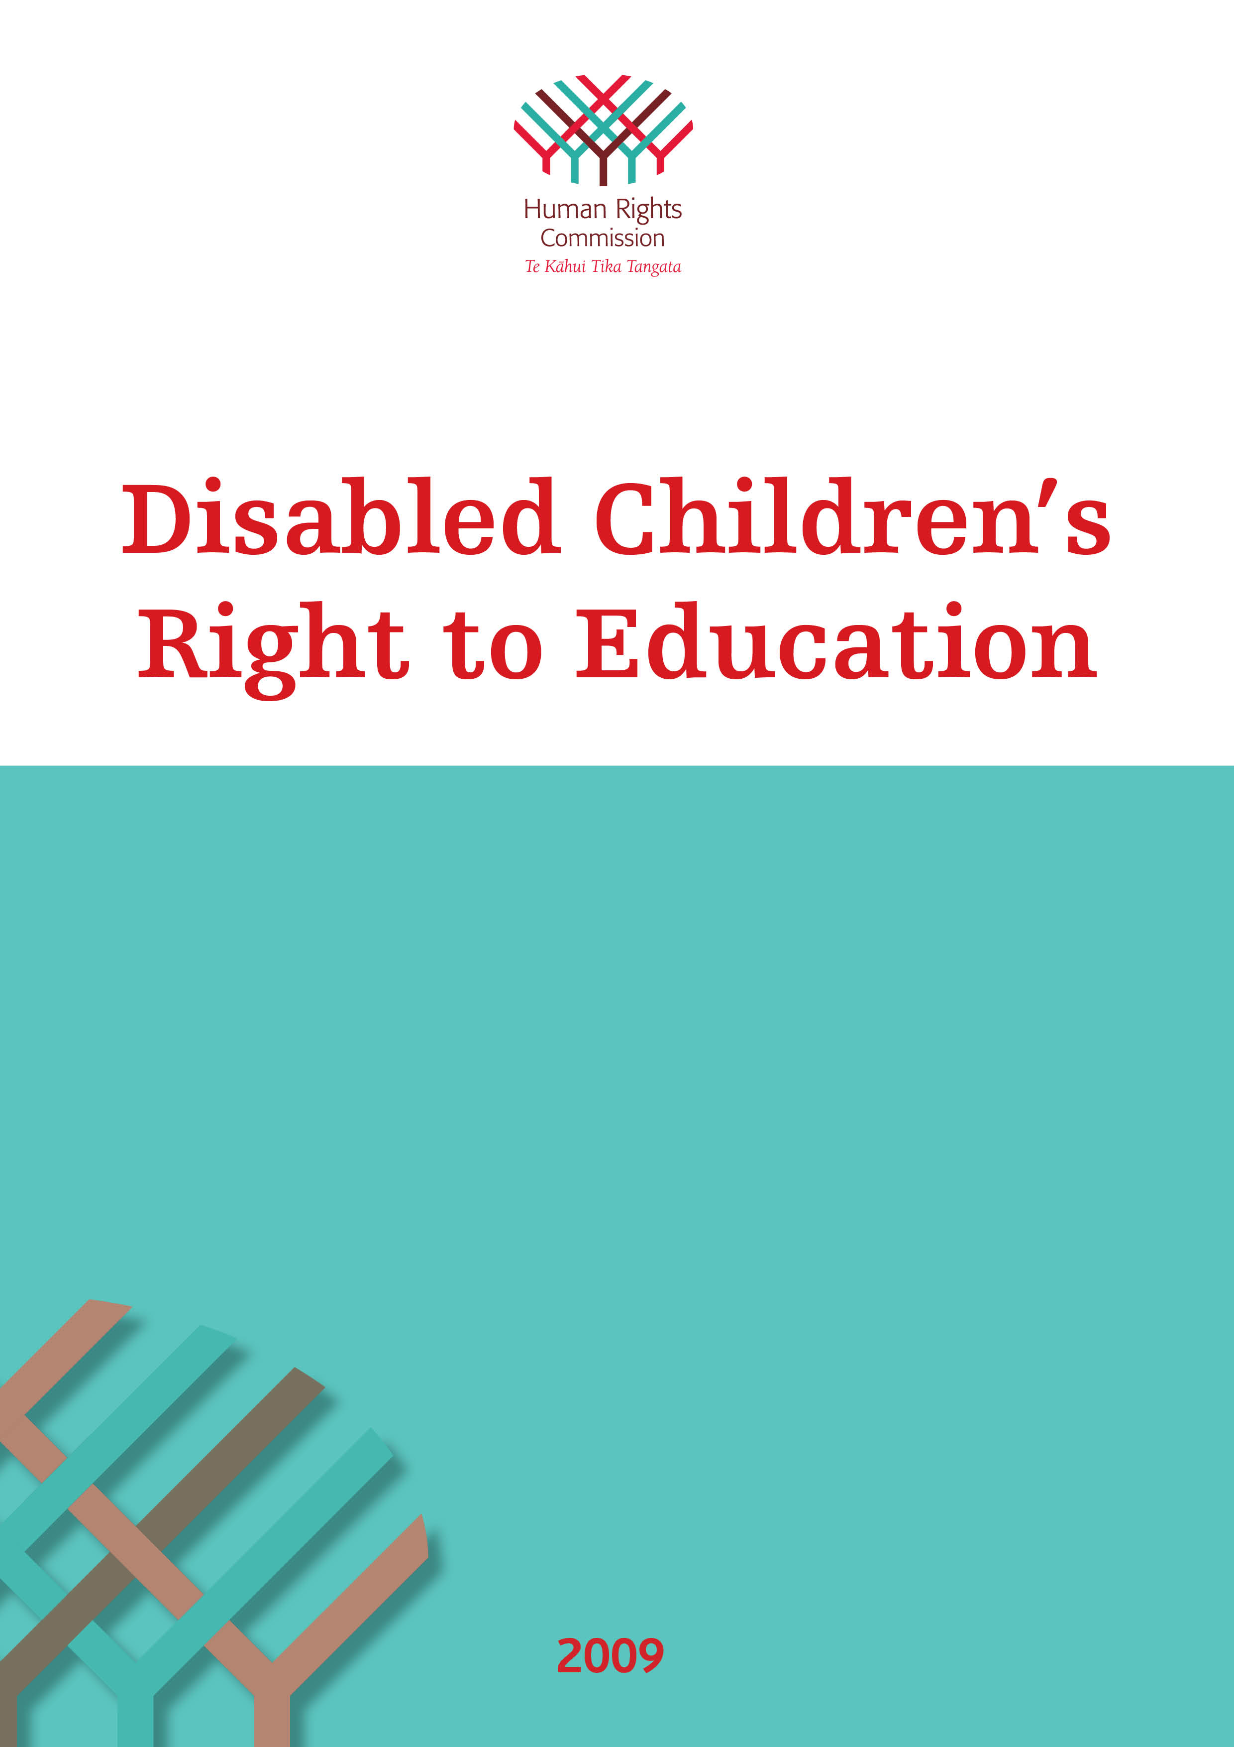
Human Rights Commission

If you have a discrimination complaint or want more information:

Auckland Office
Level 4, Tower Centre,
45 Queen Street, Auckland 1141
PO Box 6751, Wellesley Street, Auckland
Ph: 09 309 0874 Fax: 09 377 3593

Wellington Office
Level 1, Vector Building,
44 – 52 The Terrace, Wellington 6011
PO Box 12411, Thorndon, Wellington 6144
Ph: 04 473 9981 Fax: 04 471 6759

Christchurch Office
Level 3, Guardian Assurance Building,
79 – 83 Hereford Street, Christchurch 8011
PO Box 1578, Christchurch 8140
Ph: 03 379 2015
Fax: 03 353 0959

Toll free Infoline 0800 496 877
TTY (Teletypewriter): 0800 150 111
Website: www.hrc.co.nz
Email: infoline@hrc.co.nz

Language Line available

Appointment with sign language interpreter available

Aotearoa – New Zealand

ISBN 978-0-478-34959-7 (Word)
ISBN 978-0-478-34960-3 (PDF)
Disabled Children’s
Right to Education

Background

- Education is both a human right in itself and an indispensable means of realising other human rights. It enables children and young people to develop a sense of their own worth and respect for others. In doing so, it fosters their ability to contribute to and participate fully in their communities. Education is the primary vehicle by which economically and socially marginalised children and young people can eventually lift themselves out of poverty, through developing the skills and qualifications necessary for quality paid work.

- Barriers to the right to education for disabled children and young people have emerged consistently through the Human Rights Commission’s work over a number of years. They were noted in the Commission’s 2004 benchmark report Human Rights in New Zealand Today: Ngā Tika Tangata o te Motu and its 2005–2010 New Zealand Action Plan for Human Rights: Mana ki te Tangata. Five years later, these concerns are still reflected in the level of complaints and enquiries received by the Commission’s Dispute Resolutions team (DRT).

- The 2008 mid-term review of progress implementing the New Zealand Action Plan for Human Rights identified some limited progress in this area but noted:
“education-related complaints from or on behalf of disabled students continue to be amongst the most frequent groups of complaints to the Human Rights Commission” (2.7.9).

- This paper contributes to the Right to Education activities in the Commission’s SOI/SSP, namely “monitoring policy settings and initiatives that impact on achievement and participation for disabled children and young people”.

Purpose

- The purpose of this paper is to:
- provide the Commission with an assessment of the extent to which the right to education is realised for disabled children and young people in New Zealand
- enable the Commission to more effectively advocate for this fundamental right.

- The paper summarises complaints and enquiries to the Commission, New Zealand legal and policy frameworks, the concepts of inclusive and special education, the international human rights framework and legal and policy approaches in comparable overseas jurisdictions.

- It concludes that there are significant outstanding issues for disabled students in all four components of the right to education, namely limitations on the availability, accessibility, acceptability and adaptability of education services.

Complaints and enquiries to the Commission

- During 2008/09 the Commission received two major complaints from national disability organisations citing systemic discrimination against disabled students within education policies and practices. The breadth and detail of these complaints, and the profile they have had within disability communities, has highlighted the barriers that disabled children and young people and their families face.

- Firstly, IHC Advocacy brought a class action complaining about acts and omissions of government that prevent a broad range of students with disabilities from fully accessing the curriculum at their local mainstream school. Both Crown Law and the Ministry of Education were notified of this complaint in April 2009.

- Secondly, in March 2009 Deaf Aotearoa New Zealand complained that the Ministry of Education has not recognised NZ Sign Language (NZSL) as a medium for education nor the role Deaf identity and culture play for deaf students’ education. Specifically, they noted NZSL qualified specialists are not listed as approved specialists. This complaint has been placed on hold at the request of Deaf Aotearoa New Zealand as they, along with deaf education service providers, work with the Ministry of Education and its Steering Group to address these issues.

- These complaints are on top of the consistent pattern of complaints the Commission has received since January 2002. In the seven years from January 2002 to December 2008 the Commission received a total of 261 complaints and enquiries about disabled students’ right to education.
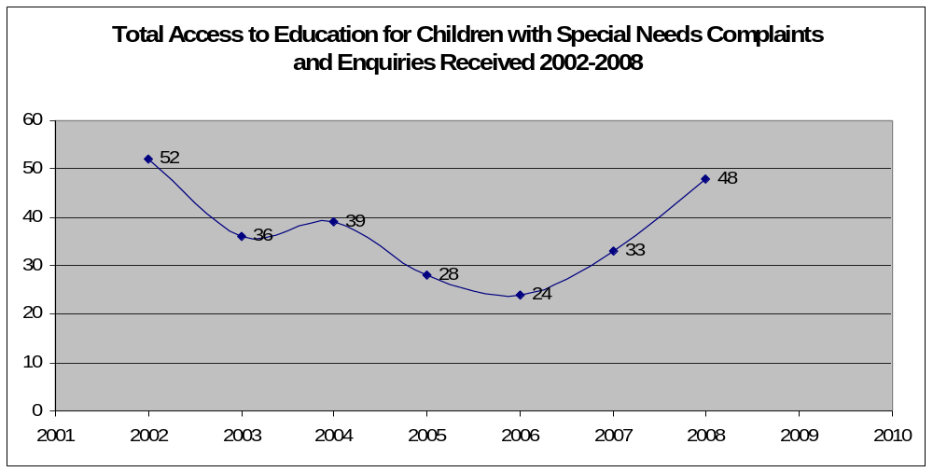

- The number of complaints and enquiries received on an annual basis showed a general trend downwards from 2003 to 2006 after a high of 52 in 2002. However, this trend has been reversed in the last two years, with the number of complaints and enquiries sharply rising in 2007 and 2008. By 18 March 2009 the Commission had already received 12 complaints, which is more than double the number received at the same time in 2008 (five complaints and enquiries).

- The way these types of complaints and enquiries are handled by the Commission has undergone a significant change in the last three years. From 2002-2005 three-quarters were handled at Stage 1 by the Commission’s InfoLine service. Since 2006 over two-thirds have been forwarded from InfoLine to other teams for further action, predominantly to mediators in the Dispute Resolutions Team. Of the 261 complaints and enquires received over the last seven years, 135 were responded to directly by InfoLine at Stage 1, while 126 were referred for further action. An analysis of outcomes for those 126 matters is attached as Appendix 1.

- Complaints and enquiries received since January 2002 covered a total of 52 disabilities, with 73 matters (28%) relating to attention deficit hyperactivity disorder (ADHD), 26 (10%) about students with autism and a further 17 (6.5%) where the student had a diagnosis of Asperger’s syndrome. There were 13 complaints or enquiries (5%) about deaf or hearing impaired students and 12 (5%) where the student had cerebral palsy.

- Over half of all the complaints and enquiries (60%) relate to four general themes:
- Problems surrounding the enrolment of children in school: schools not wanting to enrol children at all or only for limited hours (51 complaints)
- Children that have been stood down, suspended, excluded or expelled from school either because of their disability or due to behaviour that is caused by their disability (43 complaints)
- Funding or the need for special assistance, such as teacher aides, for students with disabilities (44 complaints)
- Disabled children’s ability to participate fully in wider school activities, such as school camps and other school trips (24 complaints).

- The remainder of the complaints involved issues such as:
- children with food allergies or intolerances that are not being accommodated by their schools
- problems with the way schools are disciplining disabled children (excluding formal disciplinary processes)
- general complaints that a school has not made reasonable accommodations required by a student
- disabled children being bullied at school by other children
- other problems relating to the way disabled children are treated by their schools
- complaints from schools concerned about disabled children’s right to education.

- Usually these complaints are lodged with the Commission by parents concerned that their child has been denied enrolment or treated less favourably than other students, because of the child’s disability. Typically when a disabled child faces barriers accessing or fully participating in education it has far-reaching effects not only for the child but for the family as a whole.

- In addition to the specific complaints, the Commission is aware, more generally, of the vulnerability of disabled students to harassment, bullying and assaults at school. The Commission also has information about the isolation many disabled students experience at school, often culminating in their exclusion from active recreation and sport. For students with learning disabilities this has been exacerbated by the failure to pick up other health issues including vision or hearing impairments.

- The four broad international standards for assessing the extent to which the right to education has been achieved are the concepts of availability, accessibility, acceptability and adaptability. Detailed analysis of the 261 complaints and enquires received by the Commission about disabled children’s right to education has reinforced concerns identified in the 2004 benchmark report Human Rights in New Zealand Today: Ngā Tika Tangata O Te Motu. Namely, there are significant outstanding issues for disabled students in all four components of the right to education, including:
- availability – there is an insufficient number of people skilled and qualified as inclusive educators and/or with special education training
- accessibility – participation rates of disabled students are disproportionately low
- acceptability – education standards vary considerably for disabled students and the school environment is not always a safe one for them and
- adaptability – education provision does not reasonably accommodate disabled students so that they can achieve equitable outcomes. Achievement rates for these students are disproportionately low.
New Zealand’s legal framework

- Disabled children have the same right to education as other children in New Zealand. In particular, section 8(1) of the Education Act 1989 confirms that “people who have special educational needs (whether because of a disability or otherwise) have the same rights to enrol and receive education at state schools as people who do not”.

- Under subsection 60A(1) of the Education Act 1989 the Minister of Education is empowered to publish national education goals, curriculum policy and statements, and administration guidelines, setting the regulatory framework for schools. National Education Goals 1 and 7 and National Administration Guidelines 1 and 5 are particularly relevant to realising the potential of disabled students, as are the principles of ‘high expectations’ and ‘inclusion’ in the New Zealand Curriculum.

- The meaning of the right to education for disabled students was examined in the High Court and the Court of Appeal in Daniels v Attorney-General. The High Court saw the right as a substantive one. However, the Court of Appeal viewed these rights in procedural terms and held they were met simply through statutory regulation of the education system. Only exceptional cases are likely to fall within this narrowly defined right to education.

- If schools deny enrolment to a student on the basis of a disability or treat disabled students less favourably than other students, a complaint of unlawful discrimination can be made under the Human Rights Act (HRA) 1993. This would typically be made under Part 1A for state and integrated schools. Section 57 of Part 2 may apply in limited circumstances, for example if a state-funded school is providing a private service, such as accommodation.

- The HRA does not define discrimination but makes it unlawful to treat people differently on various grounds, including disability. In the absence of a specific definition of discrimination, the definition in the Convention on the Rights of Persons with Disabilities could be read into Part 1A, including its obligation to reasonably accommodate.

- Reasonable accommodation is defined in the Convention on the Rights of Persons with Disabilities as:
“necessary and appropriate modification and adjustments not imposing a disproportionate or undue burden, where needed in a particular case, to ensure to persons with disabilities the enjoyment or exercise on an equal basis with others of all human rights and fundamental freedoms”.

- Although there is a well developed jurisprudence on reasonable accommodation overseas, considerable uncertainty still surrounds the concept in New Zealand. The Commission has made a number of submissions recommending the interests of disabled people would be better served if the HRA also contained a general duty to accommodate disability and a definition of reasonable accommodation.

- There have been a number of Part 1A complaints brought to the Commission stating disabled students have faced unlawful discrimination trying to access education. When the matter concerns the particular situation of an individual student, the Commission will usually seek mediation directly with the school, alerting the Ministry and Crown Law that it is doing so. That practice has not been inhibited by the Crown Law opinion that these complaints remain the responsibility of the particular board of trustees. The Ministry’s Deputy Secretary Special Education has recently invited the Commission to alert his office when such issues can not be resolved successfully with the school.

New Zealand’s policy approach

- The Tomorrow’s Schools policy framework adopted in the 1980s devolved decision-making to individual school boards of trustees, as set out in the Education Act 1989. This included agreements under section 9 of the Education Act, allowing for the enrolment of a capped number of students in special schools, units and attached classes or with itinerant teachers. Special schools and attached units were staffed at higher teacher-to-student ratios and had access to tagged teaching and therapy positions as well as support from Specialist Education Services. Additional teacher-aide hours could be applied for under Special Education Discretionary Assistance funding.

- Special Education 2000 (SE2000), initiated in 1997, was a fundamental overhaul of how resources were allocated. Its stated aim was “to achieve, over the next decade, a world class inclusive education system that provides learning opportunities of equal quality to all students”.

- SE2000 led to a significant increase in funding and targeting of resources to students with high needs. However, about half of the students previously covered by section 9 agreements did not meet these criteria, often because they were seen as having moderate needs. Support for these students, and other students with learning needs, would be funded out of a bulk grant paid directly to the school.

- In 2000 the government commissioned a comprehensive review of SE2000. The resulting Wylie report concluded the number of disabled students receiving some form of support under these education policies had risen to about 5.5% of the school population, and SE2000 had improved opportunities for some but not all students. The report raised significant areas of concerns and made 75 recommendations.

- In April 2001 the New Zealand Disability Strategy was launched. One of its 15 objectives is to “provide the best education for disabled people”. Seven of its eight action points are relevant to the compulsory education sector. They include ensuring no child is denied access to their local, regular school because of their impairment. Other priority actions are providing access to resources required by disabled students including New Zealand Sign Language, communication technologies and human aids, and facilitating opportunities for these students to meet their disabled peers in other schools. There is also a focus on ensuring educators understand the learning needs of disabled people, improving schools' responsiveness to and accountability for those needs, and promoting .appropriate and effective inclusive educational settings.

- Since the Wylie report, there have been some changes to special education policies, including unsuccessful attempts to modify the entry criteria for Ongoing and Reviewable Resourcing Schemes (ORRS) funding, for students with high or very high needs. Supplementary Learning Support (through extra 0.1 FTE teacher positions) was introduced to help classroom teachers provide individually adapted education programmes. Additional funding was introduced for schools that have a disproportionate and/or significant number of disabled students with moderate needs, through the Enhanced Behaviour Fund.

- The Ministry of Education began a Special Education Resourcing Review in mid 2007. In its November 2008 Briefing to the Incoming Minister, the Ministry noted the sector had high expectations that this review would result in increased funding across a number of areas.

- In April 2009 the Associate Minister of Education, the Hon. Heather Roy, announced a review of Special Education. The review’s terms of reference were released on 19 August 2009 and its first phase commenced immediately. The terms of reference state “the review must also result in services and supports which are consistent with the United Nations Convention on the Rights of Persons with Disabilities and the New Zealand Disability Strategy”. Public consultation will begin in late 2009 and extend into early 2010. In addition to receiving submissions on that consultation document, the Ministry of Education will also be convening meetings with its sector reference groups.

- The 28 May 2009 Budget announced an extra $51 million over four years in ORRS funding. The first phase of the Special Education review focuses on the most pressing priorities, including how to put this additional ORRS funding into operation. Phase two begins in late 2009 and the review will report to government in July 2010.

- In addition, the Ministry is undertaking a number of initiatives to build greater understanding about disabled students’ right to education. These include:
- QuickGuide – a summary of all the support available for students with additional support needs (to be available online by 31 July 2009)
- letters to boards of trustees reminding them of their obligations and responsibilities under the Education Act 1989 (sent in February 2009)
- a review of information provision for parents
- a review of complaints procedures and the development of a contact register.

Inclusive and Special Education – the concepts

- The special education movement has been successful in achieving changes in the nature and level of services and funding for disabled students. In the New Zealand context the Special Education 2000 review was a crucial part of this shift.

- It has also had the unintended result of ghettoising disabled students in special schools or classrooms, or as the object of special measures in mainstream classrooms, and needing specialist teachers to succeed. Disabled students continue to be seen as ‘other’, and therefore as problematic for the education system, the school and the individual teacher. Disabled students remain the object of policy rather than the subject of their own education.

- Inclusive education represents a fundamental shift from such an approach. There is a growing body of New Zealand academic research around inclusive education. IHC recently commissioned Dr Jude MacArthur to produce a publication on inclusive education, including domestic and international evidence on the comparative academic and social outcomes for disabled students taught in regular classrooms. Her book, Learning Better Together, was launched at Parliament on 3 June 2009. A comprehensive piece of recent primary research in this area is Alison Kearney’s unpublished 2009 doctoral thesis. It too strongly advocates for inclusive education.

- The Ministry of Education commissioned a 2004 literature review by the Donald Beasley Institute to inform its Enhancing Effective Practice in Special Education research programme. Dr Jude MacArthur was part of the Institute’s project team. Their 500-page draft report is available from the Ministry, and is distributed with critical comments from peer reviewers who considered conflicting evidence supporting special education services was not always fairly presented.

- Inclusive education is closely aligned with both a human rights approach and the specific principles outlined in the Convention of the Rights of Persons with Disabilities: self determination, independence and partnership. However, there are two areas where the international and local consensus about the role of separate or special education is not necessarily clear-cut, namely:
- Children with an acute sensory impairment. E.g. those who are either Deaf or blind.
- Students with severe disabilities. In much of the Western world there is an acknowledgment (though by no means universal) that between 1% and 3% of students with the most severe disabilities can not reasonably take part in the national curriculum. The range of proffered options includes separate schools, separate classrooms with mainstream schools, and social inclusion in mainstream schools and classes with a separate curriculum.

- The Convention of the Rights of Persons with Disabilities acknowledges these complexities by focusing on educational outcomes, rather than the educational setting alone. It requires that ”effective individualised support measures are provided in environments that maximise academic and social development, consistent with the goal of full inclusion”. In addition, Articles 24(3) and (4) provide some explicit guidance on the types of special measures that should be provided to enable deaf and blind/low vision students to access education.

International human rights framework

- The human right of all children to education has been recognised since the Universal Declaration of Human Rights (UDHR, Article 26) in 1948, and has been articulated in a range of international conventions, including the International Covenant on Economic, Social And Cultural Rights (ICESCR, 1966) and the Convention on the Rights of the Child (CRC, 1989).

- The right to education is outlined in the Convention on the Rights of the Child, in articles 28 and 29. Article 23 recognises children with physical or mental disabilities are entitled to enjoy a “full and decent life” in conditions that ensure dignity, promote self-reliance and facilitate the child’s active participation in the community. The Committee on the Rights of the Child’s General Comment No.9 on the rights of children with disabilities specifically adopts inclusive education as the goal for educating disabled students.

- The World Conference on Special Needs Education: Access and Quality held in Salamanca, Spain in 1994 developed the Statement and Framework for Action on Special Needs Education (the Salamanca Statement). The statement sets out four assumptions that form the basis of the inclusive education philosophy:
- all students come to school with diverse needs and abilities, so no students are fundamentally different
- it is the responsibility of the general education system to be responsive to all students
- a responsive education system provides high expectations and standards, a quality curriculum and instruction, an accessible environment and teachers who are well prepared to address the educational needs of all students
- progress in general education is a process evidenced by schools and communities working together to create citizens for an inclusive society.

- The UN Convention on the Rights of Persons with Disabilities was adopted by the UN General Assembly on 13 December 2006. Article 7 affirms disabled children are entitled to the entire range of human rights inherent to all children. Their right to appropriate support in making their voices heard is emphasised in both articles 7 and 24. Article 24 also recognises:
- a clear commitment to the principle of inclusive education
- the specific needs of children with severe and complex sensory impairments who require learning supports such as sign language, Braille and low vision aids
- disabled children require support that is individually tailored and resourced (both in terms of time and staffing) and decided in partnership with them and their parents
- modifications to the curriculum, styles of teaching and classroom organisation may be necessary.

- The UN Special Rapporteur on the Right to Education’s 2007 report lays out the obligations on States Parties that have ratified the disability convention to “ensure an inclusive education system”.

International legal and policy approaches

- Many of the issues identified overseas are pertinent to New Zealand, even though the legislative and policy environments differ.

United Kingdom

- In the United Kingdom, an Equality Duty set out in the Disability Discrimination Act 1995 places a general duty on all schools, and a specific duty on all those receiving public funding. As a result, schools are required to prepare, publish and report on their disability equality scheme. A Code of Practice for Schools details their responsibilities under the Disability Discrimination Act.

- Parents must be consulted in the preparation of both the scheme and their child’s individual education plan. Appeals can be made to the Special Educational Needs and Disability Panel about that plan, the needs assessment itself and the assistance offered. Higher appeals can be taken to the Upper Tribunal, which also hears disabled students’ complaints of discrimination by a school.

United States

- Education for disabled students in the States is governed by the No Child Left Behind Act 2001 (NCLB) and the Individuals with Disabilities Education Improvement Act 2004 (IDEA).

- The NCLB requires each state to establish a curriculum, including standards for each subject and year. By 2013 every child, including disabled students, will be entitled and expected to meet the same state-wide academic standards. The Code of Federal Regulations sets out the requirements for Individual Education Plans, including what accommodations are necessary, so the student’s performance will be improved relative to the state’s guidelines. The only exceptions are for the 3% of students whose intellectual or other disabilities are judged to be too severe for testing against these standards to be feasible.

- The IDEA requires that, to the maximum extent possible, children with disabilities are to be educated with children who are not disabled. This commitment to education in the ‘least restricted environment’ means about 96% of students with disabilities attend regular schools. The IDEA establishes the principle that disabled children are entitled to ‘free appropriate public education’. What this means in practice has been the subject of considerable litigation.

Canada

- The Canadian Human Rights Act 1977 makes it unlawful to discriminate in the area of access to education on the ground of disability. The Canadian Charter of Rights and Freedoms guarantees equal opportunities to all Canadians, including those with a ‘physical or mental disability’.

- Access to education for disabled children tends to be dealt with in the context of provincial inclusive education policies. For example, in Nova Scotia the 2007 Minister’s Review of Services for Students with Special Needs reviewed progress on implementing a 2003 action plan, making policy recommendations for further action.

- A number of state Human Rights Commissions have developed guidelines for ‘accommodating students with a disability’, for example Ontario and New Brunswick.

- The limits to reasonable accommodation in Canada are set out in a Supreme Court case British Columbia (Public Service Employee Relations Commission) v bcgseu, known as the Meiorin case.

Australia

- The federal Disability Discrimination Act 1992 (DDA) provides for the Attorney-General to issue mandatory standards covering any aspect of disabled people’s right to participate fully in society. The Disability Standards for Education came into affect in 2005 and set out definitions of key concepts such as adjustments, reasonable adjustments and ‘on the same basis’, the phrase used extensively in the disability convention. The exceptions relate to unjustifiable hardship, protection of public health and special measures.

- A review of special education in the state of Victoria was undertaken in 2006 by the non-governmental Inclusive Education Network. The report concluded there is a need for a basic school funding model based on inclusive principles, better in-service and pre-service training, improved physical access and involvement of the wider school community in decision-making.

- In 2007 the federal Department of Education, Employment and Workplace Relations published a major report on improving the learning outcomes of students with disabilities. It identified:
- the importance of moving pedagogical focus from ‘adaptations for special needs’ to ‘universal design pedagogy'
- the whole-school, diverse-needs approach to education has been more successfully adapted to primary than secondary schools
- extensive use of teaching assistants ‘locks-in’ practices and discourages flexible and creative use of resources
- persistent difficulties obtaining adequate funding for students with high or complex needs.

- The very brief overview above highlights the leverage achieved through a range of mechanisms, including:
- enforceable positive duties supported by a strong appeal process (in the United Kingdom)
- codes providing guidance for schools (in both the United Kingdom and United States, and developed by state human rights institutions in Canada)
- mandatory standards (in Australia)
- measurable targets (in the United States)
- action plans (in Canada).

Developing Options for a Commission work programme

- The six elements of the human rights approach provide some guidance around developing options for a Commission project. The table below sets out possible ways the Commission could use each to promote and protect disabled students’ right to education.

Human Rights Approach | HRC’s possible role
Linking of decision-making at every level to human rights standards set out in the relevant human rights covenants and conventions | Use the HRC’s expertise to provide guidance about the recently ratified Convention on the Rights of Persons with Disabilities
Identification of all relevant human rights involved, and a balancing of rights, where necessary, prioritising those of the most vulnerable people, to maximise respect for all rights and rights-holders | Provide advice about how to balance competing rights. Current practices suggest systemic barriers culminate in the rights of disabled students often not being prioritised
An emphasis on the participation of individuals and groups in decision-making that affects them | Promote dialogue in order to move beyond the potential impasse of Part 1A complaints, and advise schools about the importance of students’ and their families’ right to be heard
Non-discrimination among individuals and groups through equal enjoyment of rights and obligations by all | Highlight the definition of discrimination in the convention and the obligation it places on schools to reasonably accommodate
Empowerment of individuals and groups by enabling them to use rights as leverage for action and to legitimise their voice in decision-making | Build understanding about the convention, particularly the concepts of self determination, independence and partnership
Accountability for actions and decisions, which enables individuals and groups to complain about decisions that affect them adversely | Place a human rights lens over current sector concerns about accountability. e.g. those raised in ERO reviews about schools’ use of SEG funding and the resulting suggestion that 1998 Ministry guidelines are revised. The Ministry’s BIM signals accountability as a component of the Special Education Review.

Conclusion

- This paper has provided domestic evidence about the extent to which disabled children and young people are denied the right to education. When compared against international human rights standards, there are significant outstanding issues about the availability, accessibility, acceptability and adaptability of education for disabled students in New Zealand.

- In the light of that information, and given the recently announced Special Education Review, this paper proposes that the Commission develops a work programme on disabled students’ right to education beginning in the 2009/10 financial year.

Appendix 1: Complaints and enquiries Jan 2002 – Dec 2008

The table below summarises outcomes for those complaints and enquires about disabled students’ right to education that were referred from the Human Rights Commission’s InfoLine to another part of the Commission for further action.

Outcome | No | %
Complaint still open | 14 | 11%
Mediation held – successful outcome | 11 | 9%
Mediation held – partially resolved | 3 | 2%
Mediation held – no successful outcome | 7 | 6%
Mediation requested – did not proceed as school or Crown Law questioned jurisdiction (all about funding) | 4 | 3%
Resolved with other assistance from a mediator | 6 | 5%
Other information or assistance provided by mediators or other HRC staff | 25 | 20%
Mediation process not considered appropriate by complainant or HRC – no further assistance | 8 | 6%
Other agency involved so HRC role not appropriate | 17 | 13%
Complainant in discussion with school directly – no HRC assistance required at this time | 1 | 1%
Complainant discontinued complaint | 18 | 14%
Complainant was a 3rd party so HRC unable to assist | 2 | 2%
Complaint outside jurisdiction for other reasons | 5 | 4%
Complaint resolved but no details about HRC’s role | 1 | 1%
No outcome details recorded in RADAR | 4 | 3%
TOTAL | 126 | 100%

Because of their nature, three of these complaints have been included with the complaints on participation in wider school activities, while the other seven related to a lack of reasonable accommodation to these conditions and are considered separately.
Daniels v Attorney-General (3 April 2002) HC AK M1516/SW99; Attorney-General v Daniels [2003] 2 NZLR 742 (CA).
E J Ryan (2004) ‘Failing the System? Enforcing the Right to Education in New Zealand’ in Victoria University of Wellington Law Review 29. Retrieved on 11 June 2009 from http://www.nzlii.org/nz/journals/VUWLRev/2004/29.html
Now called Group Special Education Services
Ministry of Education (1996) Special Education 2000, p 5
Retrieved on 25 August 2009 from http://www.beehive.govt.nz/release/minister+releases+tor+special+education+review
Kearney, A. [2009] Barriers to school inclusion: an investigation into the exclusion of disabled students from and within New Zealand schools. An unpublished thesis presented in partial fulfilment of the requirements for the degree of Doctor of Philosophy in Education, Massey University, Palmerston North pp 221-223.
United Nations Committee on the Rights of the Child (2007) General Comment 9: The Rights of Children with Disabilities. United Nations CRC/C/GC/9. Retrieved on 11 June 2009 from: http://www.unhchr.ch/tbs/doc.nsf/898586b1dc7b4043c1256a450044f331/405ba882cb9eb3a0c12572f100506ac4/$FILE/G0740702.pdf
UNESCO and the Ministry of Education and Science, Spain (1994) The Salamanca Statement and Framework for Action on Special Needs Education. Adopted by the World Conference on Special Needs Education: Access and Quality, Salamanca, Spain, 7-10 June 1994. Retrieved on 11 June 2009 from: http://www.unesco.org/education/pdf/SALAMA_E.PDF
United Nations Human Rights Council (2007) The Right to Education for Persons with Disabilities: Report of the Special Rapporteur on the Right to Education, Vernor Muñor United Nations A/HRC/4/29. Retrieved on 11 June 2009 from http://siteresources.worldbank.org/DISABILITY/Resources/News---Events/463933-1147810251877/UNSREdu.pdf
In those cases, school districts are able to develop alternative achievement standards. The National Council on Disability’s 2008 review found that the development of these alternatives is uneven between states and generally lags behind need.
In the leading Supreme Court case Board of Education of the Hendrick Hudson Central School District v Rowley, the Court held that “personalised instruction with sufficient support services to permit the child to benefit educationally from the instruction” was required. Cases since Rowley have determined that the programme must provide for more than ‘de minimis or trivial academic achievement’ but is not required to offer ‘every available service necessary to maximise a disabled child’s potential’.
Retrieved on 11 June 2009 from: http://www.ednet.ns.ca/events/special_education_review/documents/review-committee-report-e.pdf
Essentially they outline the relevant anti-discrimination provisions, explain the requirements for reasonable accommodation (and conversely undue hardship) and describe other anti-harassment and anti-bullying provisions.
The Meiorin test for reasonable accommodation requires that the accommodation must: - be rationally connected to the function to be performed - be adopted in good faith - be reasonably necessary to achieve the purpose or goal and - not impose an undue hardship on the service provider. Undue hardship in Canadian jurisprudence is commonly considered to have three elements - excessive costs, serious risk to health and safety and the impact on other people and programmes.
Inclusive Education Network (2006) Inclusive Education in Victoria Discussion paper & proposed policy framework. Retrieved on 10 June 2009 from: http://www.strategicessentials.com.au/resources/Final%20Inclusive%20education%20paper%20and%20proposed%20policy%20May%202006.pdf
Universal Design is the design of products and environments to be usable by all people, to the greatest extent possible, without the need for adaptation or specialized design. The basic premise of universal instructional design is that curriculum should include alternatives to make it accessible and applicable to students with different backgrounds, learning styles, abilities and disabilities. (Definition retrieved on 11 June 2009 from http://www.northeastern.edu/cietl/instructional_design/documents/UIDINTRO.ppt.pdf ). Further information retrieved available at http://www.rit.edu/ntid/drt/classact/side/universaldesign.html
A recent NZEI Special Education Policy report noted, “cultural, physical and emotional safety is paramount. NZEI notes the tension between balancing the rights of individual students with the rights of all students, staff, whānau / caregivers and community”.?
Retrieved on 11 June 2009 from: http://www.minedu.govt.nz/~/media/MinEdu/Files/EducationSectors/SpecialEducation/FormsGuidelines/ManagingTheSpecialEducationGrant.pdf

