TURANGAWAEWAE
Human Rights Commission News

MARCH | 2016

IN THIS ISSUE:

CSW 60 | The assisted dying debate | Treaty x Thirty
Lily | Off to the UN | Accommodation and Human Rights
Rainbow Tick | Better housing for disabled people
At Waitangi 2016 | Speak UP—Kōrerotia | SDM Hui

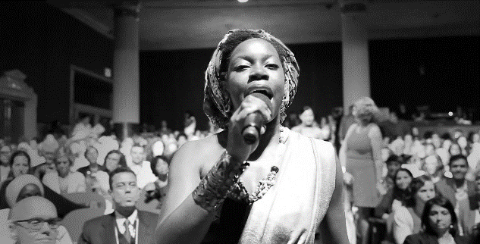
RT88888
GENDER
CSW Event Profile:

EEO Commissioner, Dr Jackie Blue is attending the 60th session of the Commission on the Status Women in New York 14 to 24 March.

COMMISSIONER
BLUE ATTENDING CSW 60

and actions to further the cause of gender equality and women’s empowerment.

CSW is part of UN Women, which is the United Nations organisation dedicated to gender equality and the empowerment of women. A global champion for women and girls, UN Women was established to accelerate progress on meeting their needs worldwide.

It stands behind women’s equal participation in all aspects of life, focusing on five priority areas: increasing women’s leadership and participation; ending violence against women; engaging women in all aspects of peace and security processes; enhancing women’s economic empowerment; and making gender equality central to national development planning and budgeting. UN Women also coordinates and promotes the United Nations system’s work in advancing gender equality. Details are available here.
The session will address the priority theme: ‘Women’s empowerment and its link to sustainable development’.

It will also evaluate progress on the 57th session: ‘The elimination and prevention of all forms of violence against women and girls’.

Dr Blue will be speaking on a Business and Professional Women’s panel about “Forced Marriage” from a New Zealand perspective.

CSW is a global policy-making body dedicated exclusively to promoting gender equality and the empowerment of women. This 60th session also provides the opportunity for policy makers, advocates, researchers and activists to network and strategise, mobilise and plan new initiatives

ASSISTED DYING
THE HUMAN RIGHTS DEBATE
RT88888
HUMAN RIGHTS

The euthanasia issue has already been called the debate of the year.

T
he Human Rights Commission has made a submission to the Health Select Committee’s Investigation into End of Life Matters. This investigation resulted from a Petition submitted by Hon Maryan Street and 8,974 others requesting:
‘That the House of Representatives investigate fully public attitudes towards the introduction of legislation which would permit medically-assisted dying in the event of a terminal illness or an irreversible condition which makes life unbearable.’
In addition, a private members bill has been introduced to the ballot which seeks to legally authorise medical practitioners to assist a person with a terminal illness to die, under certain circumstances. The Petition and the Bill follow Lecretia Seales’ landmark case, in which she sought a declaration from the High Court that her general practitioner would not be committing a crime if she were to assist her to end her life if the pain and indignity caused by her terminal brain cancer became too much for her to bear.

Lecretia’s claim had significant implications for human rights law in New Zealand, particularly the interpretation of the right to life and the right to protection from cruel or degrading treatment under the New Zealand Bill of Rights Act 1990 (BORA). Her claim also involved consideration of the fundamental human rights concepts of dignity and personal autonomy. The decision confirmed however, that any action taken by a physician to assist a terminally ill person to take his or her own life constitutes a serious criminal offence under the Crimes Act 1961, if the terminally ill person requests the intervention.

Human dignity is a core human rights concept. But in NZ a free-standing right to dignity is not expressly provided for in the BORA or in other human rights legislation as it is in South Africa for example.

Furthermore, the Canadian Charter of Rights includes the rights to liberty and security of the person, alongside the right to life. These concepts of personal autonomy are not explicitly provided for in the BORA’s expression of the right to life, which just states:

“No one shall be deprived of life except on such grounds as are established by law and are consistent with the principles of fundamental justice.”

ASSISTED DYING

RT88888
HUMAN RIGHTS
In its submission, the Commission recommends that the Committee consider whether the
current form of BORA adequately engages the human rights issues that arise from end of life matters, namely those regarding the rights to dignity and personal autonomy.
The Commission’s view is that the right to not be arbitrarily deprived of life does not directly translate into an absolute prohibition on Parliament implementing a legislative framework that would permit terminally ill people to obtain assistance to end their lives.

This position is subject to the provisos and safeguards as listed broadly here:

- Clear and sensible thresholds are necessary and an adult age of decision making of 18
- Free of coercion or influence
- Appropriate medical evidence and perhaps a psychiatric screen
- Cooling off period
- Need for ongoing monitoring and independent review of the system
- Judicial/expert oversight
- Medical professionals can ‘opt out’ ‘conscientious objection’ provisions similar to the current abortion legislation.

To read the Commission’s submission click here.

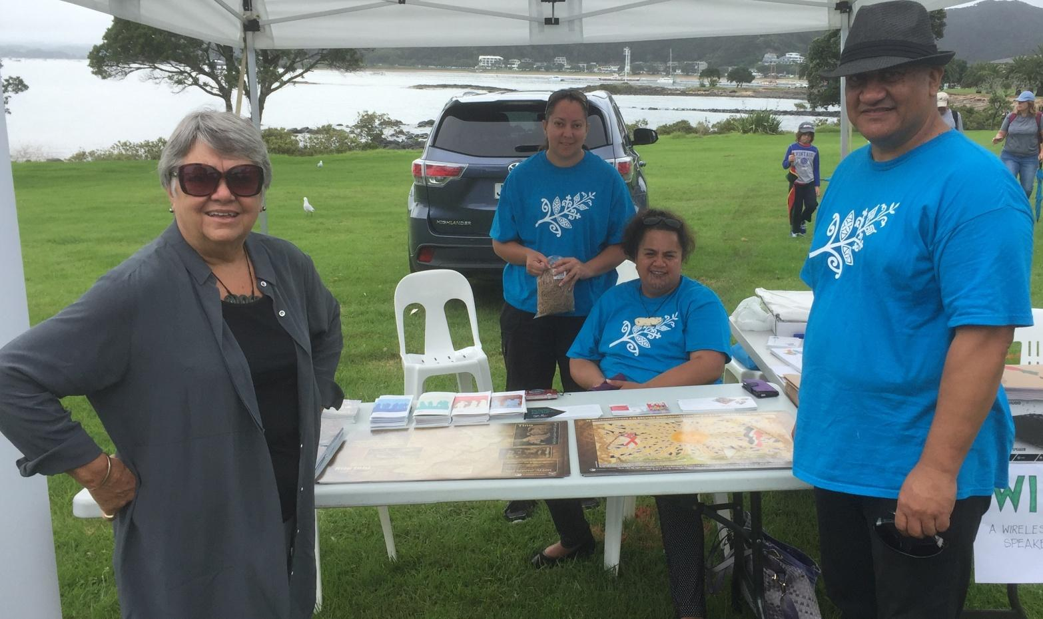
HRC AT WAITANGI
Kia tika kia pono kia pūmau: Perfecting the partnership

GENDER
RT88888
INDIGENOUS RIGHTS

Commissioner Karen Johansen, HRC staff Jessica Ngatai, Paula and Hemi Pirihi at Waitangi

T
his year the Commission attended Waitangi Day celebrations at Waitangi. It had an information table to advocate and promote the Treaty as New Zealand’s founding human rights document and the United Nations Declaration on the Rights of Indigenous Peoples (UNDRIP).
Attendance at Waitangi gave an opportunity for the Commission to engage with the local community, Māori and iwi, and all New Zealanders. The Commission’s theme for Waitangi 2016 was: Perfecting the Partnership – kia tika, kia pono, kia pumau.
The Commission shared the following Treaty and UNDRIP resources with attendees:
- Te Mana i Waitangi
- UNDRIP brochure English
- UNDRIP brochure Reo

KO TE TIRITI KI ROTO I NGĀ REO TORU TEKAU

INDIGENOUS RIGHTS
RT88888

Ko te kaupapa a Stefan Grand-Meyer rāua ko Olga Suvorova ko te tāhuri i te Tiriti o Waitangi ki ngā reo e 30. E tūmanako ana rāua mā tēnei kaupapa e āwhina te whai wāhi a ngā tāngata o Aotearoa nō iwi kē ki te Tiriti, e whakatairanga hoki i te Tiriti ki te ao whānui.

Ka noho tētahi hunga ki te tāhuri i te Tiriti, reo Māori mai, reo Pākehā mai hoki, ki ngā reo e toru tekau engari kāore anō kia whakapuakina ko ēhea ngā reo nei.

Ko te Rōpū Tāhuri Reo ā-tuhituhi, ā-waha tērā (New Zealand Society of Translators and Interpreters) ka āwhina i ngā mahi nei ki te tāhuri i te Tiriti ki ngā reo toru tekau. He kaupapa tēnei hei whakanui i te toru tekau tau o te Rōpū Tāhuri Reo. E iwa tekau ngā kaitāhuri reo ka kōkiri i ngā mahi nei.

Ko Karen Johansen te Kaikomihana mō te Tiriti me ngā Iwi Taketake, ā, nōna te reo whakamihi ki tēnei kaupapa whakahirahira,

“E mihi ana ahau ki te Rōpū nei mō tēnei mahi nui nō te mea e whakapono ana ahau māna e tautoko te whakaaro o te tini tangata tērā e noho nei rātau ki tētahi whenua kua tipu mai ki runga i ngā oati o te Tiriti … e hīkaka ana ahau ki te whai hua o ngā tāhuringa reo nei arā hei whakatipu i te māramatanga ko te Tiriti he kaupapa tika tangata mō ngā tāngata katoa o Aotearoa.”

“Ka riro mā ngā tāhuringa reo nei e whakamōhio te tangata ki te wāhi nui o te Tiriti ki roto o Aotearoa, me te āhua o te hononga ki waenga i te Karauna me te Tangata Whenua kua hua ake i te Tiriti.”

I whakamāoritia tuatahitia te Tiriti e Henry rāua ko Edward Williams, he mihingare i noho ki waenga i te iwi Māori mō te 17 tau. Ka oti tā rāua whakamāoritanga i te kotahi pō, me te whakawhiti kōrero ki ētahi rangatira Māori mō ngā mahi nei. He takarepa te hua, ā, tērā ētahi tikanga whakaaro i rerekē nei te whakamāori, pēnei i te tino rangatiratanga me te mana pupuri whenua.

Heoi, kua tipu mai ngā tikanga mō te tāhuri reo. E tūmanako ana ngā kaiwhakahaere o te kaupapa nei kia tāhuri te Tiriti ki ngā reo toru tekau tērā ka whakaatuhia ngā rerekētanga o te Tiriti reo Māori me te Tiriti reo Pākehā, ka kitea hoki ngā uauatanga o te tāhuri reo ki waenga i iwi kē, i ahurea kē.

Ka tākohatia ngā tāhuringa reo ne ki ngā tāngata katoa o Aotearoa i te Rā Tāhuri Reo o te Ao, te 30 o Mahuru 2016. (Article in English is here.)

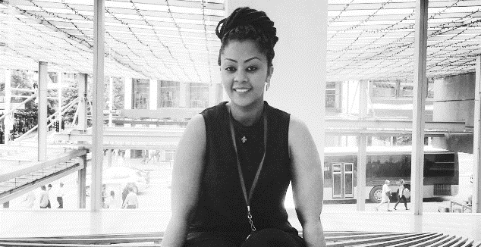
RT88888
RACE RELATIONS

My name is Lemlem Meketaw Azanaw (Lily) ለምለም መከታው አዛናው

I
was born in Sudan but am Ethiopian. My parents migrated to Sudan in the 1980s. I am from a family of six – four sisters and one brother. (I also have two brothers and one sister from my father’s side.) I am 26 years old and came to New Zealand as a refugee when I was 12 years old with my mother, one older brother and two younger sisters.

We had to leave our country because of political issues: my father was a politician. He was the leader of a party that fought for freedom and human rights. Unfortunately, my father was the leader of the party and he was the first person to be kidnapped by the government in 1992 in Sudan followed by four other political leaders.

The Sudanese government illegally transferred Ethiopian political refugees to the Ethiopian Government, with whom they had an agreement. We couldn’t live safely in Ethiopia, nor could we stay in Sudan because it was unsafe for us. My mother asked the UN for refugee status and we were fortunate to be accepted. We were moved by the UN to a refugee camp in Sudan for six months. Life in the camp was very hard, especially when the rain and wind came because the accommodation was of a poor standard. We lived there for 6 months until the New Zealand government accepted my family. We then stayed at the Mangere Centre for six weeks before we made a home in Onehunga.

I started my formal education at high school level, even though I had no previous education. My brother did though help us to learn some English when we arrived in New Zealand and also I had a home tutor who helped me to read and write. I am now finishing my Bachelor in Social Practice in June 2016 and have a diploma in mental health.

ADVICE FROM LILY

RACE RELATIONS
RT88888

As we are currently receiving refugees from Syria is there any advice you could give to those who want to be helpful to them so that they can settle in to a community, considering they are most likely to have experienced personal trauma?

Welcome them with a smile and make them feel included.

Make them feel New Zealand is their home. It is important that they are connected to services that they can get support from and showing them they are respected as a person.

Sport and healthy activity are important things in NZ. Muslim women at home in Syria will have a lot of women’s only facilities such as swimming pools, gyms, tennis clubs etc as men and women are separate in public.

But in New Zealand we mostly have mixed sex facilities: You can help new arrivals by letting them know there is a Ladies Night at the Mt Albert Pool in
Auckland for example which is subsidised and offers free Muslim women’s swimming lessons at Cameron Pool.

You have been a refugee. How did you and your family cope with being so far away from Ethiopia with little chance of going back?

It was hard at the beginning to cope in a new country – new culture, different faces, new area, and a different environment are big adjustments. The first day at school is very challenging and a struggle when you know that you don’t have friend to hang around with or you don’t know what the teachers, students are expecting from you.

And loneliness is a problem for women who are isolated at home bringing up children – especially when they don’t know the language of the country.

What do you think is the key problem that refugee youth face when they come to live in a new country other than learning English?

The key problem is to adopt the cultural environment and feel included in all of that. The fear others have of different ethnicities, skin colour and accent is noticeable.
This was at times played out as school ground bullying. In addition, most refugee youth face unemployment (more than other youth) and this is a real problem.

RT88888
HUMAN RIGHTS
VIOLENCE AGAINST WOMEN AND CHILDREN A MAJOR PROBLEM FOR NZ
Chief Commissioner presents to UN in Geneva

In just over two weeks Chief Human Rights Commissioner, David Rutherford will present to the UN Human Rights Commission as part of New Zealand’s 6th periodic review under the International Covenant on Civil and Political Rights (ICCPR).

The full report can be accessed here. A couple of key excerpts from the report follow:

Violence and abuse and the discrimination and inequalities experienced by some New Zealanders remain the most significant human rights issues.

Most serious violence against children is family violence. While there has been some good progress, the level of family and sexual violence in New Zealand is unacceptably high. New Zealand has the fifth worst child abuse record of 31 OECD countries.

Despite the many efforts of communities and successive governments, discrimination, social and economic exclusion and entrenched inequalities remain a reality for certain groups of people living in New Zealand.

Those affected include women, children, disabled people, Māori, Pacific people, migrants and refugees, older people, and other minority groups. Poor people, most notably poor Māori, Pacific people, and disabled people are the most seriously affected.

This is evident in material deprivation and incarceration rates, education achievement levels, low levels of participation in work, low incomes, poor health and inadequate housing.

The OECD Economic Survey on New Zealand notes:

“New Zealand has generally done well in enabling economic and social participation of its people.
Yet, as in many other countries, income inequality and poverty have increased, rising housing costs have hit the poor hardest, and the rate of improvement in many health outcomes has been slower for disadvantaged groups than for others.
Gaps in education achievement have narrowed, but the influence of socio-economic background on education achievement has increased.
Of particular concern are those New Zealanders who face persistently low incomes, material hardship and poor long term outcomes across a range of dimensions.
While Māori and Pasifika are less than a quarter of the population, they are significantly overrepresented in these groups.”

ACCOMODATION AND HUMAN RIGHTS

RT88888
ECONOMIC, SOCIAL, AND CULTURAL RIGHTS

T
he Human Rights Act 1993 (the Act) makes it unlawful to treat anyone differently on certain grounds (such as race, sex, sexual orientation, and disability) in specific areas of public life, but this is subject to some exceptions.

The Act makes a distinction between areas of ‘public’ and ‘private’ life. Land, housing, and other accommodation is an area of public life covered by the Act (section 53).

However, one exception in the area of accommodation applies to where a person wishes to share accommodation (such as a house, flat, or room) with someone else (section 54). This exception is intended to cover property owners, landlords, flatmates, or co-dwellers where they share the accommodation.

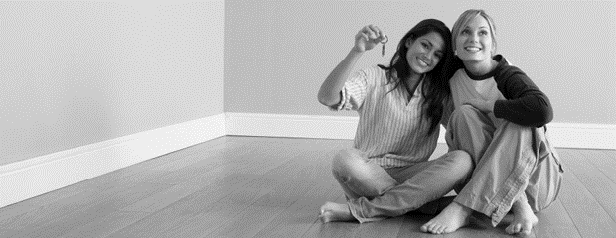
What are your rights when looking to find a flatmate?

The exception could apply to some commercial providers if there is some kind of shared living arrangement.

Another exception applies to hostels or institutions such as a hospital, club, school, university, religious institution or retirement village (section 55). In these situations, accommodation may be made available for people of the same sex, marital status, or religious or ethical belief, or disability or age group. The exception does not apply for grounds such as race or national origin. An example of where this exception may apply is a single sex hostel at a High School.

A relevant consideration to the area of accommodation is freedom of association which includes the right to come together with other individuals and collectively express, promote, follow, and defend common interest (section 17 of the New Zealand Bill of Rights Act). Freedom of association is consistent with the exceptions in the Act allowing a person to choose who they want to live or share a house, flat, or room with.

ACCOMODATION
RT88888
ECONOMIC, SOCIAL, AND CULTURAL RIGHTS

T
he Commission appreciates that people have preferences and it is not the Commission’s role to tell people how to make decisions. However, people can communicate their preferences in a respectful and responsible way to avoid offending people unnecessarily.
The Commission worked with Trade Me on developing some tips for how to find a flatmate in the context of the Act. The tips include practical ideas such as:

- Using inclusive language in advertisements (for example, “we are a group of young X people looking for a flatmate to share our home customs, language, and food” rather than “X only” or “no Y”)
- It is better to focus on personal qualities rather than stereotypes or oversimplified ideas about groups of people that do not recognise individual difference. For example you want a responsible flatmate that pays the rent on time, rather than saying ‘professional couple wanted’.

If you have an enquiry or complaint...

You can contact the Commission by calling our confidential service on 0800 496 877 or emailing infoline@hrc.co.nz. People can also complain by submitting an online form on our website www.hrc.co.nz.

If the Commission is unable to offer its dispute resolution service, it may be able to provide some helpful information. There is more information available about the Commission and its dispute resolution service at https://www.hrc.co.nz/enquiries-and-complaints/.

There is other information available online for flatmates and tenants. This includes:

- The Ministry of Business Innovation and Employment’s Tenancy Services
- Tenants Protection Association
- Citizens Advice Bureau
- Youthlaw

GETTING A RAINBOW TICK
RT88888
BUSINESS AND HUMAN RIGHTS

The Commission is working towards achieving accreditation against NZ Standard 8200:201: A standard for gender and sexual diversity in employment designed to assist organizations to be inclusive for LGBTIQ. New Zealand is the first country in the world to develop an official standard addressing rainbow-inclusive workplaces. The standard is called the Rainbow Tick.

International research shows that people from the lesbian, gay, bisexual, trans, takatāpui, queer, and intersex (LGBTTQI) communities still face discrimination and exclusion in the workforce; in recruitment, retention, training, and advancement opportunities. This is an infringement of human rights.

The Commission is aiming to be accredited by June this year.
Nine organisations/companies are currently accredited with the Rainbow Tick –

- Simpson Grierson
- Coco-cola Amatil
- ASB
- ANZ
- Westpac
- Sky City
- Sovereign
- Auckland Institute of Technology
- Fletcher Building
- Publicis Loyalty.

Others in the process of becoming accredited include:

- KPMG
- PwC
- Bell Gully
- Russell McVeagh
- Vector
- Flick Electric
- Tower Insurance
- Microsoft
- Auckland Council,
- HRINZ
- AuSM
- Repromed Fertility Specialists
- Otago Polytech
- St John Ambulance Service.

Over the next months the Commission is supporting two events aimed at prioritising human rights issues for the LGBTI community and developing concrete actions:

A human rights forum as part of the ILGA Oceania Human Rights and Health Conference (March 10: 10.30 – 12.30), and a Human Rights forum in partnership with the Auckland Pride Festival Working Group (late March, early April – date to be finalised shortly).

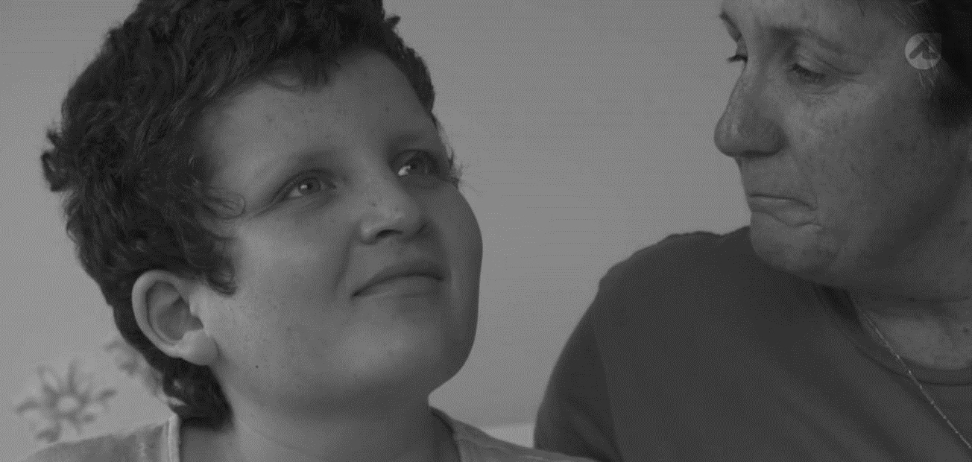
RT88888
DISABILITY RIGHTS

HOUSING PROJECT INCLUDES HOUSES CATERING FOR DISABLED

Two government funded, special housing development projects in Auckland are changing lives because these houses are modified for people with disabilities.

Housing New Zealand Corporation (HNZ) is currently developing housing tailored for people with disabilities in Ranui and a seventeen-house development is underway in Waterview.

For many people living with disabilities such as Neela Findlay, finding suitable housing can be very difficult. Neela sustained a brain injury after being deprived of oxygen during birth. She has lived under her family’s care her entire life, but now 17 has moved into one of the three community group homes in Ranui where she is provided 24-hour care but lives with her family. She has neighbours with high needs and all are part of a small community.

“The house is completely modified for Neela’s needs. We couldn’t have asked for anything better, it’s perfect. This has changed our life as a family,” Neela’s mum said to Attitude TV.
A Tenancy Support Services spokesperson explained that the government has built 1500 community group properties.”

“Now that more people with special needs are moving into the community out of institutes, some of the houses need to be highly modified and this is not something that the private sector can really provide,” she said.

“These small developments with just a few houses become a community. We have one young man that lives in house B for example but spends most of his day in house C because he has mates there.”

Two short videos produced by Attitude Group showcase these houses.

EVENT
RT88888
DISABILITY RIGHTS
Supported Decision Making Hui

This April Auckland Disability Law is hosting a national conversation hui about supported decision making (SDM).

One aspect of the Commission’s current work is focused on promoting the use of SDM. Supported decision-making is a model for supporting people with cognitive disabilities to make important decisions in their lives and helps to ensure disabled people have equal rights to make choices.

Hui topics include:

- What SDM is and why it is important
- SDM as a human right and Article 12 of United Nations Convention on the Rights of Persons with Disabilities (UNCRPD)
- What is happening in New Zealand about SDM
- Legal processes around SDM
- People’s right to make their own decisions and what it takes to make SDM work for people
- Practical publications and resources available to help facilitate SDM.
The hui is being supported by the Commission, the Office of Disability Issues and the Ministry of Social Development.

Registration for the Auckland hui on 21 and 22 April open in the first week of March. Anyone with an interest in supported decision-making is welcome to attend.

To register your interest and inform Auckland Disability Law of any accessibility requirements, email info@adl.org.nz.

RT88888
HUMAN RIGHTS

SPEAK UP – KŌREROTIA:
The Human Rights Commission radio show

Each month, the Commission hosts passionate and knowledgeable guests as they engage in discussion of a topical human rights issue.

The show has so far covered topics such as New Zealand’s refugee quota, domestic violence, Māori and Treaty issues, cultural identity, physical accessibility in, and migrant contributions to, the Canterbury earthquake rebuild, and the right to effective communication.

Upcoming topics include monitoring New Zealand’s adherence to international human rights mechanisms, and prisoners’ rights.

The show is available on a variety of platforms, including:

- as a radio show on Canterbury’s Plains FM 96.9 on the third Wednesday of the month 9-10pm and on the third Sunday of the month 5-6pm
- as podcasts available for download on iTunes.
- as podcasts available on our website.
- as transcripts, as requested by the hard-of-hearing community.

For more information, you visit the ‘Speak Up’ webpage and Facebook page.

Please send us your event notices so we can post them on our website.
Email: communicationsdesk@hrc.co.nz

To unsubscribe
Email: as above.

To Contact the Commission
- InfoLine 0800 496 877 (toll free)
- Fax: 09 377 3593 (Attn: InfoLine)
- Email: infoline@hrc.co.nz (for general enquiries) TXT 0210 236 4253
- Ph: 03 379-2015 Fax: 03 964-8964.

