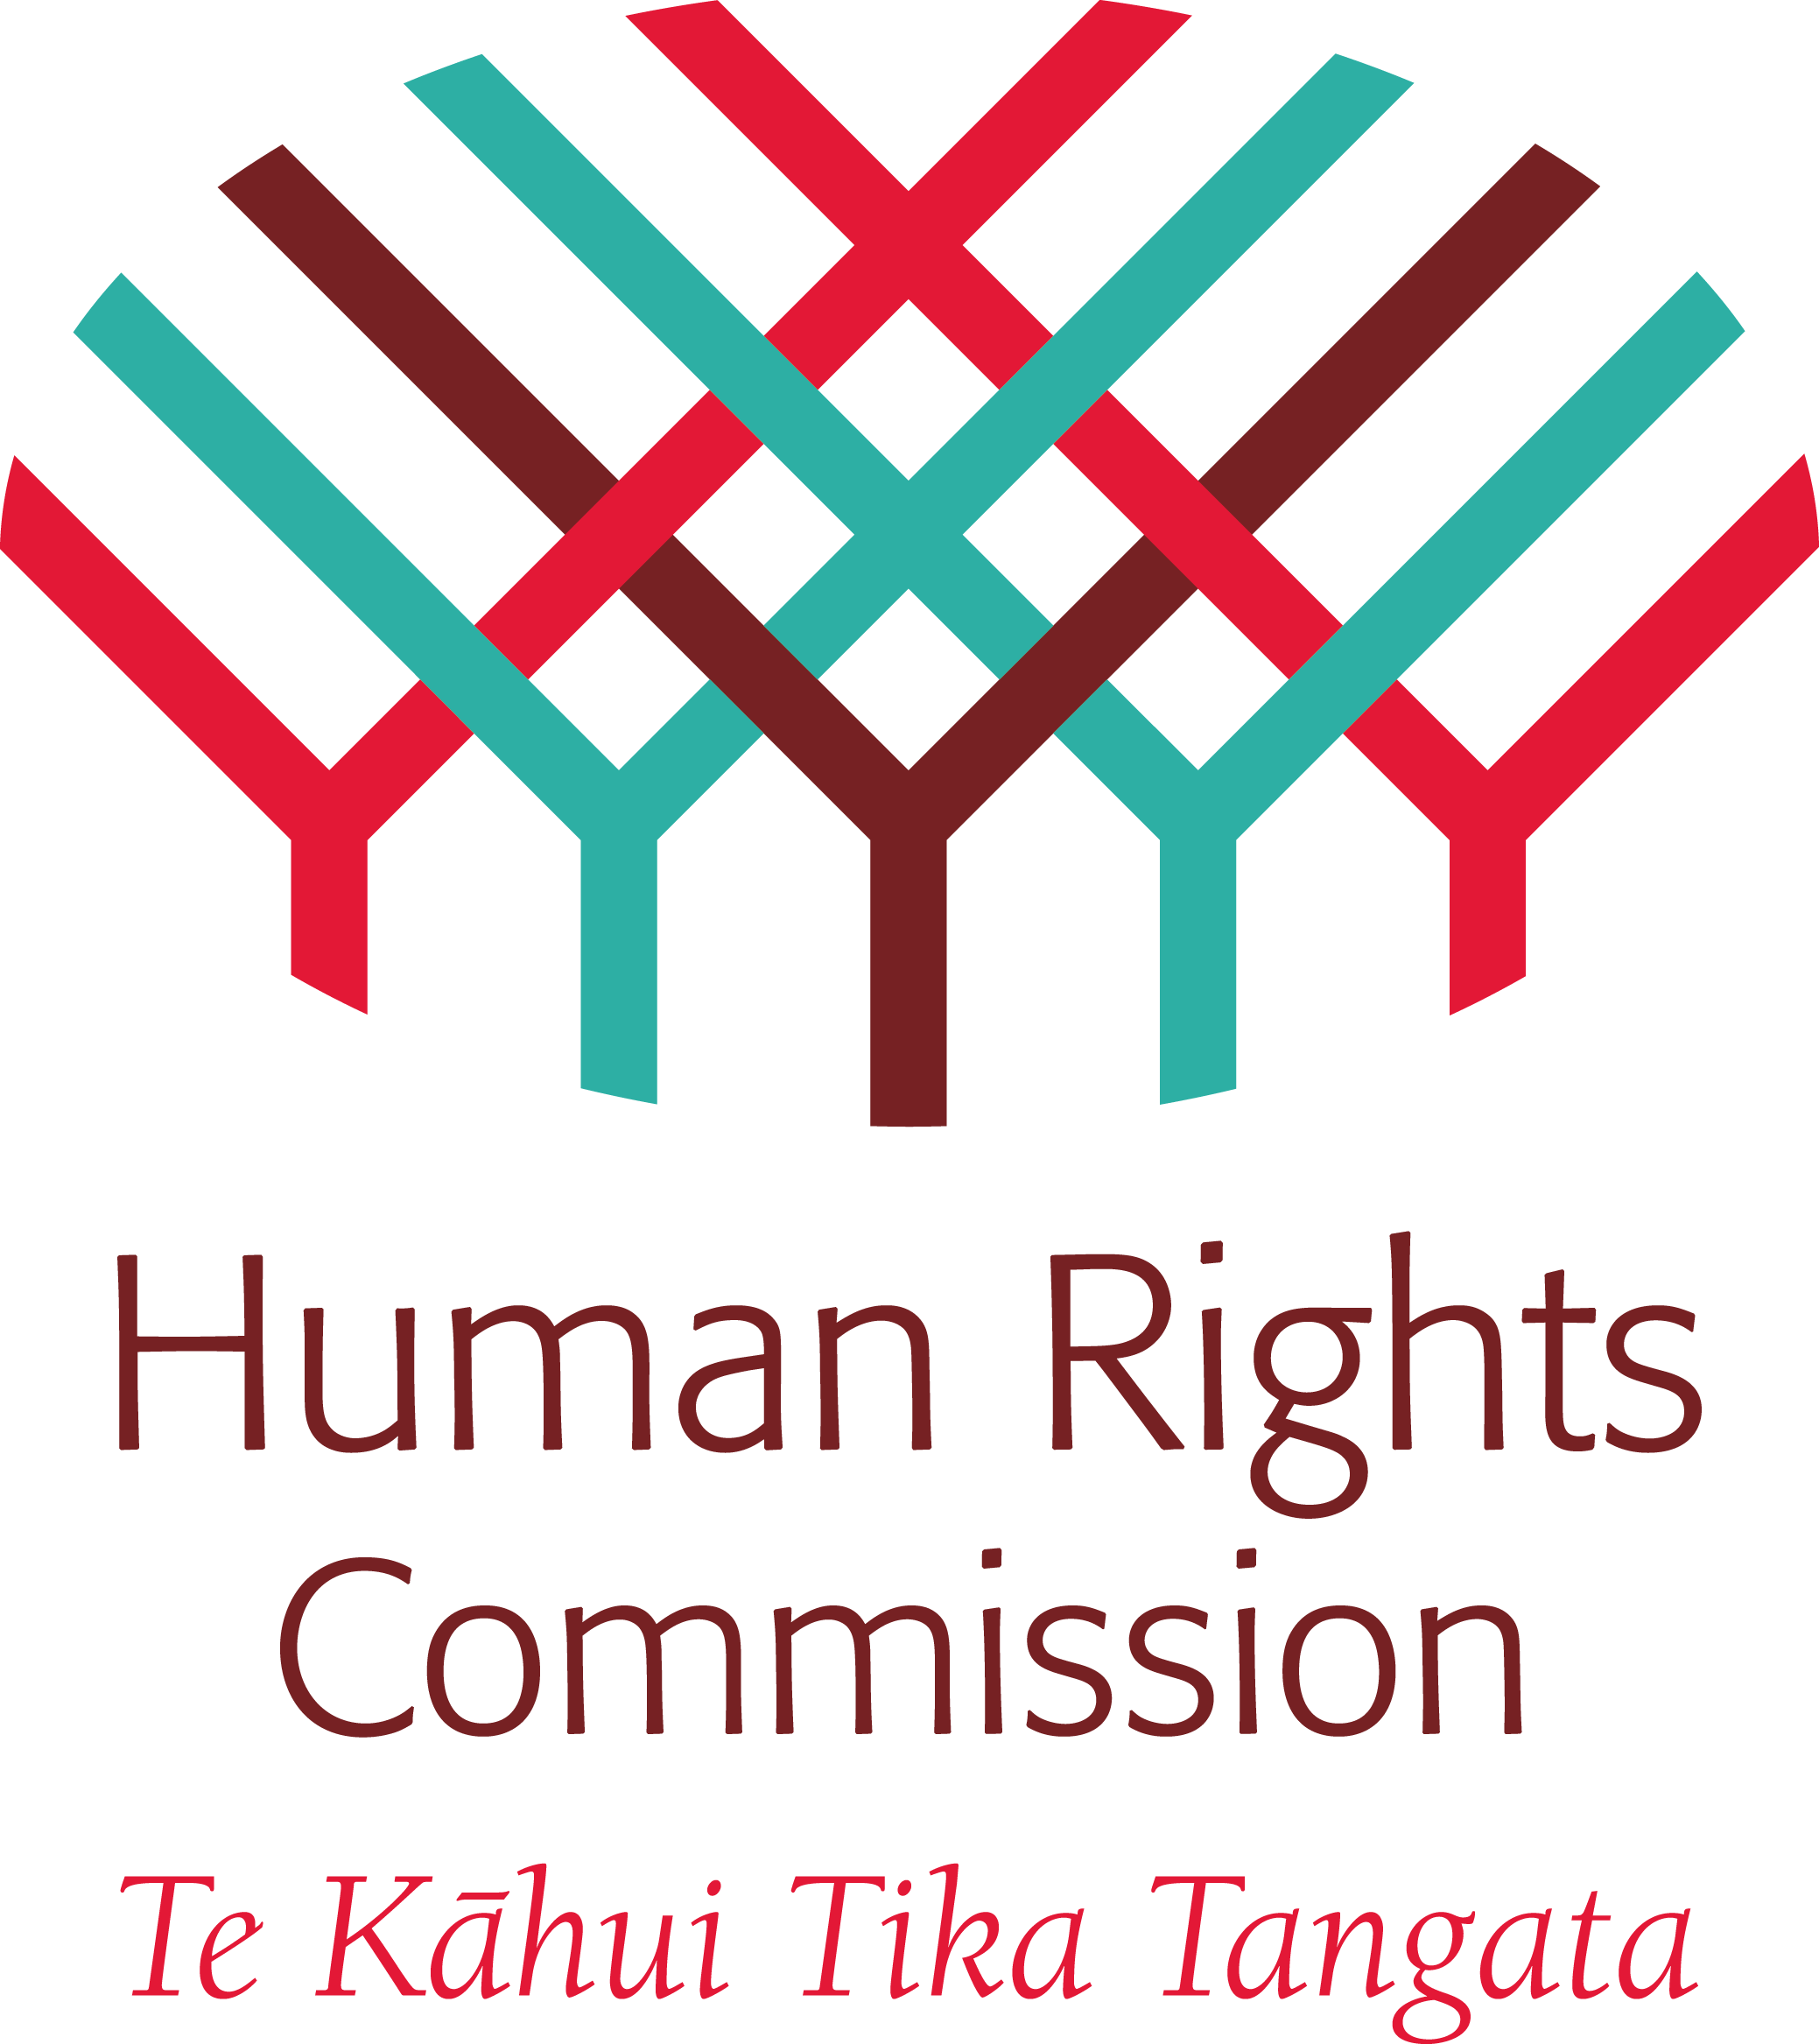
Human Rights Council
Expert Mechanism on the
Rights of Indigenous Peoples

NINTH SESSION, 11-15 JULY 2016, GENEVA

Agenda item 5: Study on the right to health and indigenous peoples, with a focus on children and youth

E ngā mana, e ngā reo, e ngā maunga, e ngā awaawa, e nga pātaka o ngā taonga tuku iho, tēnā koutou katoa. [Translation: to all expert colleagues, all voices, the mountains, the rivers, the treasure houses, greetings to all of you.]

Mr Chair, thank you for this opportunity to speak as the Commissioner representative of the New Zealand Human Rights Commission. My name is Karen Johansen. The following comments are made further to the Commission’s submission to the Expert Mechanism’s study earlier this year.

Māori concepts of health encompass individual and collective wellbeing, and are interconnected to the realisation of a range of rights, including: self-determination, development, an adequate standard of living, as well as culture, language, land and the natural environment.

Despite some gains, protection of these rights and attaining health equality for Māori remains a challenge.

On the positive side, health legislation and policy increasingly recognises Māori concepts of health. He Korowai Oranga – The Māori Health Strategy is underpinned by a framework reflective of Māori values and concepts.

A Parliamentary Committee Inquiry into the ‘determinants of health for Māori children’ recently identified key principles which include:
- The wellbeing of Māori children is inextricable from the wellbeing of their whānau (families)
- The importance of collective identity for a Māori child must be acknowledged as a first step
- Families need to be engaged in making the decisions that affect them.

These principles have been incorporated, to some extent, in Māori health policy and strategy and underpin the Government’s Whānau Ora programme.

In relation to children and youth, a recent report found improvements in the wellbeing of Māori children. The report found that fewer young Māori are smoking, for example the proportion of 14 year old students who have never smoked has increased from 30% in 1999 to around 75% per cent in 2013. Immunisation rates have risen, and rates of hospitalisation for injuries caused by assault or maltreatment have decreased.

Despite these gains, the report highlights ongoing inequalities between Māori and non-Māori children, with many lacking access to healthy food and warm housing. It found on average around a third of Māori children lived in households experiencing relative poverty, compared to 16 percent of European children. Lack of affordable housing has recently seen a dramatic increase in homelessness in New Zealand. Increasing numbers of families and children are sleeping in cars or garages, with resulting impacts on children’s health, education and social development.

Other recent data highlights a range of inequalities experienced by Māori, Pacific and poor children. They are:
- More likely to be hospitalised for asthma
- Less likely to be given certain medications

Māori children are:
- More likely to miss out on health checks within their first year (despite the health system providing for 10 free checks for all babies)
- Around three times more likely to suffer from diseases such as meningitis and rheumatic fever
- Have higher child mortality rates than other groups.

Overall, Māori continue to have higher rates for most health risks and conditions, and also are more likely than non-Māori to have unmet health needs.

The NZHRC continues to monitor and update the National Plan of Action on Human Rights. The NPA sets out the actions the government has committed to through the Universal Periodic Review process, and so is the government’s plan of action. The NPA is an online monitoring tool, designed to promote accountability through transparency. The NPA sets out concrete government actions monitored using SMART measurement criteria. Health actions include:
- To reduce the incidence of rheumatic fever in Māori and Pacific children and families
- Reduce the number of Māori placed under compulsory mental health orders
- Enhance Māori cultural competence in the disability services
- Monitor Māori health progress

As the NPA continues to be refined, new search categories are being developed which will enable users to search for progress associated with the UNDRIP and the Treaty of Waitangi, as well as in relation to the Sustainable Development Goals.

To conclude, the New Zealand Human Rights Commission:
- Welcomes the Expert Mechanism’s Study on the right to health, with a focus on children and young people
- Urges the Expert Mechanism, in its advice, to emphasise the importance of collective wellbeing to the realisation of these rights. In particular, ensuring adequate support to families, is crucial to the realisation of the right to health for indigenous children and young people.
- Notes the importance of effective monitoring and tracking of progress, and in this regard draws attention to the online monitoring tool developed as part of New Zealand’s National Plan of Action on Human Rights.

Thank you again for the opportunity to speak today.

Nō reira, tēnā koutou, tēnā koutou, tēnā koutou katoa. [and finally, greetings to you all ]

Commissioner Karen Johansen,
New Zealand Human Rights Commission
July 2016

Māori Affairs Committee, (2014), Inquiry into the Determinants of Health for Tamariki Māori. Accessible at: http://www.parliament.nz/resource/en-nz/50DBSCH_SCR6050_1/bbe4e16f5d440017fd3302f051aca3edff179b7f.
Simpson, J., Adams, J., Oben, G., Wicken, A., & Duncanson, M. (2016). The Determinants of Health for Māori Children and Young People in New Zealand (Determinants of Health for Children and Young People No. 2). New Zealand Child and Youth Epidemiology Service.
Health Quality & Safety Commission, 20 June 2016, ‘Data shows size of difference in health care treatment by ethnicity, socioeconomic status’ http://www.hqsc.govt.nz/news-and-events/media/2553/
Ibid.
http://www.radionz.co.nz/news/te-manu-korihi/301435/health-workers-missing-at-risk-babies
2013 figures, from: http://www.health.govt.nz/our-work/populations/maori-health/tatau-kahukura-maori-health-statistics/nga-mana-hauora-tutohu-health-status-indicators/infectious-disease
Ministry of Health, (2015), Annual Update of Key Results 2014/15: New Zealand Health Survey, at p viii. Accessible at: http://www.health.govt.nz/publication/annual-update-key-results-2014-15-new-zealand-health-survey
Accessible at: http://npa.hrc.co.nz/#/
http://npa.hrc.co.nz/#/action/32
http://npa.hrc.co.nz/#/action/35
http://npa.hrc.co.nz/#/action/79
http://npa.hrc.co.nz/#/action/80

