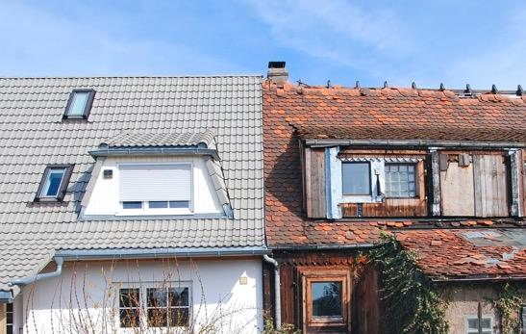
Framework guidelines on
the right to a decent home
in Aotearoa New Zealand

August 2021

Aratohu tika tangata ki te whai whare rawaka i Aotearoa

Framework Guidelines on the right to a decent home in Aotearoa

Date: XX XX 2021

What you will find in here

Page number:
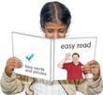

What this report is about 3

Human rights 6

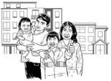
What is a decent home? 8

What a decent home is like 12

A. Values 13

B. What the United Nations
says is decent housing 17

Page number:
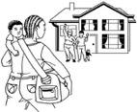

C. Freedoms and
entitlements 26
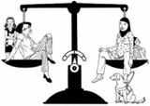

D. Equity and equality
and not-discriminating 28

E. Participation 29

F. A human rights-based
housing strategy grounded
on te Tiriti 30

G. Constructive accountability 33

H. International assistance
and cooperation 35

What should happen now? 37

What this is report about

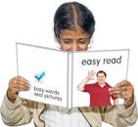
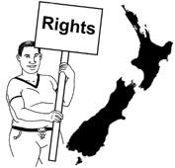
This document is about the right to a decent home in Aotearoa New Zealand.

We will look at what:

- rights are on pages 6 to 7
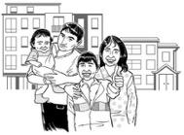
- a decent home means on pages 8 to 11.

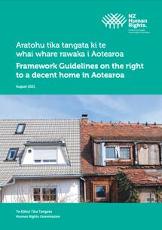
The Human Rights Commission has written a report called:

Aratohu tika tangata ki te whai whare rawaka i Aotearoa

Guidelines on the right to a decent home in Aotearoa

You can find this report on the Human Rights Commission website:
https://www.hrc.co.nz/resources/
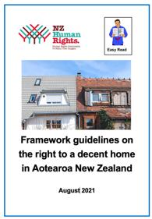

This is an Easy Read translation of the main things in the report.

There is a lot more information in the full report.

The full report also includes lots of other places you can find more information.

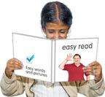
This Easy Read translation is a long document.

If you want to you can:

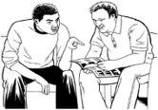
- ask someone you know to read it with you
- only read a little bit at a time.

Human rights

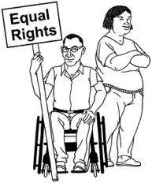
Human rights are rights to make sure everyone:
- is treated fairly
- has what they need to live a good life.

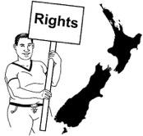

Human rights are part of:
- New Zealand law
- laws agreed between New Zealand and lots of other countries.

Laws are rules that everyone has to follow.

Housing is a human right.

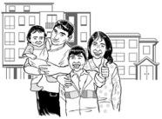
Everyone has the right to live somewhere that:
- is safe
- means they can live a good life.

Many people in New Zealand do not know that housing is a human right.

The Human Rights Commission is an organisation that works to make sure:
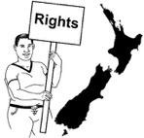
- human rights are followed in New Zealand
- people understand human rights
- people care about human rights.

What is a decent home?

The right to a decent home is about more than just a place to live.

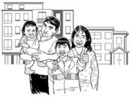
The right to a decent home is about having a good home that:

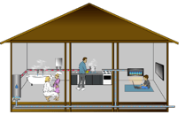
- is safe
- is warm
- does not cost too much money.

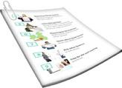
There will be more about what this means later in this document.

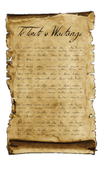
When we think about what makes a decent home in Aotearoa New Zealand it is important to think about:
- colonisation
- te Tiriti o Waitangi.

Colonisation meant Māori:
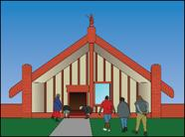
- had almost all their land taken
- were stopped from living in the sort of homes they used to have.

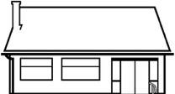
Colonisation has made it much harder for Māori to own their own homes.

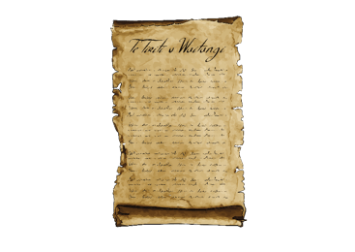
The Treaty of Waitangi / te Tiriti o Waitangi is a legal document that was signed in 1840.

The Treaty / te Tiriti is important to New Zealand.
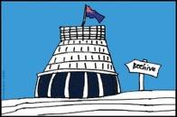

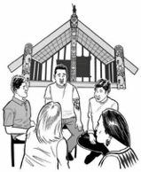
It is about Māori and the New Zealand Government:
- making decisions together
- protecting things that are important to Māori.

Te Tiriti o Waitangi says that Māori get to make all the decisions about their:
- land
- homes.

It also says the Government has to work together with Māori.
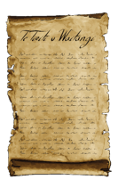

The right of everyone in Aotearoa New Zealand to a decent home is important to Te Tiriti.

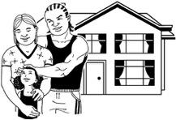
This means we talk about the right to a decent home grounded on te Tiriti.

What a decent home is like

This part of the report talks about 8 things to think about when looking at the right to a decent home grounded on te Tiriti.

We have used a letter of the alphabet for each of them.

All of these 8 things are connected with:
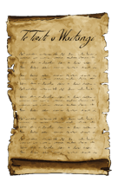
- each other
- te Tiriti o Waitangi.

A. Values

Values are the things we think are important.

Understanding our values helps us know what the important things about a decent home are.

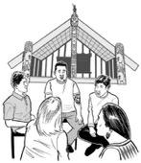
Some of the important values in te ao Māori / the Māori world are about our relationships with:

- other people
- the natural world.

Some of these values are:
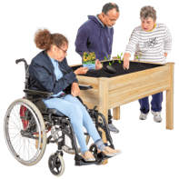
- whanaungatanga which is about close connections with people
- kaitiakitanga which is about taking care of things like land
- mana which is about authority or leadership

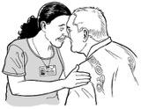
- whakapapa which is the importance of knowing about:

- where you are from
- who you are

- your whānau history / stories.

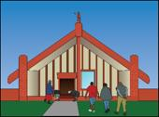
In Aotearoa New Zealand our values include:
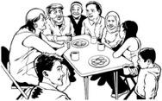
- those of te ao Māori
- the ways other communities look at things.

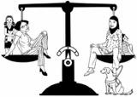
Some values that are important to us are:
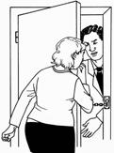
- fairness
- safety
- freedom
- autonomy.

Autonomy means people or groups can make their own decisions about things that affect them.
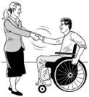
Some more values that are important to us are:

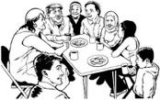
- partnership or working together
- community such as being able to be involved with things in your local area
- manaakitanga which means
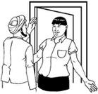
- being welcoming
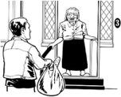
- being kind
- giving to other people
- supporting other people.

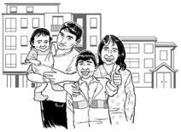
These values are an important part of the right to a decent home grounded on te Tiriti.
B. What the United Nations says is decent housing

The United Nations is a group of most of the countries in the world.

The United Nations is sometimes called the UN.

The United Nations says there are 7 things to think about when deciding if there is decent housing.

1. Habitable housing

A habitable home is one that:
- is safe to live in
- protects you from the weather.

2. Affordable housing

Affordable housing means people can pay for it without using money they need for other important things.

3. Accessible housing

Accessible housing means different things like if you can:
- afford a home
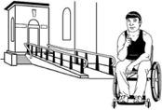
- find a home you can:
  - get inside
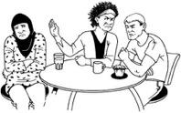
  - move around in
- not experience discrimination when looking for a home.

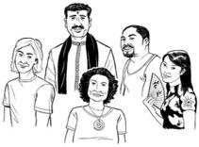
Discrimination is when people are treated unfairly because of things like:

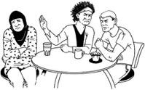
- being Māori
- being disabled
- their religious beliefs.

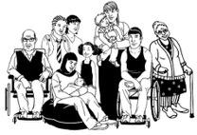
A decent home must be accessible to everyone.

This is not happening in Aotearoa New Zealand at the moment.

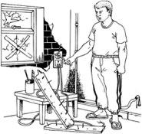
Lots of people do not have access to a decent home.

Some people find it harder to get access to a decent home than others.
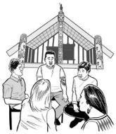
For example:
- lots more New Zealand European people own houses than Māori and Pasifika
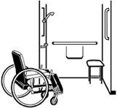
- only 2 out of every 1 hundred houses are physically accessible but lots more people need physically accessible houses.

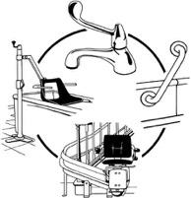
A physically accessible home is one that is a good fit for:
- people who use wheelchairs
- people who cannot walk up steps
- other people who find it hard to find a house that is built in a good way for them.

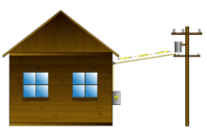
4. Services and other things houses need to work well

Houses need to have things in place to work well like:
- services like power or gas
- clean water
- a way to get rid of rubbish.

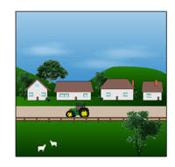
This includes housing for people who live a long way from cities.

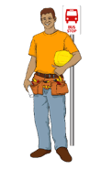
5. Location

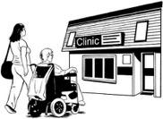
Location means that housing must be in a place where people can get to places like:
- work
- healthcare services like doctors
- schools.

6. Respect for cultural diversity

Housing should be a good fit for lots of cultures.

Cultures are ways of doing things because of:
- groups you are part of
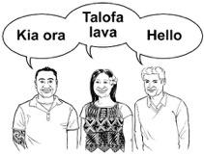
- the place you or your family come from
- what you believe.

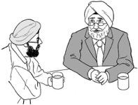
Your culture may be part of things like:
- what you eat
- how you dress.

For example a lot of housing has been built to fit with a family that is just:
- parents
- children.
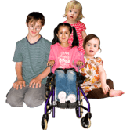

In many cultures a bigger family often lives together including people like:
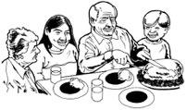
- cousins
- grandparents.
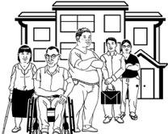

There needs to be housing that is a good fit for them too.

Respect for cultural diversity also means houses should not be built on land that is important to people.

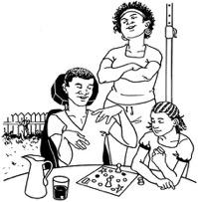
7. Security of tenure

Security of tenure means people know they:
- can feel safe in their homes
- d o not have to worry they will be made to move without a good reason.

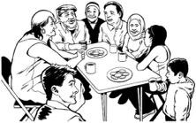
Security of tenure also means everyone does their bit so the community is a good place for everyone to stay.

C. Freedoms and entitlements

The right to a decent home includes:
- freedoms
- entitlements.

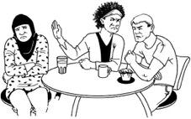
Freedoms are things you have the right to be safe from like:
- discrimination
- a landlord making you leave your home without following the law.

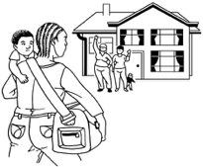
Entitlements are things you have a right to have like emergency housing if you have nowhere to stay.

Often it costs less money to make sure people have their freedoms than to have to give them entitlements.

If they have their freedoms they often do not need their entitlements.

D. Equity and equality and not discriminating

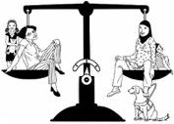
Equity and equality are about everyone being treated fairly.

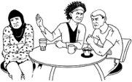
Not discriminating means not treating people unfairly.

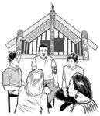
It also means doing something about the way colonisation has made things worse for Māori.

E. Participation

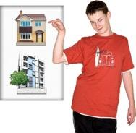
Participation is about being part of things.

Everyone has a right to be part of things to do with their housing.

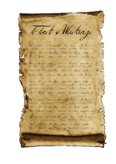
Te Tiriti means the Government has to:

- work together with Māori
- make decisions together.

Participation could also mean things like the Government asking what people think before making decisions on housing.

F. A human rights-based housing strategy grounded on te Tiriti

There needs to be a strategy to make sure everyone has the right to a decent home grounded on te Tiriti.

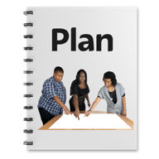
A strategy is like a plan that:
- is for a long time
- changes as the things that are part of the plan change.

A housing strategy based on human rights:
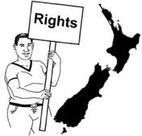
- works well when things change over time
- includes lots of different human rights
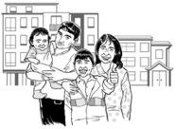
- must be built around the right to a decent home.

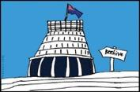
A housing strategy based on human rights also includes lots of different:
- government departments
- organisations
- people
- laws
- plans.

G. Constructive accountability

Constructive accountability is about making sure people do what they are supposed to.

It means that:
- people check if things are done right
- something changes if they are not done right.

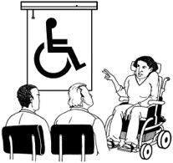
Constructive accountability also means the important thing is:
- learning from problems so we can do better next time
- not punishing people who got it wrong.

There are lots of different:
- ways of making constructive accountability
- organisations involved in constructive accountability.

It is important there is good constructive accountability around the right to a decent home.

H. International assistance and cooperation

International assistance and cooperation means:
- supporting other countries
- working together with other countries.

New Zealand has more money than a lot of other countries.

That means New Zealand should support countries that need it.

This is called development and aid.

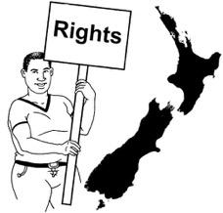
If development and aid includes support with housing the Government has to make sure what they are supporting is a good fit with human rights.

What should happen now?

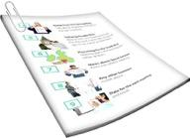
These guidelines support people to understand more about the right to a decent home grounded on te Tiriti.
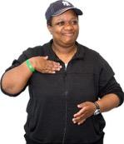

These guidelines can support the work done by:
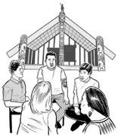
- people on their own
- hapū
- iwi
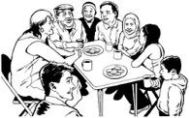
- communities.

They can also support:
- making plans to do with housing better
- holding people accountable – making sure they do what they have to.

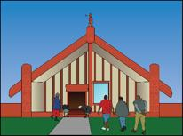
More work is needed on things like:
- making it clear what a decent home means for tangata whenua / Māori
- looking at how the Government needs to work with local government like councils to make sure people get their right to a decent home grounded on te Tiriti
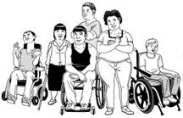
- writing more information about what the right to a decent home grounded on te Tiriti is like for disabled people.
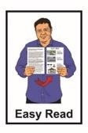
This information has been written by the Human Rights Commission.

It has been translated into Easy Read by the Make It Easy service of People First New Zealand Inc. Ngā Tāngata Tuatahi.

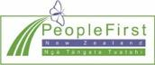
The ideas in this document are not the ideas of People First New Zealand Inc. Ngā Tāngata Tuatahi.

Make It Easy uses images from:

- Changepeople.org

- Photosymbols.com

- Sam Corliss

All images in this Easy Read document are subject to copyright rules and cannot be used without permission.

