PRISM:
Human Rights issues relating to Sexual Orientation, Gender Identity and Expression, and Sex Characteristics (SOGIESC) in Aotearoa New Zealand - A report with recommendations
PRISM: Human Rights issues relating to Sexual Orientation, Gender Identity and Expression, and Sex Characteristics (SOGIESC) in Aotearoa New Zealand - A report with recommendations
A report issued by the New Zealand Human Rights Commission
Copyright © June 2020 New Zealand Human Rights Commission
All rights reserved.
ISBN:
978-0-478-35609-0 (web version and docx)
978-0-478-35610-6 (print)

The New Zealand Human Rights Commission was set up in 1977 and works under the Human Rights Act 1993. Our purpose is to promote and protect the human rights of all people in Aotearoa New Zealand. We work for a free, fair, safe and just New Zealand, where diversity is valued and human dignity and rights are respected.
For more information, please visit our website: www.hrc.co.nz
New Zealand Human Rights Commission (2020) Prism: Human rights issues relating to Sexual Orientation, Gender Identity and Expression, and Sex Characteristics (SOGIESC) in Aotearoa New Zealand - A report with recommendations. Wellington: New Zealand.
Acknowledgements
This work was borne from kōrero which took place across five hui in 2018, assisted by Tuiloma Lina Samu, Moana Eruera, Rāwā Karetai, Rebekah Armstrong, and Annaliese Boston. The Commission would like to thank all those who attended and generously shared their experiences and recommendations; comments that were made in the hui are referenced throughout the report. This work has been greatly enhanced by community leaders who provided further contributions and comments on an earlier draft. They included Elizabeth Kerekere, Mani Mitchell, Kevin Haunui, Jack Byrne, Jono Selu, Stace Robertson, Ahi Wi-Hongi, Tommy Hamilton, and Katie Fitzpatrick. The collective effort has guided the conclusions and recommendations presented herein.

The Commission is proud to have a SOGISC Human Rights Advisor, Taine Polkinghorne, who co-facilitated the consultations and wrote this report.

Cover artwork by Huriana Kopeke-Te Aho
The overall design is a reference to the report title ‘Prism’. The poutama design at the top represents whakapapa as well as the pursuit of knowledge, and the middle pattern is called pakati. The pakati pattern represents strength and courage. I wanted to include this pattern at the top of the image to highlight the courage and strength necessary to not only highlight issues that SOGIESC communities face, but then using that information to push for change. The graphic in the middle is a nod to the cover design I did for the Counting Ourselves report. I wanted to make a clear visual link between the two reports as they both contribute to the overall understanding of our communities and highlight the change necessary for our wellbeing.

Contents
Foreword 6
Executive Summary
Introduction
SOGIESC-Diverse Communities in New Zealand
The Right to Freedom from Discrimination 19
The human rights status of sexual orientation 20
The human rights status of gender identity and expression 20
The human rights status of sex characteristics 21
The Human Rights Act 1993 22
Human Rights Commission complaints data 23
Violence and abuse 24
The Right to Information 32
Collection of official statistics 34
Sexual orientation measurement efforts 36
Gender identity measurement efforts 37
Sex characteristics measurement efforts 38
Data reflective of society 40
The Right to Recognition Before the Law 42
Passports and driver licences 44
Birth certificates 45
Children 47
People with variations of sex characteristics 47
The Right to the Highest Attainable Standard of Health 51
General Health Care 51
Aged care 53
HIV 53
Mental Health 54
Medical interventions to alter sex characteristics 58
Informed consent 61
Gender-affirming healthcare 61
Transgender prisoners 63
The Right to Education 67
Bullying 68
Safety at school 69
Ongoing professional development for teachers 70
The New Zealand Curriculum 71
The Right to Work 76
Employment rates 76
Wage discrimination 77
Pre-employment and employment discrimination 77
Concealing SOGIESC in the workplace 78
Issues for trans employees 79
New Zealand inclusion initiatives 79
Proactive improvements 80
Glossary
Foreword

As a signatory to the original Yogyakarta Principles in 2007, I had the privilege of working with a panel of international experts to set out international human rights law as it relates to a person’s actual or perceived sexual orientation, gender identity or expression, and sex characteristics (SOGIESC). We had no doubt: SOGIESC rights are human rights. This idea animated the Yogyakarta Principles. Today, it drives the SOGIESC movement.
While sexuality diverse communities have had the benefit of rapid gains in social acceptance in Aotearoa New Zealand, the pace of change for those with diverse gender identities, gender expressions, and sex characteristics has been much slower. In keeping with the Human Rights Commission’s statutory role to educate, advocate, and promote respect for human rights in New Zealand, Prism is designed to address this shortcoming. It emphasises the need for an interdisciplinary approach that blends law, policy, social work and community-led initiatives to enable the full enjoyment of human rights in Aotearoa New Zealand, regardless of a person’s SOGIESC.
Significant change can be brought about through public policy, law reform, access to justice and administrative actions. With many international examples of good practice to benefit from, I urge the New Zealand government to work with local SOGIESC-diverse communities, organisations, individuals and the Human Rights Commission to address these issues in a principled and evidence-based way.
Prism must be read in the context of the work undertaken by SOGIESC-diverse communities over decades to advance their human rights. I applaud their brave and tireless work.
I also applaud and profusely thank Taine Polkinghorne who wrote Prism. He was assisted by many other Human Rights Commission staff, including Katja Rangsivek, Bart English, Hannah Northover, Tuiloma Lina Samu, Hemi and Paula Pirihi, Jess Ngatai, Jac Lynch, Rebekah Armstrong, Margaret MacDonald and Kerri Kruse. My deep thanks to them all.
Nō reira aku mihi ki te hapori uenuku, e takatū nei, hei painga mō te hapori me ō koutou whānau katoa hoki. Kia kaha kia māia kia manawanui i ēnei wā o te taumahatanga
[So I greet the rainbow community, who progress positive outcomes for their community and all of their families. Be strong, resolute and steady in these troubling times].
Ma le fa’aaloalo lava
[Respectfully yours/Yours sincerely]
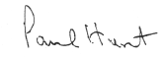

Paul Hunt
Chief Human Rights Commissioner

Executive Summary

Prism explores six human rights issues relating to people with a diverse sexual orientation, gender identity and expression, and sex characteristics in Aotearoa New Zealand.While not exhaustive, this analysis reflects the voices of the SOGIESC-diverse people who attended the Commission’s consultation hui in 2018. The purpose of this paper is to introduce these six human rights issues and to assist in providing a baseline understanding for greater discussion and collaboration.
Prism is an original contribution to the human rights landscape in Aotearoa New Zealand. It is not common for these rights to be discussed with explicit regard to people with a diverse sexual orientation, gender identity and expression, or sex characteristics. These rights are enshrined in international covenants, conventions, and declarations. All people, including SOGIESC-diverse people, are entitled to the full enjoyment of these rights.

Summary of Findings

- The Right to Freedom from Discrimination (Article 2, UDHR)The Human Rights Act 1993 does not provide explicit legal protection from discrimination with regards to gender identity, gender expression, or sex characteristics.
- Overt and subtle forms of discrimination are widespread against people with an actual or perceived diverse SOGIESC, and they are more likely to become victims of crime.

- The Right to Information (Article 19, UDHR)Unmet information needs are a considerable obstacle for the identification and resolution of issues concerning people with a diverse SOGIESC.
- Data collection does not currently reflect a human rights-based approach. This is particularly clear in response options that limit diverse answers and the ability of SOGIESC-diverse people to be counted.

- The Right to Recognition BEFORE THE LAW (Article 16, ICCPR)New Zealand’s official identity documents contain sex/gender information which can be difficult to correct for transgender, non-binary, and intersex people.
- The human rights principle of self-declaration for identity documents is not yet fully implemented; it applies for passport and drivers’ licence records but not for birth certificates.
- The current process to amend sex on a birth certificate requires meeting a medical threshold and the involvement of the Family Court, presenting barriers to having a child, enrolling in school, getting married, and other areas of life.

- The Right to the Highest Attainable Standard of Health (Article 12, ICESCR)Surgical interventions not required for the preservation of life continue to be performed on people with diverse sex characteristics before an age at which they can consent to these procedures.
- People with a diverse SOGIESC have poorer physical and mental health outcomes than the general population.
- Healthcare practitioners and providers often lack the training to meet the needs of SOGIESC-diverse service users.
- Gender affirming healthcare is difficult to access and highly dependent on geographical residence.

- The Right to Education (Article 26, UDHR)Young people have a right to learn about diversity in SOGIESC. The New Zealand Curriculum allows for such learning within health education, but this is not adequately integrated into practice in schools.
- For youth with a diverse SOGIESC, school is often not a safe environment in which they can thrive and learn.
- Youth with a diverse sexual orientation or gender identity are, respectively, three and four-and-a-half times as likely as other students to be bullied.

- The Right to Work (Article 23, UDHR)People with a diverse SOGIESC experience discrimination and bullying in the workplace.
- The most common complaint received by the Human Rights Commission on the ground of sexual orientation is related to discrimination in employment.
- A significant percentage of people with a diverse SOGIESC do not feel safe enough or fear discrimination at work or when applying for jobs. They often conceal their identities or partners for fear of discrimination if these details are disclosed to others in their work environments.

Introduction
This paper is entitled “Prism.” When light hits a prism, a rainbow can be seen. But a prism does not create colours; it reveals them. This paper provides a particular lens through which to see people with a diverse sexual orientation, gender identity and expression, and sex characteristics: the human rights lens.
SOGIESC-diverse people add to the fabric of society. They have unique strengths, attributes, creativity, and resilience. While great progress has been achieved to advance SOGIESC human rights in Aotearoa New Zealand, this paper describes some of the key human rights challenges that remain. People with a diverse SOGIESC includes those who may be lesbian, gay, bisexual, trans, non-binary, intersex, queer, asexual, takatāpui, whakawahine, tangata ira tāne, and a range of other cultural identities from the Pacific and around the world. These are often referred to as LGBTIQ+, MVPFAFF, or Rainbow identities and communities.
In addition to drawing on existing data and research, this paper was informed by five focused community consultation meetings (hui) held between February and April 2018. These meetings were designed, led, and facilitated by Human Rights Commission (Commission) staff identifying as transgender and takatāpui. The purpose of the meetings was to hear directly from these communities about the human rights issues they face. This approach is fundamental to the Commission’s ability to identify how to improve human rights protections for all communities in Aotearoa. Additional desk-based research and targeted engagement with key groups have supplemented the information, current to the end of 2019.
The discussions showed considerable consistency regarding the main human rights issues for people with a diverse sexual orientation, gender identity and expression, and sex characteristics. This original paper reports on these and other key issues that are frequently raised with the Human Rights Commission as affecting SOGIESC-diverse people. Prism offers a vision, information, and recommendations to any organisation, group, or individual interested in supporting the positive development and wellbeing of people with a diverse SOGIESC in Aotearoa New Zealand. These include policy- and decision-makers, elected representatives, teachers, allies, and SOGIESC-diverse communities.
The recommendations made at the end of each chapter reflect the government’s obligations under Te Tiriti o Waitangi; previous national and international submissions made by the Human Rights Commission; as well as submissions and reports published by SOGIESC-diverse individuals, coalitions, and organisations.
SOGIESC-Diverse Communities in New Zealand
It is difficult to encompass the diversity of SOGIESC people and communities under any single umbrella term. All people have a sexual orientation, gender identity and expression, and sex characteristics. For the purposes of this paper, the definitions described in the Yogyakarta Principles are followed:
- Sexual orientation (SO) refers to each person’s capacity for profound emotional, affectional and sexual attraction to, and intimate and sexual relations with, individuals of a different gender or the same gender or more than one gender;
- Gender identity (GI) refers to each person’s deeply felt internal and individual experience of gender, which may or may not correspond with the sex assigned at birth, including the personal sense of the body (which may involve, if freely chosen, modification of bodily appearance or function by medical, surgical or other means) and other expressions of gender, including dress, speech and mannerisms;
- Gender expression (GE) refers to a person’s presentation of gender through physical appearance – including dress, hairstyles, accessories, cosmetics – and mannerisms, speech, behavioural patterns, names and personal references. Gender expression may or may not conform to a person’s gender identity;
- Sex characteristics (SC) are each person’s physical features relating to sex, including genitalia and other sexual and reproductive anatomy, chromosomes, hormones, and secondary physical features emerging from puberty.
People with a diverse sexual orientation, gender identity and expression, and sex characteristics span all regions of New Zealand; cover all age, disability and religious demographics; and come from a wide range of ethnic and cultural backgrounds, including Māori, Pacific, and Asian. They are parents, children, siblings, and whānau members. Though they are often represented as homogenous attributes, sexual orientation, gender identity and expression, and sex characteristics are overlapping yet distinct concepts integral to each person. Obstacles to the full enjoyment of human rights differ widely between various groups in SOGIESC-diverse communities depending on intersecting factors which may include ethnicity, age, disability, and geographic location, among others.
The colonisation of Aotearoa New Zealand in the 19th century had a profound impact on its indigenous people and their human rights. Indigenous peoples with diverse sexual orientations, gender identities and expressions, and sex characteristics have existed throughout history in all cultures, populations, and regions, including in the Pacific. Prior to the arrival of European settlers, diverse identities, expressions, and practices were accepted as a normal part of Te Ao Māori. Like other indigenous peoples, Māori were colonised and suffered historic injustices. This included loss of lands, territories and resources, customs, language, and traditional lifestyles within Aotearoa. The negative and intergenerational impacts of colonisation on sexual and gender fluidity accepted in traditional Māori society have had, and continue to have, dramatic consequences, including loss of acceptance within their own societies and communities.
Takatāpui is an ancient Māori term meaning ‘intimate companion of the same sex’. As a result of colonisation, the word was lost from the language and oral tradition. In the early 1980s, it was rediscovered independently by takatāpui academics in manuscripts from the 1840s. Since then, the term has been reclaimed to encompass not just diverse sexual orientations amongst Māori, but also diverse gender identities, expressions, and sex characteristics. Māori identity predicates takatāpui identity “with a spiritual connection to takatāpui tūpuna (ancestors).” Despite reclamation of this identity, many takatāpui today experience dual stigma. On top of the systemic inequities of being Māori, they experience additional discrimination because of their diverse SOGIESC.
Te Tiriti o Waitangi is New Zealand’s unique human rights document, signed on February 6, 1840 between the British Crown and several Māori rangatira (chiefs). It is regarded as the founding text of Aotearoa, assuring a tūrangawaewae (standing place to belong) for all people in New Zealand. It affirms the rights tangata whenua had prior to 1840 and gave tauiwi (non-Māori) and the Crown a set of rights and responsibilities that enabled them to settle in Aotearoa. These rights extend to takatāpui and other people with a diverse SOGIESC.
The United Nations Declaration on the Rights of Indigenous People (UNDRIP) articulates how human rights apply in the specific context of Indigenous Peoples. It has been described as providing ‘a blueprint for implementation of Te Tiriti’. The Declaration affirms that “Indigenous Peoples have the right to the full enjoyment, as a collective or as individuals, of all human rights” and is underpinned by core rights including self-determination, non-discrimination, cultural rights, rights to land and natural resources, and rights to participate in decision-making.
While the Declaration does not explicitly reference Indigenous SOGIESC communities, UN bodies have provided guidance highlighting the need for diverse and/or vulnerable groups within indigenous communities to be represented and to have their special needs considered. Approaching issues from a Tiriti- and human rights-based perspective includes that Māori, as Tiriti-partners, are part of decision-making; Māori are able and supported to exercise rangatiratanga, self-determination, and to lead solutions; and that equity for Māori is a core focus.

Human Rights Status of SOGIESC-Diverse People
In the 70 years since the Universal Declaration of Human Rights was adopted, new understandings and applications of human rights have emerged. The principles underlying all human rights are those of equality, dignity, and self-determination. These principles are equally applicable to people with a diverse sexual orientation, gender identity and expression, or sex characteristics, who may also be particularly vulnerable to breaches of human rights. These communities do not have or seek new rights or special rights.
International human rights law applies to all people, including SOGIESC-diverse people, without exception. While there is no explicit covenant or convention that has as its stated purpose the elimination of discrimination against people with a diverse sexual orientation, gender identity and expression, or sex characteristics, the rights of SOGIESC diverse people are firmly anchored in existing and binding human rights treaties. The Yogyakarta Principles, adopted in 2007, apply existing international human rights law to sexual orientation, gender identity and expression, and sex characteristics. They address a broad range of human rights and emphasise that SOGIESC-diverse people have the rights to universal enjoyment of all human rights, including non-discrimination and recognition before the law. While not themselves legally binding, the Principles affirm existing legal standards that States have agreed to be bound by. They are not a wish list of aspirational goals; every statement and recommendation in the document is grounded in existing obligations under international human rights law and binding human rights treaties. The Yogyakarta Principles have been well tested as sources of interpretation, having been cited hundreds of times at the United Nations Human Rights Council; in bills, legislation, and executive policy; and court decisions.
In 2017, a supplementary paper to the original Principles was published: the Yogyakarta Principles plus 10. These additional Principles articulate the following ten years’ progressive understandings of existing human rights relevant to SOGIESC; such as the right to legal recognition, the right to sanitation, and the right to protection from poverty. Where the Yogyakarta Principles are quoted in this paper, they are in bold.
Independently of the Yogyakarta Principles, an Independent Expert against violence and discrimination based on sexual orientation and gender identity (IE SOGI) was created in 2016 for a period of three years. The role of the Independent Expert was created by the United Nations and placed issues relating to SOGI formally on the international human rights agenda. However, the establishment of the mandate was and remains controversial. In 2016, it was repeatedly challenged in various organs of the UN General Assembly by countries who vigorously sought to undermine its function. Despite ongoing campaigns against its renewal, the mandate was successfully renewed at the Human Rights Council for a further three years in 2019. The New Zealand government co-sponsored the successful resolution to renew the mandate.
Having ratified many international human rights treaties, covenants, conventions, and protocols, New Zealand is obliged to implement these existing international standards through its domestic laws. The New Zealand Human Rights Commission (the Commission) monitors the progress made regarding human rights in New Zealand, including the rights of people with a diverse sexual orientation, gender identity and expression, or sex characteristics. The Commission has produced four relevant reports specifically on these populations.
People with a diverse SOGIESC in Aotearoa New Zealand face specific and unique barriers to the full enjoyment of human rights. The stigma and discrimination they face leads to violations of civil, political, economic, social, and cultural human rights. The issues affecting these populations are the same as many other minority communities, including but not limited to minority stress, healthcare, housing, education, employment, safety, and violence. Despite the resilience of these communities, they are consistently over-represented in negative statistics regarding mental health, addiction, lifespan, homelessness, and employment. Multiple minority identities, such as having disabilities or impairments; being from an indigenous population, a person of colour, or non-white; living with HIV or in unstable housing; in addition to having a diverse SOGIESC, can compound experiences of violence and discrimination.

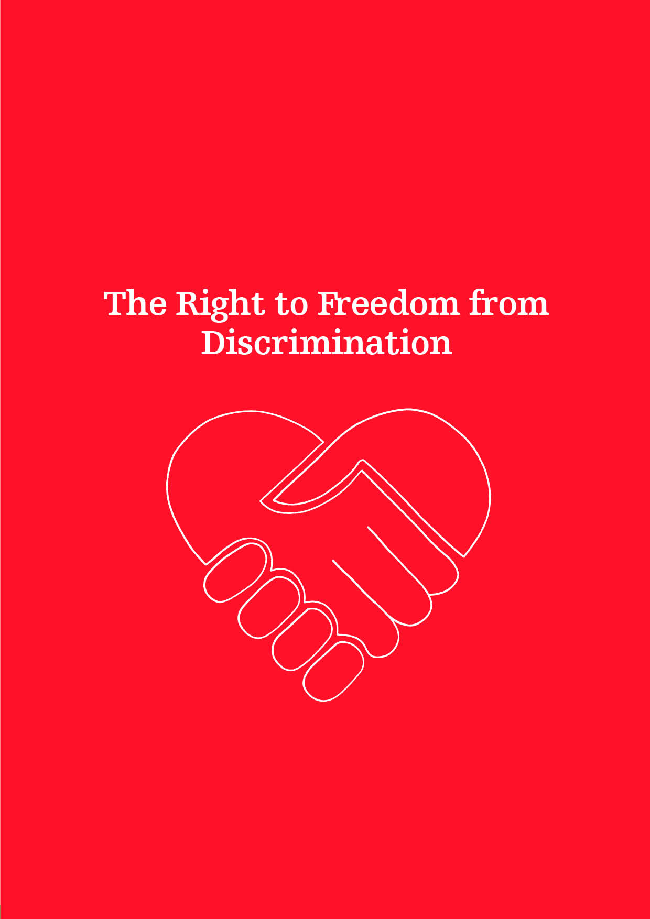

The Right to Freedom from Discrimination

The first article of the Universal Declaration of Human Rights stipulates that “[a]ll human beings are born free and equal in dignity and rights. They are endowed with reason and conscience and should act towards one another in a spirit of brotherhood.”
Article 2
Universal Declaration of Human Rights
Everyone is entitled to all the rights and freedoms set forth in this Declaration, without distinction of any kind, such as race, colour, sex, language, religion, political or other opinion, national or social origin, property, birth or other status…
[emphasis added]

This basic assumption of equality and dignity of all human beings is at the heart of all human rights and provides the foundation for the right to freedom from discrimination. Anchored in Article 2 of the Universal Declaration of Human Rights, the prohibition of discrimination on the basis of ‘other status’ in international human rights law is properly considered to include sexual orientation, gender identity and expression, and sex characteristics.
Even though such protections are guaranteed under international law, SOGIESC-diverse people often have little access to justice through remedy and redress. Violence and discrimination can be the result of exclusionary laws and policies. The terms used to define identity in legislation are crucial in determining the extent to which universal human rights are recognised and given protection under the law.
The rights to equality and non-discrimination for SOGIESC-diverse people are explicitly mentioned and emphasised in Yogyakarta Principle 2. The Principle explains that “discrimination on the basis of sexual orientation or gender identity includes any distinction, exclusion, restriction or preference… which has the purpose or effect of nullifying or impairing equality before the law… or the recognition, enjoyment or exercise, on an equal basis, of all human rights and fundamental freedoms.” The Principle stipulates that States should ensure that the human rights concepts of equality and non-discrimination are reflected in their national constitutions or other appropriate legislation. It also affirms that States shall adopt legislation and other measures in order to prohibit and eliminate discrimination against people with a diverse sexual orientation, gender identity and expression, and sex characteristics in the public and private spheres.

The human rights status of sexual orientation
Prior to the European colonisation of Aotearoa, homosexuality was accepted as a normal and natural part of Māori society. The entrenchment of Western Christian social values and structures would go on to have serious consequences for people with a diverse sexual orientation (and gender identity, gender expression, and sex characteristics) in Aotearoa and across the Pacific.
In 1858, the New Zealand Parliament imported most English law. At that time English law prohibited male, but not female, homosexual conduct, even when it was private and consensual adult behaviour. Almost 130 years later, the New Zealand government passed Homosexual Law Reform legislation in 1986, decriminalising male homosexuality. Sexual orientation was added as a prohibited ground of discrimination in the Human Rights Act of 1993. Civil unions for all couples came into effect in 2005, followed by marriage equality in 2013. In 2017, the government formally apologised to men convicted of historical homosexual offences, recognising the hurt and suffering they experienced as a result, and the continued effects their criminal convictions have had on their lives.

The human rights status of gender identity and expression
Gender expression is included in the definition of gender identity and, as such, all references to gender identity should be understood to be inclusive of gender expression as a ground of discrimination. In 2004, MP Georgina Beyer’s member’s bill was drawn from the ballot and introduced to Parliament. The Bill intended to specifically include gender identity in the definition of sex in section 21(1)(a) of the Human Rights Act. In 2006, the acting Solicitor-General wrote a legal opinion concluding that transgender people were already covered by the Human Rights Act, and Beyer withdrew her Bill as it was considered unnecessary. The Commission has interpreted the Act to include gender identity since at least 2005. In 2006, the Commission began an inquiry into the discrimination faced by transgender people, publishing the report of the inquiry, To Be Who I Am, in 2008. As a direct result, in 2012 the Department of Internal Affairs amended their passport policy allowing holders to select M, F, or X options for their sex through a statutory declaration process, with no requirement for medical evidence. In 2013, the New Zealand Transport Agency expanded their options for recording sex on a driver’s licence record to Male, Female, and Indeterminate through a similar process.
The Universal Periodic Review (UPR) is a mechanism of the United Nations Human Rights Council (HRC). It is a process aimed at improving the human rights situation ‘on the ground’ of each of the United Nations (UN) Member States. The human rights record of each UN Member State is peer-reviewed by other Member States in a 5-year cycle, with New Zealand’s most recent review taking place in January 2019. Directly prior to the review, the Minister of Justice stated in his speech to the UN HRC that the government planned to specifically acknowledge gender identity as a prohibited ground of discrimination in law. Until 2019, New Zealand had never received any recommendations related to SOGIESC during a UPR cycle.

The human rights status of sex characteristics
There is no explicit protection from discrimination for people with variations of sex characteristics in New Zealand legislation. This gap has been noted by the Commission and the Intersex Trust of Aotearoa New Zealand (ITANZ) in submissions to the United Nations Committee on the Rights of the Child in 2015, the Committee Against Torture in 2017, and the Working Group of the Universal Periodic Review in 2019. As a result of this collaborative work, New Zealand received four intersex-specific recommendations from the Committee on the Rights of the Child in 2016. There is also no law prohibiting surgical (cosmetic) interventions not necessary for the preservation of life on people with variations of sex characteristics. In 2017, the United Nations Committee Against Torture requested the New Zealand government comment on reports of surgery and other medical treatment to which intersex children were subjected, and provide the number of intersex children who had undergone surgery, from 2015 to 2019. The government responded in September 2019 stating seven intersex people underwent surgery in the reporting period.

The Human Rights Act 1993
Section 21 of the Human Rights Act 1993 (the Act) recognises thirteen prohibited grounds of discrimination, including sex and sexual orientation. ‘Sexual orientation’ is defined under s 21(1)(m) of the Act to mean a “heterosexual, homosexual, lesbian, or bisexual orientation.” ‘Sex’ under s 21(1)(a) simply states that the term “includes pregnancy and childbirth”. Although yet to be determined by the New Zealand Courts, the Commission interprets sex under s 21(1)(a) of the Act to include gender identity, gender expression, and sex characteristics; accepting complaints of discrimination on this basis.
While the Commission has interpreted the Human Rights Act to include discrimination on the basis of gender identity under the ground of sex discrimination since at least 2005, trans people have made it clear that they do not feel protected by the Commission’s position. Amending s21(1)(a) of the Act to also include gender identity, gender expression, and sex characteristics under the ground of sex was raised at every public hui the Commission hosted for SOGIESC-diverse people in 2018, and continues to be raised in other fora. The need to amend the Act has been identified by the Minister of Justice in his speech before the United Nations. Amendment of this legislation was recommended by the Committee on the Elimination of Discrimination against Women in July 2018. Further, it was also the subject of two recommendations to the New Zealand government through the 2019 UPR cycle. The government did not explicitly accept these recommendations, however it indicated that it would consider amending the Human Rights Act to include gender identity as a prohibited ground of discrimination. Communities have expressed hope to the Commission that the Minister’s reassurance extends to protections for all three groups.

Human Rights Commission complaints data
There are many ways in which discrimination against a person with a diverse SOGIESC manifests in New Zealand. Some indication of its prevalence can be drawn from the complaints made to the Human Rights Commission. From 1 January 2008 to 31 December 2019, the Commission has received 1,947 complaints on the ground of sex (including gender identity and sex characteristics) and 377 on the ground of sexual orientation (Figure 1).
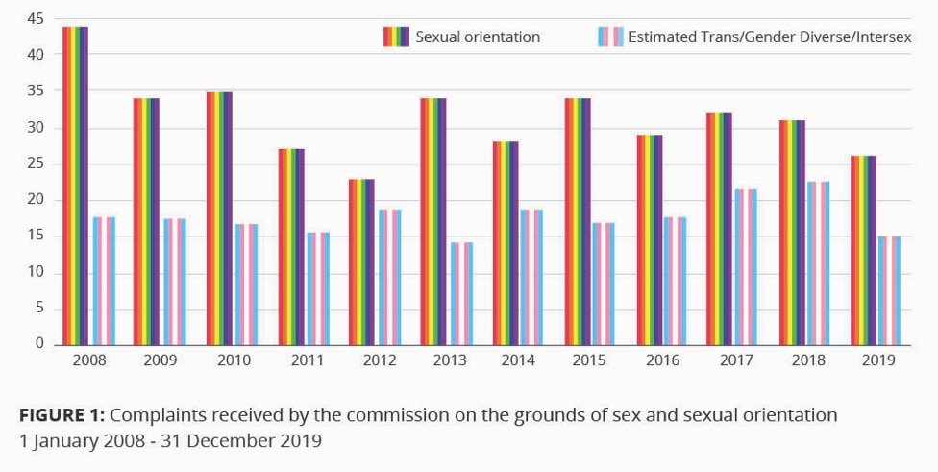
Of the complaints made under the ground of sex during this time, 212 (11%) were made by persons who identify as transgender, gender diverse, or intersex (Figure 2). The data reflect that the population of trans and gender diverse people is smaller than those with a diverse sexual orientation.
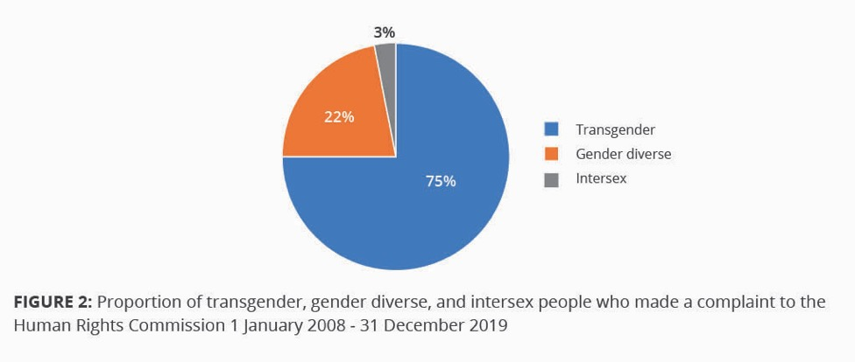
The main area of discrimination differs between these two groups. Trans and gender diverse people were most commonly discriminated against in the area of government activity, while employment was the biggest issue for those discriminated against due to their sexual orientation (Table 1). Discrimination in regard to health, education, and work will be discussed in forthcoming chapters.
Table 1: Most common area of discrimination for trans and gender diverse people, and sexuality diverse people, complaining to the Human Rights Commission 1 January 2008 - 31 December 2019
Rank | Area (No. of Complaints)
 | Trans and Gender Diverse | Sexual Orientation
1 | Government Activity (78) | Employment (124)
2 | Provision of Goods and Services (47) | Provision of Goods and Services (94)
3 | Employment (44) | Government Activity (70)

Violence and abuse
Multiple comprehensive reviews show that people with a diverse sexual orientation and gender identity experience a higher risk of physical and sexual violence than the general population. In most cases, the person’s sexual orientation or gender identity was a factor in the perpetration of the abuse. The United Nations Independent Expert on protection against violence and discrimination based on sexual orientation and gender identity states, “the data available show that [lesbian, gay, bisexual, trans and gender non-binary persons] face the near-certainty of suffering violence during their lives, and that as a general rule [they] live every day in the awareness and fear of it.”
“Hate crime” and “hate speech” are two terms used to describe some of the violence and abuse experienced by people with a diverse SOGIESC. They are different but related concepts, with concerns in common. The Commission receives numerous requests for information about hate speech and hate crime, the lack of legislative protection in New Zealand, and the lack of justice sector-related data. These requests include incidents where SOGIESC have been a factor.
Violence against people with diverse sexual orientations, gender identities and expressions, and sex characteristics was an issue of concern to participants at the Commission’s Wellington hui. “Hate crimes” are criminal offences that occur because the perpetrator is motivated, in whole or part, by a person or group’s actual or perceived personal characteristics. When a hate-motivated crime occurs, the perpetrator is charged under standard criminal law provisions relating to the offence. However, the motivation for the offence can be considered an aggravating factor for sentencing purposes if an individual is convicted. At least in part due to this legal situation, very limited data is collected by New Zealand Police and the Ministry of Justice pertaining to crimes related to sexual orientation and gender identity or how frequently hate-motivated factors are taken into account during the sentencing process. The Commission’s Transgender Inquiry found great limitations on enforcing the Sentencing Act’s provisions; the aggravated motivation of a crime must be recorded at each stage of the justice process, from reporting through to sentencing. This requires a person’s sexual orientation or gender identity to be accurately noted throughout.
Like hate crime, hateful or harmful speech has become an issue of considerable public concern in New Zealand. Hate speech is not defined in New Zealand legislation, and New Zealand legislation does not protect generally against words that attack a person or group based on real or perceived personal characteristics. “Hate speech” legislation generally targets only words which incite violence or prejudicial action against members of particular groups.
The main laws covering hate speech in New Zealand are the Human Rights Act and the Harmful Digital Communications Act. There are considerable anomalies in the existing legislation. Section 61 of the Human Rights Act prohibits the “incitement of disharmony” on the basis of race, ethnicity, colour or national origins. These criteria do not extend to the incitement of disharmony on the basis of religion, gender identity, disability, sexual orientation, or other status. The 2015 Harmful Digital Communications Act seeks to deter, prevent, and mitigate harm caused by digital communications and to provide victims of harmful digital communications with a quick and efficient means of redress. Principle 10 of this Act states that a digital communication should not denigrate an individual by reason of colour, race, ethnic or national origins, religion, gender, sexual orientation, or disability. Both laws have to be interpreted in the context of the New Zealand Bill of Rights Act, which affirms the right to freedom of expression.
SOGIESC-diverse community leaders have told the Commission that they are concerned about the nature, volume, and harm of hateful speech. They have observed that hate speech against SOGIESC-diverse communities tends to be sexually explicit or violence-oriented, and its ubiquity online and in the media causes harm. During the Commission’s work, these leaders have described hate speech as denying the existence of trans and non-binary identities, noting an increase in use of coded language which attempts to deny the rights of trans people while appearing reasonable to the average person. These concerns mirror an international rise in hate speech and hate crimes against SOGIESC diverse communities. In the wake of the terrorist attacks at two Christchurch mosques on March 15, 2019, the Minister of Justice fast-tracked a review of New Zealand’s hate speech laws. The review by the Ministry of Justice will inform any government decisions which could, for example, include deciding whether hate speech provisions should be expanded to cover other grounds of discrimination.
The internet has the potential to both support and harm users. It provides access to information and community support for many minority groups independent of a person’s geographical location. Conversely, cyberbullying is an alarming phenomenon allowing online violence and abuse to be brought into the home. Netsafe, New Zealand’s independent, non-profit online safety organisation, undertook first-of-its-kind research on online hate speech in New Zealand in 2018. It found minorities more likely to be targeted with hateful content online, with 26% of non-heterosexual people targeted compared with 9% of heterosexual people. The findings mirror international research regarding the prevalence of online hate against vulnerable groups. Further research by Netsafe on image based sexual abuse (IBSA) showed threats of IBSA were 8% for non-heterosexual people versus 3% for heterosexual people. Rates of sharing intimate content online without consent was 10% for non-heterosexual respondents compared to 3% of all respondents. A recent survey on the health and wellbeing of transgender and non-binary people in Aotearoa New Zealand reported 39% of participants had been sent nasty or threatening messages through the phone or on the internet.
Counting Ourselves was a survey on the health and wellbeing of 1178 trans and non-binary people in Aotearoa New Zealand conducted in 2018. It presents the biggest and only data set on trans and non-binary populations in New Zealand ever collected. The results showed high levels of discrimination, with 67% of participants having experienced discrimination at some point. 44% of respondents had been discriminated against in the past 12 months compared with 17% of respondents in the General Social Survey, but Asian and disabled people had even higher rates of discrimination; both 60%. Counting Ourselves respondents had higher rates of discrimination than the general population in every specified situation in the survey, including on the street (25% vs. 6%), in a shop or restaurant (14% vs. 3%), and trying to get a job or at work (12% vs. 3%). Respondents reported avoiding places due to fear of discrimination; most commonly at a gym or pool (58%) followed by a sports club or team (50%). They further reported high rates of harassment and discrimination when using the bathroom. 43% had been told or asked if they were using the wrong bathroom, and 70% had avoided using a public bathroom in the last 12 months. Rates of sexual violence against trans and non-binary people were two to three times higher than that for women in the general population and seven to 12 times higher than for men in the general population.
Statistics New Zealand’s 2018 General Social Survey measured rates of discrimination amongst adult respondents aged 18 and over. Those who had a gay/lesbian (34.1%) and bisexual (39.3%) sexual orientation faced higher rates of discrimination in the past year compared with heterosexual adults (16.3%).
The recent Ministry of Justice New Zealand Crimes and Victims Survey showed that people with diverse sexual orientations were more likely to become the victims of crimes. Gay/lesbian (40.3%) and bisexual people (49%) were more likely to be victimised, compared to heterosexual people (29.1%) (Figure 3).

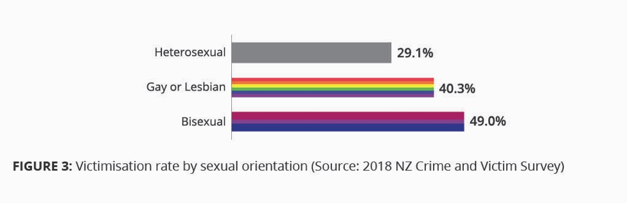
Gay, lesbian, and bisexual victims as a group were less likely to report crimes to the Police than the national average (13% compared to 23% of the general population). The survey asked for perceived drivers of crime incidents; 6% of all incidents and 8% of personal offence incidents were perceived to be driven by discrimination based upon sexuality. 35% of sexual offence incidents and 13% of violent interpersonal offence incidents were perceived to be driven by discrimination based upon sexual orientation.
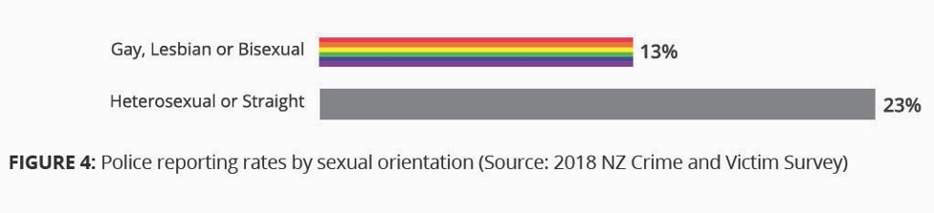
Survey respondents who had been victimised were significantly more likely to suffer psychological distress. The survey did not explore whether the victimisation caused psychological distress, or the reverse; and data were only available about sexual orientation, not gender identity, gender expression, or sex characteristics. However, given the high rates of psychological distress for people with a diverse SOGIESC, this phenomenon is concerning. Mental health is discussed in a later chapter.
As noted earlier, having more than one minority identity, in addition to a diverse sexual orientation, gender identity or expression, or sex characteristics, increases experiences of violence and discrimination. Racism compounds violence experienced by Māori, Pacific peoples, Asian, and other non-European SOGIESC-diverse people. Often people with multiple minority identities feel that they cannot bring their whole self into certain spaces. For example, SOGIESC spaces may not accessible for people with disabilities, while mainstream groups may not be inclusive and welcoming of SOGIESC identities.
Discrimination does not only come from outside SOGIESC-diverse communities. Intra-community experiences of discrimination in New Zealand include ableism, racism, transphobia, and biphobia; all under-researched areas at present. These may be further sources of tension that can be experienced in vastly different ways due to ethnicity, class, education, and privilege; and manifest as lateral violence. For example, bisexual people can experience invisibility of their identity; when in a relationship with a same-gender partner they are often assumed to be homosexual (gay/lesbian), and when in a relationship with a different-gender partner, often assumed to be heterosexual.

Recommendations:
Amend section 21(1)(a) of the Human Rights Act 1993 to explicitly include gender identity, gender expression, and sex characteristics as specific prohibited grounds of discrimination;
Update hate speech provisions to effectively address hate speech based on sexual orientation, gender identity, gender expression, and sex characteristics;
Collect data about crimes motivated by hostility towards people with a diverse SOGIESC, including through research and effective police and justice sector recording processes;
Provide comprehensive resources to employers, educational institutions, government agencies, sports bodies, housing rental agencies, health, aged care, and other service providers outlining how people with a diverse gender identity, gender expression, and sex characteristics are fully protected from discrimination under section 21 of the Human Rights Act 1993;
Ensure that anti-violence strategies, policies, and services developed or funded by government specify and address the experiences and needs of SOGIESC-diverse persons and communities, as identified by them.

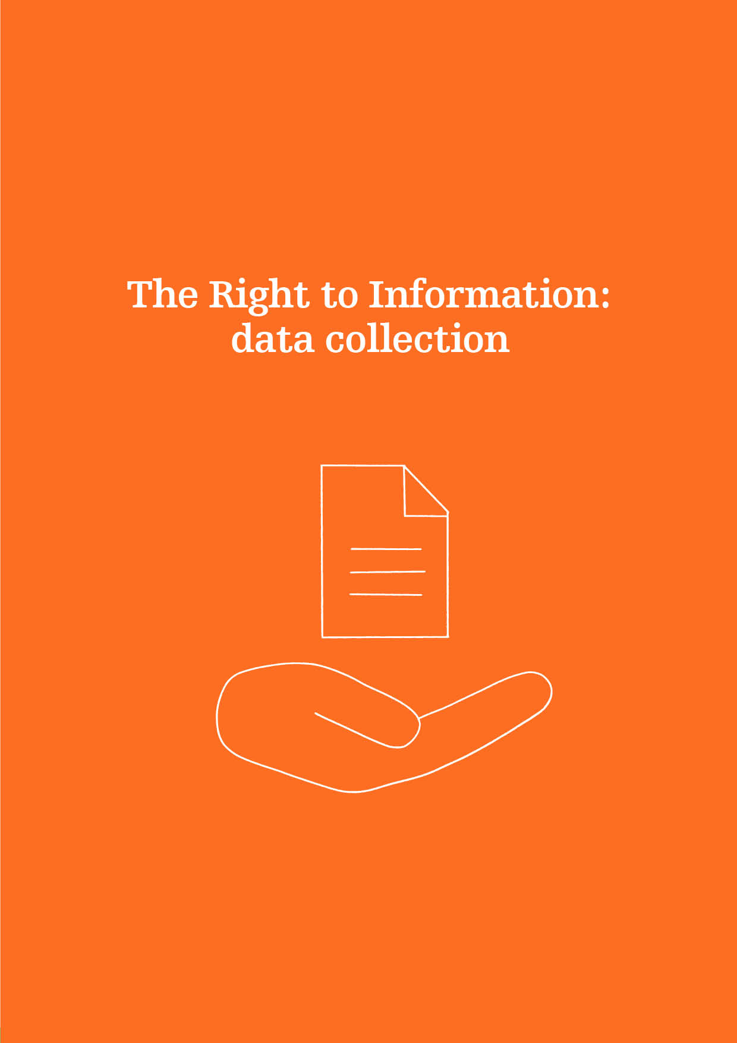

Article 19
INTERNATIONAL COVENANT ON CIVIL AND POLITICAL RIGHTS
(2) Everyone shall have the right to … seek, receive and impart information and ideas of all kinds, regardless of frontiers, either orally, in writing or in print, in the form of art, or through any other media of his choice.

The Right to Information
Human rights cannot be monitored without data. While all groups have equal access to information in Aotearoa, the kind of information available is not equally collected among those groups. That is, there is an unmet need regarding measuring diversity in SOGIESC. When this diversity is under-reported, it has negative implications for generating an evidence base regarding the issues faced by these communities, and significantly impacts on funding and resourcing.
A human rights-based approach to data collection requires data to be collected for each specific population. Such data should be managed in accordance with ethical, scientific, and human rights standards. It should be made available to the public in a disaggregated form to allow for an independent and deep analysis of inequalities. In this way, it can also help identify the extent of discrimination faced by different groups. The Office of the United Nations High Commissioner for Human Rights (OHCHR) states that a human rights-based approach to data collection is predicated on the principle of self-identification, allowing the populations of interest to be self-defining. Furthermore, “individuals should have the option to disclose, or withhold, information about their personal characteristics.” Privacy is an issue of particular importance for marginalised communities such as people with diverse sexual orientations, gender identities and expressions, and sex characteristics. Diversity in SOGIESC can be highly stigmatised in certain contexts. As such, it is important to collect data on an as-needed basis only, in a manner that is strictly confidential and used exclusively for statistical purposes.
Absence of evidence is usually considered evidence of absence
Access to official statistics is part of the public’s right to information. SOGIESC-diverse people have diverse needs and experience some different human rights challenges than the general population. As at December 2019 there are limited official data sets on sexual orientation, and none on the number of people with a diverse gender identity, gender expression, or sex characteristics. The lack of reliable data on the size and characteristics of SOGIESC-diverse populations limits the capacity of policymakers, administrators, and practitioners to address these needs. This means that “in most contexts policymakers are making decisions in the dark, left only with personal preconceptions and prejudices or the prejudices of the people around them.” Yogyakarta Principle 19 (f) stipulates that States shall “[e]nsure that all persons, regardless of sexual orientation or gender identity, enjoy equal access to information and ideas, as well as to participation in public debate.”
It is difficult to prove a problem exists when there are no numbers to support this. Without accurate baseline data on SOGIESC-diverse communities, there can be no robust analysis of the scope or nature of the challenges faced, nor measures put in place to alleviate those challenges. This is considered to be one of the key factors underpinning why people with diverse sexual orientations, gender identities and expressions, or sex characteristics have largely been omitted from funding, planning, and responses until the first recognition in a national Budget in May 2019. One recent example of this exclusion is the report of the Government’s Mental Health and Addictions Inquiry, He Ara Oranga, which did not specifically address the needs of people with diverse sexual orientations, gender identities and expressions, and sex characteristics in its recommendations. This was despite an in-depth and lengthy submission signed by multiple SOGIESC organisations on the issues these populations face. Without the collection of statistics, appropriate budgets cannot be allocated or prioritised to deal with key issues affecting these populations, such as the rates of youth suicide.

Collection of official statistics
Internationally, the field of gender and sex data collection is a new and developing area. Measurement challenges are not unique to New Zealand, with many other Statistical Offices around the world grappling with similar issues. In the English language, “gender” is often used interchangeably with “sex,” complicating data collection. Further, while “sex” is limited, sex characteristics – distinct from gender – is a broader and more precise term used in human rights discourse and by the United Nations.
Cultures throughout the Pacific region recognise and accept gender diversity that Western societies largely do not. Indigenous identities which sit outside of a Western framework of sexual orientation, gender identity and expression, and sex characteristics are usually not counted at a population level, resulting in suppression and erasure. While statistical standards may acknowledge that these identities exist, they are still classified in a Western way. This restricts non-Western SOGIESC-diverse people from understanding themselves within their cultural context and terminology and paints all SOGIESC-diverse individuals as culturally monolithic.
Statistics New Zealand (Stats NZ) is the agency tasked with collecting official statistics in Aotearoa. During the most recent national Census in March 2018, Stats NZ did not collect data on sexual orientation, gender identity, or sex characteristics. The lack of data collection at the population level has been raised by community advocates and the Human Rights Commission over many years, both with Stats NZ directly and with international mechanisms including UN Treaty Bodies and during the Universal Periodic Review. In 2018, the Committee on the Elimination of Discrimination Against Women recommended that the New Zealand government, “set up a centralized system for the collection, analysis and dissemination of comprehensive data, disaggregated by sex, gender identity and sexual orientation.” Disaggregation allows groups to be compared to evaluate progress and is therefore a key part of the government’s human rights obligations.
Since mid-2019, Stats NZ has been undertaking significant work to evaluate and refresh their sex and gender identity standards. To ensure information collected reflects New Zealand society and its diversity, measurement tools must be both contemporary and fit for purpose. In response to high community interest, unmet information needs, and known issues with existing standards, this evaluation will determine the updates needed to provide best practice guidance for collecting information in New Zealand. Public consultation on the standards is due to take place in 2020.
There are no firm numbers available to indicate how many people collectively have a diverse SOGIESC in New Zealand. The Mental Health Foundation estimated that between 6 and 15% of the New Zealand population has a diverse SOGIESC, noting that the higher end of this range is more likely to be accurate.

Sexual orientation measurement efforts
The Ministry of Health has collected sexual orientation data in the annual New Zealand Health Survey since the 2015/2016 survey wave. Responses consistently show between 3-4% of participants have a non-heterosexual orientation, however sexual orientation response options are limited to four options and not culturally specific.
Sexual identity data were collected for the first time by Stats NZ in a household survey in 2018. A total of 3.5% of respondents identified as something other than heterosexual or straight; made up of 1.9% identifying as bisexual, 1.1% as gay/lesbian, and the remaining 0.5% as other identities including takatāpui, asexual, and pansexual. A statistical standard for sexual identity has recently been developed and published by Stats NZ, alongside a framework for sexual orientation.
A 2012 nationally representative survey of 8,500 New Zealand secondary school students reported 3.8% of the students were attracted to the same or both sexes, and a further 4.3% reported they were unsure or attracted to neither. A 2016 survey of employees in the public service indicated approximately 7% had a non-heterosexual orientation. In a 2013/2014 survey of over 18,000 people, 5.8% of New Zealanders identified as non-heterosexual. However, this study is likely to underestimate the number of people who are attracted to the same gender or have engaged in same-gender sexual behaviour. This is supported by another recent longitudinal study in New Zealand which found that almost 20% of respondents were not heterosexual. 12.6% were ‘mostly heterosexual’, 3.5% were bisexual, and 1.9% were gay/lesbian.
The New Zealand government has a duty to act in a manner consistent with the Human Rights Act. Given the inclusion of sexual orientation as a prohibited ground of discrimination in the Act, successive governments have failed to collect data at a population level and monitor the situation of people with diverse sexual orientations.

Gender identity measurement efforts
In 2015, Stats NZ released a world first statistical standard providing guidance on the collection, classification, and dissemination of gender identity data. The standard recommended a third gender classification of ‘gender diverse’ in addition to male and female. This umbrella term was intended to code responses from binary and non-binary trans people, but has instead been interpreted as a question – rather than a coding scheme – with three mutually exclusive options. The standard has been heavily criticised by trans, non-binary, and intersex communities for not meeting their needs; when interpreted in a mutually exclusive way, binary trans people are not recorded at all, while many non-binary people do not identify with the term gender diverse. Creating further confusion and flow on effects for data collection, some government agencies and organisations now offer gender diverse as a third gender option.
The 2019/20 Household Economic Survey was the first time Stats NZ began to collect data on sex and gender through the ‘two-step’ question method. This method involves asking a question about sex recorded at birth, combined with a question on gender. Comparing an individual’s two responses is used to determine the number of trans respondents. The data from this survey are due to be published by the end of 2020.
Outside of the government sector, the aforementioned Youth 2000 survey series is the most comprehensive source of data regarding gender and sexuality diverse young people. The survey was carried out in 2001, 2007, 2012, and again in 2019. The 2019 sample, in contrast to previous survey waves, was not nationally representative; covering only the greater Waikato, Auckland, and Northland regions. At the time of writing, Youth’19 data have not yet been published, and the survey data from 2012 (Youth’12) remain the only and best data set that exists to estimate the size of the trans population in New Zealand. In Youth’12, 1.2% of students identified as transgender and a further 2.5% were not sure of their gender.
The trans-led Counting Ourselves survey collected data from 1178 trans and non-binary people over the age of 14 living in New Zealand. The survey collected data concerning mental and physical health, experiences of discrimination, experiences in healthcare settings, and levels of support from communities and whānau. Questions also covered legal gender recognition, experiences at school and work, and experiences of violence. Another independent research project producing a crucial data set is Honour Project Aotearoa. This survey on the health and wellbeing of takatāpui people will assist in filling knowledge gaps about this population. At the time of writing, the survey results were being analysed and due to be published in a forthcoming report.

Sex characteristics measurement efforts
Diversity in sex characteristics has never been measured in New Zealand. During the most recent national Census in March 2018, intersex people were suggested to request a paper survey form and mark both male and female when responding to the binary sex question. An international estimate of 1.7% of live births is frequently cited, corresponding to more than 900 babies born in New Zealand each year.
Stats NZ's statistical standard for sex was introduced in 1995 and has two classifications: male and female. In limited circumstances, a third sex classification of ‘indeterminate’ may be required for individuals whose sex cannot be determined as male or female.
The introduction of a third ‘sex’ option for people with variations of sex characteristics is against good practice internationally and regionally when collecting sex data. There is no one intersex sex; it is an umbrella term to describe over 40 distinct sex characteristics variations. Having a third classification for people with variations of sex characteristics can create an assumption that all intersex people belong in that category and not male or female, when most intersex people identify as male or female; and removes their ability to identify their own gender, which may be female, male, or a non-binary gender. Such a category forcibly outs intersex people and infants, if it is an option that infants can be assigned to. Social and legal support for people not legally recognised as male or female is lacking, thus a third sex option for people with variations of sex characteristics has the potential to cause them harm. It also assumes that a diagnosis is given at birth based on external anatomy. In reality, an individual with an intersex variation can receive a diagnosis at a range of times in their life, including before birth (pre-natal), at birth, at puberty, when trying to conceive, post-mortem, or by chance.
Some work is underway in the medical field to establish a registry of intersex people in Aotearoa. Medical information collected from consenting participants will help to ascertain the number and types of intersex variations in New Zealand. Based on the i-DSD registry in the United Kingdom, this information would be held in a single repository, and aid in providing a more complete picture of intersex people in Aotearoa. It is hoped that this will improve long-term follow-up and care outcomes for those with diverse sex characteristics.

Data reflective of society
SOGIESC-diverse people are particularly vulnerable to human rights breaches through being chronically under-served and under-resourced, on top of the heightened stigma and discrimination they experience. The invisibility of certain populations, such as takatāpui, within SOGIESC diverse communities requires consideration of the associated human rights implications. The unmet information and data needs for SOGIESC-diverse people will become clearer in the chapters that follow.
Recommendations:
Develop and implement, in consultation with SOGIESC-diverse people, a comprehensive plan to collect sexual orientation, gender identity, and sex characteristics data in population and household surveys;
Develop definitions, classifications, data standards, and data collection guidelines reflective of SOGIESC-diverse groups in accordance with this plan.

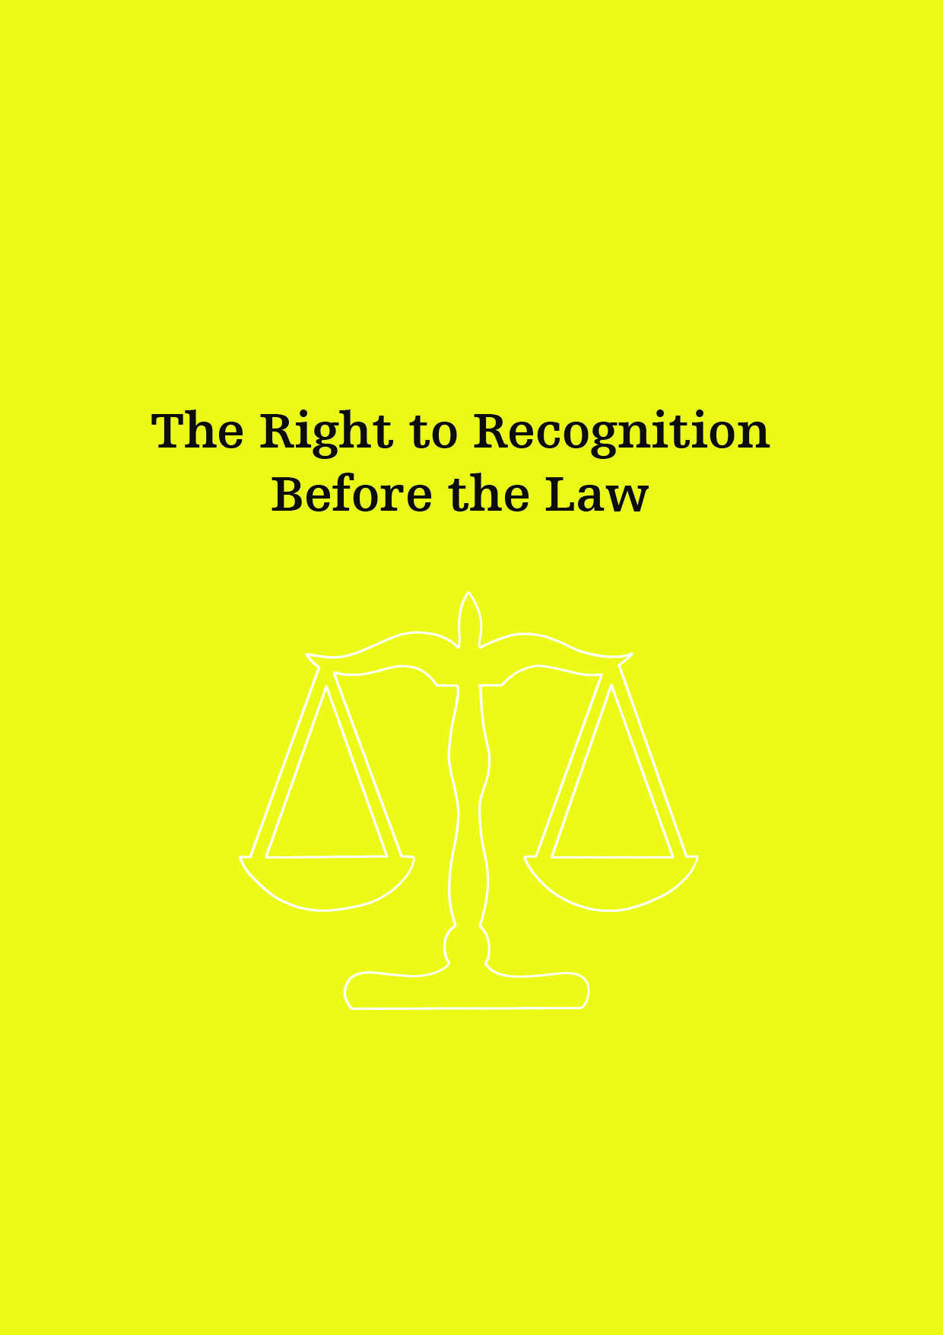

The Right to Recognition Before the Law
Article 16
International Covenant on Civil and Political Rights
Everyone shall have the right to recognition everywhere as a person before the law.
The right to recognition before the law is enshrined in Article 16 of the International Covenant on Civil and Political Rights. The right to be recognised as unique and distinguishable from others has been described as the very basis of individual rights. This means that all individuals are entitled to legal recognition regardless of their legal or transitional status or the terms they use to describe themselves. Recognition of an individual’s affirmed gender allows access to rights and freedoms, including entitlements related to health, education, housing, access to social security, and employment. For people with a diverse gender identity, gender expression, or sex characteristics, legal recognition of their identity is crucial in order to uphold human dignity and equal protection before the law. The OHCHR has recommended States issue identity documents based on the self-determined gender of the person concerned.
People who attended the Commission’s hui stated that despite forward momentum, New Zealand has a long way to go to realise the rights of all people with a diverse sexual orientation, gender identity and expression, and sex characteristics. This is particularly evident in the shortcomings regarding the right to recognition before the law. Many people with gender identities different to their sex assigned at birth struggle to be recognised on their official identity documents. The absence of full legal gender recognition bars people from meaningful and full participation in society, education, employment, and social security. When name and gender/sex details on official documents do not match gender identity or expression, the holder of the document is more likely to be subjected to discrimination, humiliation, and undignified experiences.
Data from Counting Ourselves showed that only 50% of trans and non-binary participants had the correct name on all identity documents. 32% had the wrong name on all identity documents. When it came to gender markers, 83% had the wrong gender on their New Zealand birth certificate, 60% had the wrong gender on their New Zealand passport, and 55% had the wrong gender on their driver’s licence (Figure 5). The report stated consequences of this included being denied benefits (18%), verbally harassed (17%), asked to leave (10%), and assaulted or attacked (2%). Reasons given for why documents had not been updated included the correct gender option was not provided (38%), cost (31%), fear of discrimination (25%), and not knowing how to change documents (23%).
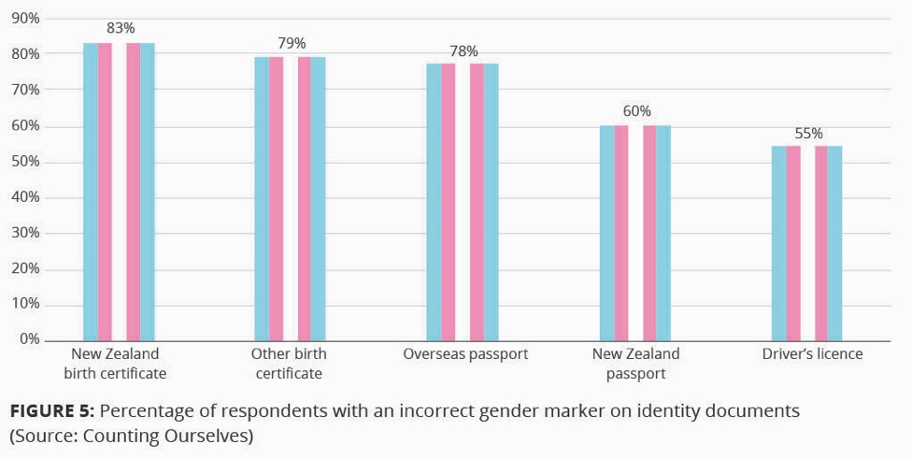

Yogyakarta Principle 31 states that “Everyone has the right to legal recognition without reference to, or requiring assignment or disclosure of, sex, gender, sexual orientation, gender identity, gender expression or sex characteristics.” This includes that everyone has the right to obtain identity documents. Such documents should only include information which is relevant, reasonable, and necessary for a legitimate purpose; without such a purpose, States should refrain from collecting information on this issue. The United Nations Independent Expert on protection against violence and discrimination based on sexual orientation and gender identity has expressed “significant doubts as to the real need for the pervasive exhibition of gender markers in official and non-official documentation;” indicating that ending the registration of sex and gender in identity documents, as is already the case with ethnicity and religion, solves the problem of needing to amend them. While gendered information is still collected, all people have the right to change that information in identity documents. This process should be quick, accessible, and transparent, and reflect a person’s self-determined gender identity and gender expression.

Passports and driver licences
The Commission’s Transgender Inquiry in 2006 and 2007 recognised the need for transgender people to have congruent official identification documents. The report of the Inquiry stated that “documents that accord with a trans person’s gender identity affirm their dignity and secure participation as equal citizens.” As a result, the Inquiry recommended improving consistency in the policies of government agencies with respect to amending sex details on official documents such as passports, driver licences, and birth certificates. This recommendation was made at a time when amending sex markers on passports and driver’s licenses was much more difficult than it is now.
As a direct outcome of the Inquiry, in 2012 the Department of Internal Affairs updated its passport policy to allow a passport holder to choose a sex marker based on self-determination, regardless of the details on their birth certificate. This policy provides an accessible way to secure an official piece of government identification by statutory declaration with no requirement for medical evidence. This is crucial for those who do not want to, or cannot safely, medically transition. In addition to M and F, a third option of X is available. However, passports are only granted to citizens, excluding vulnerable population groups such as refugees and asylum seekers. Cost can present an additional barrier to those who cannot afford the fee for a new passport. In 2013, a similar policy of self-declaration by statutory declaration was implemented for New Zealand drivers’ license records by the New Zealand Transport Association.

Birth certificates
Applying a self-declaratory model to amending birth certificates is more complicated than passports or drivers licence records as it requires a change in the law. The current process is therefore an outlier compared with policies for other official documents. It is possible for trans, non-binary, and intersex New Zealanders to amend the sex marker on their birth certificate to one of two binary options. An application must be made to the Family Court, alongside presentation of expert medical evidence of medical treatment that enables “physical conformation” with an applicant’s gender identity. This process presents an obstacle to the full enjoyment of the right to legal gender recognition by restricting access and privileging those who pursue a medical transition. Such a process is inconsistent with the rights to bodily autonomy and integrity due to the requirement of modifying one’s body in order to acquire a birth certificate displaying the correct sex. UN bodies have found that if a person is forced or coerced to undergo surgeries or hormone treatment in order to obtain legal recognition, this may amount to ill-treatment or torture. The United Nations High Commissioner for Human Rights has noted that judicial procedures “may constitute a disproportionate and unnecessary intrusion into the exercise of individual rights, particularly where a judge is asked to determine the validity of a person’s gender identity, which is a deeply personal and intimate matter.”
The Births, Deaths, Marriages, and Relationships Registration Bill was introduced to Parliament in 2017. Recommendations made by the Select Committee in 2018 proposed changes to simplify the process of amending sex on birth certificates, bringing the process in line with existing domestic self-declaration processes. The Bill proposed moving beyond binary male and female options for sex, and removing requirements for an applicant to provide medical evidence or take part in a Family Court process. The Commission welcomed these proposed changes as they provided a meaningful step towards a rights-based model of self-determination, bodily integrity, and non-discrimination for the communities affected. In February 2019, the Minister responsible for the Bill deferred further progress citing insufficient public consultation. A subsequent update from her office noted that the Registrar General would waive the fees associated with making an application, in order to reduce financial barriers. A working group of trans and intersex people, as well as medical and legal experts, was established for five months to provide advice to the Minister on how to further reduce barriers to amending sex markers in the current process. Removing the current Family Court requirement to allow people to amend the sex on their birth certificate through self-determination would require a change in the law, which lay outside the working group’s mandate. The working group produced a final report on their findings to the Minister at the end of their appointment, but no timeframes have been established for the resolution of the broader issues identified by the Minister. This further jeopardises the human rights of trans, non-binary, and intersex communities.

Children
Children and young people are protected from discrimination based on gender identity under the United Nations Convention on the Rights of the Child. On this basis, the process of recognition should ensure young people also have access to legal recognition of their gender identity. The Office of the United Nations High Commissioner for Human Rights states that children should be allowed to use their own names and pronouns, and express their self-defined gender identity, regardless of their legal gender markers. Children under the age of 18 are covered in section 29 of the current Births, Deaths, Marriages and Relationships Registration Act. The impact of the proposed changes to the Bill would be significant for transgender children and youth who are required to show a birth certificate as proof of identity, such as when enrolling in school. There is an assumption that children cannot consent to legal gender recognition processes because of their age or level of understanding. The New Zealand passport policy provides a good practice example of access to recognition before the law for children under the age of 18. In addition to self-determining the sex on their passport through a statutory declaration with support from a legal guardian, an applicant also requires a letter of support from a counsellor or health professional.

People with variations of sex characteristics
Like some transgender people, individuals with diverse sex characteristics may need to amend their identity documents. While the right to legal recognition is a pressing issue for intersex people, it is secondary to ending surgical and medical intervention without their own informed consent and their right to bodily autonomy, discussed later in the chapter. It is against good practice regionally and internationally to include a third option for ‘intersex’ when registering the sex of a new-born. International human rights treaties require that children be registered immediately after birth. This registration includes a name and the right to acquire a nationality, but does not require States to register sex or gender. The intersex human rights movement calls for the registration of intersex children as female or male at birth, with the awareness that, like all people, they may grow up to identify with a different sex or gender. A joint consensus statement by Australia and New Zealand intersex community organisations and independent advocates in 2017 affirmed this position by asserting “[t]he larger goal is not to seek new classifications but to end legal classification systems and the hierarchies that lie behind them.”
As intersex is an umbrella term for more than 45 variations in sex characteristics, there is no one intersex sex. It is not a sex category, nor a gender identity. Variations in sex characteristics are not the same as non-binary genders. The majority of intersex people identify as male or female, and a third category reinforces the idea that intersex people cannot be (real) men or women. Further, a separate category reinforces the idea that documents should be based on biology. This is not supported by a rights-based model of self-determination. While based on good intent, unintended consequences of registering a baby as intersex may encourage non-lifesaving surgical procedures to be performed so as to avoid this classification.
Recognition before the law is key to the enjoyment of rights for all people. The State has an obligation to “provide access to legal recognition in a manner consistent with the rights to freedom from discrimination, equal protection of the law, privacy, identity and freedom of expression.” At present, New Zealand legislation is far from established international good practice with regard to the right to legal recognition, preventing barriers to the full enjoyment of human rights for transgender, non-binary, and intersex people.
Recommendations:
Amend the Births, Deaths, Marriages, and Relationships Registration Act to ensure that the process for an individual to update the nominated sex on their birth record is predicated on a rights-based model of self-determination, bodily integrity and non-discrimination in accordance with New Zealand’s international human rights obligations;
Ensure that individuals who amend the sex on their birth certificate can nominate a non-binary gender identity and consult with transgender, non-binary, and other gender diverse individuals, and intersex people, as to what the third option should be;
Remove the intersex sex option suggested by the Select Committee after the Bill’s first reading;
Include in the definitions clauses a provision that defines “gender identity” along the lines of the definition adopted in Argentina and Malta;
Consider whether New Zealand’s legislative framework should provide for the right of official recognition of gender identity;
Enable transgender and intersex refugees and asylum seekers to obtain official documentation reflecting their self-defined gender and name based on a statutory declaration, until they can change these details using processes available to permanent residents. Extend this option to migrants who cannot amend their name and gender marker on official documents in their country of origin.

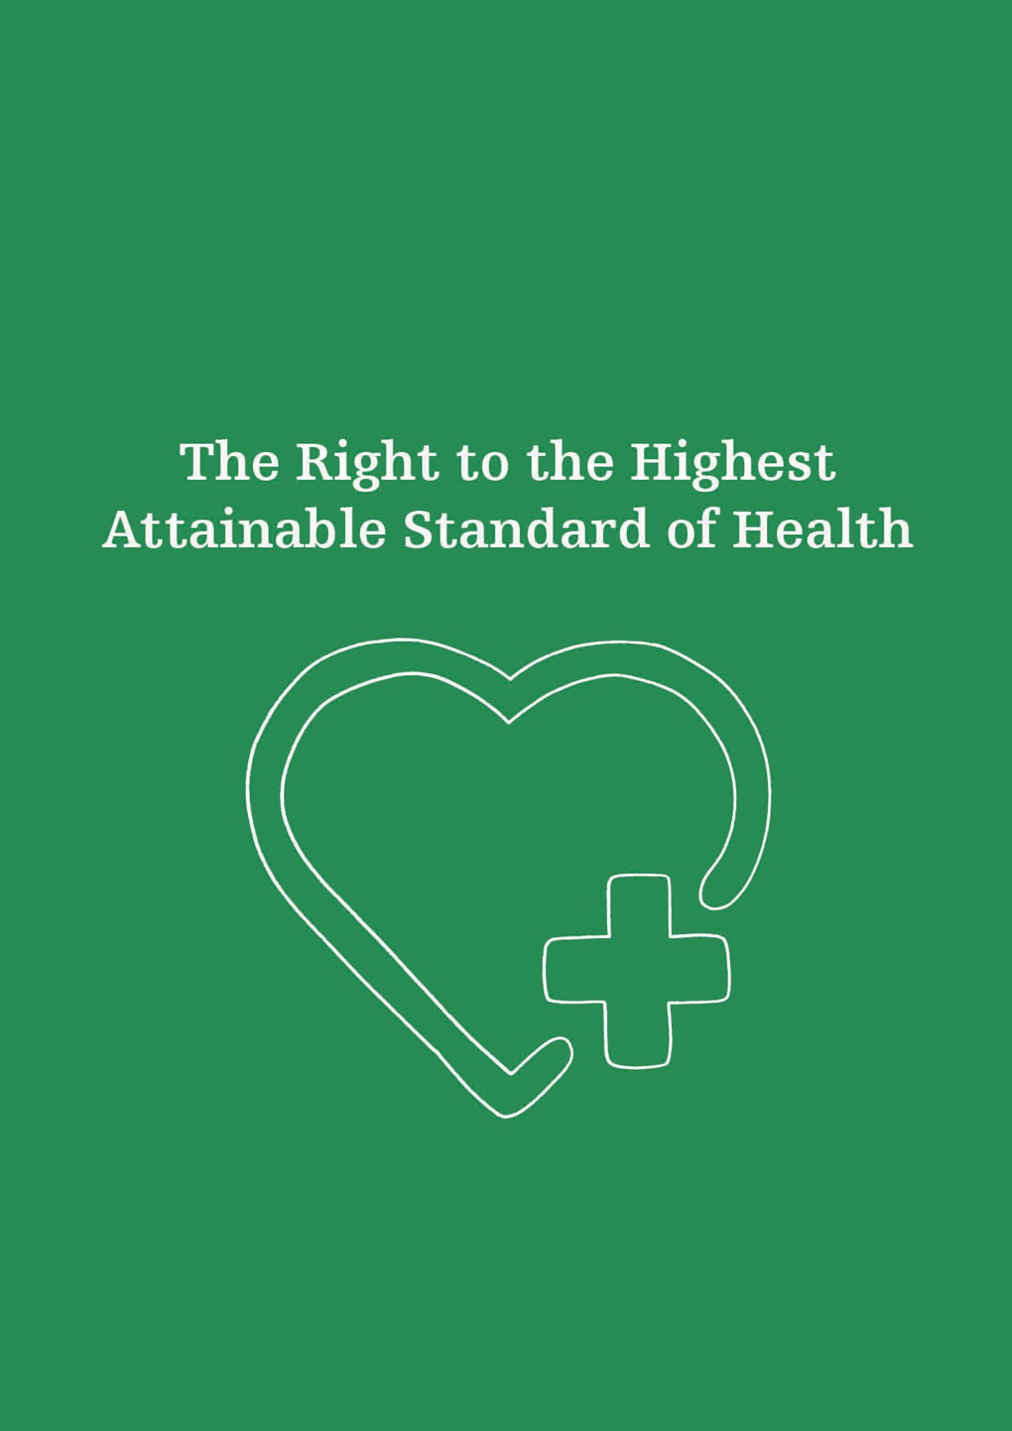

The Right to the Highest Attainable Standard of Health
Article 12
INTERNATIONAL COVENANT ON ECONOMIC, SOCIAL AND CULTURAL RIGHTS
(1) The States Parties to the present Covenant recognize the right of everyone to the enjoyment of the highest attainable standard of physical and mental health.

The right to health is anchored in Article 12 of the International Covenant on Economic, Social and Cultural Rights and Article 25 of the Universal Declaration of Human Rights. While it is often misunderstood as a right to health care, the right to health is much broader, also encompassing access to safe water, adequate sanitation, a safe working environment, access to health-related information and education, and other critical socio-economic factors promoting conditions of good health. The right to health framework includes the components of availability, accessibility, acceptability, and quality. The right to health entitles every person to prevention, treatment, and control of diseases; access to essential medicines; maternal, child, and reproductive health; and participation in health-related decision-making at national and community levels.
People with a diverse sexual orientation, gender identity and expression, and sex characteristics have the same need for health care and protection as anyone else. However, they encounter barriers and disparities in accessing and receiving services that affirm their whole being. Health featured prominently in all the Commission’s 2018 hui. Participants stated that the full enjoyment of the right to health remains a distant goal for many SOGIESC-diverse people in New Zealand. This was true for both mental and physical health, with an emphasis on the need for gender affirming healthcare for trans people, and informed healthcare for intersex people.

General Health Care
Inequity in health outcomes between different groups has long been recognised in New Zealand. Participants in the Commission’s hui emphasised that they faced inequalities and were discriminated against in the health sector. Social stigma, marginalisation, and discrimination from whānau and wider society are the reason for poor health outcomes, not a person’s sexual orientation, gender identity and expression, or sex characteristics.
The Commission has heard on multiple occasions that it is the norm to expect low SOGIESC cultural competency and hostile environments from clinicians in the health sector. Hui participants spoke of the legacy of distrust they have towards the medical profession, and experiences of avoiding necessary healthcare. As noted by the World Health Organization, “[e]xcluding anyone from accessing needed health services results in preventable ill health.” For people with a diverse sexual orientation, gender identity and expression, or sex characteristics, health professionals are often not the trusted authorities they are supposed to be, but a source of anxiety, stress, and trauma. This was particularly a concern for the disabled SOGIESC-diverse people the Commission spoke with.
This distrust stems from an inadequate understanding of the unique experiences and health needs of people with a diverse SOGIESC. Practitioners and healthcare providers may not hold accurate or contemporary knowledge about providing sensitive medical care, or may lack specific training on the needs of SOGIESC-diverse people. This deters these communities from seeking essential healthcare services.

Aged care
There are distinct health-related issues facing older adults with a diverse SOGIESC. During a community consultation with older adults in 2019, issues were raised with the Commission about discrimination against this group. Participants provided examples of same sex partners being separated in residential care and pressure put on older trans people to transition back. With a growing ageing population, New Zealand’s aged care facilities must consider diversity in their clients’ SOGIESC, including how personal care needs are met and end-of-life decisions are made.
Privacy also plays a significant role in the wellbeing and lives of older adults with a diverse SOGIESC. Consistent with New Zealand research, the attitudes of some aged care workers can result in older adults feeling forced to conceal their SOGIESC. This is not surprising given this generation’s lived history included many years of their identities being criminalised and stigmatised. Historical experiences of rejection from family may result in a feeling of vulnerability as they become dependent on others to assist in meeting their needs. Those who spoke to the Commission recommended that barriers could be reduced through education and acceptance of SOGIESC-diversity in aged care facilities.

HIV
While new HIV infections have shown a promising decrease for the past two consecutive years, HIV remains an issue of concern for SOGIESC-diverse communities. People living with HIV are protected from discrimination under the Human Rights Act. There are an estimated 4,000 people living with HIV in Aotearoa, with the most at-risk group of acquiring the virus being men who have unprotected sex with men (MSM). For decades, the prevention of HIV infection has centred around sex education and the promotion of condom use. Pre-exposure prophylaxis (PrEP) is a modern HIV prevention strategy which complements other safe sex practices to prevent infection. PrEP is a daily oral pill taken by HIV-negative people to prevent transmission of the virus. New Zealand was one of the first countries in the world to fund this medication, which reduces the risk of HIV infection by 99% when taken as recommended.
HIV was classified as a notifiable disease in 2017, meaning that those living with the virus can access treatment for the disease even if they are otherwise ineligible to receive publicly funded health services. Starting medication on the day of the diagnosis, rather than delaying it, leads to the best health outcomes. Through technological advancements and increasing availability of medication, the life expectancy of a person living with HIV is now the same as a person without the virus, provided they are on treatment and have an undetectable viral load. An undetectable viral load means there is no risk of transmitting HIV to another person.

Mental Health
A significant body of evidence shows poorer rates of mental health and a higher risk of experiencing distress, addiction, and suicide for people with a diverse sexual orientation, gender identity and expression, and sex characteristics. The Suicide Mortality Review Committee individually reviewed each suicide death of rangatahi Māori between 2007 and 2011. Issues related to sexuality were significant in at least 7.2% of deaths, however this figure is likely to be an under-representation of SOGIESC diversity being a factor in rangatahi Māori suicide. Data from the General Social Survey show that bisexual people were less satisfied with life than those with other sexual orientations. 35% of bisexual respondents experienced poor mental wellbeing, compared to 22% of straight/heterosexual and 21% gay/lesbian people. Youth’12 found that students attracted to the same and both sexes are significantly more likely than students attracted to the opposite sex to show depressive symptoms, engage in deliberate self-harm, and attempt suicide (Figure 6). They were also more likely to use alcohol and other addictive substances (Figure 7). Counting Ourselves reported 71% of trans and non-binary participants had experienced high or very high rates of psychological distress in the last four weeks; almost nine times higher than the general population (8%), with the rate for disabled participants even higher at 92%. Youth’12 data for suicide rates supported this, showing 37% of trans participants had attempted suicide at some point; more than twice the rate reported by same- or both-sex attracted young people.
The Ministry of Health’s 2019 Suicide Prevention Strategy names rainbow populations for the first time, calling for the development of guidance and resources with a specific focus on these communities. The previous strategy was described as “inappropriately conservative” on SOGIESC risk of suicide in a community submission on the draft.
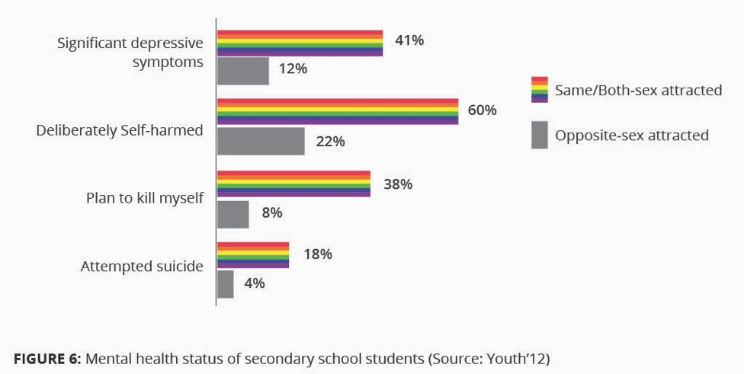
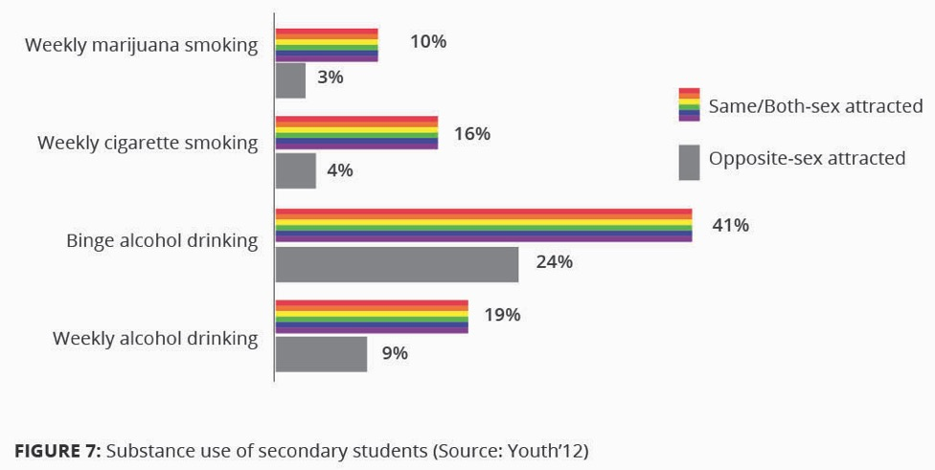

The poor health outcomes for SOGIESC-diverse people are linked to experiences of minority stress. Minority stress explains the ways in which stigma, prejudice, and discrimination create hostile and stressful social environments that causes mental health problems. The framework describes the relationship between social stressors and the health disparities seen in sexuality diverse communities compared with the heterosexual population, and has since been applied to transgender populations to illustrate the same concept. Participants at each of the Commission’s three public hui reiterated that minority stress and other mental health issues could be improved by appropriate and timely access to specifically trained professionals.
In general, existing mental health and addiction services fail to achieve equal outcomes for SOGIESC-diverse people. A 2018 study on queer and trans experiences of accessing mental health support in Aotearoa New Zealand showed that wait times for accessing mental health support were lengthy, with some people reporting they were only able to access help following a suicide attempt. The government’s 2018 Inquiry into Mental Health and Addiction, He Ara Oranga, acknowledged unmet mental health needs in SOGIESC-diverse communities. It outlined the communities’ experiences of inequality in mental health and addiction outcomes. Despite this, the Bill to establish a new Mental Health and Wellbeing Commission did not include mention of SOGIESC-diverse people as a group whose views must be sought in performing its function. Submissions recommending the inclusion of these groups were made during the Select Committee process, and the Bill is now awaiting a second reading.
At present, gaps in service delivery are filled by community organisations which are not funded to do this work. Peer-led support models provide protective factors but are not sustainable long-term without adequate resourcing. Responses by, and for, the community have the most buy-in and success, but tend to be the least resourced, operating on minimal funding and/or run by volunteers. He Ara Oranga confirmed that responses to strengthen protective factors for SOGIESC-diverse people are best led by them in a collaborative way with health services.

Medical interventions to alter sex characteristics
Accounts and testimonies from intersex people in Aotearoa New Zealand and overseas have described the key human rights issue impacting their lives. These include the practices of non-life preserving surgical and hormonal intervention at an age before a person can participate in decisions related to the management of their health; a pathologising approach to normalising diverse sex characteristics. Such practices violate the right to bodily autonomy, and associated rights to freedom from torture and ill-treatment. The surgical approach to genital normalisation became common in the 1970s and has been used to justify performing thousands of surgeries on people with variations of sex characteristics. Sex characteristics are not binary, but bimodal. Differences in the definitions of intersex have implications on which variations are counted, with only some variations visible at birth. When a new-born baby is visibly intersex, ‘genital normalisation’ surgeries often take place, including in present-day New Zealand. These procedures make intersex bodies conform to sex and gender stereotypes by altering internal and external organs to make them ‘consistent.’ These practices have lifelong physical and mental consequences and are rooted in the idea that women must be able to have vaginal intercourse and men must be able to stand to urinate. Section 204A(3)(a) of the Crimes Act makes such procedures legal in New Zealand.
Intersex people who have been subject to medical or surgical intervention often have difficulty accessing their complete health records, despite the legal requirement of retention of, and access to, these files. Because of the intention to minimise diversity and normalise sex characteristics, some people are told their diagnosis and full treatment history, while others are not. Surgical interventions on healthy tissue can result in sterilisation, scarring, pain, trauma, reduced function and sensation of sexual organs, and loss of fertility or potential fertility complications. International literature shows that delaying medical interventions until a person is old enough to participate in decision-making processes about their body has positive effects on psychosocial outcomes. Genital-normalising surgeries are usually performed when an intersex person is an infant; too young to be part of the decision-making process.
The intersex human rights movement seeks to end non-life preserving surgical interventions where they can be deferred until a person is old enough to decide for themselves. That is, either at the age of 16 years; or for a child younger than 16, when they have sufficient maturity and intelligence to understand the nature and implications of treatment. In its General Comment No. 20 on the rights of the child during adolescence, the UN Committee on the Rights of the Child stated that, “[t]he voluntary and informed consent of the adolescent should be obtained whether or not the consent of a parent or guardian is required for any medical treatment or procedure.” Therefore, consent of the parent for surgery cannot be considered as the consent of the child.
This is not an ‘anti-surgery’ position; medical procedures can be justified in cases of conditions that pose a health risk or are considered life-threatening, such as when an infant is unable to urinate. The World Health Organization (WHO) states that, “parents often consent to medical intervention for their children in circumstances where full information is lacking and without any discussion of alternatives.” WHO has documented the call for deferment of intersex genital surgeries until the individual is old enough to make decisions for themselves.
Intersex participants at the Commission’s hui noted that the historic harm done by health professionals to intersex people in New Zealand has not been acknowledged to date. Further, there is no medical reparation available, as a form of retrospective justice, for those who have been surgically or otherwise altered. The surgical practice of genital normalisation has been described as torture and condemned by the United Nations as a grave violation of the rights to bodily integrity, bodily autonomy, and privacy. New Zealand’s practices have also been identified as a failure to meet our obligations under the Convention on the Rights of the Child.
The Committee on the Elimination of Discrimination Against Women, during its 2018 review of New Zealand, expressed concern about “the conduct of medically unnecessary procedures on intersex infants and children before they reach an age at which they are able to provide their free, prior and informed consent.” It recommended New Zealand “adopt clear legislative provisions explicitly prohibiting the performance of unnecessary surgical or other medical treatment on intersex children before they reach the legal age of consent, provide the families of intersex children with adequate counselling and support and provide redress to intersex persons who have undergone such unnecessary surgical or medical treatment.” Also of note is that the Government accepted a recommendation from the 2019 Universal Periodic Review to consider putting an end to non-consensual medical procedures which affect intersex persons.
In 2017, a national, multidisciplinary Clinical Reference Group was established by the Ministry of Health for a fixed term of two years. Under its terms of reference, the group’s membership brings together lived experience intersex expertise with clinical, psychosocial, and human rights perspectives. The group’s mandate is to improve health practices, systems, and approaches for intersex children and youth up to 18 years of age. The development of this group came as a result of two intersex roundtables co-hosted by the Commission, the Intersex Trust of Aotearoa New Zealand (ITANZ), and Tīwhanawhana Trust in 2016 and 2017; and in response to the New Zealand government’s reporting to the Committee on the Rights of the Child in 2016. The group has a programme of work which includes undertaking a stocktake of current educational resources relevant for the health workforce, intersex children and young people, and their whānau; recommending tools to establish a national data set of clinical outcomes for intersex children and youth; developing a primary care referral pathway; and updating the Starship Hospital neonatal guideline about babies born with variations of sex characteristics; but has not addressed the practice of surgical normalisation in New Zealand.

Informed consent
Informed consent plays a fundamental role in respecting, protecting, and fulfilling the right to health. In the health setting, it means to grant permission in full knowledge of possible consequences, including the risks and benefits; and is the concept of being involved in decisions that affect a person’s life. In the case of people with diverse sex characteristics and gender identities, informed consent is relevant to rights regarding self-determination, bodily autonomy and integrity, and reproductive justice. Young people aged 16 or older are considered able to make decisions about their medical care. However, age is not a barrier to informed consent. Younger people are not prohibited from consenting to their own medical treatment if deemed competent to make an informed choice.

Gender-affirming healthcare
Throughout most of New Zealand, the provision of transgender healthcare is inconsistent. The government has admitted that delivery of health services for trans people has not kept up with the sharp increase in demand. National guidelines for the provision of gender affirming healthcare for children, youth, and adults in New Zealand were published in 2018. ‘Gender affirming healthcare’ covers a wide range of interventions including counselling support, laser hair removal, voice therapy, hormone therapy, and surgeries. Contrary to the right to health, there remain major gaps in the availability and accessibility of services; while some services fail to meet an acceptable standard. Trans health services are needed in all parts of the country, and hui participants emphasised that a person’s geographic residence should not impact on the services they can access. There are many delays and long waiting lists to access interventions, as well as demand for procedures which are not provided at all through the public system. At the time of the Commission’s 2008 Transgender Inquiry, some individuals reported travelling long distances to access appropriate health care or support services. Recent research shows this ‘postcode lottery’ – differential access based on geographic location – still remains today. Such inequities are well described in Chapter 2 of the Counting Ourselves community report.
The responsibility to provide gender affirming health care, including surgical procedures, lies within District Health Boards (DHBs). Unmet need, defined as those who want but have not had a type of care, was measured in the Counting Ourselves survey. The level of unmet need for non-medical (including laser hair removal, voice therapy, and counselling support) and medical (including hormone therapy and surgeries) care ranged between 19 – 48%.
In particular, trans and non-binary people face significant wait times for access to surgical interventions. For many years, surgical referral pathways within individual DHBs have been unclear and confusing to navigate. Attempts to improve pathways are underway to clarify processes for accessing trans health services. In the Northern Region (Northland and Auckland metro DHBs), Wellington, and Canterbury, trans people have been involved in the service design and delivery of local pathways. Lower or genital surgeries are managed nationally rather than regionally and are even more difficult to access. From 2005, these surgeries were funded through the Ministry of Health’s Special High Cost Treatment Pool, when three feminising and one masculinising procedures were agreed to be funded every two years. As of October 2018, the 3 + 1 maximum became a minimum service specification.
At the time of writing, more than 200 people were waiting on an active list for genital reconstruction surgeries. Numbers of referrals have been increasing sharply in recent years, yet this figure it is likely to still underestimate demand. The 2019 Wellbeing Budget allocated funding to undertake an estimated additional 12 – 14 genital reconstruction surgeries per year, on top of the current four every two years. This announcement was welcomed by transgender communities as a first step in the right direction. It is significant as delaying necessary treatment is not a neutral option and can lead to self-harm or suicide.

Transgender prisoners
The Department of Corrections is funded to provide primary healthcare to the same standard as a person would receive in the community. Despite this, the transgender prisoners who met with the Commission raised healthcare as a major human rights issue. They spoke of a lack of access to doctors and wait times between four to eight weeks to be seen for a general health issue. There was no oversight or monitoring of their hormone therapy by health professionals, and one person discussed a disruption in medication for about two months when admitted to the facility. Hormone therapy is a medically necessary intervention for many trans individuals, and withdrawal of hormone treatment can be associated with harmful side effects on physical and mental health.
The Commission met with prisoners three weeks after the Department of Corrections implemented a new policy on the management of transgender prisoners. This policy was rolled out to improve the care, management, and safety of trans people in prison, whether they are in a facility which aligns with their gender identity or not. Any individual deprived of liberty must have access to health services which are culturally appropriate and acceptable.
The Transgender Prisoner policy was due to be reviewed within four months of implementation. 29 trans prisoners took part in this process, and a number of the review’s findings match the testimonies the Commission heard while visiting trans prisoners. This included facial hair removal as one of the most pressing and distressing issues impacting trans prisoners; as well as Corrections officers deliberately addressing prisoners by their incorrect birth names, including those who had legally changed their names. 14% of prisoners in the review felt an ad hoc approach was taken with their healthcare, with changes made to their hormone treatment regime. Only 53% of staff nationally had completed the training four months after the policy had been implemented. The review recommended making amendments to the policy, updating the staff training package, and following up on matters raised by prisoners who require additional health support.
Recommendations:
Urgently implement measures to address current disparities experienced by the SOGIESC communities in accessing services throughout the health sector;
Develop practice standards to improve access to health and peer-led service delivery for marginalised SOGIESC-diverse communities, particularly Māori, Pacific peoples, people with disabilities, trans people in detention, and older people;
Provide guidance, training, and resources for all workers in the aged care sector on diversity in sexual orientation, gender identity and expression, and sex characteristics;
Require District Health Boards to ensure trans and non-binary people's access to gender affirming health services available in New Zealand, over their lifespan, based on an informed consent model of healthcare, aligned with evidence-based international standards;
Support the development of guidelines, training and resources for health professionals on an informed consent model of healthcare for trans and non-binary people and provide information and resources for individuals, families and communities about accessing gender affirming services;
End the practice of medical interventions on people with variations of sex characteristics which can be deferred to a later age;
Create clear pathways to access publicly funded reparative surgery and support for people with variations of sex characteristics through each District Health Board.

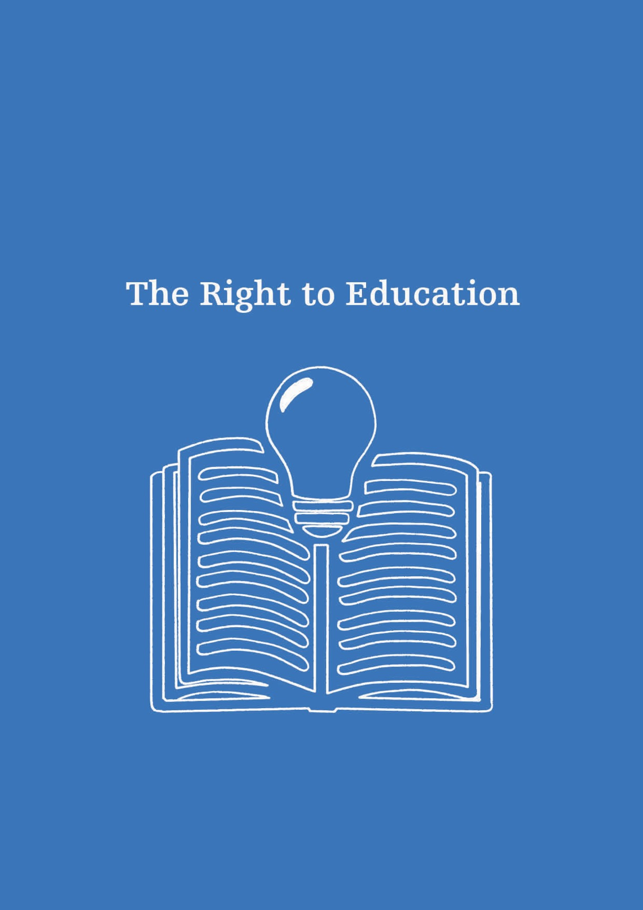

The Right to Education
Article 26
Universal Declaration of Human Rights
(1) Everyone has the right to education. Education shall be free, at least in the elementary and fundamental stages. Elementary education shall be compulsory. Technical and professional education shall be made generally available and higher education shall be equally accessible to all on the basis of merit.
Essential for the development of human potential, education enables the full enjoyment of human rights as well as respect for the rights of others. Education is a primary tool to alleviate poverty and enable full participation in communities. The right to education includes free and compulsory primary education, availability of different forms of secondary education, and access to higher education. It must be accessible to all on an equal basis. It is this equal basis that is not safeguarded for children and youth with a diverse sexual orientation, gender identity and expression, and sex characteristics in New Zealand. While they are able to attend school, hui participants stated that many SOGIESC-diverse youth do not feel safe there and do not see themselves reflected in the curriculum.
Schools have an obligation to provide a safe environment where all students can participate and receive equal access to education. An environment which is unsupportive of students with a diverse sexual orientation, gender identity and expression, or sex characteristics may be in breach of health and safety legislation and the Human Rights Act. Implementing and promoting anti-discrimination policies can provide protection for students and schools, promoting personal respect and physical and emotional safety. The right to education is also about creating high-quality teaching and learning environments where there is freedom from violence, bullying, and harassment; where individuality and diversity are respected; and where all those involved are able to participate fully.
Just over one in 10 of the students in Youth’12 said they had a diverse sexual orientation and/or gender identity, or were questioning their gender and sexual identity. The data showed that the majority of these youth were thriving, with most reporting on a scale that school was ‘OK’ or better. Trans students were more likely to volunteer than non-trans students (48% compared with 35%), while same/both sex attracted youth were more likely to volunteer than opposite sex attracted youth (34% compared with 27%). These positive results indicate that student wellbeing goes beyond academic achievement.

Bullying
New Zealand students experience higher rates of bullying than most other developed countries. However, SOGIESC-diverse young people experience even higher rates of bullying at school, with an associated impact on their mental health and educational outcomes. As the Youth’12 survey has shown, and Counting Ourselves has confirmed, students with diverse sexual orientations and gender identities are three times more likely to experience bullying than the general population (Figure 8).
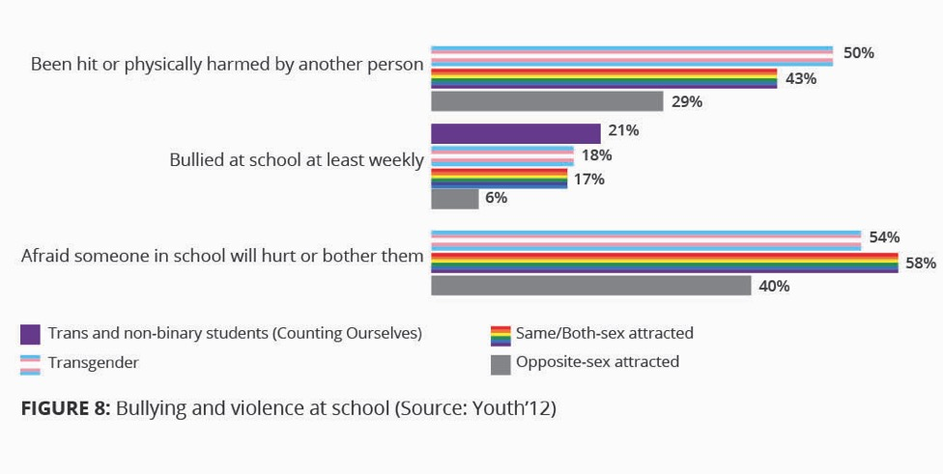
Unique forms of discrimination for SOGIESC-diverse communities can include outing or threatening to out a person, or questioning if someone is a “real” girl or boy. Homophobic, biphobic, and transphobic abuse at school has a lasting impact on students with diverse sexual orientations and gender identities, both during schooling years and beyond.
A 2018 Pricewaterhouse Coopers economic impact analysis conservatively estimated the cost of bullying in Australian schools at AU$525 million for each individual school year group. These costs are related to the impacts of decreased productivity, chronic mental and physical health issues, and impacts on family and the community from continued bullying that can extend to violence. The study did not disaggregate students who had a diverse sexual orientation, gender identity and expression, or sex characteristics, but notes that they experience higher rates of bullying. In some cases, this bullying might even lead young people to drop out of school altogether. This has implications on their career choices and earning potential.

Safety at school
World-first research in New Zealand has shown that fostering belonging in the school environment improves the achievements of students with a diverse sexual orientation and gender identity. All school staff, including the principal, teachers, administrators, and coaches, have a responsibility to foster belonging for all students, including those with a diverse SOGIESC. While some schools have made laudable inroads in creating inclusive spaces, many do not offer such an environment. Remaining barriers include school uniforms, gender segregation, gendered bathrooms, and recognition of students’ identities, as well as inadequate policies and procedures around bullying, discrimination, and language use. Many schools have gendered uniforms which may make life more difficult for trans students and limit their ability to socially transition. Gendered bathrooms were identified as an issue of concern for trans youth by hui participants. These issues become heightened for trans students attending a single-sex school.
The ability to easily amend the sex marker on a birth certificate through an administrative process would be significant for transgender children and young people, as they are required to show a birth certificate when enrolling in a school. The Ministry of Education uses the name and sex from a birth certificate to record a student in the Ministry’s and school’s systems. While the Ministry’s system only offers binary gender options, they are able to update a trans student’s name and gender without requiring a new birth certificate, and are able to support schools to do the same. A trans student’s preferred name should be used at all times, including on academic records and in formal communication, regardless of whether the student has changed the name on their birth certificate. The safety, sense of being, and privacy of trans students is paramount, and only the school principal, school counsellor, and a trans student’s teachers should be aware of a trans student’s gender identity. It is not appropriate for a school to disclose a trans student’s gender identity to other students and their families, except with the trans student’s permission.
Safety was a theme found in the youth who completed the Office of the Children’s Commissioner’s What Makes A Good Life survey in 2019. Of the 5,631 children and young people who completed the online survey, 10% (540) identified as having a diverse SOGIESC. This group were more likely than the overall group to mention safety and the need for safe spaces to explore identity. They raised issues of correct pronoun usage, access to gender-neutral toilets, and educating the public about SOGIESC issues. This group also frequently mentioned online bullying, discrimination, and exclusion. They spoke about others making assumptions about them because of their sexuality, and some said they were excluded by binary pronouns.

Ongoing professional development for teachers
Teachers and coaches are often not trained in regard to students with diversity in SOGIESC and can unintentionally cause harm. Recent analysis of the Youth’12 survey data recommended three areas to focus on to increase academic success among students with a diverse sexual orientation and gender identity: strong professional development for teachers, enabling those teachers to incorporate SOGIESC topics into lessons, and ensuring that policy environments are safe for all students (extending to school ball partners, uniforms, and anti-discrimination policies). Research suggests that sporting and physical education contexts can be some of the most unsafe environments for SOGIESC-diverse young people. This is related to the highly gendered and binary organisation of some sports, and the overt homophobia, biphobia, and transphobia pervasive in these spaces.
In addition, there is a lack of relevant support groups and safe spaces within schools. Qualitative research on gay and bisexual Pasifika men’s experiences of school-based support services showed that participants wanted staff to do more to support them, such as undergo professional development in SOGIESC diversity, as well as cultural competency training for working with Pasifika students. All participants described the need for increased visibility and safe spaces in their school environments. In a recent report from the Education Review Office, some school boards stated that they “didn’t have any” students with diverse sexual orientations, gender identities and expressions, or sex characteristics, despite extensive national and international research to the contrary. Such statements are usually used as an excuse to refrain from protecting students of diverse identities and to exclude content relevant to them. Where schools do have active support groups for SOGIESC-diverse students, research suggests that these can be both safe and empowering. In some schools, these groups engage in educating other students and teachers about SOGIESC diversity and inclusion.

The New Zealand Curriculum
The Ministry of Education’s 2007 New Zealand Curriculum places emphasis on values, including diversity; requiring that students learn to respect themselves, others, and human rights. In 2015, the Ministry of Education published the Te Kete Ipurangi Guidelines, providing examples of good practice age-appropriate content that should be taught at each level of the school curriculum, from Year 1 to Year 13. The aim of the guidelines is to support the inclusion and wellbeing of students with diverse sexual orientations, gender identities and expressions, and sex characteristics. The same year, the Ministry published a guide for principals, Boards of Trustees, and teachers regarding sexuality education. That guide outlines how schools should go about teaching sexuality in all school levels in an age-appropriate manner and what content should be addressed at each year level. It also gives specific guidance about inclusive environments, school policies, events, and the importance of access to health services. However, many schools do not know about these two guideline documents, and barriers such as teacher knowledge; commitment from school leaders; inadequate professional development opportunities; and challenges to teaching the material, whether real or perceived, result in further varied educational practice across New Zealand schools.
Interpretations of a school’s curriculum as ‘crowded’ also pose a potential barrier to the delivery of comprehensive sexuality and health education. Currently, it is at the discretion of each school how they teach health education, including sexuality and mental health education. Under the Education Act 1989, a school’s Board of Trustees must consult with their community about what is taught in health education programmes, including sexuality education, every two years. During this community consultation, parents may ask the principal to ensure their child is excluded from the sexuality education parts of the health education curriculum. Most schools have their own values which can impact on the information taught and the way in which it is delivered to students. This results in a wide range of education being provided to youth in schools; from teaching no sexuality education to abstinence-based sexuality education, right up to comprehensive education regarding consent, safety, and pleasure.
“sexual education IS all super straight and not queer, trans, or intersex friendly. It’s ‘condom on a banana,’ showing people videos from the 1980s, or graphic photographs of genitalia with sexually transmitted infections.”
The Education Review Office’s 2018 report concluded that only 22% of primary and secondary schools visited offered good and comprehensive sexuality education. Another 50% complied at a basic level with aspects of the curriculum but were not comprehensive (Figure 9). The schools in the compliant category had visible gaps in their curriculum. For example, only around 30% of primary schools taught about gender and sexuality diversity, rising to around 70% for secondary schools. The schools deemed as unsatisfactory had significant gaps in their curriculum regarding sexual education.

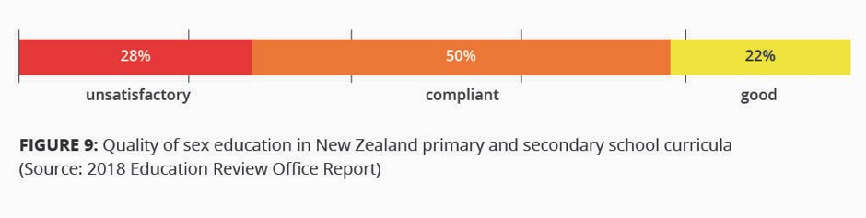
Counting Ourselves showed high rates of disability among participants. The implications of this are significant given that a substantial body of research shows that disabled people struggle to, or do not have access to, education.
In addition to the provision of sexuality education in New Zealand schools, young people need access to mental health education. This includes learning about drugs and alcohol, identity, interpersonal skills, resilience, and wellbeing. A new resource draws on international research to argue that mental health education should address both personal skills and knowledge (such as mindfulness and positive psychology), as well as social contexts (including discrimination, equity, and injustice). Teachers and schools require support, resources, and professional development in order to implement meaningful programmes.
Health services in schools, such as nurses, school counsellors, and access to doctors, increase the likelihood of students accessing care in relation to sexual health and mental health. Every school should have free, on-site, confidential health services.
The New Zealand government has received recent recommendations from the UN Committee on the Elimination of Discrimination Against Women to “ensure the inclusion in school curricula of mandatory, culturally sensitive and age-appropriate education on sexual and reproductive health and rights and responsible sexual behaviour, focusing on the prevention and the consequences of early pregnancy and sexually transmitted infections.” Improved sexual-health education and provision in schools could reduce stigma against students with a diverse SOGIESC. A priority area for further action is ensuring that all children and young people have access to high-quality comprehensive sexuality education. This education should address identity-based discrimination and incorporate a universal approach to sexual and reproductive rights.
Recommendations:
Implement anti-discrimination policies and guidelines for teachers and coaches in all schools that explicitly name sexual orientation, gender identity and expression, and sex characteristics;
Legislate that schools must update names and gender markers on student records by request, before a legal name change;
Provide further guidance from the Ministry of Education to support schools to be inclusive of trans and non-binary students, including by reiterating that school records and databases should reflect a student’s chosen name and gender and this does not require changes to name or sex on a birth certificate;
Provide dedicated, ongoing support and professional learning development to teachers and schools regarding SOGIESC diversity;
Standardise health education in the timetable at least two times per week or cycle;
Include sexuality education (12-15 lessons per year minimum); and mental health education, including learning about drugs and alcohol, identity, wellbeing, interpersonal skills, social and political contexts; and access to health care; in health education content;
Ensure all students have access to free and confidential health services at school.

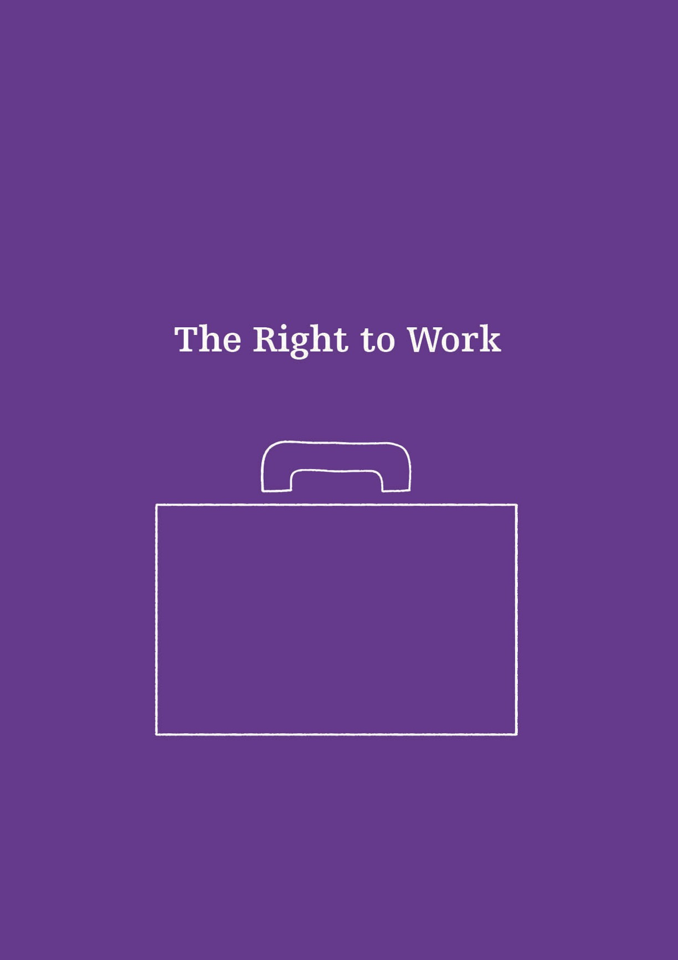

The Right to Work

The right to work is essential for accessing other human rights and is inherent to a dignified life. It encompasses the right to be treated fairly at every point of the employment process, whether it is getting a job, fair pay, or promotion pathways. The right to work is set out in the Universal Declaration of Human Rights and the International Covenant on Economic, Social and Cultural Rights. Employment allows people the opportunity to earn a living and participate in society. At a minimum, the benefits gained from work should be enough to provide an adequate standard of living.
Article 23
Universal Declaration of Human Rights
(1) Everyone has the right to work, to free choice of employment, to just and favourable conditions of work and to protection against unemployment.
(2) Everyone, without any discrimination, has the right to equal pay for equal work.
(3) Everyone who works has the right to just and favourable remuneration ensuring for himself and his family an existence worthy of human dignity, and supplemented, if necessary, by other means of social protection.
(4) Everyone has the right to form and to join trade unions for the protection of his interests.
A 2015 International Labour Organization (ILO) report on discrimination at work on the basis of sexual orientation and gender identity found that lesbian, gay, bisexual, and transgender workers face more discrimination throughout the employment cycle compared to the general population. This begins in education and continues through to job application, interview, job offer, and commencement of employment. A lack of employment rights and equal opportunities for advancement in a career negatively affects family life, including children’s lives.

Employment rates
In New Zealand, no data on employed or unemployed people with diverse sexual orientations, gender identities and expressions, or sex characteristics is available from the Ministry of Business, Innovation, and Employment. The unemployment rate of trans and non-binary participants in Counting Ourselves was more than twice the general population: 11% versus 5%.

Wage discrimination
Seminal work from Lee Badgett in the 1990s was the first to show a relationship between wage discrimination and sexual orientation. ILO’s Director-General has indicated that of all workers, trans people fare the worst in employment and struggle to maintain a livelihood. Data from Counting Ourselves showed the annual median income for trans and non-binary people is $15,001 - $20,000, compared with a median income of $35,001 – $40,000 for the general population. The relationship between income and poverty is evident in the stark material hardship experienced by trans and non-binary people, with 51% of participants having gone without fresh fruit and vegetables compared to 18% of the general population; and 64% reporting putting up with feeling cold, compared to 20% of the general population, to reduce costs.

Pre-employment and employment discrimination
The Commission has produced pre-employment guidelines for employers and employees to ensure equality and fairness for all job applicants. ‘Pre-employment’ includes job advertising, job applications and interviews, and job selection processes. The Commission receives a high number of complaints from SOGIESC-diverse people related to pre-employment and employment discrimination. As shown in Table 1, employment is the most common area of discrimination under the ground of sexual orientation. Employment was also the most frequently mentioned form of discrimination in submissions from transgender people to the Transgender Inquiry.
The Organisation for Economic Co-operation and Development (OECD) has produced two recent papers which describe this discrimination. They confirm with survey-based and experimental evidence that people with diverse sexual orientations and gender identities face barriers in the labour market. This includes being less likely to get an interview than their heterosexual counterparts; and experiencing gaps in employment status, remuneration, and access to career progression.
The New Zealand Council of Trade Unions’ network, Out@Work, represents union members who have a diverse SOGIESC. Out@Work report that organisations seem to be struggling to support their SOGIESC-diverse workers. Discrimination related to a person’s diverse sexual orientation, gender identity and expression, and sex characteristics often goes unreported for a number of reasons, including that the recipient would have to out themselves to make a complaint. Instead, they just leave the job. Remarks, insults, jokes, and exclusion can make workplace environments difficult for SOGIESC-diverse employees. Whether deliberate or unintentional, such behaviours foster an environment that can make people feel unsafe and can deter them from to disclosing their sexual orientation, gender identity and expression, or sex characteristics.

Concealing SOGIESC in the workplace
The high risk of experiencing discrimination leads many people to conceal their diverse sexual orientations, gender identities and expressions, or sex characteristics in the workplace. This can have an adverse effect on their productivity and mental health. In 2019, the State Services Commission conducted an anonymous online survey, WeCount, to measure gender identity and sexual orientation and aspects of inclusion in the Public Service. The report of the survey described participants’ comfort at work, with a clear trend showing greater levels of comfort being out highest among respondents who were gay/lesbian, followed by bisexual, transgender, and then intersex, participants. Research by the ILO indicates many workers hide their SOGIESC due to fear of hostility and rejection. This research shows that there is a direct correlation between this secrecy and workers’ stress, anxiety, and loss of productivity. 44% of WeCount respondents agreed, or strongly, agreed that they avoid collaborating or interacting with workmates who they know or feel have views opposed to SOGIESC-diverse people and communities. More than 20% of the survey respondents felt uncomfortable bringing their whole selves to work. Their qualitative responses indicated fearing harm to their career aspirations if they were to be open about their SOGISC.

Issues for trans employees
While people with diverse sexual orientations experience issues in the workplace, those with diverse gender identities often experience unique and greater barriers. Trans people can be especially vulnerable to pre-employment discrimination if any required documentation, including references, transcripts, or work history discloses their transgender status. Out@Work reports that employees who are trans and/or transitioning face the biggest issues in the workplace, with indications that they are subject to the most severe forms of workplace discrimination. This can include the inability to obtain identity documents, the reluctance of employers to accept their new sex/gender, and increased vulnerability to bullying by their colleagues. 74% of participants in Counting Ourselves reported concealing their trans or non-binary status in the workplace due to fear of discrimination.
Due to high rates of discrimination, many trans people can be frozen out of formal economies and take on precarious or self-directed work in the informal labour market. Some trans people have few employment options other than sex work. This is reinforced by anecdotal evidence that while most sex workers do not stay in the industry long-term, most trans sex workers do. 19% of Counting Ourselves participants aged 18 or over had engaged in sex work or worked in the sex industry.

New Zealand inclusion initiatives
Promoting diversity makes business sense. In New Zealand, there have been recent attempts in the area of employment to accommodate diverse sexual orientations and gender identities. In 2011, the then-Department of Labour published a resource for people transitioning at work. At the time there was little awareness of non-binary transgender people, and as a result their issues were not addressed in the resource. Employment New Zealand has developed guidance for employers on how to accommodate the needs of transgender people who are undergoing a gender transition. A 2015 voluntary standard designed by Standards New Zealand established general principles for demonstrating that an organisation can be accredited as an inclusive and safe workplace for people of diverse sexual orientations and gender identities. A common place for businesses and corporates to be measured against the standard is the organisation Rainbow Tick. The Rainbow Tick is given to organisations that have successfully completed a baseline certification ascertaining whether their workplace understands and welcomes sexual and gender diversity. While it is common practice for any standard designed in either the private or public sector to be refreshed regularly to ensure it remains consistent and relevant, it has not been updated since it was created in 2015.
All people should be able to bring their whole self to work and not have to hide parts of who they are.
The New Zealand Workplace Equality Study was published by Rainbow Tick in 2019. The survey measured employees’ experiences of their organisation’s SOGIESC inclusion initiatives within their own Rainbow Tick-accredited organisations. The 18% of survey respondents who had a diverse SOGIESC viewed their workplaces as far less inclusive than the 82% who were heterosexual and cisgender. This shows the need for policies to be designed, implemented, and monitored by the people affected by them; a fundamental human rights principle often described as, “Nothing about us, without us.”
Valuing diversity and inclusion enhances a company’s reputation as a good employer, attracts a larger pool of qualified candidates, reduces the risk of discrimination and harassment, and drives innovation. Such initiatives communicate clearly to the general public the principles and values of an organisation. Excluding a group of people based on their actual or perceived SOGIESC costs employers with regards to recruitment, retention, and job performance.

Proactive improvements
Improving workplace conditions for SOGIESC-diverse employees requires change at two levels: individual and institutional. As with schools and education centres, the biggest positive impact will come from developing, implementing, and monitoring anti-discrimination policies. In line with international human rights law, including the United Nations Guiding Principles on Business and Human Rights, the UN has developed Standards of Conduct for businesses to tackle discrimination against people with a diverse SOGIESC.
They recommend recognising the need for a nuanced and diverse approach based on the diversity of SOGIESC, including references to non-discrimination in job advertisements, developing an effective diversity and inclusion policy stating specific desired outcomes, and establishing a framework for determining whether these outcomes have been met. They specifically recommend addressing the rights of transgender and intersex people, noting that companies tend to lag behind for these groups. This may include adopting pro-active policies for transgender inclusion; recognising the self-determined gender of staff, customers, and stakeholders regardless of their official identity documents; supporting the employee to use the bathroom and changing room facilities of their choice; and adopting the appropriate dress code. Protecting the rights of trans staff can be further enhanced through amending employee names, gender, and title records, and providing workplace training to managers and colleagues.

Recommendations:
Update the 2015 New Zealand standard, Rainbow-inclusive workplaces: A standard for gender and sexual diversity in employment (NZS8200:2015), through consultation with a wide range of people with diverse SOGIESC. Ensure their representation on the Committee reviewing this standard;
Develop, implement, and monitor anti-discrimination workplace policies through community consultation which are inclusive of all people with a diverse sexual orientation, gender identity and expression, and sex characteristics;
Recognise the self-determined gender of staff, customers, and stakeholders irrespective of official identity documents, in line with UN standards;
Support staff, customers, and stakeholders to use the bathroom and uniform of their choice in the workplace;
Provide ongoing workplace training related to diversity in sexual orientation, gender identity and expression, and sex characteristics.

Conclusion
Current to the end of 2019, this paper has provided an overview of six human rights issues relating to people with diverse SOGIESC in Aotearoa New Zealand. While an original contribution, Prism does not aim to be exhaustive. This report is intended to assist understanding and dialogue in the areas where progress is most pertinent for people with a diverse SOGIESC. Achieving social acceptance and equality requires a broad range of actors, and this work must be prioritised and resourced by government, businesses, and organisations, including the Human Rights Commission.
Human rights are not only concerned with individuals, but also with the collective. When discrimination is diminished, everyone benefits. Wellbeing increases with a sense of belonging. SOGIESC-diverse people already have the solutions to advance their human rights; the importance of being guided by local stakeholders must not be underestimated or overlooked. Lessons can be learned by incorporating indigenous thinking and systems of knowledge from the outset, for example through whakawhanaungatanga and the building of relationships. The views traditionally missing from the discussion must be actively sought and resourced in order to represent the full diversity of SOGIESC diverse people in Aotearoa New Zealand.
The Commission welcomes action on Prism’s recommendations. Improved services, resources, and access is what SOGIESC-diverse people say they need. Treating everyone the same is not the solution, because people are not the same. Systemic change requires systemic intervention to advance the human rights of SOGIESC-diverse people. A free, safe, and just New Zealand values diversity by uplifting, empowering, and respecting a dignified life for all. Human rights alone cannot reduce inequalities in discrimination, data, legal gender recognition, health, education, and employment; but they have a vital role. Prism reflects light on a path towards the realisation of human rights for those with a diverse sexual orientation, gender identity and expression, and sex characteristics.

Glossary of terms

Asexual – A person who does not experience sexual attraction to others.
Bisexual – A person who experiences romantic and/or sexual attraction to their own and other genders.
Cisgender – A person whose gender aligns with their sex assigned at birth.
Gay – A person who experiences romantic and/or sexual attraction to people of the same gender. More commonly used in relation to males.
Gender diverse – An umbrella term used by some who identify outside of the male/female gender binary. Being transgender can be one way of being gender diverse, but not all gender diverse people identify as transgender and vice versa.
Gender expression – refers to a person’s presentation of gender through physical appearance – including dress, hairstyles, accessories, cosmetics – and mannerisms, speech, behavioural patterns, names and personal references. Gender expression may or may not conform to a person’s gender identity.
Gender identity – refers to each person’s deeply felt internal and individual experience of gender, which may or may not correspond with the sex assigned at birth, including the personal sense of the body (which may involve, if freely chosen, modification of bodily appearance or function by medical, surgical or other means) and other expressions of gender, including dress, speech and mannerisms.
Heterosexual – A person who experiences romantic attraction and/or sexual attraction to people of a different gender.
Homosexual – A person who experiences romantic attraction and/or sexual attraction to people of the same gender.
Intersex – A person whose sex characteristics are more diverse than typical definitions for male or female bodies, including sexual anatomy, reproductive organs, hormonal patterns, and/or chromosome patterns.
Lesbian – A woman who experiences romantic attraction and/or sexual attraction to other women.
LGBTQIA+ – An acronym of different identities within Rainbow communities, including Lesbian, Gay, Bisexual, Transgender, Queer, Intersex, and Asexual. The plus denotes inclusion of other terms not listed.
Non-binary – An umbrella term for gender identities which are neither male nor female.
Pacific communities have their own culturally specific terms relating to sexual orientation and gender identities. These concepts are more or just as much about familial, genealogical, social, and cultural selfhood.
Fa’afafine (Samoa & American Samoa), Leiti/ Fakaleiti (Tonga), Fakafifine (Niue), Akava’ine (Cook Islands), Pina (Tuvalu), Māhū (Taihiti and Hawaii), Vakasalewalewa (Fiji) and Palopa (Papua New Guinea).

Pansexual – A person who experiences romantic and/or sexual attraction to people regardless of their sex or gender.
Queer – A reclaimed umbrella term that encompases identities and expressions outside of heterosexual, monogamous, and normative gender expressions.
Rainbow communities – An umbrella term commonly used in Aotearoa to describe those who have a diverse sexual orientation, gender identity or expression, and sex characteristics.
Sex assigned at birth – All babies are assigned a sex at birth, usually determined by a visual observation of external genitalia. A person’s gender may or may not align with their sex assigned at birth.
Sex characteristics – refer to each person’s physical features relating to sex, including genitalia and other sexual and reproductive anatomy, chromosomes, hormones, and secondary physical features emerging from puberty.
Sexual orientation – refers to each person’s capacity for profound emotional, affectional and sexual attraction to, and intimate and sexual relations with, individuals of a different gender or the same gender, or more than one gender.
SOGIESC – An acronym including sexual orientation, gender expression and identity, and sex characteristics.
Takatāpui – A traditional Māori term which means ‘intimate companion of the same sex.’ It has been reclaimed by some Māori to describe their diverse sexual orientation, gender identity or expression, and sex characteristics.
Tangata ira tāne – A te reo Māori term which roughly translates as trans man.
Transgender – An umbrella term for a person whose gender differs from their sex assigned at birth. Transgender people may be binary or non-binary, and some opt for some form of medical intervention (such as hormone therapy or surgery). Used as an adjective rather than a noun, and often shortened to ‘trans.’
Transition – Steps taken by trans people to live in their gender which may include social, legal, or medical aspects. A social transition may include changing clothes, hair, pronouns, or name; a legal transition may include changing name and/or gender marker on legal documents; and a medical transition may include medical treatments such laser hair removal, hormone therapy, or various surgeries. There are no wrong or right ways to transition; each person will have their own personal goals.
Trans man – A man who was assigned female at birth.
Trans woman – A woman who was assigned male at birth.
Transsexual – An older term considered to be outdated by some younger populations. Transsexual is not an umbrella term; those who prefer this term often see it as an important distinction from transgender. It may refer to a person who has had or is in the process of changing their body to affirm their gender.
Whakawahine – There is no direct English translation, but roughly translates as trans woman. More literally, it translates as being or becoming, in the manner or spirit of a woman.

New Zealand and Aotearoa New Zealand are used interchangeably throughout this report.
Sexual orientation, gender identity and expression, and sex characteristics, and the terms used to describe them, are based on cultural, historical, linguistic, religious, class, ethnic, and intergenerational differences as language evolves over time.
Aotearoa New Zealand has a large Pasifika population. These cultures have their own terms and cultural frameworks which do not directly translate into the English language or Western concepts of gender. The acronym MVPFAFF was coined by Phylesha Brown-Acton in 2011 at the 2nd AsiaPacific Outgames. It stands for māhū (Tahiti and Hawai'i), vakasalewalewa (Fiji), palopa (Papua New Guinea), fa'afafine (Samoa and American Samoa), akava'ine (Cook Islands), fakaleiti or leiti (Kingdom of Tonga), and fakafefine (Niue).
Terminology has evolved quickly in this area. As words can be contested between groups and individuals, there is no single correct way describe such diversity. To some people, the terms Rainbow and LGBTIQ+ do not convey the full spectrum of identities. Reflective of the language used within the United Nations system, the New Zealand Human Rights Commission uses SOGIESC as an umbrella term because all people have a sexual orientation, gender identity and expression, and sex characteristics.
These five hui were held between 13 February and 18 April 2018. Public meetings took place in Auckland, Wellington, and Christchurch. Two further consultations were by invitation: one was held in prison with transgender prisoners and the other was specifically for disabled SOGIESC-diverse people.
Takatāpui is a traditional term reclaimed by some Māori to embrace both their culture and spirituality, as well as their diverse sexual orientations, gender identities and expressions, and sex characteristics.
For definitions of sexual orientation and gender identity, see The Yogyakarta Principles: Principles on the application of international human rights law in relation to sexual orientation and gender identity (Geneva, 2007) at 6. For definitions of gender expression and sex characteristics, see The Yogyakarta Principles plus ten: Additional principles and state obligations on the the application of international human rights law in relation to sexual orientation, gender identity, gender expression and sex characteristics to complement the Yogyakarta Principles (Geneva, 2017) at 6.
Leonie Pihama “Challenging homophobia is a collective responsibility” (12 May 2017) <leoniepihama.wordpress.com>; Clive Aspin “Hōkakatanga – Māori sexualities” (22 January 2019) Te Ara - the Encyclopedia of New Zealand <http://www.teara.govt.nz/>.
Niko Besnier and Kalissa Alexeyeff (eds) Gender on the edge: Transgender, gay, and other Pacific Islanders (University of Hawaiʻi Press, Hawai’i, 2014).
Melody Thomas “BANG! Season 2 Episode 6: Takatāpui” (podcast, 2 June 2018) Radio New Zealand <https://www.rnz.co.nz/>.
The Spinoff “Pre-colonial attitudes to sex and gender fluidity | On the Rag: Sex positivity” (video, 22 October 2019); Kassie Hartendorp “What do we really know about gender diversity in te ao Māori?” (23 October 2019) The Spinoff <www.thespinoff.co.nz>.
Elizabeth Kerekere Takatāpui: Part of the whānau (Tīwhanawhana Trust and Mental Health Foundation, Auckland, 2015).
Elizabeth Kerekere “Part of the Whānau: The Emergence of Takatāpui Identity – He Whāriki Takatāpui” (PhD Thesis, Victoria University of Wellington, 2017).
Ibid.
Ibid.
United Nations Declaration on the Rights of Indigenous Peoples GA Res 61/295 (2007).
Ibid, Art 1.
Expert Mechanism on the Rights of Indigenous Peoples Free, prior and informed consent: a human rights-based approach – Study of the Expert Mechanism on the Rights of Indigenous Peoples UN Doc A/HRC/39/62 (10 August 2018) at [20(c)].
The Yogyakarta Principles: Principles on the application of international human rights law in relation to sexual orientation and gender identity (Geneva, 2007).
Gwyneth Williams Jurisprudential annotations to the Yogyakarta Principles (University of Nottingham Human Rights Law Centre, 2007).
The Yogyakarta Principles plus ten: Additional principles and state obligations on the the application of international human rights law in relation to sexual orientation, gender identity, gender expression and sex characteristics to complement the Yogyakarta Principles (Geneva, 2017).
Resolution adopted by the Human Rights Council on 30 June 2016: Protection against violence and discrimination based on sexual orientation and gender identity GA Res 32/2 (2016). Focusing on violence and discrimination based on sexual orientation and gender identity, the mandate excludes sex characteristics from its scope. This decision was the result of mixed views amongst intersex people and communities; some intersex people felt that inclusion in the mandate may be detrimental to intersex human rights movements, contributing to erasure of intersex issues and conflation with LGBT issues. The Independent Experts, Professor Vitit Muntarbhorn and Victor Madrigal-Borloz, have remained faithful to the mandate but have been very open to listening to the views of intersex communities. They have included references to sex characteristics in thematic reports where there was a clear intersection with SOGI. (C. de Preux de Baets, personal communication to T. Polkinghorne, August 28, 2019).
The mandate of the Independent Expert has two functions: to raise awareness of the violence and discrimination faced by people on the basis of their sexual orientation and gender identity (SOGI), and to advise States on ways they can implement measures to reduce that violence and discrimination. All mandates are established for a period of three years and then given opportunity to be renewed.
International Service for Human Rights “LGBTI rights: Defending the United Nations Independent Expert on Sexual Orientation and Gender Identity” (press release, 27 October 2017).
OutRight Action International and others Defending the Independent Expert on protection against violence and discrimination based on sexual orientation and gender identity at the 71st Session of the United Nations General Assembly (2017).
International Lesbian, Gay, Bisexual, Trans and Intersex Association “UN renews crucial mandate for protection against violence and discrimination based on sexual orientation and gender identity” (press release, 12 July 2019). The resolution was adopted by a vote of 27 countries in favour, 12 against, and 7 abstaining; see Resolution adopted by the Human Rights Council on 12 July 2019: Mandate of the Independent Expert on protection against violence and discrimination based on sexual orientation and gender identity GA Res 41/18 (2019). This margin of success was even larger than the result three years earlier in 2016, when the original resolution was adopted by a vote of 23 countries in favour, 18 against, and 6 abstentions; see Resolution adopted by the Human Rights Council on 30 June 2016: Protection against violence and discrimination based on sexual orientation and gender identity GA Res 32/2 (2016).
International Lesbian, Gay, Bisexual, Trans and Intersex Association, International Service for Human Rights and ARC International Renewal of the Mandate of the Independent Expert on protection against violence and discrimination based on sexual orientation and gender identity: Compilation of the Adoption of the 2019 SOGI Resolution 41/18 (2019) at Annex 1.
These are 1) 2008 Report of the Inquiry into Discrimination Experienced by Transgender People; 2) 2010 chapter on the Rights of Sexual and Gender Minorities, as part of the Commission’s 2010 review of human rights in New Zealand; 3) 2016 Intersex Roundtable Report: The practice of genital normalisation on intersex children in Aotearoa New Zealand; and 4) 2017 Intersex Roundtable Report: Ending the practice of genital normalisation on intersex children in Aotearoa New Zealand.
Victor Madrigal-Borloz Report to the Human Rights Council by the Independent Expert on protection against violence and discrimination based on sexual orientation and gender identity UN Doc A/HRC/38/43 (11 May 2018) at [57].
Victor Madrigal-Borloz Report to the Human Rights Council by the Independent Expert on protection against violence and discrimination based on sexual orientation and gender identity UN Doc A/HRC/38/43 (11 May 2018) at [58].
Asia Pacific Forum and the United Nations Development Programme Promoting and Protecting Human Rights in relation to Sexual Orientation, Gender Identity and Sex Characteristics: A Manual for National Human Rights Institutions (Sydney, Australia, 2016) at 130.
Victor Madrigal-Borloz Report to the General Assembly by the Independent Expert on protection against violence and discrimination based on sexual orientation and gender identity UN Doc A/72/172 (12 July 2018) at [33].
Victor Madrigal-Borloz Report to the General Assembly by the Independent Expert on protection against violence and discrimination based on sexual orientation and gender identity UN Doc A/72/172 (12 July 2018) at [4].
The Yogyakarta Principles: Principles on the application of international human rights law in relation to sexual orientation and gender identity (Geneva, 2007).
Elizabeth Kerekere “Part of the Whānau: The Emergence of Takatāpui Identity – He Whāriki Takatāpui” (PhD Thesis, Victoria University of Wellington, 2017).
With the English Laws Act of 1858, New Zealand inherited all laws in force in England on 14 January 1840, including the British legal framework which specifically criminalised sodomy in England’s Offences Against the Person Act 1828.
Ministry for Culture and Heritage “Homosexual Law Reform in New Zealand” (14 June 2016) <https://nzhistory.govt.nz/>.
Human Rights Act 1993, s 21(1)(m). Sexual orientation in the Act means a heterosexual, homosexual, lesbian, or bisexual orientation.
Civil Union Act 2004.
Marriage (Definition of Marriage) Amendment Act 2013. This amendment to the principal Act clarified that a marriage is between two people regardless of their sex, sexual orientation, or gender identity.
Amy Adams, Minister of Justice “Apology to men convicted of historical homosexual offences and First Reading of the Criminal Records (Expungement of Convictions for Historical Homosexual Offences) Bill” (Wellington, 7 July 2017).
The Yogyakarta Principles plus ten: Additional principles and state obligations on the the application of international human rights law in relation to sexual orientation, gender identity, gender expression and sex characteristics to complement the Yogyakarta Principles (Geneva, 2017) at 6.
Human Rights (Gender Identity) Amendment Bill 2004 (225K-1). The proposed amendment was put forth by Beyer, a Member of Parliament and trans woman, to clarify legal protection for trans people.
Cheryl Gwyn “Crown Law opinion on transgender discrimination” (23 August 2006). The opinion by the acting Solicitor-General cited decisions by Canadian, United Kingdom, and European courts, and found that the prohibition of discrimination on the ground of sex in the Human Rights Act includes prohibition of discrimination on the ground of gender identity.
New Zealand Human Rights Commission “Does the Human Rights Act 1993 prohibit discrimination based on gender dysphoria or transsexualism?” (Unpublished manuscript, 2005).
New Zealand Human Rights Commission To Be Who I Am: Report of the Inquiry into Discrimination Experienced by Transgender People (Wellington, 2008).
Department of Internal Affairs “Information about changing sex / gender identity” (2019) <https://www.passports.govt.nz/>.
New Zealand Transport Agency “Updating your licence” (undated) <https://www.nzta.govt.nz/>.
Office of the High Commission for Human Rights “Universal Periodic Review” <www.ohchr.org>
Andrew Little, Minister of Justice. “Speech to United Nations Human Rights Council for the third Universal Periodic Review” (Geneva, Switzerland, 21 January 2019).
Murphy “NZ told to improve human rights of LGBTQI people” Radio New Zealand (22 January 2019).
Intersex Trust Aotearoa New Zealand Submission from the Intersex Trust of Aotearoa New Zealand (ITANZ) to the Committee on the Rights of the Child (Unpublished submission, 2015). See also New Zealand Human Rights Commission New Zealand’s 5th periodic review under the United Nations Convention on the Rights of the Child: Supplementary submission of the New Zealand Human Rights Commission to the Committee on the Rights of the Child’s 73rd Session (2016); however, note that the Commission’s submission states incorrectly at [41] that discrimination is prohibited on the basis of sex characteristics under the Human Rights Act 1993.
Intersex Trust Aotearoa New Zealand Submission from the Intersex Trust of Aotearoa New Zealand (ITANZ) to the Committee Against Torture (2017).
Intersex Trust Aotearoa New Zealand Submission to the Universal Periodic Review (2018) at 4. See also New Zealand Human Rights Commission New Zealand’s Third Universal Periodic Review: Submission of the New Zealand Human Rights Commission at [45].
Committee on the Rights of the Child Concluding observations on the fifth periodic report of New Zealand UN Doc CRC/C/NZL/CO/5 (21 October 2016) at [25(b)]-[25(e)].
Committee Against Torture List of issues prior to submission of the seventh periodic report of New Zealand UN Doc CAT/C/NZL/QPR/7 (9 June 2017) at [32].
Committee Against Torture Seventh periodic report submitted by New Zealand under article 19 of the Convention pursuant to the optional reporting procedure, due in 2019 (25 September 2019) at [32].
The thirteen protected characteristics include sex, marital status, religious belief, ethical belief, colour, race, ethnic or national origins, disability, age, political opinion, employment status, family status, and sexual orientation. These characteristics are protected in areas of public life including government activity; education; employment and pre-employment; provision of goods and services; and land, housing, and accommodation.
New Zealand Human Rights Commission “Making a complaint: Information for transgender complainants” (video, 4 March 2019).
New Zealand Human Rights Commission “Does the Human Rights Act 1993 prohibit discrimination based on gender dysphoria or transsexualism?” (Unpublished manuscript, 2005).
Auckland, Wellington, and Christchurch stakeholder engagement meeting notes are publicly available. See New Zealand Human Rights Commission “Universal Periodic Review” <https://www.hrc.co.nz/international-reporting/universal-periodic-review/>.
Andrew Little, Minister of Justice. “Speech to United Nations Human Rights Council for the third Universal Periodic Review” (Geneva, Switzerland, 21 January 2019). See also Labour “Inclusiveness and dignity for all rainbow New Zealanders” (undated).
Committee on the Elimination of Discrimination against Women Concluding observations on the eighth periodic report of New Zealand UN Doc CEDAW/C/NZL/CO/8 (25 July 2018) at [12(a)].
Human Rights Council Working Group on the Universal Periodic Review Report of the Working Group on the Universal Periodic Review: New Zealand UN Doc A/HRC/41/4 (1 April 2019) at [122.51] and [122.52].
United Nations Human Rights Council Report of the Working Group on the Universal Periodic Review of New Zealand UN Doc A/HRC/41/4/Add.1 (17 June 2019) at [17]. The government noted, “New Zealand will do more to protect the rights of rainbow communities. New Zealand will consider amending the HRA to include gender identity as a prohibited ground of discrimination. We have noted these recommendations because a decision has not yet formally been made in relation to making specific law changes.”
Because of the way the Commission collects data, discrimination based on gender identity and sex characteristics comes under the ground of sex. Complainants can tick more than one option within the ground, for example if they were discriminated against because they are trans and intersex.
Victor Madrigal-Borloz Report to the Human Rights Council by the Independent Expert on protection against violence and discrimination based on sexual orientation and gender identity UN Doc A/HRC/38/43 (11 May 2018) at [26].
Ibid.
See “Hate crime compared with hate speech” in New Zealand Human Rights Commission Kōrero Whakamauāhara - Hate Speech: An overview of the current legal framework (Wellington, 2019) at 7-8.
New Zealand Human Rights Commission Stakeholder Engagement Meeting Notes: Sexual orientation, gender identity, and sex characteristics (SOGISC) consultation (Wellington, 7 March 2018).
New Zealand Human Rights Commission Kōrero Whakamauāhara - Hate Speech: An overview of the current legal framework (Wellington, 2019) at 7.
Sentencing Act 2002 s 9(1)(h). Section 9(1)(h) of the Act says the court must take into account the offender’s hostility towards the victim’s gender identity or sexual orientation as an aggravating factor in sentencing. An aggravating factor can make a sentence higher.
New Zealand Human Rights Commission To Be Who I Am: Report of the Inquiry into Discrimination Experienced by Transgender People (Wellington, 2008) at [4.56], [4.57], and [4.73].
New Zealand Human Rights Commission Kōrero Whakamauāhara - Hate Speech: An overview of the current legal framework (Wellington, 2019) at 4.
See Human Rights Act 1993, ss 61 and 131. See also Harmful Digital Communications Act 2015.
New Zealand Bill of Rights Act 1990, s 14.
The negation of identities – suggesting that they are made up and do not exist – provides an environment for violence and discrimination to flourish. See Victor Madrigal-Borloz Report to the Human Rights Council by the Independent Expert on protection against violence and discrimination based on sexual orientation and gender identity UN Doc A/HRC/38/43 (11 May 2018) at [62].
Office of the United Nations High Commissioner for Human Rights Joint open letter on concerns about the global increase in hate speech (23 September 2019).
ActionStation The People’s Report on Online Hate, Harassment and Abuse (Wellington, 2019).
Ruth Pearce Understanding Trans Health (Policy Press, Bristol, 2017).
Edgar Pacheco and Neil Melhuish Online Hate Speech: A survey on personal experiences and exposure among adult New Zealanders (Netsafe, 2018).
Amnesty International #ToxicTwitter: Violence and abuse against women online (London, 2018); Amy Walker “Online hate crime against disabled people rises by a third” The Guardian (online ed, London, 10 May 2019).
Edgar Pacheco, Neil Melhuish and Jandy Fiske Image-based sexual abuse: A snapshot of New Zealand adults’ experiences (Netsafe, Wellington, 2019).
Jaimie Veale and others Counting Ourselves: The health and wellbeing of trans and non-binary people in Aotearoa New Zealand (Transgender Health Research Lab, University of Waikato, Hamilton, 2019).
Ibid
Statistics New Zealand “Wellbeing statistics: 2018” (26 June 2019) <http://www.stats.govt.nz/>.
Ministry of Justice New Zealand Crime and Victims survey: Key findings cycle 1 (March – September 2018) Descriptive statistics (Wellington, May 2019) at 33. Survey questions about respondents’ sexual orientation and gender identity were located in a self-complete section, so the answers were confidential and not known to the interviewer (M. Slyuzberg, personal communication to T. Polkinghorne, August 9, 2019).
Ibid. Due to a small sample size, this difference was not statistically significant.
Ministry of Justice New Zealand Crime and Victims survey: Key findings cycle 1 (March – September 2018) Descriptive statistics (Wellington, May 2019).
Stace Robertson All of Us: Minority Identities & Inclusion in Aotearoa New Zealand (2017).
Gloria Fraser Supporting Aotearoa’s rainbow people: A practical guide for mental health professionals (Youth Wellbeing Study and RainbowYOUTH, Wellington, 2019) at 45.
Stace Robertson All of Us: Minority Identities & Inclusion in Aotearoa New Zealand (2017); Szu-Ying Chiang, John Fenaughty, Mathijs Lucassen, and Theresa Fleming “Navigating double marginalisation: Migrant Chinese sexual and gender minority young people’s views on mental health challenges and supports” (2019) 21 Culture, Health & Sexuality p807; Hadassah Grace “Transphobic. Biphobic. Misogynistic. Welcome to Christchurch’s only ‘gay bar’” The Spinoff (New Zealand, 17 November 2019); Tara Pond and Panteá Farvid “‘I do like girls, I promise’: Young bisexual women’s experiences of using Tinder” (2017) 8 Psychology of Sexualities Review p6.
Lateral violence is directed sideways (laterally), meaning the aggressors are peers. The oppressed become the oppressors and those who are victims of a situation of dominance turn on each other instead of confronting the system that oppresses them.
Gloria Fraser Supporting Aotearoa’s rainbow people: A practical guide for mental health professionals (Youth Wellbeing Study and RainbowYOUTH, Wellington, 2019) at 41.
Victor Madrigal-Borloz Report to the Human Rights Council by the Independent Expert on protection against violence and discrimination based on sexual orientation and gender identity UN Doc A/HRC/38/43 (11 May 2018) at [64]; Moira Clunie and others Rainbow communities, mental health and addictions: A submission to the Government Inquiry into Mental Health and Addiction (2018).
United Nations Human Rights Office of the High Commissioner A human rights-based approach to data (Geneva, 2018).
Ibid.
Victor Madrigal-Borloz Report to the Human Rights Council by the Independent Expert on protection against violence and discrimination based on sexual orientation and gender identity UN Doc A/HRC/41/45 (14 May 2019) at [17] and [74]. In accordance with the principle of “do no harm,” there must be carefully considered reasoning behind the collection of any data, with rigorous adherence to risk assessments and consideration of data management when it must be collected. See Victor Madrigal-Borloz Report to the General Assembly by the Independent Expert on protection against violence and discrimination based on sexual orientation and gender identity UN Doc A/73/152 (12 July 2018) at [81(c)].
Victor Madrigal-Borloz Report to the Human Rights Council by the Independent Expert on protection against violence and discrimination based on sexual orientation and gender identity UN Doc A/HRC/41/45 (14 May 2019) at [69].
Statistics New Zealand Summary of Principles and Protocols for Producers of Tier 1 Statistics (28 September 2012).
As at December 2019, the sexual orientation data sets that do exist include four waves of the Ministry of Health’s NZ Health Survey, starting from the 2015/2016 survey; and Stats NZ’s 2018 General Social Survey. These data are from sample, rather than population, surveys.
Victor Madrigal-Borloz Report to the Human Rights Council by the Independent Expert on protection against violence and discrimination based on sexual orientation and gender identity UN Doc A/HRC/41/45 (14 May 2019) at [71].
Victor Madrigal-Borloz Report to the Human Rights Council by the Independent Expert on protection against violence and discrimination based on sexual orientation and gender identity UN Doc A/HRC/41/45 (14 May 2019) at [71].
The Yogyakarta Principles plus ten: Additional principles and state obligations on the the application of international human rights law in relation to sexual orientation, gender identity, gender expression and sex characteristics to complement the Yogyakarta Principles (Geneva, 2017) at 21.
Victor Madrigal-Borloz Report to the Human Rights Council by the Independent Expert on protection against violence and discrimination based on sexual orientation and gender identity UN Doc A/HRC/41/45 (14 May 2019) at [20].
Moira Clunie and others Rainbow communities, mental health and addictions: A submission to the Government Inquiry into Mental Health and Addiction (2018); Te Tai Ōhanga – The Treasury “The Wellbeing Budget 2019” (30 May 2019).
He Ara Oranga: Report of the Government Inquiry into Mental Health and Addiction (4 December 2018). The report mentions the word ‘rainbow’ only 28 times across 219 pages.
Moira Clunie and others Rainbow communities, mental health and addictions: A submission to the Government Inquiry into Mental Health and Addiction (2018).
Suicide Mortality Review Committee Ngā Rāhui Hau Kura: Suicide Mortality Review Committee Feasibility Study 2014–15. Report to the Ministry of Health, 31 May 2016 (Suicide Mortality Review Committee, Wellington) at 88. The Suicide Mortality Review Committee individually reviewed each suicide death of rangatahi Māori between 2007 and 2011. Issues related to sexuality were significant in at least 7.2% of deaths, however this figure is likely to be an under-representation of SOGIESC diversity being a factor in rangatahi Māori suicide.
Economic Commission for Europe: Conference of European Statisticians In-depth review of measuring gender identity: Note by Canada and the United Kingdom UN Doc ECE/CES/2019/19 (9 April 2019) at [3] and [80].
Economic Commission for Europe: Conference of European Statisticians In-depth review of measuring gender identity: Note by Canada and the United Kingdom UN Doc ECE/CES/2019/19 (9 April 2019).
New topics, including sexual orientation and gender identity, were considered for inclusion in the 2018 Census. However, following cognitive and public testing in 2016 and 2017, Stats NZ concluded that the quality of information collected in the Census could not be guaranteed, and a decision was made to not retain the questions in the survey. See Statistics New Zealand “Sex, gender, and sexual orientation” (24 September 2018) <https://www.stats.govt.nz/>.
University of Auckland Gay Men’s Sexual Health research group. Submission to Statistics New Zealand: 2018 Census content (2015).
New Zealand Human Rights Commission Women’s Rights in New Zealand: Submission of the New Zealand Human Rights Commission for the Seventh Periodic Review of New Zealand under the Convention on the Elimination of Discrimination Against Women (2018).
Aotearoa New Zealand’s Sexual Orientation, Gender Identity and Intersex (SOGII) UPR Coalition. Submission to the Universal Periodic Review (2013); Aotearoa New Zealand IDAHOBIT Day Coalition Submission to the Universal Periodic Re http://www.apc.org.nz/pma/nzupr2-sogii.pdfw (2018); New Zealand Human Rights Commission New Zealand’s Third Universal Periodic Review: Submission of the New Zealand Human Rights Commission (2018).
Committee on the Elimination of Discrimination against Women Concluding observations on the eighth periodic report of New Zealand UN Doc CEDAW/C/NZL/CO/8 (25 July 2018) at [50].
Victor Madrigal-Borloz Report to the Human Rights Council by the Independent Expert on protection against violence and discrimination based on sexual orientation and gender identity UN Doc A/HRC/41/45 (14 May 2019) at [13], [72] and [78]; Victor Madrigal-Borloz Report to the Human Rights Council by the Independent Expert on protection against violence and discrimination based on sexual orientation and gender identity UN Doc A/HRC/38/43 (11 May 2018) at [94].
Statistics New Zealand “Reviewing the statistical standards for sex and gender” (19 December 2019) <https://www.stats.govt.nz/>.
Moira Clunie and others Rainbow communities, mental health and addictions: A submission to the Government Inquiry into Mental Health and Addiction (2018).
Ministry of Health “2018/19 Annual Data Explorer: sexual orientation” (14 November 2019). <https://www.health.govt.nz/>
Respondents could select their sexual orientation from the options heterosexual, gay or lesbian, bisexual, or other sexual identity.
Stats NZ noted this figure may underestimate the true proportion of gay, lesbian, and bisexual people in New Zealand. See Statistics New Zealand “New sexual identity wellbeing data reflects diversity of New Zealanders” (26 June 2019) <https://www.stats.govt.nz/>.
A statistical standard provides a comprehensive set of guidelines for information collection on a particular topic, allowing consistency in data collection. The framework for sexual orientation supports the collection and reporting of information by outlining the components, related definitions, and scope of the concept of sexual orientation. See Statistics New Zealand “Statistical standard for sexual identity” (24 September 2019) <https://www.stats.govt.nz/>.
Mathijs Lucassen and others “Youth’12 The health and wellbeing of secondary school students in New Zealand: Results for young people attracted to the same sex or both sexes” (The University of Auckland, Auckland, 2014).
Geoff Plimmer and Clara Cantal “Workplace Dynamics in New Zealand Public Services” (Victoria University of Wellington, Wellington, 2016).
Lara Greaves and others “The diversity and prevalence of sexual orientation self-labels in a New Zealand national sample” (2016) 46 Archives of Sexual Behavior p1325.
Janet Spittlehouse, Joseph Boden, and L.J. Horwood (2019) “Sexual orientation and mental health over the life course in a birth cohort” Psychological Medicine p1.
Statistics New Zealand “Sex, gender, and sexual orientation” (24 September 2018) <https://www.stats.govt.nz/>.
Frank Pega, Sari Reisner, Randall Sell and Jaimie Veale “Transgender health: New Zealand’s innovative statistical standard for gender identity” (2017) 107 American Journal of Public Health p217.
More than 28,000 households will be asked to take part in the Household Economic Survey between July 2019 – June 2020. See Statistics New Zealand “Gender inclusive questions introduced to better reflect New Zealanders” (24 June 2019) <https://www.stats.govt.nz/>.
Taylor Brown, Jody Herman and Andrew Park “Exploring international priorities and best practices for the collection of data about gender minorities: Report of meeting” (The Williams Institute, Los Angeles, 2017).
Youth 2000 is a nationally-representative survey series on the health and wellbeing of secondary school students in New Zealand. Each survey wave has asked about student’s sexual attraction, while Youth’12 was the first to ask whether a student considered themselves to be transgender.
Youth19 Rangatahi Smart Survey (undated) <https://www.youth19.ac.nz/>.
Terryann Clark and others “The health and well-being of transgender high school students: Results from the New Zealand adolescent health survey (Youth’12)” (2014) 55 Journal of Adolescent Health p93.
Jaimie Veale and others Counting Ourselves: The health and wellbeing of trans and non-binary people in Aotearoa New Zealand (Transgender Health Research Lab, University of Waikato, Hamilton, 2019).
Te Kotahi Research Institute, University of Waikato Honour Project Aotearoa (undated) <https://www.waikato.ac.nz/>. The overall aim of Honour Project Aotearoa is to investigate the life experiences of takatāpui to gain insight into understandings of health and wellbeing. It will also investigate issues of access, provision, and appropriateness of the health care services to this specific Māori community.
D. McGregor, personal communication to T. Polkinghorne, February 12, 2018.
There are more than 40 variations in sex characteristics recognised, presented in a range of different ways that may affect genetic, reproductive, and endocrine systems. See Melanie Blackless and others “How sexually dimorphic are we? Review and synthesis” (2000) 12 American Journal of Human Biology p151.
New Zealand’s annual rate of live births is consistently around 60,000. 1.7% of 60,000 is 1,020 babies, providing an estimate of infants born with variations in sex characteristics. See Statistics New Zealand “Births and deaths” (undated) <https://www.stats.govt.nz/>.
Statistics New Zealand “Sex statistical standard” (undated) <http://archive.stats.govt.nz/>.
Participants of the Third International Intersex Forum Malta Declaration (2013); Joint statement by Australia and Aotearoa/New Zealand intersex community organisations and independent advocates Darlington Statement (March 2017).
Olaf Hiort “I-03 DSDnet: Formation of an open world-wide network on DSD” (paper presented to Proceedings of the 4th international symposium on disorders of sex development, Glasgow, June 2013) at 13 <http://www.gla.ac.uk/media/media_279274_en.pdf>.
Tiffany Jones “The needs of students with intersex variations” (2016) 16 Sex Education p602.
(S. Lum, personal communication to T. Polkinghorne and others, August 16, 2018).
Joint statement by Australia and Aotearoa/New Zealand intersex community organisations and independent advocates Darlington Statement (March 2017) at [8].
Joint statement by Australia and Aotearoa/New Zealand intersex community organisations and independent advocates Darlington Statement (March 2017) at [A].
In response to the recommendations received by the New Zealand government from the UN Committee on the Rights of the Child in 2016, the Ministry of Health established a Child & Youth Intersex Clinical Reference Group. The group is mandated to recommend “existing... tools that may support the establishment of a national data set and/or audit system for intersex children and youth.” See Paediatric Society New Zealand Annual Report 1 July 2017 – 30 June 2018: New Zealand Child and Youth Clinical Network (February 2019).
i-DSD registry “i-DSD registry” (undated) <i-DSD registry>.
Victor Madrigal-Borloz Report to the Human Rights Council by the Independent Expert on protection against violence and discrimination based on sexual orientation and gender identity UN Doc A/HRC/41/45 (14 May 2019).
Victor Madrigal-Borloz Report to the General Assembly by the Independent Expert on protection against violence and discrimination based on sexual orientation and gender identity UN Doc A/73/152 (12 July 2018) at [19].
The right to recognition before the law is guaranteed under article 6 of the Universal Declaration on Human Rights.
Victor Madrigal-Borloz Report to the General Assembly by the Independent Expert on protection against violence and discrimination based on sexual orientation and gender identity UN Doc A/73/152 (12 July 2018) at [22].
Office of the United Nations High Commissioner for Human Rights Discrimination and violence against individuals based on their sexual orientation and gender identity UN Doc A/HRC/29/23 (4 May 2015) at [79(i)].
Auckland, Wellington, and Christchurch stakeholder engagement meeting notes are publicly available. See New Zealand Human Rights Commission “Universal Periodic Review” <https://www.hrc.co.nz/international-reporting/universal-periodic-review/>.
New Zealand Human Rights Commission To Be Who I Am: Report of the Inquiry into Discrimination Experienced by Transgender People (Wellington, 2008) at Chapter 6; Victor Madrigal-Borloz Report to the General Assembly by the Independent Expert on protection against violence and discrimination based on sexual orientation and gender identity UN Doc A/73/152 (12 July 2018) at [36]; Victor Madrigal-Borloz Report to the Human Rights Council by the Independent Expert on protection against violence and discrimination based on sexual orientation and gender identity UN Doc A/HRC/38/43 (11 May 2018) at [43]; Victor Madrigal-Borloz Report to the General Assembly by the Independent Expert on protection against violence and discrimination based on sexual orientation and gender identity UN Doc A/73/152 (12 July 2018) at [18]; Jaimie Veale and others Counting Ourselves: The health and wellbeing of trans and non-binary people in Aotearoa New Zealand (Transgender Health Research Lab, University of Waikato, Hamilton, 2019) at 85.
Jaimie Veale and others Counting Ourselves: The health and wellbeing of trans and non-binary people in Aotearoa New Zealand (Transgender Health Research Lab, University of Waikato, Hamilton, 2019) at 85.
The Yogyakarta Principles plus ten: Additional principles and state obligations on the the application of international human rights law in relation to sexual orientation, gender identity, gender expression and sex characteristics to complement the Yogyakarta Principles (Geneva, 2017) at Principle 31.
Victor Madrigal-Borloz Report to the General Assembly by the Independent Expert on protection against violence and discrimination based on sexual orientation and gender identity UN Doc A/73/152 (12 July 2018) at [37].
Victor Madrigal-Borloz Report to the Human Rights Council by the Independent Expert on protection against violence and discrimination based on sexual orientation and gender identity UN Doc A/HRC/38/43 (11 May 2018) at [43].
New Zealand Human Rights Commission To Be Who I Am: Report of the Inquiry into Discrimination Experienced by Transgender People (Wellington, 2008) at Chapter 6.
To amend sex or acquire a passport with the X sex marker, a statutory declaration explaining one’s gender history must be submitted. In the case of applicants under 18 years of age, a letter from a registered counsellor or medical professional in support of the change is also necessary. See Department of Internal Affairs “Information about changing sex / gender identity” (19 May 2019) <https://www.passports.govt.nz/>.
Simon Collins “X marks the spot on passport for transgender travellers” The New Zealand Herald (online ed, Auckland, 5 December 2012).
Upon arrival to New Zealand, refugees and asylum seekers with a diverse gender identity, gender expression, or sex characteristics may not have identity documents with them, or those documents may not reflect their correct identity. This impacts on their ability to live safely and with dignity, open a bank account, access emergency benefits, and find employment. Section 392 of the Immigration Act prevents the Human Rights Commission’s complaints jurisdiction from receiving complaints about decisions made under that Act.The unique challenges of refugees and asylum seekers with a diverse GIGESC are clearly visible in this context.
Sex is not printed on the license but is held in the database. A licence holder can update their recorded sex in the system by statutory declaration from the options Male, Female, or Indeterminate. Another identity document, such as a passport, displaying the nominated gender must be provided. See New Zealand Transport Agency “Updating your licence” (undated) <https://www.nzta.govt.nz/>.
Births, Deaths, Marriages, and Relationships Registration Act 1995, s 28. Section 28 allows an eligible adult to apply to the Family Court for a declaration that their birth certificate should show the sex specified in the application.
The requirement for medical and legal scrutiny creates a high evidential threshold. Being forced to undergo medical procedures, including surgery, sterilisation, or hormonal therapy as a requirement for legal recognition of gender identity is a violation of international human rights law and the rights to bodily autonomy and integrity. Such practices and policies have been recognised as tantamount to torture or cruel, inhuman or degrading treatment by United Nations mechanisms. See The Yogyakarta Principles: Principles on the application of international human rights law in relation to sexual orientation and gender identity (Geneva, 2007) at Principle 3; Sheherezade Kara Gender is not an illness: How pathologizing trans people violates international human rights law (GATE, 2017).
Victor Madrigal-Borloz Report to the General Assembly by the Independent Expert on protection against violence and discrimination based on sexual orientation and gender identity UN Doc A/73/152 (12 July 2018).
International Covenant on Civil and Political Rights Human Rights Committee Concluding observations on the fourth report of Slovakia UN Doc CCPR/C/SVK/CO/4 (22 November 2016) at [14] and [15]; International Covenant on Civil and Political Rights Human Rights Committee Concluding observations of the Human Rights Committee: Ireland UN Doc CCPR/C/IRL/CO/3 (30 July 2008) at [8]; International Covenant on Civil and Political Rights Human Rights Committee Concluding observations on the fourth periodic report of Ireland UN Doc CCPR/C/IRL/CO/4 (19 August 2014) at [7]; International Covenant on Civil and Political Rights Human Rights Committee Concluding observations on the seventh periodic report of Ukraine UN Doc CCPR/C/UKR/CO/7 (22 August 2013) at [10]; International Covenant on Civil and Political Rights Human Rights Committee Concluding observations on the fourth periodic report of Korea UN Doc CCPR/C/KOR/CO/4 (3 December 2015) at [14] and [15]; Committee on the Elimination of Discrimination against Women Concluding observations on the combined fourth and fifth periodic reports of Switzerland UN Doc CEDAW/C/CHE/CO/4-5 (25 November 2016) at [38] and [39]; Concluding observations of the Committee on the Elimination of Discrimination against Women: The Netherlands UN Doc CEDAW/C/NLD/CO/5 (5 February 2010) at [46] and [47]; Committee against Torture Concluding observations on the fifth periodic report of China with respect to Hong Kong, China UN Doc CAT/C/CHN-HKG/CO/5 (3 February 2016) at [29(a)].
Victor Madrigal-Borloz Report to the General Assembly by the Independent Expert on protection against violence and discrimination based on sexual orientation and gender identity UN Doc A/73/152 (12 July 2018) at [40].
Births, Deaths, Marriages, and Relationships Registration Bill (296-2) (select committee report).
New Zealand Human Rights Commission “Birth certificate changes welcomed by takatāpui, trans and non-binary people” (press release, 10 August 2018).
Tracey Martin “Births, Deaths, Marriages, and Relationships Registration Bill to be deferred” (press release, 25 February 2019).
Tracey Martin “Government reduces barriers to changing birth registration” (press release, 1 August 2019).
Department of Internal Affairs “Working group for reducing barriers to changing registered sex” (2019) <https://www.dia.govt.nz/>.
New Zealand Human Rights Commission (26 February 2019) “The current system for amending gender on birth certificates is burdensome and harmful for trans, non-binary, and intersex people.” <https://www.facebook.com/NZHumanRightsCommission/>.
Committee on the Rights of the Child General comment No. 15 (2013) on the right of the child to the enjoyment of the highest attainable standard of health (art. 24) UN Doc CRC/C/GC/15 (17 April 2013) at [8].
Victor Madrigal-Borloz Report to the General Assembly by the Independent Expert on protection against violence and discrimination based on sexual orientation and gender identity UN Doc A/73/152 (12 July 2018) at [39].
United Nations Office of the High Commissioner for Human Rights “Embrace diversity and protect trans and gender diverse children and adolescents” (press release, 17 May 2017).
Department of Internal Affairs “Information about changing sex / gender identity” (2019) <https://www.passports.govt.nz/>.
Joint statement by Australia and Aotearoa/New Zealand intersex community organisations and independent advocates Darlington Statement (March 2017) at [8]. See also Participants of the Third International Intersex Forum Malta Declaration (2013).
Convention on the Rights of the Child GA Res 44/25 (1989), art 7; International Covenant on Civil and Political Rights DA Res 2200A (XXI) (1966), art 24; Convention on the Rights of Persons with Disabilities GA Res 61/106 (2006), art 18(2).
Joint statement by Australia and Aotearoa/New Zealand intersex community organisations and independent advocates Darlington Statement (March 2017).
Tiffany Jones “Intersex and families: Supporting family members with intersex variations” (2017) 17 Journal of Family Strengths art 8.
International Covenant on Civil and Political Rights (1966), art 1.
Victor Madrigal-Borloz Report to the General Assembly by the Independent Expert on protection against violence and discrimination based on sexual orientation and gender identity UN Doc A/73/152 (12 July 2018) at [21].
Paul Hunt “Missed opportunities: Human rights and the Commission on Social Determinants of Health” (2009) 16 Global Health Promotion p36.
Office of the United Nations High Commissioner for Human Rights & World Health Organization The Right to Health: Fact Sheet No. 31 (2008).
Ibid.
Michael Stevens Rainbow health: The public health needs of LGBTTI communities in Aotearoa New Zealand with policy recommendations (Affinity Services, Auckland, 2013).
Lisa Marriott, and Dalice Sim “Indicators of inequality for Māori and Pacific People” (Victoria University of Wellington, Wellington, 2014).
Auckland, Wellington, and Christchurch stakeholder engagement meeting notes are publicly available. See New Zealand Human Rights Commission “Universal Periodic Review” <https://www.hrc.co.nz/international-reporting/universal-periodic-review/>.
These experiences are likely related to the fact that New Zealand’s undergraduate medical school curricula do not include compulsory SOGIESC topics. Crowded curriculums are cited as a barrier, and education directors are constantly having to triage the information taught in the syllabus. See, for example, Gloria Fraser Queer and trans experiences of accessing mental health support in Aotearoa: Summary of findings for participants and community advisors (Victoria University of Wellington, Wellington, June 2018). The 2010 Trans Pulse survey found that in Ontario, Canada, 21% of trans patients avoid accessing emergency medical services due to fear of transphobia. See Greta Bauer and Ayden Scheim Transgender people in Ontario, Canada: Statistics from the Trans PULSE Project to inform human rights policy (Trans PULSE Project, London, Ontario, 2015); see also Terryann Clark and others “Youth’12 Overview: The health and wellbeing of New Zealand secondary school students in 2012” (University of Auckland, Auckland, 2013).
Auckland, Wellington, and Christchurch stakeholder engagement meeting notes are publicly available. See New Zealand Human Rights Commission “Universal Periodic Review” <https://www.hrc.co.nz/international-reporting/universal-periodic-review/>.
World Health Organization Sexual health, human rights and the law (Geneva, 2015) at 29.
Gloria Fraser Supporting Aotearoa’s rainbow people: A practical guide for mental health professionals (Youth Wellbeing Study and RainbowYOUTH, Wellington, 2019) at 20; Ahi Wi-Hongi, Adeline Greig and Evan Hazenberg “Towards a model of informed consent: Trans healthcare in Aotearoa New Zealand” in Evan Hazenberg and Miriam Meyerhoff (eds) Representing Trans (Victoria University of Wellington, Wellington, 2017).
RainbowYOUTH and We Are Beneficiaries OutLoud Aotearoa: Sharing the stories and wishes of queer, gender diverse, intersex, takatāpui, MVPFAFF and rainbow communities around Aotearoa’s mental health and addictions services (RainbowYOUTH, Auckland, 2018); Gloria Fraser Queer and trans experiences of accessing mental health support in Aotearoa: Summary of findings for participants and community advisors (Victoria University of Wellington, Wellington, June 2018).
Oscar Taylor, Charlene Rapsey and Gareth Treharne “Sexuality and gender identity teaching within preclinical medical training in New Zealand: Content, attitudes and barriers” (2018) 131 New Zealand Medical Journal p35.
Youth’12 data showed same-sex attracted youth were less likely to be able to see a doctor when they needed, not wanted to, compared with heterosexual youth (35% versus 18%), with similar figures for trans versus non-trans youth (39% compared to 18% non-trans youth). Counting Ourselves data showed 36% of participants had avoided seeing a doctor when they needed to because they were worried about being mistreated as a trans or non-binary person. 20% of participants reported that this had happened in the past 12 months.
Victor Madrigal-Borloz Report to the General Assembly by the Independent Expert on protection against violence and discrimination based on sexual orientation and gender identity UN Doc A/74/181 (17 July 2019) at [46].
The Royal Australian & New Zealand College of Psychiatrists “Position statement: Recognising and addressing the mental health needs of the LGBTIQ+ population” (position statement, September 2019).
J. Latham and C. Barrett “As we age”: An evidence-based guide to intersex inclusive aged care (Australian Research Centre in Sex, Health and Society, La Trobe University, Melbourne, October 2015).
Stephen Neville and others “Perceptions towards lesbian, gay and bisexual people in residential care facilities: A qualitative study” (2014) 10 International Journal of Older People Nursing p73.
Michael Stevens Rainbow health: The public health needs of LGBTTI communities in Aotearoa New Zealand with policy recommendations (Affinity Services, Auckland, 2013).
Of the 178 people newly diagnosed with HIV in 2018, 111 or 62.4% were men who had sex with men. The remaining diagnoses were made up of 45 men and 22 women, three of whom were transgender. See AIDS Epidemiology Group AIDS – New Zealand (University of Otago, Otago, May 2019); and New Zealand AIDS Foundation “Continued dramatic decline in national HIV diagnoses” (media release, 15 May 2019).
Human Rights Act 1993 s 21(1)(h)(vii) states that disability means the presence in the body of organisms capable of causing illness.
“MSM” includes trans men; see United Nations Population Fund, Global Forum on MSM & HIV, United Nations Development Programme, World Health Organization, United States Agency for International Development, World Bank Implementing comprehensive HIV and STI programmes with men who have sex with men: Practical guidance for collaborative interventions (United Nations Population Fund, New York, 2015) at xvii.
Stephen Neville, Jeffery Adams and Judith Holdershaw “Social marketing campaigns that promote condom use among MSM: A literature review” (2014) 30 Nursing Praxis in New Zealand p5.
The medication was funded from 1 March 2018 for people who are at high risk of contracting HIV infection. See PHARMAC “PrEP for HIV prevention: emtricitabine with tenofovir disoproxil fumarate (Truvada)” (9 September 2019) <https://www.pharmac.govt.nz/>.
Ending HIV NZ “Everything has changed. We can end HIV by 2025.” (video, 30 January 2017).
A 2017 amendment to the Health Act 1956 classified HIV as an infectious disease. This means that under para B23 of the Health and Disability Services Eligibility Direction 2011, those living with HIV become eligible for certain health services related to the treatment and follow up of the HIV only (but not universal healthcare for other care needs).
Nathan Ford and others “Benefits and risks of rapid initiation of antiretroviral therapy” (2018) 32 AIDS p17.
Margaret May and others “Impact on life expectancy of HIV-1 positive individuals of CD4+ cell count and viral load response to antiretroviral therapy” (2014) 28 AIDS p1193.
Viral load is the term used to describe the amount of HIV in the blood. When the amount of HIV in a person’s blood is no longer able to be measured in a standard blood test, an HIV-positive person is said to have an “undetectable viral load.”
Moira Clunie and others Rainbow communities, mental health and addictions: A submission to the Government Inquiry into Mental Health and Addiction (2018); Jeffery Adams, Pauline Dickinson and Lanuola Asiasiga Mental health promotion and prevention services to gay, lesbian, bisexual, transgender and intersex populations in New Zealand: Needs assessment report (Te Pou o Te Whakaaro Nui, Auckland, May 2012).
Statistics New Zealand “New sexual identity wellbeing data reflects diversity of New Zealanders” (26 June 2019) <https://www.stats.govt.nz/>.
Mathijs Lucassen and others “Youth’12 The health and wellbeing of secondary school students in New Zealand: Results for young people attracted to the same sex or both sexes” (The University of Auckland, Auckland, 2014).
Ibid.
Jaimie Veale and others Counting Ourselves: The health and wellbeing of trans and non-binary people in Aotearoa New Zealand (Transgender Health Research Lab, University of Waikato, Hamilton, 2019).
Ministry of Health Every Life Matters – He Tapu te Oranga o ia Tangata: Suicide Prevention Strategy 2019–2029 and Suicide Prevention Action Plan 2019–2024 for Aotearoa New Zealand (10 September 2019).
Moira Clunie and others Suicide prevention and the rainbow population (2016).
Ilan Meyer “Prejudice, Social Stress, and Mental Health in Lesbian, Gay, and Bisexual Populations: Conceptual Issues and Research Evidence” (2003) 129 Psychological Bulletin p674.
Brian Rood and others “Expecting Rejection: Understanding the Minority Stress Experiences of Transgender and Gender-Nonconforming Individuals” (2016) 1 Transgender Health p151.
Auckland, Wellington, and Christchurch stakeholder engagement meeting notes are publicly available. See New Zealand Human Rights Commission “Universal Periodic Review” <https://www.hrc.co.nz/international-reporting/universal-periodic-review/>.
He Ara Oranga: Report of the Government Inquiry into Mental Health and Addiction (4 December 2018) at 72.
Gloria Fraser The Rainbow Mental Health Support Experiences Study (Victoria University of Wellington, Wellington, 2019).
He Ara Oranga: Report of the Government Inquiry into Mental Health and Addiction (4 December 2018) at 11.
The establishment of a new Mental Health and Wellbeing Commission was a recommendation from the Government Inquiry into Mental Health and Addiction.
Mental Health and Wellbeing Commission Bill 2019 (188-1), s 13.
Both OUTLine and the Human Rights Commission made submissions recommending s 13 of the Bill be amended to explicitly include rainbow communities. The submission by OUTLine was signed by over 500 individuals and 80 organisations. Submissions can be accessed from the Mental Health and Wellbeing Commission Bill on the Parliamentary website.
Protective factors are characteristics associated with a lower likelihood of negative outcomes. In contrast, risk factors are characteristics at the biological, psychological, family, community, or cultural level that precede and are associated with a higher likelihood of negative outcomes. See Substance Abuse and Mental Health Services Administration “Risk and Protective Factors” SAMHSA <www.samhsa.gov>
Aotearoa New Zealand IDAHOBIT Day Coalition Submission to the Universal Periodic Review (2018).
He Ara Oranga: Report of the Government Inquiry into Mental Health and Addiction (4 December 2018) at 37.
New Zealand Human Rights Commission Intersex roundtable report 2016: The practice of genital normalisation on intersex children in Aotearoa New Zealand (Wellington, 2016) at 10; Steph Lum (ed) YOUth and I: Issue 1; Amnesty International “Taiwan: Valentine’s Day for intersex activist Hiker” (14 February 2018) <https://www.amnesty.org/en/>; United Nations Office of the High Commissioner for Human Rights Background Note on Human Rights Violations against Intersex people (October 2019).
United Nations Office of the High Commissioner for Human Rights “Free & Equal fact sheet: Intersex” (October 2015) United Nations Free & Equal <www.unfe.org>.
In the 1960s, New Zealand-American psychologist John Money developed a hypothesis that gender was social and environmental rather than innate, and as such could be changed via nurture. He believed that surgical intervention to an infant or child’s sex characteristics, including their genitals, to conform to ‘ideal’ male or female standards, would result in successful gender assignment.
The bell curves of ‘male’ and ‘female’ sex characteristics overlap, rather than being mutually exclusive in two distinct and separate (binary) categories. Bimodal distribution means to have two peaks.
New Zealand Human Rights Commission Intersex roundtable report 2016: The practice of genital normalisation on intersex children in Aotearoa New Zealand (Wellington, 2016) at 2; Georgiann Davis Contesting Intersex: The Dubious Diagnosis (NYU Press, New York, 2015).
Committee Against Torture Seventh periodic report submitted by New Zealand under article 19 of the Convention pursuant to the optional reporting procedure, due in 2019 (25 September 2019) at [329] and [330].
United Nations Office of the High Commissioner for Human Rights Background Note on Human Rights Violations against Intersex people (October 2019); Dainius Pūras Report to the General Assembly on the Right of everyone to the enjoyment of the highest attainable standard of physical and mental health UN Doc A/70/213 (30 July 2015) at [84] and [85].
The Crimes (Definition of Female Genital Mutilation) Amendment Bill 2019 (194-1) will expand the definition of female genital mutilation to be consistent with that of the World Health Organization, but does not provide protection for normalising procedures on the genitals of intersex children.
Vee Blackwood “Upholding rights of intersex people to obtain early health records” (2 March 2018) Office of the Privacy Commissioner <http://www.privacy.org.nz/>.
United Nations Office of the High Commissioner for Human Rights Background Note on Human Rights Violations against Intersex people (October 2019) at 3: The root causes of human rights violations against intersex people include harmful stereotypes, stigma, taboos, and pathologization (i.e. treating intersex persons as necessarily ill or disordered).
Milton Diamond and Jameson Garland “Evidence regarding cosmetic and medically unnecessary surgery on infants” (2014) 10 Journal of Pediatric Urology p2. See also New Zealand Human Rights Commission Intersex roundtable report 2016: The practice of genital normalisation on intersex children in Aotearoa New Zealand (Wellington, 2016); New Zealand Human Rights Commission Intersex roundtable report 2017: Ending the practice of genital normalisation on intersex children in Aotearoa New Zealand (Wellington, 2018).
Katrina Roen “Intersex or diverse sex development: Critical review of psychosocial healthcare research and indications for practice” (2019) 56 The Journal of Sex Research p511.
This is often referred to as ‘Gillick competence.’ See Richard Griffith “What is Gillick competence?” (2016) 12 Human Vaccines & Immunotherapuetics p244.
Committee on the Rights of the Child General comment No. 20 (2016) on the implementation of the rights of the child during adolescence UN Doc CRC/C/GC/20 (6 December 2016) at [39].
United Nations Office of the High Commissioner for Human Rights Background Note on Human Rights Violations against Intersex people (October 2019) at 10.
World Health Organization Sexual health, human rights and the law (Geneva, 2015) at 26.
Ibid at 17 and 27.
New Zealand Human Rights Commission Stakeholder Engagement Meeting Notes: Sexual orientation, gender identity, and sex characteristics (SOGISC) consultation (Auckland, 13 February 2018).
Juan E. Méndez Report of the Special Rapporteur on torture and other cruel, inhuman or degrading treatment or punishment UN Doc A/HRC/22/53 (1 February 2013).
Committee on the Rights of the Child Concluding observations on the fifth periodic report of New Zealand UN Doc CRC/C/NZL/CO/5 (21 October 2016) at [25(b)]-[25(e)].
Committee on the Elimination of Discrimination against Women Concluding observations on the eighth periodic report of New Zealand UN Doc CEDAW/C/NZL/CO/8 (25 July 2018) at [23(c)].
Committee on the Elimination of Discrimination against Women Concluding observations on the eighth periodic report of New Zealand UN Doc CEDAW/C/NZL/CO/8 (25 July 2018) at [24(c)].
Working Group on the Universal Periodic Review New Zealand’s responses to recommendations (as of 13 September 2019) at 122.102.
New Zealand Human Rights Commission Intersex roundtable report 2017: Ending the practice of genital normalisation on intersex children in Aotearoa New Zealand (Wellington, 2018) at Appendix 4.
Ibid.
New Zealand Human Rights Commission Intersex roundtable report 2016: The practice of genital normalisation on intersex children in Aotearoa New Zealand (Wellington, 2016).
New Zealand Human Rights Commission Intersex roundtable report 2017: Ending the practice of genital normalisation on intersex children in Aotearoa New Zealand (Wellington, 2018).
Committee on the Rights of the Child Concluding observations on the fifth periodic report of New Zealand UN Doc CRC/C/NZL/CO/5 (21 October 2016) at [25(b)]-[25(e)].
Health and Disability Commissioner (Code of Health and Disability Services Consumers' Rights) Regulations 1996, Right 7.
Care of Children Act 2004, s 36.
Health and Disability Commissioner (Code of Health and Disability Services Consumers' Rights) Regulations 1996, Right 7.
In October 2018, the Acting Health Minister stated, “Our health system has never met the needs of transgender New Zealanders, and that has to change.” See Thomas Coughlan “Gender affirmation surgery cap lifted” Newsroom (New Zealand, 23 October 2018).
Jeannie Oliphant and others Guidelines for gender affirming healthcare for gender diverse and transgender children, young people and adults in Aotearoa, New Zealand (Transgender Health Research Lab, University of Waikato, Hamilton, 2018).
For example laryngeal shave and facial feminisation surgery.
New Zealand Human Rights Commission To Be Who I Am: Report of the Inquiry into Discrimination Experienced by Transgender People (Wellington, 2008) at Chapter 6.
Professional Association for Transgender Health Aotearoa “Is the provision of gender affirming health care equitable across the District Health Boards in Aotearoa, New Zealand?” (21 September 2019) PATHA <https://patha.nz/>; Gloria Fraser Queer and trans experiences of accessing mental health support in Aotearoa: Summary of findings for participants and community advisors (Victoria University of Wellington, Wellington, June 2018) at 9.
Jaimie Veale and others Counting Ourselves: The health and wellbeing of trans and non-binary people in Aotearoa New Zealand (Transgender Health Research Lab, University of Waikato, Hamilton, 2019).
Ministry of Health “Delivering health services to transgender people Advice for health professionals” <https://www.health.govt.nz/>
Jaimie Veale and others Counting Ourselves: The health and wellbeing of trans and non-binary people in Aotearoa New Zealand (Transgender Health Research Lab, University of Waikato, Hamilton, 2019).
Auckland District Health Board “July 2017 update: NRTCCAG Membership” <https://www.adhb.health.nz/>; Healthpoint “Hauora Tāhine - Pathways to Transgender Healthcare Services” (undated) <https://www.healthpoint.co.nz/>
Gender Minorities Aotearoa “Wellington Health Pathways Update” (9 October 2019) <genderminorities.com>. See also Victoria University of Wellington’s 2018 trans-affirmative healthcare pilot program run through Student Health Services. While not a regional pathway, the pilot provided six university students an alternative way of accessing hormone therapy. Alex Ker and others The trans-affirmative healthcare pilot clinic: A new approach to enabling equitable access to gender-affirming hormone therapy (Victoria University of Wellington, Wellington 2018).
Health Quality & Safety Commission and Ko Awatea Gender-affirming care in Canterbury: Simplifying the complexity (Christchurch, 2019).
This rate (3+1) was set by the Minister of Health in 2004 when 8 trans women and 2 trans men were on the wait list; and funding came into effect from 2005. See Ministry of Health “Gender reassignment media queries with responses: June 2017 – March 2018” (8 May 2018) (obtained under Official Information Act 1982 request to Jennifer Shields, fyi.org.nz) at 6.
Thomas Coughlan “Gender affirmation surgery cap lifted” Newsroom (New Zealand, 23 October 2018).
At the end of December 2019, there were 219 people on the active list. A. Wyatt, personal communication to T. Polkinghorne, May 29 2020.
Data from Counting Ourselves showed the unmet need for genital reconstruction surgery was 39% in trans women and non-binary people assigned male at birth, and 21% in trans men and non-binary people assigned female at birth. See Jaimie Veale and others Counting Ourselves: The health and wellbeing of trans and non-binary people in Aotearoa New Zealand (Transgender Health Research Lab, University of Waikato, Hamilton, 2019) at 25.
Letter from Dr Andrew Simpson (Chief Medical Officer, Ministry of Health) to Louisa Wall MP (Health Select Committee Chairperson) regarding the Petition of Diane Sparkes – surgery for transgender youth: follow up questions (31 May 2019).
Jeannie Oliphant and others Guidelines for gender affirming healthcare for gender diverse and transgender children, young people and adults in Aotearoa, New Zealand (Transgender Health Research Lab, University of Waikato, Hamilton, 2018) at 26.
Department of Corrections Annual report 1 July 2017 – 30 June 2018 (Wellington, 2018) at 57.
The World Professional Association for Transgender Health recommends hormone-prescribing physicians “provide ongoing medical monitoring, including regular physical and laboratory examination to monitor hormone effectiveness and side effects.” See The World Professional Association for Transgender Health Standards of Care (7th ed, WPATH, 2012) at 42.
Ibid at 67.
Department of Corrections “I.10 Management of transgender prisoners” (2018) <https://www.corrections.govt.nz>.
Dainius Pūras, Report to the Human Rights Council of the Special Rapporteur on the right of everyone to the enjoyment of the highest attainable standard of physical and mental health UN Doc A/HRC/38/36 (10 April 2018) at [38].
Department of Corrections “Transgender Policy Practice Review” (unpublished report, 2019).
In New Zealand, secondary education is also compulsory up until 16 years of age.
Universal Declaration of Human Rights GA Res 217A (1948), art 26.
Auckland, Wellington, and Christchurch stakeholder engagement meeting notes are publicly available. See New Zealand Human Rights Commission “Universal Periodic Review” <https://www.hrc.co.nz/international-reporting/universal-periodic-review/>.
New Zealand Post Primary Teachers’ Association Affirming diversity of sexualities and gender identities in the school community: Guidelines for principals, boards of trustees and teachers (Wellington, 2017).
New Zealand Human Rights Commission Human Rights in New Zealand – Ngā Tika Tangata o Aotearoa (Wellington, 2010) at Chapter 12.
Mathijs Lucassen and others “Youth’12 The health and wellbeing of secondary school students in New Zealand: Results for young people attracted to the same sex or both sexes” (The University of Auckland, Auckland, 2014). 3.7% of the students surveyed responded that they were both/same sex attracted with a further 4.4% not sure or neither; and 1.2% responded that they were transgender, with a further 2.5% not sure of their gender.
United Nations Children’s Fund A familiar face: Violence in the lives of children and adolescents (UNICEF, New York, 2017) at 41.
Terryann Clark and others “The health and well-being of transgender high school students: Results from the New Zealand adolescent health survey (Youth’12)” (2014) 55 Journal of Adolescent Health p93; Alexandra McGregor and Andrew Webber He whakaaro – education insights: What do we know about discrimination in schools? (Ministry of Education, Wellington, 2019); Victor Madrigal-Borloz Report to the General Assembly by the Independent Expert on protection against violence and discrimination based on sexual orientation and gender identity UN Doc A/74/181 (17 July 2019) at [5].
Family Violence: It’s Not OK and RainbowYOUTH You, Me / Us (Auckland, 2016); Safe House Center “Power and control wheel for LGBT relationships” (undated) <https://www.safehousecenter.org/>
Karen Humphries-Waa and Justine Sass From Insult to Inclusion: Asia-Pacific report on school bullying, violence and discrimination on the basis of sexual orientation and gender identity (United Nations Educational, Scientific and Cultural Organization, Bangkok, 2015); Simon Denny and others “The association between supportive high school environments and depressive symptoms and suicidality among sexual minority students” (2014) 0 Journal of Clinical Child & Adolescent Psychology p1.
Alannah and Madeline Foundation The economic cost of bullying in Australian schools (National Centre Against Bullying, 2018) <https://www.ncab.org.au/research/>
Mark Henrickson ““You have to be strong to be gay”: Bullying and educational attainment in LGB New Zealanders” (2007) 19 Journal of Gay & Lesbian Social Services p67.
John Fenaughty, Mathijs Lucassen, Terryann Clark, & Simon Denny “Factors associated with academic achievement for sexual and gender minority and heterosexual cisgender students: Implications from a nationally representative study” (2019) 48 Journal of Youth and Adolescence p1883.
New Zealand Post-Primary Teachers Association “Affirming diversity of sexualities and gender identities in the school community: Guidelines for principals, boards of trustees and teachers” (May 2017) <http://www.ppta.org.nz>.
Lee Kenny “Gender neutral uniforms and toilets, care around pronouns; how schools are embracing gender diversity” Stuff (New Zealand, 11 August 2019); Tom Kitchin “Transgender student gets backing to stay at all-boys Christ's College as a female” Stuff (New Zealand, 27 June 2019); Shannon Power “A girls [sic] school in New Zealand is helping students to transition” Gay Star News (London, 13 November 2017).
Auckland, Wellington, and Christchurch stakeholder engagement meeting notes are publicly available. See New Zealand Human Rights Commission “Universal Periodic Review” <https://www.hrc.co.nz/international-reporting/universal-periodic-review/>.
Ministry of Education “Enrolling and starting your child at school” (13 December 2019) <https://parents.education.govt.nz/>.
C. Ruru, personal communication to T. Polkinghorne, October 14 2019
New Zealand Human Rights Commission Trans people fact sheet A (Wellington, 2008).
Children’s Commissioner and Ministry for Children What makes a good life? Children and young people’s views on wellbeing (Wellington, 2019).
Catherine Edmunds “Gender and sexuality diverse student inclusive practices: Challenges facing educators” (2016) 2 Journal of Initial Teacher Inquiry p36.
Nine to Noon “Determinants for academic success among LGBT students” (podcast, 12 November 2019) Radio New Zealand <https://www.rnz.co.nz/>
Erik Denison and Alistair Kitchen “Out on the fields: The first international study on homophobia in sport” (Australian Sports Commission, Canberra, 2015).
Jaimie Veale and others Counting Ourselves: The health and wellbeing of trans and non-binary people in Aotearoa New Zealand (Transgender Health Research Lab, University of Waikato, Hamilton, 2019) at 66; InsideOUT “Making schools safer for trans and gender diverse youth” (2016) <http://www.insideout.org.nz> at 14.
Simon Denny and others “The association between supportive high school environments and depressive symptoms and suicidality among sexual minority students” (2014) 0 Journal of Clinical Child & Adolescent Psychology p1.
Jono Selu “‘THIS TEA IS HOT!’ Pasifika gay & bisexual men’s experiences of school-based support services” (unpublished master’s thesis, University of Auckland, 2017).
Education Review Office Promoting wellbeing through sexuality education (Wellington, 2018) at 10.
Victor Madrigal-Borloz Report to the General Assembly by the Independent Expert on protection against violence and discrimination based on sexual orientation and gender identity UN Doc A/74/181 (17 July 2019) at A; Mathijs Lucassen and others “Youth’12 The health and wellbeing of secondary school students in New Zealand: Results for young people attracted to the same sex or both sexes” (The University of Auckland, Auckland, 2014).
Education Review Office Promoting wellbeing through sexuality education (Wellington, 2018).
Hayley McGlashan and Katie Fitzpatrick “LGBTQ youth, activism, and school: Challenging sexuality and gender norms” (2017) 117 Health Education Journal p485.
Ministry of Education The New Zealand Curriculum (Wellington, 2007) at 10.
Ministry of Education Guide to LGBTIQA+ students (Wellington, 2015).
Ministry of Education Sexuality Education: A Guide for Principals, Boards of Trustees and Teachers (Wellington, 2015).
Education Review Office Promoting wellbeing through sexuality education (Wellington, 2018).
Education Act 1989, s 25AA
Education Act 1989, ss 60B and 25AA.
Education Review Office Promoting wellbeing through sexuality education (Wellington, 2018).
Counting Ourselves reported 22% of participants identified as neurodiverse, with a further 14% having a disability.
New Zealand Human Rights Commission Article 24 The right to an inclusive education: Implementation report - Independent Monitoring Mechanism on the Rights of Persons with Disabilities (Wellington, 2016); New Zealand Human Rights Commission Disabled children’s right to education (Wellington, 2009).
Katie Fitzpatrick and others Mental health education and hauora: Teaching interpersonal skills, resilience and wellbeing (NZCER Press, Wellington, 2018) at 32.
Health Select Committee Inquiry into improving child health outcomes and preventing child abuse, with a focus from preconception until three years of age (November 2013) at Chapter 4.
Committee on the Elimination of Discrimination against Women Concluding observations on the eighth periodic report of New Zealand UN Doc CEDAW/C/NZL/CO/8 (25 July 2018) at [32(b)].
New Zealand Human Rights Commission Human Rights in New Zealand – Ngā Tika Tangata o Aotearoa (Wellington, 2010) at Chapter 19.
Committee on Economic, Social and Cultural Rights, General Comment 18 on Article 6 of the Covenant on Economic, Social and Cultural Rights UN Doc E/C.12/GC/18 (6 February 2006).
New Zealand Human Rights Commission Tracking Equality at Work 2018: Summary and Recommendations (Wellington, 2018).
International Labour Organization Discrimination at work on the basis of sexual orientation and gender identity: Results of the ILO’s PRIDE Project (Geneva, 2015); New Zealand Human Rights Commission To Be Who I Am: Report of the Inquiry into Discrimination Experienced by Transgender People (Wellington, 2008) at [4.49].
International Labour Organization “Making workplace policies supportive of all families” (media statement, 17 May 2017).
K. Mottley, personal communication to T. Polkinghorne, December 11 2017.
M.V. Lee Badgett “The wage effects of sexual orientation discrimination” (1995) 48 Industrial and Labor Relations Review p726.
International Labour Organization “Message for International Day Against Homophobia and Transphobia” (media statement, 17 May 2014).
Jaimie Veale and others Counting Ourselves: The health and wellbeing of trans and non-binary people in Aotearoa New Zealand (Transgender Health Research Lab, University of Waikato, Hamilton, 2019).
New Zealand Human Rights Commission The A-Z pre-employment guide for employers & employees. (Wellington, 2016).
New Zealand Human Rights Commission To Be Who I Am: Report of the Inquiry into Discrimination Experienced by Transgender People (Wellington, 2008) at [4.27] to [4.49].
Marie-Anne Valfort “LGBTI in OECD countries: A review, working paper no. 198” (OECD, Paris, 2017); Organisation for Economic Co-operation and Development “Society at a glance 2019: OECD social indicators” (Paris, 2019).
Experimental evidence in this paper referred to the random assignment of individuals to a treated group (SOGIESC-diverse) and a control group (not SOGIESC-diverse). Individuals in both groups are typically fictitious “applicants” for a specific benefit (such as a job, an apartment for rent, a service, or a piece of information). Such experiments enable the extent of discrimination to be measured, which could not be achieved using observational data.
New Zealand Council of Trade Unions “Out @ Work Council” <https://www.union.org.nz/outatwork/>.
Human Rights Commission meeting with Out@Work (18 April 2019).
New Zealand Human Rights Commission To Be Who I Am: Report of the Inquiry into Discrimination Experienced by Transgender People (Wellington, 2008) at [4.37] and [4.42].
Victor Madrigal-Borloz Report to the General Assembly by the Independent Expert on protection against violence and discrimination based on sexual orientation and gender identity UN Doc A/74/181 (17 July 2019) at [11].
State Service Commission WeCount 2019: LGBTQIA+ representation in the public service (Wellington, December 2019).
International Labour Organization Discrimination at work on the basis of sexual orientation and gender identity: Results of the ILO’s PRIDE Project (Geneva, 2015).
International Labour Organization “The right to be yourself at work” (media statement, 17 May 2016).
New Zealand Human Rights Commission meeting with Out@Work (18 April 2019). This was also the most common form of discrimination described in submissions from transgender people to the Commission’s Transgender Inquiry in 2006 and 2007.
International Labour Organization “Message for International Day Against Homophobia and Transphobia” (media statement, 17 May 2014).
Jaimie Veale and others Counting Ourselves: The health and wellbeing of trans and non-binary people in Aotearoa New Zealand (Transgender Health Research Lab, University of Waikato, Hamilton, 2019).
New Zealand Human Rights Commission meeting with Gender Minorities Aotearoa (23 January 2019).
Jaimie Veale and others Counting Ourselves: The health and wellbeing of trans and non-binary people in Aotearoa New Zealand (Transgender Health Research Lab, University of Waikato, Hamilton, 2019).
Department of Labour Transgender People at Work (2011).
Employment New Zealand “Transgender employees” (undated) <https://www.employment.govt.nz/>.
Standards New Zealand Rainbow-inclusive workplaces: A standard for gender and sexual diversity in employment (NZS8200:2015) (2015).
Rainbow Tick <https://www.rainbowtick.nz/>.
Only 334 of the 1865 survey respondents (18%) had a diverse SOGIESC. This was made up of 150 gay men, 57 bisexual women, 55 lesbian women, 25 gender diverse people, 25 bisexual men, 8 asexual people, and one intersex person. The sexual orientations of the gender diverse and intersex people were not reported. See Rainbow Tick New Zealand Workplace Equality Study: Employee Survey (2019).
United Nations Office of the High Commissioner for Human Rights Tackling Discrimination against Lesbian, Gay, Bi, Trans, & Intersex People: Standards of Conduct for Business (Geneva, 2017).
Ibid.
Ibid.

