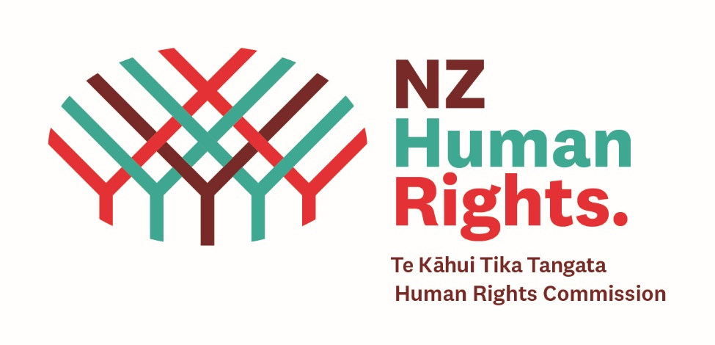

The key recommendations to the government are:

Taking immediate action

- Immediately work in partnership with disabled people in all their planning and putting in place all the other recommendations to:
- improve the information about COVID-19 and Omicron so it is easier to find it and use
- make sure there are more and easier ways to get what people need like masks, rapid antigen tests, a support worker if the usual worker is sick, more help if someone has to isolate at home if they are sick
- set up a 24-hour 7 day a week service people can contact and find a way to get their support if their usual support person is not able to come to work
- giving people more flexible options including how to get the right support for learning if they are staying away from school

Preparing for the continued responses to COVID-19

- Thinking ahead, the government must plan much better to make sure people will keep getting their support when workers might get sick with COVID-19 or for future emergencies.
- Give more funding to Māori and Pacific organisation who people are finding very helpful in supporting them

In the medium-term:

Designing systems and policies for disability inclusiveness

- Making sure there is much better information collected about tāngata whaikaha Māori and disabled people and experiences of COVID-19/Omicron so that we can see all the time what is happening and if anything needs to be done differently

Transforming society’s assumptions about disability

- Making sure disabled people are part of making decisions about COVID-19 at all levels of government
- Giving much better support to whānau and families and other people who care about and support tāngata whaikaha Māori and disabled people

