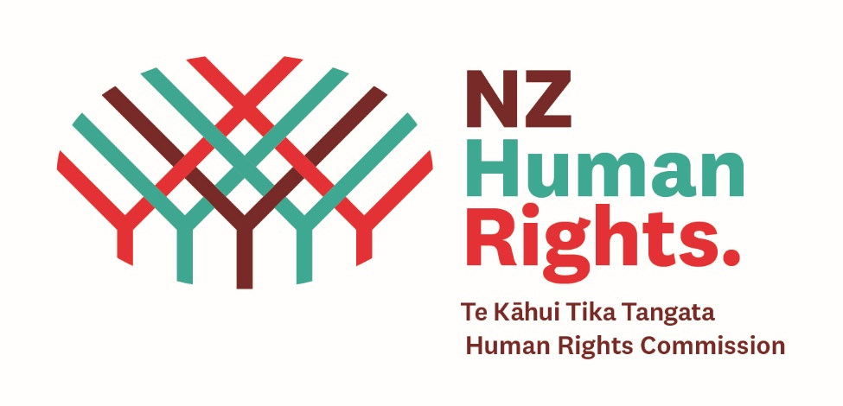

Background Notes

Tāngata whaikaha Māori is the term used throughout this report to refer to Māori with a disability — whaikaha means ‘to have ability’ or ‘to be enabled’. The Human Rights Commission recognises a range of terms are used for this group, such as Whānau Hauā, Tāngata Turi and throughout the information gathering process encouraged submitters to use whichever terms resonated most with them.
Section 5(2)(h) of the Human Rights Act 1993– provides for the Human Rights Commission to inquire into matters that may involve the infringement of human rights.
https://www.legislation.govt.nz/act/public/1993/0082/latest/DLM304276.html

Notes on what the Commission can legally do

- Inquire into matters (generally involves “gathering evidence, coming to conclusions and making recommendations.” (In this case to the Government.)

- May bring civil proceedings before the Human Rights Review Tribunal if it considers its inquiry discloses breach/es of human rights (s 92E)

- Can ask the District Court to require evidence from a person for the purpose of the Inquiry (s 126A)

What legal standing does this Inquiry have?

The inquiry is an exercise of the Commission’s section 5(2)(h) function to inquire into matters that may involve infringements of human rights. The Commission can report back on what its inquiry has found and make recommendations for change.

