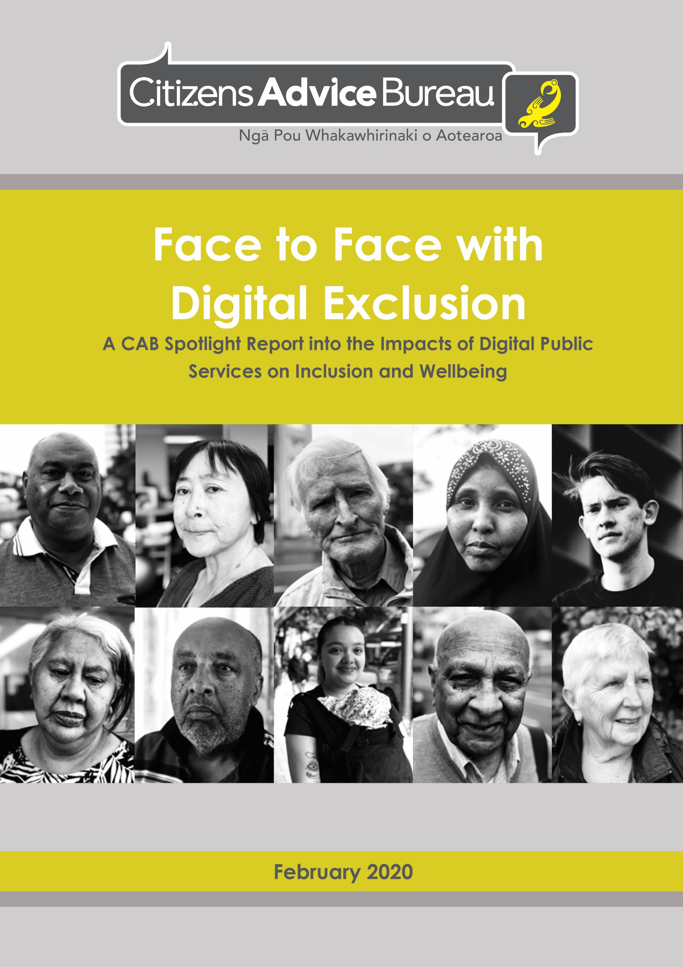

Published in February 2020 by

Citizens Advice Bureaux New Zealand

Ngā Pou Whakawhirinaki o Aotearoa

PO Box 24249, Manners St, Wellington 6142, New Zealand

ISBN: 978-0-473-51451-8 (print)

978-0-473-51452-5 (PDF)

This document is available online at: [www.cab.org.nz](http://www.cab.org.nz)

© Citizens Advice Bureaux New Zealand 2020

Creative Commons License

This work is licensed under a [Creative Commons Attribution-NonCommercial-NoDerivatives 4.0 International License](http://creativecommons.org/licenses/by-nc-nd/4.0/).

This document may be cited as: Citizens Advice Bureaux New Zealand (2020) *Face to Face with Digital Exclusion: A CAB Spotlight Report into the Impacts of Digital Public Services on Inclusion and Wellbeing.*

Contents

Foreword 2

Introduction 4

Executive summary 5

About the CAB 8

CAB clients who experience digital exclusion 9

What do we mean by digital exclusion? 9

About the data 10

A snapshot of digital exclusion 11

Digital exclusion impacts across age groups 12

Youth does not guarantee digital inclusion 13

Digital exclusion leaves older people feeling disempowered 14

Māori and Pacific Peoples are disproportionately disadvantaged 15

Barriers to inclusion 18

Lack of access to computer and internet 18

Limited digital literacy 20

Financial barriers 21

General literacy difficulties 22

Language barriers 24

Disability 25

Lack of desire to be online 26

People’s experiences of government’s digital approach 28

Not about choice 29

Removal of non-digital channels 29

Reduced access to paper-based resources 31

Making digital the only option 35

Not ‘simple and straightforward’ 36

RealMe experienced as a barrier 36

KiwiSaver withdrawals 37

Not ‘people first’ 38

Disadvantaging those who are already vulnerable 39

Community services left to fill the gaps 40

Support with tax issues 41

Navigating citizenship applications 42

Increased demand for immigration assistance 43

Progressing inclusion 45

Recommendations 47

Provide genuine choice in how people can interact with government 47

Develop an integrated strategy to address barriers to inclusion 48

Ensure services are people-centred 49

Fund the capacity of CAB volunteers to carry out their vital support role 50

Conclusion 51

Foreword

This year the Citizens Advice Bureau celebrates 50 years of providing information and advice in Aotearoa New Zealand. The CAB service is provided by trained volunteers, people who give their time for free to help others in their community. Tens of thousands of people have volunteered for the CAB during this past half century and New Zealand communities have been strengthened and enriched as a result.

The impetus for this report has been the concern of CAB volunteers at the number of people struggling to access government services and support because digital is the only option provided or other options are hard to find and access.

CAB volunteers are on the frontline of helping people access their rights and entitlements, often when people need extra support. This is our core service. However, this should not be a replacement for government providing services in the range of ways that people need, so that people do not experience unnecessary barriers to accessing tax payer funded public services. This relates to the fundamental human rights of people and what we should all expect of our public services.

The government has a legal obligation in its provision of public services to ensure that it does not exclude people from the services, rights and entitlements they are trying to access. Many government services are particularly important for already-marginalised groups within the community: people with disabilities, Māori and Pacific Peoples, older people, and those for whom English is not a first language. Access to government services is a human right.

Unfortunately, what this report shows is that many people are becoming stressed, frustrated and excluded in their attempts to engage with government services. While online services can dramatically improve the experience of those who engage digitally, services must be designed and provided in a way that accommodates everyone, including those who are not online. We acknowledge the government’s focus on wellbeing and hope the insights provided by this report will lead to a commitment to deliver services in ways that support the wellbeing of everyone. Taking a rights-based approach will help ensure that disadvantaged individuals and communities are neither overlooked nor left behind.

This report is based on anonymised information taken from over 4000 records of CAB volunteers’ actual interactions with clients. It shows the depth, breadth and importance of the work of CAB volunteers, particularly in helping those who are vulnerable. It reveals the complexity and often time-consuming nature of the issues that people come to get help with.

Given the vital work that CAB volunteers do in communities throughout New Zealand (482,000 client interactions last year), and the fact that often people are referred to the CAB by government agencies, we are also calling on government to increase funding to the CAB so that volunteers are able to do this vital work with adequate support. With our face-to-face service we are often filling a gap left by the withdrawal of a number of government counter and face-to-face services.

Currently the CAB is struggling to survive financially, while acting as a vital support to people who need help to interact with government. The empathetic, non-judgmental and empowering service provided by CAB volunteers is a taonga in over 80 communities throughout New Zealand and deserves to be adequately funded and valued by government.

**Kerry Dalton**

**Chief Executive**

**Citizens Advice Bureau New Zealand**



# Introduction

With the internet rapidly becoming the default gateway for interacting with government agencies, some of New Zealand’s most vulnerable people and communities are being left behind. Many public counter services have closed and accessing face-to-face support from government departments is increasingly difficult for some people. For those who experience digital services as a barrier, the emphasis on ‘doing things online’ means further disadvantage and leaves many people feeling frustrated, isolated and excluded from being able to fully participate in society. As a consequence, the accessibility of the public service is ever more contingent on community services that bridge the gap by providing the in-person support that people need.

As an independent civil society organisation, the Citizens Advice Bureau (CAB) plays a critical role in meeting the needs of people marginalised by government services moving online. CAB volunteers around Aotearoa help clients every day to overcome aspects of digital exclusion and empower clients to solve their problems and take next steps. This is about ensuring that no person suffers disadvantage because they can’t or don’t wish to engage online. While Government undergoes a digital transformation and withdraws from being physically present and accessible in communities, the CAB is relied upon to be there.

Using the stories of CAB clients, this report puts a spotlight on the realities of digital exclusion in New Zealand. It looks at the experiences of people who come to the CAB for help, and who are struggling because the information and services they need are increasingly located online. The report focuses on people’s interactions with government agencies. This is about recognising the particular responsibility the state has towards its citizens and the human rights implications for people when the systems of government impede access to entitlements or put obstacles in the way of fulfilling obligations.

The report highlights the challenges faced by people across a broad range of demographics and the barriers they encounter when dealing with government services online. It highlights that ‘digital' is not always best and that retaining ‘human’ services is a critical part of ensuring that wellbeing is supported and enhanced. The report provides a number of recommendations about the way public services should be shaped into the future and how the government should ensure that the core social infrastructure provided by the CAB is sustainably resourced and supported.

# Executive summary

This report puts a spotlight on digital exclusion in New Zealand, particularly looking at how digital public services are impacting on inclusion and wellbeing. It provides insights taken from the analysis of over 4000 CAB client enquiries where issues of digital exclusion were identified. For the purposes of this report, digital exclusion has been framed as situations where people face barriers to participating fully in society because of information and services being online.

**Who is digitally excluded?**

The report shows that a wide range of people experience digital exclusion. Within a three-month period, CAB volunteers recorded 4,379 client interactions where digital exclusion was identified.

***People across age demographics are digitally excluded*** – Analysis of CAB client enquiries revealed that digital exclusion is experienced across age demographics. This challenges the assumption that it’s primarily older people who struggle with online services and that these problems will phase out over time. These findings also reinforce that youth in itself does not guarantee digital inclusion.

***Māori and Pacific Peoples are disproportionately disadvantaged*** –Māori and Pacific Peoples were clearly overrepresented amongst CAB clients experiencing digital exclusion, accounting for 20% and 17% of digitally excluded clients respectively. The disproportionate impact of digital exclusion on Māori and Pacific Peoples is well-documented and a concerning indication that the digital transformation of government services is not serving the needs of people equally.

**What are the barriers?**

The report sets out the range of barriers that CAB clients faced as a result of government information and services being online. These barriers were:

***Lack of access to computer and internet –*** Despite improvements in digital infrastructure across New Zealand, many CAB clients were without ready access to a computer or other appropriate device, or to reliable and affordable internet access.

***Limited digital literacy -*** Even with access, many people lacked the skills or confidence to carry out tasks online and needed assistance to navigate digital processes.

***Financial barriers*** – Cost was an issue, not just in terms of having and maintaining a computer, and an internet connection, but because of the barriers some people face when payments are expected to be made online.

***General literacy difficulties –*** For others it was difficulties with reading, writing and language comprehension, that meant online information and processes were inaccessible.

***Language barriers –*** Language barriers were another issue experienced by some CAB clients. A lack of confidence with written English was a particular challenge, with a resulting anxiety about completing important online processes in a language that is not the person’s mother tongue.

***Disability –*** People with a range of disabilities also sought help from the CAB because of challenges accessing the internet and navigating online information and services.

***Lack of desire to be online –*** For some people there was a lack of motivation to engage online. While often framed as a barrier, many CAB clients stated that this was about a preference for person-to-person support. Clients expressed frustration that choice was being taken away with the increasing digitisation of public services.

**What are people’s experiences of government’s digital approach?**

This report uses a range of client stories to illustrate common themes in people’s experiences of government’s digital approach.

***Not about choice***

For those experiencing digital exclusion, their experiences of government services were that increasingly it is not about choice, with many government agencies scaling back on non-digital channels, reducing access to paper-based resources, and in some cases making digital the only option. Examples were:

* Immigration New Zealand systematically closing all its public counter services and ceasing the bulk printing of visa-related forms, leaving CABs to print hundreds of thousands of pages of forms for clients each year.
* Tenancy Services making the option of completing a paper-based application to the Tenancy Tribunal almost invisible on its website.
* Department of Internal Affairs stopping the printing of passport renewal forms.
* Ministry of Business Innovation and Employment making the system for requesting Employment Mediation Services an online process, with no accessible paper-based option.

***Not simple and straightforward***

Promises about simple and straightforward digital processes were also frequently not borne out in reality. Examples were:

* The difficulties many people faced in making use of RealMe, the government-operated online authentication service. This included being told by a government department not to use Gmail to register and to avoid using an iPhone or iPad and instead use a ‘proper computer’.
* The KiwiSaver withdrawal process was something that clients struggled to navigate digitally, and commonly needed in-person assistance from the CAB to carry out.

***Not ‘people first’***

The experience of many people is that the digital transformation of government services is not putting people first, but rather is putting digital first. This means that people who are already vulnerable and are negatively impacted by social inequality are at risk of being further disadvantaged. A clear example of this was the digitisation of aspects of our social welfare system and the resulting barriers some people face when they are told to apply online, or to use MyMSD, when what they really need is time with another human offering face-to-face support.

***Community services left to fill the gaps***

A consequence of government agencies focusing on online service delivery is also that community services are being left to fill the gaps. CABs are playing an essential role helping people who experience digital public services as a barrier. While this role sits within the core mandate of the CAB, volunteers are under increasing pressure and feel inadequately resourced to meet the level of need. Areas where digitally excluded clients sought the assistance of the CAB included clients seeking support with tax issues, applying for citizenship and helping with immigration applications.

**What needs to happen?**

The report looks at some of the initiatives currently in place to increase digital inclusion in New Zealand but concludes that digital inclusion cannot be achieved without lifting our sights and focusing on inclusion more broadly, so that people’s needs are at the centre and wellbeing can genuinely be supported and enhanced. It sets out a number of recommendations about the future delivery of government’s public services.

***Provide genuine choice in how people can interact with government***

* Government agencies should be accessible to people in a range of ways, reflecting that not everyone’s best interests will be served by moving public services online. In particular, this is about ensuring that citizens can interact with government face-to-face, without having to overcome various hurdles designed to push people online.
* Government forms should continue to be accessible as printed paper copies, at least for the time being. The costs of printing should be carried as part of delivering public services and should not be transferred to individuals and community services.
* A range of payment options should remain available. These should be easy and accessible and no-one should be penalised for not being able to pay online.

***Develop an integrated strategy to address barriers to inclusion***

* Government must develop an integrated strategy that focuses on actively reducing the barriers to inclusion, recognising that the same barriers that people face in achieving social equality impact on their opportunities and experiences of being online. This strategy needs to go further than just looking at access to computers and courses that support improved digital literacy, and position digital inclusion in a wider context of social inclusion.
* In relation to the specific digital exclusion issues identified in this report, the Government should:
  + Increase access to free Wi-Fi and digital devices for those in low income households and those suffering disadvantage as a result of a lack of access.
  + Support people with disabilities to access appropriate equipment and technology that is best suited to their needs. Ensure public services are accessible and that service design is informed by consultation with people with disabilities and by universal design principles.
  + Ensure that offline services are available and accessible and that offline channels are part of the proactive design of improved public services.
  + Make access to paper copies of government forms and resources as easy and straightforward as possible, eg, a ‘Request a paper copy be sent to you’ option.
  + Ensure free-access computers, printing services, and facilities for scanning and uploading documents are readily accessible in the community.
  + Ensure free language assistance is available to people who need it to successfully interact with government, ie, to fully understand information and make informed decisions.
  + Provide ongoing learning opportunities with the aim of increasing basic digital literacy and confidence, and include ongoing ‘helpdesk’ type support.

***Ensure services are people-centred***

* Government services should be designed to be people-centric, prioritising the needs of the people who use the services, not the needs of the agency providing them, and not from an assumption that digital is best. User testing of systems needs to factor in the challenges people may face that are beyond the functional task.
* The focus on digital uptake should be removed from the Government’s Better Public Service Result 10 and be replaced with measures that reflect the diversity of people’s needs.
* Particular attention should be given to the needs of Māori and Pacific Peoples given their significant overrepresentation amongst those experiencing digital exclusion.

***Fund the capacity of CAB volunteers to carry out their vital support role***

* Government should ensure the survival of the CAB through adequate funding. This is about supporting the capacity of CAB volunteers to carry out their role, including assisting people who experience digital exclusion to interact with government.
* Specific funding is also needed to address the impact on the CAB of government shifting its information and services online, eg, funding for printing, for hardware, software and facilities, for learning and development for staff and volunteers, and to support the capacity of the CAB for strategic engagement on digital exclusion and inclusion issues.

# About the CAB

People come to the CAB for help with the full range of issues affecting them in their day-to-day lives. Increasingly, this includes the need for support to access information and services that are online, to navigate digital processes, and to find a way forward when going on the internet is not something they want to or feel able to do. Many of these people experience digital processes as a barrier and need assistance to carry out tasks so that they can participate fully in society.

As identified in the 2018 PriceWaterhouseCoopers review of the Citizens Advice Service in Wellington, a highly valued aspect of the CAB service is its accessibility.[1] Over 2,500 CAB volunteers around New Zealand help close to half a million people each year by providing *accessible*, *accurate*, *confidential* and *independent* advice that *empowers* people to solve problems, understand their rights, access services, and enhance their personal and community wellbeing.

“[CAB] attracts individuals in need by offering free and non-time limited services with a real life “human” interaction. This personal customer experience allows [CAB] volunteers to provide a level of empathy, impartiality and anonymity that can be difficult to find elsewhere. It also provides reassurance to individuals that someone is there to help during moments of despair, when they have exhausted alternative options or do not know who to turn to.” PwC Review of CAB Wellington Service[2]

The mandate of the CAB is to help people understand their rights and responsibilities and access services, without putting any barriers in the way. The CAB provides a unique information and advice service, assisting people to solve problems, understand their rights, access services, and enhance their personal and community wellbeing. A key part of this is helping people to engage with government so that entitlements can be accessed and rights upheld. As public services move online the role of the CAB has become even more critical.

# CAB clients who experience digital exclusion

This report is based on the analysis of CAB client enquiries where digital exclusion has been identified. It provides an insight into the ways that the focus on developing digital services has created new challenges for some people. In this section of the report we look at the people who are being most significantly impacted.

## What do we mean by digital exclusion?

For the purposes of this report we have framed digital exclusion as situations where people face barriers to participating fully in society because of information and services being online.[3] This can mean they experience difficulties accessing the information or services they need, come up against obstacles when trying to act on their rights or fulfil their obligations, or encounter challenges in being able to navigate processes and systems to get the outcomes they want. In practical terms digital exclusion can be a lack of access to a computer or the internet, a lack of digital confidence or skills, or experiencing a range of other barriers such as language and literacy. For some people it is also about choice and the experience of being excluded as a consequence of non-digital, in-person and paper-based channels being downscaled or removed.

## About the data

The data presented in this report is taken from an analysis of CAB client enquiries. In September 2019, CABs in over 80 locations around Aotearoa[4] started collecting specific information from clients about their experiences of digital exclusion. Within a three-month period, CAB volunteers recorded over 4,379 situations where clients were identified as digitally excluded.

While this number is substantial, it’s important to also note that the feedback from CAB volunteers is that this is just a snapshot of the digital exclusion they are seeing. The reported data does not include the many additional services provided by CABs that are not recorded as full client interviews; in particular, those who come to the CAB just to access paper copies of forms. It also only captures situations where digital exclusion has been proactively identified. We know from our volunteers that it is not always easy to ask additional questions of clients when the client is already under stress and just wants their immediate issue to be addressed.

In this report we use examples from those 4,000+ client interactions to highlight the issues digitally excluded people face. The client enquiries have been anonymised, with random names attributed, and any identifying details have been removed so that confidentiality is maintained. Some of the particulars may have been altered slightly to ensure the privacy of individuals is protected, but the substance of the client issue remains.

This report focuses on the insights gained from analysing the rich qualitative data captured through client interactions. There is also some analysis of the demographic characteristics of people experiencing digital exclusion. This includes information about age, ethnicity, gender and location. For the purposes of this report we have only provided a surface level analysis of the demographic data. There is the potential to uncover more insights through further analysis – something that may be possible in the future if the necessary resourcing is available.

Throughout the report there are reflections from CAB volunteers and staff who see the issues of digital exclusion on a daily basis. These people play a critical role in bridging the gap for clients who are struggling with the push from both the public and private sector for people to engage online. The insights from CAB personnel include observations of the impacts on clients as well as the consequences for the CAB service in having to respond to this growing area of need.

# A snapshot of digital exclusion

In a three-month period, CAB volunteers recorded 4,379 enquiries where the client was experiencing digital exclusion. This equates to 10% of all clients during this period. These clients faced barriers to participating fully in society because of information and services being online.

**4,379**

**FOUR THOUSAND THREE HUNDRED AND SEVENTY-NINE**

clients recorded as

**digitally excluded**

**in a three-month period**

Sometimes this was about a lack of access to a computer or the internet, but was also frequently about a lack of digital skills or confidence, and a broader range of barriers relating to literacy, language, finances and disability. For others it was a matter of choice, and the difficulties faced when wanting to interact offline in an increasingly online world. …………………………………………………………………………………………..

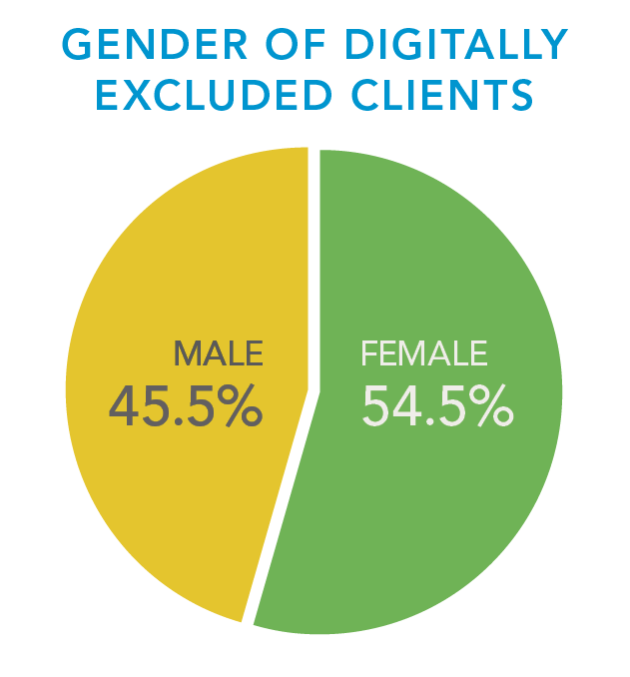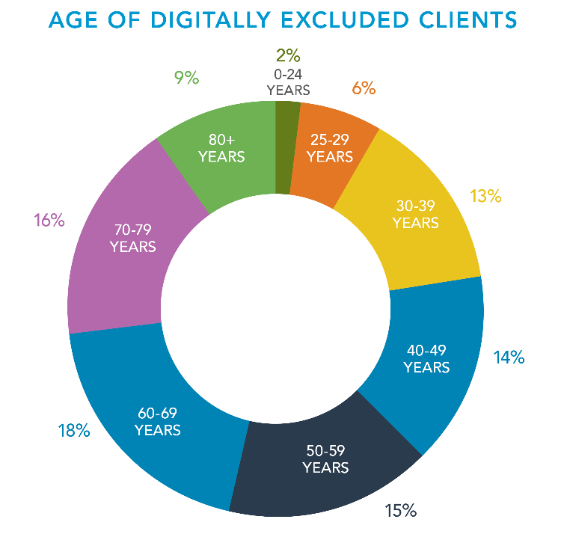

***“Digital exclusion is being experienced across age groups”***

Digital exclusion is experienced by clients across age groups. While older people are clearly represented amongst those who are digitally excluded, younger people also face difficulties because of information and services being online.

…………………………………………………………….

People of all genders experience digital exclusion.* It is more common for CAB clients experiencing digital exclusion to be female, but we note that the proportion of digitally excluded clients who are male is greater than the proportion of male clients generally (45.5% digitally excluded versus 40% all male clients in the same period).

*We acknowledge that digital exclusion is also something that may be experienced by people who identify as gender diverse and transgender. People identifying with these gender profiles are currently a small percentage (<1%) of overall enquiries received by the CAB and were less than 0.02% of those recorded in this data set.

CAB Spotlight Report: Face to Face with Digital Exclusion

© Citizens Advice Bureaux New Zealand, February 2020

11

## Digital exclusion impacts across age groups

CAB Spotlight Report: Face to Face with Digital Exclusion

© Citizens Advice Bureaux New Zealand, February 2020

1

The locations marked on the adjacent map represent the CABs throughout New Zealand that recorded situations of clients experiencing digital exclusion.

* For the ten CABs named on the map, digitally excluded clients made up more than 20% of the total number of clients they assisted.
* Two CABs, Mangere and Otaki, recorded issues of digital exclusion impacting on 30% or more of all their clients.
* 54% of CAB Mangere’s digitally excluded clients were Pacific Peoples.
* CAB Glen Innes was the location that assisted the largest number of digitally excluded Māori clients, accounting for 14% of all digitally excluded Māori.

………………………………………………………………

Māori and Pacific Peoples are significantly over-represented amongst CAB clients experiencing digital exclusion, together making up 37% of these clients.

…………………………….

Clients experiencing digital exclusion seek help from the CAB for a huge range of issues, frequently to do with accessing a government service. By far the most common area where digitally excluded clients seek support is for citizenship and immigration issues.

There is a common assumption that digital exclusion is an issue for older people who haven’t grown up learning, working, and socialising in the digital world. Our data shows that while older people are disproportionally represented amongst those who struggle with the growing digital divide relative to the CAB’s usual age distribution of clients, there are people across all age groups who are digitally disadvantaged.

Of the 4,379 clients identified as digitally excluded, there were comparable numbers of people experiencing digital exclusion in every 10-year age bracket from 30 – 39 years through to 70 – 79 years, each grouping amounting to between 500 and 800 people impacted. This reflects the range of barriers and issues that can contribute to digital exclusion, irrespective of age.

*Graph showing the ages of CAB clients who are digitally excluded compared with the ages of all clients for the period 1 September 2019 to 30 November 2019.*

## Youth does not guarantee digital inclusion

In the 3-month period analysed, those aged under 30 years accounted for 9% of CAB clients experiencing digital exclusion. While this is a small percentage compared to other age brackets, it nevertheless equates to almost 400 clients aged between childhood and 29 years being impacted. This also does not account for additional young people who may experience negative consequences as children of digitally excluded adult clients.

Matt, who is 22 years old, needed advice on how to get a photo ID, and also how to register his child's birth. We spent some time providing information from the CAB and government websites to explain these processes, including accessing forms for filling in, and what proof of identity was needed for each process. Matt said that even though he’s young he prefers to fill out forms rather than go online.

While it may be the case that many young people are comfortable and confident online, youth on its own does not equate to digital inclusion. Young people are still prone to the barriers that can span age, such as access and literacy issues, and to the inequities caused by things like discrimination and poverty. Also, as is true across all age groups, there are some young people who prefer to fill out a paper form or speak to another person, rather than do things online.

Nikau, who is 17 years old, is applying for a passport and wanted someone to be his identity referee. He has no computer or Wi-Fi access and is not able to apply online. We printed out a passport renewal form for Nikau and explained who could be an identity referee.

Malia, aged 19, came in with a supporting letter asking for a food parcel. She and her partner and their young child have just moved in to social housing after living in their car for a number of months. They have no money and no food. They don’t have a computer and access to the internet is only available using their phone and free Wi-Fi. They are also not very confident using digital processes. We sorted Malia out with a food parcel and put her in contact with other services for their ongoing financial needs.

Aidan, aged 20, wanted help to deal with his drinking problems. He had no access to a phone or the internet. We searched our database and gave information about Alcoholics Anonymous (AA) meetings. We let Aidan use the phone so he could call the AA contact person and find out about meetings in his area.

## Digital exclusion leaves older people feeling disempowered

There’s no doubt that the rapid shift to things being online is having a significant impact on older people. While this is acknowledged, there seems to be an attitude that the issues will diminish over time as the proportion of the those aged over 65 who have lived and worked with the internet increases. While it’s likely that there will be improvements in population-wide digital literacy over time, this needs to be balanced with the reality that technologies continue to change and develop and that there is a constant “new”.

“He described himself as "old school" and had no access to the internet and no knowledge of how to use it.” CAB Volunteer

The impact of digital exclusion on older people is very visible amongst CAB clients. Older clients express feelings of stress and frustration at being left behind or shut out of processes. Common issues are the lack of access to a computer, lack of digital skills or confidence, and in some cases, a lack of desire, energy, time, or sense of priority, to spend time learning something new.

Older clients say they don’t feel valued because they ‘don’t understand the internet’ and that this makes them ‘feel depressed’. They feel that they have no say and that change is just being forced upon them. If they can access online information and services they may still struggle to understand what’s there and can ‘feel stupid’ having to ask for help.

“An elderly client said that she was 'fearful' of computers and stated that she could not cope with them. She felt she was not able to learn now.” CAB Volunteer

George, aged 75, needed to renew his passport and explained that he doesn’t have the confidence or skills to do it online. He wanted the paper form which had to be downloaded and printed from the Passports website. We printed the passport documents for him, including the new fees table.

In addition to new digital technologies, older people are struggling with the removal or decline of systems and services that were previously able to be relied on, such as public counter customer services and postal services. These challenges can mean that older people find it more difficult to access information, get their entitlements, and even to stay connected to their own families.

*“For some of our older clients, everything being online makes them feel disempowered. It can have a really negative impact on their sense of dignity, independence, and overall wellbeing.”*

*CAB Manager*

Wiremu, aged 78, wanted to find out if he qualified for a government subsidy for a heat pump. He has a disability and can no longer manage getting wood or cleaning out the ashes from his existing word burner. We helped Wiremu complete the online eligibility tool. He appeared to be eligible but the insulation in his property has to be checked first before a grant can be made. We helped Wiremu choose a provider and complete the form, then printed out the information for him to take away.

Margaret, aged 87, rang the CAB asking for the physical address of her power company. We found this online for her. She had been waiting on the phone to the power company for over an hour. She was tired of waiting so had decided to go and see them in person. She has a computer that she uses for keeping in touch with family but didn’t want to use a computer for “business purposes”.

## Māori and Pacific Peoples are disproportionately disadvantaged

Māori and Pacific Peoples experience inequality in New Zealand on numerous fronts, resulting in poorer health outcomes, lower educational achievements, and greater material hardship.[5] From our analysis of CAB client enquiries, digital exclusion is yet another area where Māori and Pacific Peoples are disproportionately disadvantaged. During the period of analysis, 20% of digitally excluded clients were Māori compared to being 13% of CAB clients generally, while Pacific Peoples made up 17% of those experiencing digital exclusion in contrast to being only 8% of clients generally. This over-representation of Māori and Pacific Peoples is consistent with other research into digital inclusion and exclusion.[6]

In their engagement with tangata whenua, the government team leading the development of a Digital Inclusion Blueprint for Aotearoa noted that: “As had been expected, we found factors such as poverty, health, education and social needs that disadvantage Māori generally, also have a direct correlation to the access, motivations, trust and skills that are related to digital inclusion / exclusion.”[7] Despite this awareness, the digital transformation of government services appears to be barrelling forward without regard for the negative impacts on Māori and the ways in which digital exclusion is exacerbating existing inequalities.

*Graph showing ethnicities of CAB clients who are digitally excluded compared with the ethnicities of all clients for the period 1 September 2019 to 30 November 2019*

In similar ways, Pacific Peoples’ experiences of social disadvantage are intensified by the growing digital divide. In the New Zealand Survey of Adult Skills, which measures skills in literacy, numeracy and problem solving in technology-rich environments, Pacific Peoples were much less likely to be able and willing to use a computer. One in five Pacific Peoples aged 16 to 65-years either had no computer experience, did not pass a simple computer-use assessment, or declined to use a computer. This compared with one in ten non-Pacific Peoples aged 16 to 65-years.[8]

The Government has articulated a clear aspiration to lift Māori and Pacific income, skills and opportunities.[9] However, the impacts of digital exclusion are likely to have the opposite effect. The disproportionate disadvantage experienced by Māori and Pacific Peoples makes it clear that the focus on ‘going digital’ means that services are not being designed to meet the needs of all groups of people equally.

**Ethnicity of digitally excluded clients aged 0-24 years**

For younger CAB clients, the over-representation of Māori and Pacific Peoples amongst those who are digitally excluded is even more extreme. Almost half (48.5%) of the digital exclusion enquiries from under 25-year-olds were from Māori and Pacific Peoples (23.7% and 24.7% respectively).

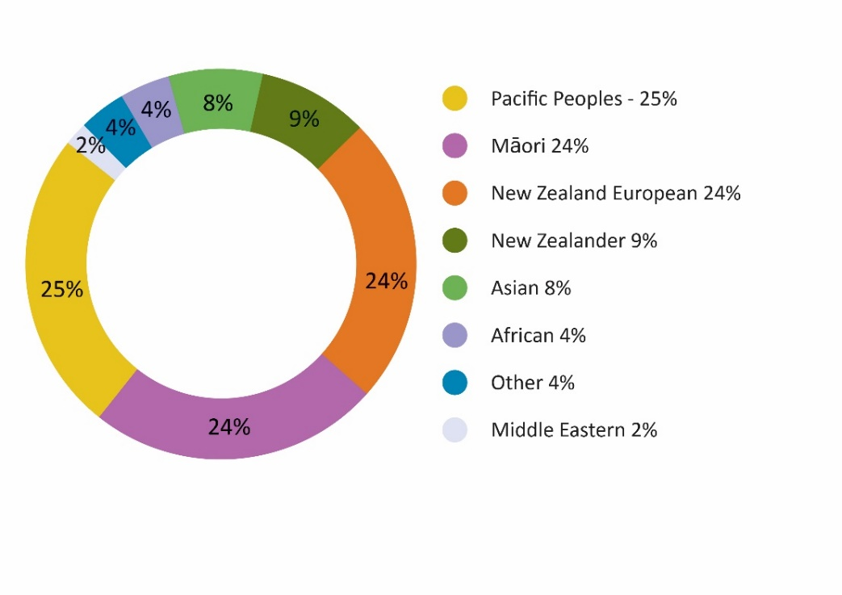

For digitally excluded Māori, the most common reason for seeking help from the CAB is for material (non-financial) welfare assistance, which is generally about accessing a food parcel.

For digitally excluded Pacific Peoples, by far and away, the primary reason support is sought from the CAB is to navigate citizenship and immigration processes.

# Barriers to inclusion

There are a range of barriers being faced by people as a result of things being online. These barriers can result in exclusion, not just from participating in the digital world, but from being able to participate in society more generally. People who cannot access and use the internet, or for whom the internet itself presents a barrier, are increasingly disadvantaged. The *Out of the Maze: Building Digitally Inclusive Communities* report identified that people who are unable to access the internet experience exclusion, isolation, powerlessness and limited opportunity.[10] The report highlighted that “losing the ability to be digitally connected could have a disproportionately disastrous impact on people in vulnerable or tenuous times, or when moving through a life transition”.[11]

The barriers CAB clients experience around online interactions are consistent with the findings of other research into digital exclusion.[12] These barriers include the lack of access to a computer and / or the internet, limited digital literacy, financial barriers, general literacy issues, language barriers and disability. However, our client enquiry data also reinforces that genuine inclusion is about supporting people’s ability to choose how they interact and ensuring that other channels of communication stay open. Digital technology can be a tool for good, making people’s lives better and enhancing wellbeing, but it can also be itself the barrier to inclusion. Following are examples of CAB client enquiries that reflect the full range of barriers people are experiencing when trying to participate in an increasingly digitised world.

## Lack of access to computer and internet

A fundamental barrier that some people face in getting to the online information and services they need is their lack of access to a computer or to the internet. While the 2017 report *Digital New Zealanders: The Pulse of our Nation*, noted that New Zealand ranks among the best in the world in terms of our digital infrastructure,[13] access is still an issue. In the 2013 Census, 23% of New Zealand households were without access to the internet.[14] The 2018 Census showed a substantial increase in digital access with only 14% of participating households stating they don’t have access to the internet.[15] However, given the digital exclusion issues with the most recent census and the all-time low response rate,[16] this is likely to be an under-estimation.

“The client has no computer or internet and says he doesn’t know how to use it anyway. He does not trust the internet.” CAB Volunteer

Regardless of the official number, many of the digitally excluded clients coming to the CAB report that they don’t have a computer at home or they aren’t connected to the internet. Where people do have digital devices, it’s often a mobile phone, which may not be suitable for reading and navigating large amounts of information or filling in online forms. Internet access can also be limited or unreliable, or based on the ability to gain free Wi-Fi access. Some people are able to make use of free computer and internet services in the community, such as in libraries and community centres, but not everyone is able to access these services or feels comfortable transacting online in these public settings.

“He explained that he can only access a computer in the library, but he doesn’t feel secure doing things on a public system.” CAB Volunteer

As can be seen from the enquiries from CAB clients, difficulties with computer and internet access make it harder for people to participate, to get the information they need, and to carry out tasks and transactions. In some cases, a lack of access can also result in significant, negative consequences for people when it means that they are unable to access their entitlements or fulfil their obligations, and can be penalised as a result.

Karen was sent to the CAB by Work and Income so we could help her register for MyMSD and get a job seeker benefit. She doesn't have or use a computer. We helped Karen to complete the MyMSD application process as far as we could go with the information she had available.

Dayal applied to bring his fiancé to New Zealand but the application was declined. He was told it was due to incorrect information or an absence of information according to various clauses of the Immigration Operations Manual. Dayal has no access to a computer so asked if we could print out copies of the relevant clauses for him so he can see what is needed for resubmitting the application. We printed out the necessary information as well as details for contacting the Immigration NZ helpline.

Pita came in to the CAB with a letter from IRD stating that he hasn’t paid his tax obligations and threatening court if he doesn’t pay within 30 days. Pita is elderly, doesn’t have a computer and is not computer literate. He hadn’t received any other communication from IRD so didn’t know how much he owes. We called IRD together and outlined the situation, including how distressed Pita was by the letter. We came to an agreement with IRD that we would download the IR3 form for Pita and he will complete it then send it to IRD. IRD undertook to make a note of the call and to record that Pita has no computer access.

## Limited digital literacy

Binh has been off work for six months and hasn’t yet been able to get a benefit paid from Work and Income. They want four months of his bank statements. He has no computer or printer at home and lacks any digital confidence. He struggles to use a keyboard and read instructions. English is also not his first language. We showed Binh how to log on to his Gmail account and access the bank statements his daughter had emailed him. We printed these out for Binh.

Even when people do have access to a computer and the internet, the various tasks involved in using a computer can create challenges for them.

Some CAB clients who experience digital disadvantage struggle because they lack a range of core digital competencies. They may not have the specific technical skills, but it is also often about a lack of confidence and motivation to give these things a go. Clients regularly ask for assistance with the functional tasks of using the internet, such as accessing and sending emails, searching for information, opening tabs, and downloading or uploading documents or images.

Judy had to email documents to the parking infringement service and asked if we could help as she had no idea how to do it. She needed to access her emails so she could forward one to the CAB and to send documents she only had as paper copies. We showed her how to attach documents to an email. We wrote down step-by-step instructions so she could do this at home. We also scanned the documents and emailed them for Judy and copied her into the email.

Despite initiatives aimed at improving access to technology and the internet, and programmes to increase people’s digital skills, many people continue to struggle and need assistance to navigate online processes.

Sione had received an email from Immigration NZ regarding an NZeTA (New Zealand Electronic Travel Authority) visa and was suspicious when the website asked whether he would accept the use of cookies. He was very wary as he’d recently been scammed over the phone by someone claiming to be from the IRD. We explained to Sione what cookies are on the internet and options for managing preferences.

“The client stated that he doesn’t have access to a computer and is not computer literate. He said that he doesn't know or understand technological things.” CAB Volunteer

Dahlia has been having issues with her landlord and is very concerned about mould growing on the walls. She asked for help to complete a “14-day Notice to Remedy” to send to her landlord. We found the form on the Tenancy Services website and filled it in with Dahlia. We typed for Dahlia as she was not confident using a computer. We printed the form so she could sign it, then scanned it and emailed it on her behalf.

## Financial barriers

For some people cost is a very definite barrier to being online. This can be the cost of a computer or other device, or the cost of data to keep them connected. In the situations we see at the CAB, the affordability of internet access generally sits alongside much broader challenges with the current costs of living in New Zealand. As can be seen from the following situations, while the clients identified that they face digital exclusion, their reasons for coming to the CAB are often because they need help with much more pressing and fundamental issues such as access to food and housing support.

“Client’s internet provider won’t connect her to the internet until her overdue account is paid. They keep telling client to go online to check her account, but she can’t do this! She is very stressed as they say they have now referred the account to a debt collector.” CAB Manager

Kahu is homeless and can’t afford the cost of accessing the internet. We helped him with questions he had about housing, about having contact with his children, and about getting a food parcel.

Maria has access to the internet on her mobile phone but is only able to make limited use of this due to data costs. Maria was out on bail awaiting a court hearing for drug-related offending and wanted help on issues related to the care of her children.

Andre was told by Housing NZ to get some budgeting help and wanted to know where he can go. He was struggling with a range of costs, including the increased costs of his medication, and was also in need of food assistance. He doesn’t have a computer and says he’s unable to afford or use one. We searched our online directory and gave him contact details for local budgeting services. We also helped him to access a food parcel.

Bronwyn doesn’t have a computer and says the cost of getting internet into her home is too expensive. She has to use a computer at the library, which only allows limited time. Bronwyn wanted our help with looking for work and accessing job agencies online.

In some cases, it’s the need to be able to pay for things online that creates difficulties. This is particularly concerning in relation to interactions with government, where payment may be about meeting obligations or accessing entitlements. Not everyone has a credit or debit card or has access to or confidence in using online banking. As alternative options start to disappear, some people are left struggling to participate and to complete processes that increasingly require payment to be made online.

The option of paying by cheque is rapidly disappearing. State-owned Kiwibank has announced that it will stop accepting or providing cheques from 28 February 2020.[17] Inland Revenue and the Accident Compensation Corporation have also announced that they will no longer accept payments by cheque from March 2020.[18] The argument is that “cheques are part of a paper-based world and don't mesh with the increasingly digital world we now operate in”.[19] With the closure of many shopfronts for government and other services, the option of fronting up to make a payment over the counter by cash or EFTPOS is similarly vanishing.

When it comes to important transactions such as paying for bills, meeting tax obligations, fulfilling repayment commitments and paying application fees for visas, passports and citizenship; the focus on paying online can present an additional challenge in navigating the digital world. In some cases, the only available option is to purchase a Prezzy Card (at an additional cost of $5.95) and load money on it so that they can pay online. While electronic payments are promoted as simpler, easier and safer; for some people they are yet another barrier.

Roger rang to ask where he can go to pay his bills. He had always paid them at his local PostShop but it has now closed and Kiwibank will not take his payments. We looked online to find other PostShop locations for him. Roger is elderly. He has no computer and says he doesn’t want to start using one to pay for things online.

Ruheen was applying to have a visa transferred to her new passport. She wanted us to check the application form and assist with filling in the rest of it. She also needed to find out the fee. We helped Ruheen to complete the application form and searched for the fee online. It was $130 and it needed to be paid by credit card or a bank cheque. There was no debit card option and the client didn’t have a credit card, so we advised her to go to the bank and get a bank cheque to post in with her application.

Johanna asked for the address details for posting a cheque to Inland Revenue. She doesn’t have a computer and is unable to pay her bill online. We helped Johanna to find the IRD address and took a photocopy of her bill to send in with payment as there was no tear-off slip.

Mahir wanted help to register his daughter’s birth and get a birth certificate for her. We went through the online process but when we reached the payment stage he realised he didn’t have a credit or debit card to be able to pay online. He went and purchased a Prezzy Card so he could pay online then came back in to the bureau. The process hadn’t saved so we had to start again.

## General literacy difficulties

Another common theme underlying the digital navigation difficulties people face are basic literacy challenges. A lack of confidence with reading and writing and with comprehension of information can mean that even with access to a computer and the internet, there are still significant barriers to overcome. In these situations, the ability to access one-on-one, in-person support is critical.

Tavita had recently taken on some paid work, one day a week, and was anxious about the impact on his benefit. He has literacy difficulties, is not confident on the phone, and cannot use a computer. He wants to keep doing the work as it’s good for his mental health. We went through the information on Work and Income’s website and determined that his paid work will result in a small weekly deduction from his benefit. We phoned Work and Income and they said Tavita needed to supply payslips and a letter from his employer. We asked for an appointment for him but they couldn’t give him one this month and bookings for the next month weren’t yet available on their online system. We tried calling Tavita’s employer without success so wrote a letter to his employer listing the information needed. We also wrote a note for Tavita to take to Work and Income about his employment details.

With the closure of public counters for government and a range of essential services, and the delays and difficulties faced when using many call centre phone services, people who are already disadvantaged are struggling to get the support they need. Many of these people come to the CAB for help.

Gary bought a car online from a registered motor vehicle dealer. After the sale he discovered that the clock had been wound back at least 50,000km and there were various other issues that meant the vehicle was not as advertised. He came to the CAB for help to fill in an online application to the Motor Vehicles Disputes Tribunal. He didn’t have access to a computer or the internet and had a lack of digital confidence. He also faced literacy barriers and had difficulty understanding the language used. We found the correct form online and worked with Gary to complete it. We printed out the form so he could send it by post with his application fee to the Motor Vehicle Disputes Tribunal.

Susan brought in a letter from her bank with information about the returns of her KiwiSaver investments. She wanted help with reading the letter. We read it through with Susan and explained the contents of the letter. Susan often brings in letters for the CAB to read for her. She has difficulties with general literacy and cannot use a computer.

These clients need and value the opportunity to work through their issue with another person, to be listened to and supported to take next steps. In practical terms this can involve explaining written information and processes in ways the client can understand, presenting options, and supporting the client to navigate processes and make informed decisions. For these clients, being told by government and other agencies that they “just need to look online” is an unsatisfactory response and does not support wellbeing.

*“In our area there are very high levels of illiteracy, Both reading / writing and computer literacy. With all support offices closed people are confused and unsure what to do or where to go for further help. They cannot afford to pay someone to help them.” CAB Manager*

## Language barriers

For some of the client enquiries we looked at, it was the client’s lack of confidence with English language, particularly written English, that created an additional barrier to carrying out online processes. A lack of language confidence can mean people feel anxious about whether they are interpreting and understanding information correctly. This concern is particularly prevalent for interactions with government where the stakes may be high.

As identified from our analysis of enquiries from digitally excluded clients, citizenship and immigration matters were the most common areas where support was needed. For these clients, language was frequently an issue in the mix. This was not necessarily about lacking English language competency, or the ability to have a basic conversation in English, but in having the confidence to complete important processes in a language that is not their mother tongue.

“Individuals are suffering because of an inability to access information and services due to lack of computer literacy and language. This is especially the case for older people and migrants.” CAB Manager

Where English is a significant barrier, efforts are made by CAB volunteers to access language support through the CAB’s network of volunteers, or through language services that may be available in the community. Previously, clients were able to access the CAB service in a range of languages through the CAB’s dedicated multilingual service, Language Connect. This service was closed in December 2018 after Immigration New Zealand discontinued its funding.[20] This has made it more difficult to address the language barriers faced by clients, not only in their access to digital services, but in their access to information and services generally.

“Some questions in online forms are difficult for English speaking New Zealanders, let alone those with English as a second language.” CAB Volunteer

Cheng’s wife was on a visitor’s visa which was soon to expire. Cheng was trying to get her visa extended but was having difficulty with the process. He had limited English. He decided to go to the Immigration New Zealand Office so he could get some help. This was a 4-hour drive from his home. When he arrived, he discovered that there was no longer a public Immigration office. He came to the CAB for help working out what visa forms he should fill in to allow his wife to stay and also to get a residence visa. Due to Cheng’s limited English he was unable to fill in the forms without assistance. We helped him fill in the forms and wrote down what he had to do next, including which forms his wife had to sign and which ones had to be witnessed by a JP. We also gave Cheng a printed form with the application costs and the addresses to send his documents to once they were signed.

## Disability

Laila had received an email saying she has a message on her MyMSD. Laila has good spoken English but struggles with reading in English and also doesn’t use a computer. We phoned Work and Income and waited a long time before being able to speak to someone. They advised that the message was to tell Laila that her benefit will be stopped after this week unless she reapplies. We organised an appointment for Laila to go to Work and Income and get things sorted out as soon as possible.

People with disabilities can face extra challenges accessing the internet and navigating online information and services.[21] According to the 2013 Statistics NZ Disability Survey, 24% of the New Zealand population identified as having a disability.[22] While disability does not in itself equate to digital exclusion, people with disabilities are among those identified as the least digitally included in New Zealand.[23] In particular, people with disabilities have lower levels of access to the internet than the wider population.[24] Just as the disabilities people have are diverse, so are the range of barriers they can face in the digital environment. These can include issues with seeing, hearing, dexterity, understanding and learning, concentration, and physical access.[25]

While technological advancement can in some circumstances offer people with disabilities greater independence, this will usually require more than just having access to a computer and the internet. For many, the costs of specialised devices and software, and the failure to ensure that devices, websites and software are designed to be accessible to everyone, means that information and services being online results in them being further disadvantaged.[26]

Clients with a range of disabilities access the CAB service for assistance. This can be reading something out for a person who is visually impaired, taking time to explain information to someone who needs support to understand what is being asked of them, or filling in a form for someone whose motor coordination is impaired. The assistance provided by the CAB in these instances is comparable whether the tasks are paper-based or online. However, the increasing use of online processes by government means that the in-person support the CAB provides is even more critical for those with disabilities that would otherwise struggle to participate fully in society.

Jeffrey is autistic and finds it difficult to understand digital processes. He needed a food parcel as his benefit had been reduced after he failed to attend an appointment. We organised a food parcel for him and discussed his needs in terms of income support.

Mary has a will but wants to ensure her family has clear instructions if she becomes incapacitated. Mary is blind and can't use a computer or cell phone. We provided Mary with information about setting up an enduring power of attorney and also the option of preparing a living will.

Tama came in to the CAB for help to fill in an application form for social housing. He has been living in a car and says he can’t take it anymore. He has significant brain damage from an accident many years ago. He said that he can’t afford a computer and with his condition he can’t use one anyway. We helped Tama fill out the form and gave him details for relevant support services.

## Lack of desire to be online

Another factor that is regularly framed as a barrier to digital inclusion, is where people lack the motivation or desire to be online. They may be reluctant to learn new skills or want to use that energy elsewhere. In some cases, it may be a distrust of computers and the internet that undermines their willingness to engage. For others, it’s the reality that there are much more pressing and important issues to deal with such as finding housing and having enough food to feed their family.

“Our client said he had only low-level computer skills and finds it difficult doing things online. He says that he strongly dislikes online processes because of their impersonal nature and because often you can't fully express what you want to say.” CAB Volunteer

The flip-side of this perceived barrier is that some people express clearly that they want to be able to choose how they participate. They may react against being told that they have to go online if they want to be included. Rather than lacking motivation, they may prefer to access information and carry out tasks in other ways. This is generally about the preference for dealing directly with another person – something they value about the assistance they receive from the CAB. As government and other services become almost exclusively situated in the digital environment, some of our societies most disadvantaged people are being further marginalised by the inaccessibility of ‘human’ services.

“Clients are becoming frustrated, confused, angry and worried. They feel disadvantaged. The older clients feel that they are not valued like younger people who understand the internet. It makes people feel depressed. People feel that they have no say. It is being forced onto them. They struggle understanding the online info and can't ask anyone or feel stupid if they do. Choice is being taken away.” CAB Manager

Tushar wanted help to get his daughter’s visa transferred to her new passport. He doesn’t have a computer and says he doesn’t want to learn how to use one. We found the form on the Immigration NZ website, printed it off and helped the client to complete the form.

Natalia had a small amount of undeclared income from doing some cleaning work. She wanted to tell Inland Revenue about it but preferred to talk to someone either face-to-face or on the phone. She didn’t want to set up a myIR account. She said she didn’t trust the online system and is wary of IRD. We provided Natalia with contact details for IRD and she tried contacting them from the bureau. She was unable to get through. We found the address for the local office and she decided she would call in to make an appointment to declare her earnings.

Sandra needed help to work out who the owner of a property was. She had received some information but it only had a website and she found looking online for things complicated. She has no computer or internet and doesn’t know how to use one. She said she doesn’t want one either as she is very distrusting of them. We searched online and made some phone calls and tracked down the information she wanted.

# People’s experiences of government’s digital approach

The current Government has put wellbeing at the centre of its vision for New Zealand, noting that: *“Wellbeing is when people are able to lead fulfilling lives with purpose, balance and meaning to them.”[27]* It is within this framework of wellbeing that we believe the Government’s approach to providing digital services needs to be examined. While well-designed, client-centred digital services can help facilitate simpler, more efficient and effective services for many people, this simply isn’t the experience of many New Zealanders.

The Government has refreshed its goal around delivering better public services by stating that improved interactions with government mean that:

*“People have easy access to Public Services, which are designed around them, when they need them.”*[28]

This goal has been accompanied by a new target that: *“80% of the transactions for the twenty most common public services will be completed digitally by 2021.”*[29] Based on the experiences of digitally excluded CAB clients we can see that these two things may sit in uncomfortable tension with each other.

Government agencies are often the only way that people can access specific rights or meet specific obligations such as accessing income support and paying taxes. It is critical therefore that government’s change processes don’t leave anyone behind. Unfortunately, the almost zealous drive to embrace all things digital means that people are being left behind, left out, and in some cases, being made invisible to processes they can no longer participate in. In our enthusiasm about the genuine benefits that digital transformation provides, it’s important that we recognise that it does not benefit all people, or provide the right response in all situations.

“The client said she was not confident searching online herself – she wants a real person to talk to.” CAB Volunteer

With government agencies disappearing behind RealMe logins and online service delivery, community organisation such as the CAB are increasingly under pressure to act as intermediaries between vulnerable people and the government supports or systems they are trying to access. This is a significant part of the daily work of CABs across Aotearoa. The following section of this report uses evidence from CAB client enquiries to highlight some of the difficulties faced by people as a result of government’s shift to existing primarily online.

## Not about choice

Digital channels are often promoted as simpler, faster and easier to use, with government agencies actively celebrating the move to digital as providing a more convenient option for people. With this enthusiasm for shifting things online, digital services are also inevitably being given preferential status and have quickly become the primary option offered by government, with non-digital channels scaled back, buried, or removed entirely. This means that people don’t get a genuine choice in how they interact with government. The impact of this is that some people are being disadvantaged as they either struggle to interact digitally, or struggle to access services in other ways.

“The client has no computer. She is unable to access or print documents. The information she needs is not available except online.” CAB Volunteer

### Removal of non-digital channels

The digital transformation process within Immigration New Zealand (Immigration NZ) has been a clear instance of backing digital as the best option, while at the same time putting significant barriers in the way of other avenues for accessing its services. Immigration NZ has been a frontrunner in the government’s shift to digital services. This has included closing ‘shop fronts’, no longer printing immigration forms and guides, and generally ‘promoting’ online as the preferred means of engagement.

From the beginning of 2016 there was a steady flow of notifications from Immigration NZ advising of impending public counter closures, usually with only a month’s notice.[30] By the end of 2017, offices had been closed in Henderson, Manukau, Hamilton, Palmerston North, Wellington and Christchurch, leaving only one public counter at Auckland's Queen Street office. This was closed in December 2018. A similar wave of closures has occurred with Immigration NZ’s offshore offices.

These closures have not been without controversy with immigration experts and Pacific Island community leaders raising concerns about the impact on vulnerable people, particularly those who have English as a second language.[31] They identified that often the people working through the immigration forms are the New Zealand-based family members and sponsors or small business employers who may not have the expertise or resources to complete immigration processes online without support.

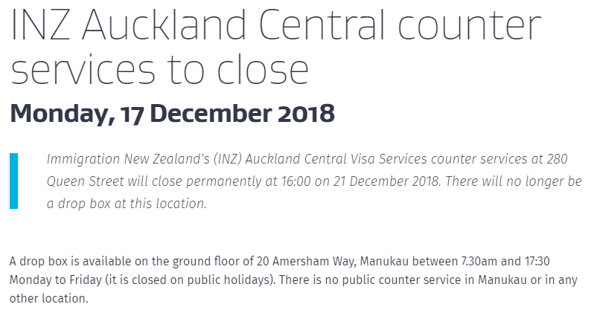With the closure of the Auckland Central Immigration NZ counter in December 2018, there is now no public counter service anywhere in New Zealand. The only remaining ‘public access’ point is a drop box in Manukau where applicants can leave their applications to be processed.[32] Immigration NZ has recognised that in some instances an in-person service will be necessary, however, this can only be arranged through the Contact Centre. No face-to-face service is possible without an appointment, putting a significant barrier in the way for those trying to access this service.

*Screenshot from* [*https://www.immigration.govt.nz/about-us/media-centre/news-notifications/inz-auckland-central-counter-services-to-close*](https://www.immigration.govt.nz/about-us/media-centre/news-notifications/inz-auckland-central-counter-services-to-close)*, accessed August 2019*

Keisa came to the CAB to ask where the Immigration office was and was shocked to learn there wasn't one. She wanted her returning resident's visa transferred to her new Samoan passport. Keisa doesn’t have a computer. We printed out the relevant forms so she could get a printed visa label rather than an e-visa. We helped Keisa to complete the form and printed information about fees, payment and where to send the forms and her passports. She was so surprised to find there is no longer a public Immigration New Zealand office. She said that without the CAB she would have had no idea what to do.

Guidance from Immigration NZ has increasingly focused on encouraging people to apply online. The move to online has been celebrated as providing an easier, faster and more convenient option for people.

*Screenshot from* [*https://www.immigration.govt.nz/about-us/media-centre/news-notifications/inz-auckland-central-counter-services-to-close*](https://www.immigration.govt.nz/about-us/media-centre/news-notifications/inz-auckland-central-counter-services-to-close)*, August 2019*

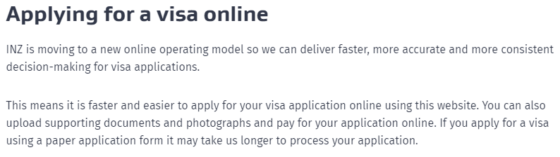

As noted in this information from Immigration NZ, the closure of the public counter has been justified on the basis that people can gain access to Immigration NZ’s services more conveniently through other channels ie, online and by calling the Immigration Contact Centre. For digitally excluded people, this assumption of greater convenience is clearly flawed

*Excerpt from Immigration NZ handout, left for clients at the Manukau public counter site, September 2017*

### Reduced access to paper-based resources

Although some government agencies state that they will continue to provide the ability to interact via paper forms and resources, the option is frequently buried in an attempt to drive people towards the use of the digital channel. Paper resources are also increasingly only available if people print these out themselves, shifting this burden onto the person trying to access the public service or onto organisations like the CAB that are picking up the printing costs for government resources without any recompense.

#### Immigration: No more printed forms

From 1 March 2018 Immigration NZ ceased providing the option to bulk order visa-related forms. There was some remaining stock that CABs were able to access until June 2018. From that point on, the options for clients have been to either apply online, download and print a pdf copy of the forms, or to manoeuvre through the various obstacles and convince someone at the Immigration NZ Contact Centre to post printed copies out to them. At the site of the closed Auckland Central counter an information sheet was left for clients advising that they could go to their local Citizens Advice Bureau to access copies of forms. There was no forewarning from Immigration NZ that clients were being redirected to the CAB.

In a survey of CABs, 40 CAB sites (approximately half the CABs in New Zealand) provided either specific or estimated numbers of Immigration NZ pages printed. The most frequently requested forms were *Sponsorship Form for Temporary Entry*, *Visitor Visa Application* and *Residence Application* forms. The combined total number of pages of immigration forms printed per month was 34,791, with sixteen CABs printing over 1000 pages per month. Over a year this equates to over 400,000 pages of Immigration NZ documents being printed by CABs.

“We started a clinic specifically to help clients with immigration forms. It has shown that INZ’s estimate of the time it takes to apply is totally unrealistic. I have taken 8 hours with one family who then had to return the next day with more information to upload.” CAB Volunteer

#### Tenancy: Paper applications are hidden

Elijah wanted an application for permanent residency and information about application fees. He doesn't have access to a computer and is unable to apply online. We printed the forms and guide for Elijah and checked the Immigration NZ website for fees.

Ani wanted most up-to-date version of the *Sponsorship Form for Temporary Entry* as she was sponsoring her mum to visit from overseas. She had completed one but Immigration NZ told her the form was out-of-date and wouldn't accept it. We searched the Immigration NZ website and found the most recent version of the form and printed this off for Ani.

Rose phoned wanting a form to extend her daughter’s visitor visa. We explained that Immigration NZ doesn’t provide forms any longer and that she can apply online or print the form. She’s not comfortable applying online for visa services and wanted a printed copy. She didn’t have a computer or means to print out the form. We printed the necessary forms for her and she arranged to come in and pick them up later that day.

Another example of a government agency pushing people online by reducing access to paper-based resources is in relation to Tenancy Tribunal applications. Making a paper-based application is possible, but the form itself is essentially hidden on the Tenancy Services website. This is indicative of an approach which seems to focus on what is convenient for the government agency, not what works for the people they are there to help.

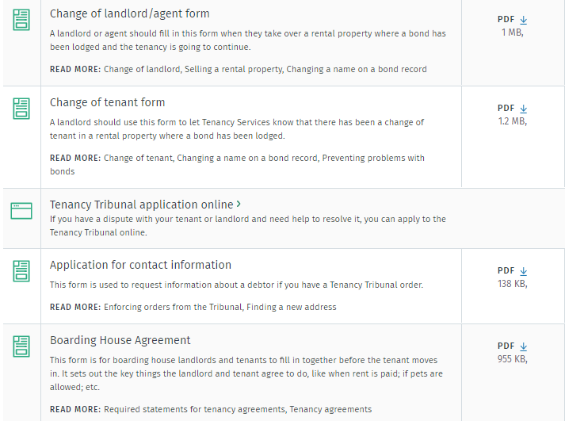

The long list of forms and resources on the Tenancy Services website includes an entry for an application to the Tenancy Tribunal but this is not a downloadable PDF like the other entries on the page. It is a redirection to the page for applying online.[33]

*Screenshot from:* [*https://www.tenancy.govt.nz/forms-and-resources/*](https://www.tenancy.govt.nz/forms-and-resources/)*, November 2019*

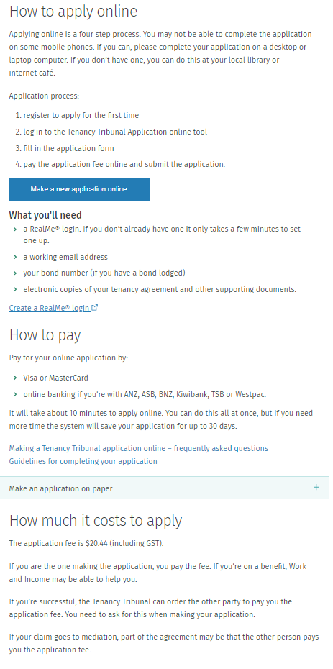Further digging on the Tenancy Services website can get you to a page that includes a small, easily-overlooked sentence stating ‘Make an application on paper’, which you then need to expand to find that the form is still not available to you, not even to download and print. Instead, potential applicants are again advised that “If possible, it is best to apply online.” If the potential applicant is persistent enough to pursue getting a paper form, then they have to pick one up from one of the limited number of Tenancy Service Centres, ask to have one posted out, or visit a CAB or Community Law Centre that may have copies of the form.

For those who struggle to navigate online, the option of making a paper-based application is essentially invisible.

*Screenshot from:* [*https://www.tenancy.govt.nz/disputes/tribunal/making-an-application/*](https://www.tenancy.govt.nz/disputes/tribunal/making-an-application/)*, January 2020*

Peta is a landlord. He was referred to the CAB by Community Law so we could help him complete his application to the Tenancy Tribunal. Community Law had initially directed him to complete the application form online at home, but English is not his first language and he also finds it difficult to use the internet. He had a big pile of paperwork to support the application. We helped Peta recover his RealMe account, then we supported him to complete the online application.

Helen wanted assistance making an application to the Tenancy Tribunal. Tenancy Services had told her to make an application online but she feels she doesn’t have the computer skills to do this. We sat at a computer and together we filled out the online application to the Tenancy Tribunal.

Jacqui has been given 90 days’ notice to move out of her rented accommodation. She wants to dispute this via the Tenancy Tribunal. She is unable to read, has no email address and no computer at home. We found the correct form and printed it out, then read through it with Jacqui and wrote in her answers for her.

#### DIA: Passports online

George is renting from Housing NZ and the property he lives in with his family has significant issues with dampness and pests. George had requested action over the phone but nothing has changed and he now wishes to make a complaint to the Tenancy Tribunal. He has set aside money for the fee but doesn’t have access to a computer and can’t afford to get documents printed out at the library. George didn’t have all the things needed to complete the form, so we made a list of the items for him to bring next time. We also gave George a hard copy of the application form so he had the option of completing it on paper, or could use it as a practice run before he comes back to complete the form online.

The Department of Internal Affairs (DIA) stopped producing printed forms for the renewal of adult passports at the end of February 2019. As with many other government processes, the focus for passport renewals is on encouraging people to complete the process online where they are able to do so. The experience of CAB clients reveals the many reasons why this can be a challenge.

*“Many of our clients when offered the option of doing their passport online, don’t want to for whatever reason. Some don’t like the digital environment, some are not digitally literate and some would just prefer to do a form, even when it’s pointed out that the processing will be faster online.” CAB Manager*

For passport applications there is an added concern from clients about the security of their personal information in the online environment. Where people are reliant on computers in libraries and community facilities, they can be reluctant to use these public-access devices for something as personal as a passport application. Similarly, where a person does have the ability to pay electronically, they may not feel comfortable or confident entering these details online on a computer that is available to the general public.

CABs assist people with the online passport process where this is the approach the client wants to take and feels comfortable with, but there is still significant demand for printed forms. CABs express concern that the shift to prioritising online service delivery has been made without sufficient supports in place for those who are not ready and equipped for this change.

“There’s still high demand for hard copy forms as our clients either lack computer skills or don't even have a computer at home. DIA should continue to provide passport forms as hard copies.” CAB Volunteer

“We have many clients for whom no amount of digital assistance will enable them to renew their passport online. We absolutely need to have access to a paper form for these people who don't own a computer, don't have an email address and are not able to learn to access these due to age or disability. Please ensure that a paper form option remains available.” CAB Manager

Jaden wanted a copy of a passport application form. He doesn’t have access to a computer or a RealMe account. Jaden was wary of completing the application online and would rather do the form in hard copy and then take it in by hand. We talked this through and downloaded the correct passport form for Jaden and provided directions to the Passport Office. We also talked about getting photos to go with the form.

Lou wanted help with renewing her passport. She was recently married and needed to change her last name. She has no access to a computer at home. Together we looked up the information online and established that Lou needed to apply for a new passport, rather than renew it. We found a hard copy of the form and went through it together. Lou took it with her to finish off at home.

Bella needed two passport renewal forms, one for her and one for her partner. She had phoned the Passports Office and was told to go to the Post Office or CAB for hard copy forms. The Post Office said they only had application forms, not renewal forms, and sent her to us. Bella felt like she has had the run around trying to get these forms. We gave Bella two hard copy renewal forms and also discussed the option of completing the process online but she said she didn’t feel computer savvy enough for that.

Nicholas came in for help setting up a RealMe account. He wanted to renew his passport online. He has a mobile phone and tablet at home but doesn’t want to complete such a detailed process on a small screen. We worked together on the computer and successfully completed the passport renewal form. Nicholas received a confirmation email from DIA immediately afterwards.

### Making digital the only option

A particularly problematic situation of a government agency forcing people to use online services is in the case of access to employment mediation. Employment Mediation Services, within the Ministry of Business, Innovation and Employment (MBIE), provide a free mediation service to any employee or employer with an employment relationship problem. However, this service can only be applied for online. While this system no doubt makes the process simple and convenient for some, it acts as a barrier for others, reducing access to this service.

“The client may need to apply for mediation with MBIE, but a mediation application requires a "RealMe" identity. Unfortunately, the online process is a significant barrier to people accessing mediation.” CAB Volunteer

Chase has a personal grievance with his employer. The Employment Relations Service have advised him to apply for free mediation. He wants to know how to go about this. We went through the Employment NZ website and explained that he needed a RealMe login to lodge an application. We showed Chase how to set up the RealMe login and also showed him where he could find further information on the CAB website.

Julia needed employment mediation which is only accessible online. She doesn’t have a computer and wondered if there was a form to download. We looked at the Employment NZ website and clarified for Julia that the application has to be done online and there is no actual form to download. We suggested that she comes in to the CAB so we can work through the process on the computer and made an appointment for her next week.

Ibrahim had been to an employment clinic where he was advised to seek mediation to resolve his dispute with his employer. He was given the Employment NZ phone number. He called but was told to apply for mediation online. Ibrahim doesn't have a computer so came to the CAB for help. We worked through the online application but Ibrahim needed supporting documentation that he didn’t have with him. We made a list of information he needed: employment agreement, payslips, contact details for both parties, any emails or texts, etc, RealMe login details. Ibrahim will gather the information and come back tomorrow for further help.

## Not ‘simple and straightforward’

Ideally digital services should provide a simple and straightforward way for people to interact with government agencies. Unfortunately, the claims of easy and uncomplicated processes are not always borne out in reality. Instead digital processes can present as another barrier to people getting what they need when they need it.

### RealMe experienced as a barrier

An example of where a digital process appears to be a barrier is RealMe. This is a New Zealand Government-operated authentication service that you can use to log in to various government and other online services. If you’re a verified user, which requires more proof of identity, you can also use RealMe for things like applying for a passport or opening a bank account. While RealMe promises a streamlined digital experience, the reality for many people is far from straightforward. For many clients RealMe presents as a barrier to accessing the information and services they need.

“The increasing use of RealMe login is another barrier - those with a language barrier don't understand the information required and the reason they have to provide it.” CAB Volunteer

For some clients the process is further complicated by the fact that they don’t have an active email address. An email address is required for setting up a RealMe account and logging in to it. It’s also common for clients to seek help because they’ve forgotten their username and / or password and need support to reset their login details.

Kelly wanted to fill in an online application to the Tenancy Tribunal. We offered to help her fill in the online form. Kelly had to first obtain a RealMe login. We helped her to complete all the steps for this except for the verification, which she had to go and do at a NZ Post Shop.

Amelia is applying for a student loan. She’s having trouble with her RealMe ID and with the online application. We went to the RealMe website and helped Amelia change her login details. She then successfully logged in. She wanted help with the online application for Study Link so we went through this process together.

Fetu wanted help applying for a New Zealand passport. He had recently become a NZ citizen and wasn't sure what the RealMe identity verification was all about. We looked at the Passports website and discussed whether he would need a RealMe identity verification. We explained that he could still apply for a passport without using RealMe but would have to have his identity verified by a witness. We printed off the information from the Passports website for him.

Safraz is applying for a temporary visa. He’s having trouble setting up a RealMe account which is required for the application process. We went to the website and then guided the client through the process on the CAB computer.

A revealing example of the obstacles people face in setting up a RealMe account is that they are advised against using a Gmail account for this purpose. This is despite Gmail being the most popular email system worldwide with over one billion users.



*Screenshot from* [*https://www.immigration.govt.nz/new-zealand-visas/apply-for-a-visa/tools-and-information/general-information/how-to-create-a-realme-account*](https://www.immigration.govt.nz/new-zealand-visas/apply-for-a-visa/tools-and-information/general-information/how-to-create-a-realme-account)*, November 2019*

For one client, advice received from the Immigration NZ Contact Centre included not only that the client needed to create a new email account with another provider, just for this purpose, but also to please avoid using an iPhone or iPad as these platforms are not supported, and that Immigration NZ recommend the client use “a proper computer” instead.

### KiwiSaver withdrawals

Another example of a service that clients find very difficult to navigate digitally is the process for withdrawal of KiwiSaver funds. This is a common area of enquiry to CABs, usually on the grounds of significant hardship. As a category of people who are already struggling and under financial pressures, it’s not surprising that there are then also issues of digital exclusion. Clients regularly ask for help locating the appropriate KiwiSaver forms online, for these to be printed out, and then also for assistance to fill these in.

For many clients seeking help with KiwiSaver issues, there is a sense that the system is complex and confusing. They know they have some money in a fund, but they may have little understanding of how and when they can access it, or even who exactly the money is with. For these people, the availability of online information about KiwiSaver is not enough and it is common for clients to seek the CAB’s assistance to navigate through the process.

Leah’s husband had passed away recently. She wanted to withdraw his KiwiSaver but when she approached the bank his funds are with, they said they couldn’t help her and sent her to the CAB. Leah doesn’t have access to a computer or confidence to use one and doesn’t have all the information about her husband’s fund. We found details for the KiwiSaver provider online and then phoned on her behalf. We arranged for a withdrawal form to be emailed to the local branch of the bank for her to collect (there was no form available for her to print off on their website). We reassured Leah that if she had any difficulty with getting or using the form then she could to return to us for further assistance.

Bill wanted to know if he could still get superannuation if he was working and also wanted to know about KiwiSaver contributions. He turns 65 soon. We explained that he would need to fill out forms to apply for superannuation and that he could do this online. He told us that he doesn’t have a computer and has no myIR or MyMSD accounts. We gave him information about superannuation and KiwiSaver and what the options are if he’s working after age 65. He asked if he could go in to see MSD about his superannuation and we assured him he could. We discovered that Bill didn’t know who his KiwiSaver provider is or how much money he has in savings. We suggested he ring Inland Revenue to find out.

Maureen had completed her application for national superannuation and wanted it checked out, as well as her KiwiSaver withdrawal. She has no home computer and a lack of confidence in using a public access one at the library. We checked through her paperwork and explained what needed to be certified and where signatures needed to be witnessed and we photocopied her ID documents for her.

Rangi wanted to withdraw money from his KiwiSaver account on the basis of significant financial hardship. He’s living out of his car at present. He doesn't have a phone or any means to access the internet or to photocopy documents he needs in order to be able to apply. We read through the information with him to establish exactly what evidence was required. We photocopied various documents and provided Rangi with details for seeing a JP so he could complete a statutory declaration about his assets and liabilities.

## Not ‘people first’

Digital.govt.nz, which is the online home of information, tools and guidance to support digital transformation across the public sector, makes the following statement about the goal of government:

*“Digital government is about putting people first. We’re focusing on what people need from government in these fast-changing times and how we can meet their needs using emerging technologies, data and changes to government culture, practices and processes.”[34]*

Taking a human-centred approach is of course critical to ensuring that the use of technology supports people’s needs. Unfortunately, what many people experience is services designed to be ‘digital first’, rather than ‘people first’; services that appear to provide convenience, efficiency and cost savings for government, rather than for the people being served. For those who are already disadvantaged in society and who struggle to interact with government, the digital transformation of the public sector often makes things harder and fails to meet people’s needs. This is particularly problematic in areas where difficulty accessing services has a negative impact on wellbeing.

Daniel is struggling financially. He lives in a lodge. He’s divorced from his wife and has children he is paying child support for. He says he is so stressed that he doesn’t know what to do. Daniel has a low paying job and after he pays his accommodation costs and expenses, he has no money for food. He has no access to a computer or the internet and English is not his first language. We worked through the eligibility tool on the Work and Income website to establish whether Daniel would be entitled to any support. We printed out all the relevant information for Daniel about his potential entitlements. We tried phoning Work and Income but gave up after half an hour of waiting. Daniel will try to go and see them instead. We helped Daniel to set up a MyMSD account. We also organised for him to see a budget adviser and to get a food parcel. Daniel was relieved and was very thankful for the help, which he said lifted a weight off his shoulders.

### Disadvantaging those who are already vulnerable

There is perhaps no clearer example of where access to services and wellbeing are linked than in relation to our social welfare system. This system is intended to provide a security net for those who experience significant disadvantage. It is a response to pervasive and persistent social inequities and the marginalisation of different groups, including children living in poverty, increasing numbers of people who are homeless and people dealing with a range of complex needs. As well as ensuring people have an adequate income and standard of living, the hope is that our welfare system also treats people with dignity and supports them to participate meaningfully in society.

Jodie wanted help applying for a benefit. She had previously been on a benefit and then got a job through

Work and Income. When the job finished she booked an appointment with Work and Income but when she got there her client manager said to go and apply online instead using MyMSD. Jodie lacked confidence with the process and said it was very complicated. She already had a RealMe account but couldn’t get back into it and so couldn’t get in to her MyMSD account. We contacted MSD on Jodie’s behalf and worked through the issues to get her back in to MyMSD.

Yousef needed help filling out a form for Work and Income. It said on the website that it could easily be done online but Yousef had difficulties with language and literacy comprehension and so found this hard. He needed assistance with reading and preferred to fill in a paper form with our support.

For those who need to access this kind of support, it’s essential that there are no barriers. However, the realities of social inequality that people experience offline, generally also translate into inequalities online. The focus on delivering services digitally can present as yet another obstacle they have to overcome.

“Every service that goes online takes disadvantaged people further out of the society in which we live.” CAB Volunteer

Individuals and whānau in need of income support, or navigating issues relating to it, are often in high-stress and vulnerable situations. In these circumstances, there is significant demand for in-person or face-to-face support. This is something that clients increasingly struggle to get from government, and which they place considerable value on in terms of the service they receive from the CAB. Amongst the top 10 areas of enquiry by CAB clients experiencing digital exclusion were income support, budgeting and general financial difficulties, and material (non-financial) welfare assistance. The types of support CABs are providing for these clients indicates that online solutions are not meeting the needs of people already experiencing significant disadvantage.

## Community services left to fill the gaps

The focus on delivering public services online means that people’s ability to access direct human support from government agencies is diminishing. Community services, such as the CAB, are being left to fill the gaps.

“With the increasing delivery of government information and services online, people’s ability to access information and communicate with government is being gradually eroded, creating a rapidly expanding group of people who are forced to rely on the assistance of others.” CAB Manager

The CAB provides an essential intermediary role between individual citizens and the government, bridging the gap to help people access the information and services they need. There is a reliance on the CAB to be there and to be accessible, even when government is not. It’s commonplace for government pamphlets, guides and websites all to point people towards the CAB as the place to go for help, but unfortunately there is little recognition by government of the additional demands this puts on CAB’s limited resources.

Dealing with complex issues and helping clients to fill in forms can be time consuming. It takes time to sit alongside someone and work through each question on an online form. For the digital exclusion enquiries analysed for this report, 23% of these involved interactions of 30 minutes or more. We know however, from our volunteers, that some of these interactions can take hours and can involve multiple visits to resolve a specific matter. The barriers to digital inclusion people face will often also be barriers that impact on the support required, such as support relating to language, literacy, or disability. This sometimes involves making an appointment for the client to come in and work with a specific CAB volunteer, or for CABs to establish specialised clinics setting aside time to address more complex needs.

This role as digital intermediary sits within the CAB’s core mandate and existing service delivery model, but responding to the increasing need in this area has not been without its challenges. It has impacted on the workload of volunteers and has placed additional demands on CAB resources. Some volunteers feel under pressure and inadequately resourced to meet the level of need. There is also a sense of frustration that government is transferring work over to the CAB without resourcing the service adequately. Following are some examples of the increased demand on CAB services to address the needs of people struggling to interact with government digitally.

### Support with tax issues

Inland Revenue has undergone significant digital transformation over the past few years. The aim of this change process has been to modernise the tax system so that it’s easier for people to pay their tax and receive their entitlements.[35] People can now use online services for all tax processes – they can file returns, pay their taxes, set up payment plans, lodge their donations receipts, and include attachments online.

With still a few more years of this major transformation programme to run, Inland Revenue has identified that one of its most significant external risks in the process is the challenge of encouraging the use of digital channels and changing the way people interact with Inland Revenue, while ensuring their needs continue to be met.[36] There is an acknowledgement that some people will always need more personal support, and a commitment to ensure that this support will continue to be available, but there is also an expectation that the demand on Inland Revenue’s support services will decrease as people become comfortable with “myIR being their first and best port of call.”[37] In the coming few years Inland Revenue have identified that: “Encouraging customers to rely primarily on online services and not call Inland Revenue unless necessary will be a key focus.”[38]

While these changes to the tax system will simplify and improve many people’s experience, the focus on digital channels means that for those who are struggling to engage online, support is required. This is a role the CAB is playing. A common challenge for these clients is the difficulty setting up or using myIR because they don’t have a computer or other device, they don’t have an email address, or because they lack the digital skills and confidence to operate online. Clients also come to the CAB to access tax-related forms and for help to complete these forms. Some clients face challenges in understanding information or correspondence from Inland Revenue.

“We are in a low socio-economic area and clients don't have access to the internet except on cell phones when in range or if affordable. Most require explanation of the service and help with documents.” CAB Manager

Tax is one of those areas where people can feel very anxious about getting things wrong and so want reassurance that they are on the right track. CABs provide the support people need so that they can navigate online information, but also respond to people’s need for reassurance by being the human interface that they can’t get from the digital world.

“People go where they feel supported, and can get ‘low-friction’ help fast. For vulnerable people, the focus is on finding help from somewhere that is familiar and non-threatening and where service providers are supportive and understand their realities. The CAB provides this supportive, independent, non-threatening and non-judgemental service.” PwC Review of CAB Wellington Service[39]

Lucy phoned because she wanted to know if she would be eligible for a rates rebate. Until recently she had worked but now her only income is her superannuation. She rang IRD to get her income for the year and was directed to use myIR, which she doesn't have. She wanted to know if we could help her. Lucy doesn’t have a computer and is not confident with digital devices. She said that when she called IRD she couldn’t navigate through the system to ‘speak to a human’. We arranged for her to come in to the CAB so we could help her.

Nadia had been advised that she was due a tax refund but was unclear about when the payment would be made. She wanted further clarification. She hadn’t been able to set up a myIR account as she hasn't got an email address. She has also experienced difficulties accessing help over the phone as she has a speech impairment and the phone robot is unable to identify her words. We rang IRD for the client but were unable to speak to a staff member or obtain information over the phone. Due to the "heavy volume of calls” we arranged for a call back.

Jarod is just starting his own business and wanted to know what his obligations are. He is a young person and is a manual worker. He says he is comfortable using a computer to stay in touch with friends, but that’s about it. He went on to the IRD website to find out about his tax obligations, but he ‘kept getting lost'. Jarod says he is not confident navigating all this information and feels out of his depth. He said he would far rather talk to someone. We went through a range of information with him about starting his own business.

### Navigating citizenship applications

Applying for citizenship is a significant event for people. It reflects a person’s commitment to New Zealand and also allows them to access a range of benefits. Given its significance, it’s a process that people are keen to make sure they are doing right. A citizenship application can be submitted online, in person or by post. While completing the online application may be quicker and easier for some people, others find this challenging. People face the usual range of barriers around access to a computer and the internet, poor digital literacy, general literacy difficulties and language barriers.

Specific challenges also include the need to have a RealMe login, to have digital copies of photos and documents, and to be able to pay online. This means the applicant needs access to a computer or other device to complete the application on, a smartphone or digital camera for taking appropriate photos, a scanner to create digital copies of documents, a credit or debit card to pay the application fee, and an internet connection to access the appropriate sites and submit the application. When these things are not readily accessible, the task of completing a citizenship application online is a daunting one.

“The client does not have a computer or smartphone and does not use the Internet. Rather than looking things up online she comes to CAB if she needs advice.” CAB Volunteer

People come to the CAB because they want support to access information and guidance to navigate through the process. The online process may not be accessible to them for any one or more of the reasons above, or it might just feel too hard. CAB volunteers support people with the online process when this is what they want to do, but some people have a clear preference for a paper copy application form.

Bert wanted to apply for New Zealand citizenship. He has lived in New Zealand for 40 years. He wanted to know the process and how to get hard copies of the forms. He said he wasn’t comfortable using a computer and cannot afford internet at home, so applying online wasn’t really an option. We outlined the process and cost, and gave him the forms in hard copy for him to complete.

Leti and Henare don’t have access to a computer or the internet. They wanted information about applying for New Zealand citizenship and copies of the appropriate forms. We gave them the forms and went through their eligibility and what is required. They didn’t feel able to do the process online and didn’t want to send all their original documents by post, so we explained that they could make an appointment to submit everything in person. We gave them the 0800 number to call to make an appointment. The closest office didn’t have any available appointments so they were going to travel to another office that is open more often. This was 1.5 hours’ drive away. We showed them on a map where the office is located.

### Increased demand for immigration assistance

The demand on CABs for support with immigration issues has steadily increased over the past 5 years. Last year CABs responded to around 20,000 immigration-related enquiries; 12,000 of these were in-depth client interviews. Common immigration enquiries include helping clients to find and complete visa application forms, to extend visas, to lodge a complaint or an appeal, and to apply for residency.

Immigration processes are often complex, and can be high stakes for the parties involved. In many cases, the CAB client is a New Zealander, coordinating the process for a visiting family member or as part of the residence application process for a partner or relative. The difficulties in navigating through immigration processes can put increased strain on family members in New Zealand who are being relied on to sort the process out. They may already be supporting overseas family members financially. Of the digitally excluded clients seeking help with immigration and related issues, 38% identified as Pacific Peoples and a further 5% were Māori.

“Our clients have the usual language, literacy, and computer literacy issues but there is an additional issue with distrust of Immigration NZ and fear that filling out the form wrong will mean they get deported.” CAB Manager

CABs have been significantly impacted by the closure of Immigration NZ’s public counter services. Waiting times for getting through to the Immigration NZ Contact Centre are regularly up to an hour. Where English is not the client’s first language, additional support may also be needed to understand the requirements of an application. Similarly, this can be needed for clients who have poor literacy and need guidance and reassurance to complete immigration processes.

While the push has been for people to complete visa application forms online, CABs are meeting the needs of the many people who are not equipped for this change, face barriers to using services online, or may prefer being able to complete the process using hard copy paper forms. The demand on CAB services in relation to immigration reflects the need many people have for in-person support.

Muna had submitted sponsorship forms to Immigration NZ and these were returned on the basis the form was out of date. Muna has a lack of digital confidence and faces literacy barriers. We checked online and found that the old form was still on the website, even though the search enquiry stated that a more recent version was available. We phoned Immigration NZ and they said that the most recent form was the one that had to be used as it has additional pages and is substantially different. Muna was distressed and tired. We accessed the new form and offered to help her complete it when she felt ready.

Eru asked us to print an Immigration NZ form for a partnership visa application for his Tongan wife. He has a support person who will take the form to Tonga next week. Eru didn’t want to do an online application as he’s not computer literate and didn’t have all the necessary information with him to do it at our office. We printed out the required forms and guide from the Immigration NZ website.

Christine doesn’t have a computer at home. She asked for help emailing a *Temporary Visa Application Form* to the New Zealand Immigration Office. We helped her to use the CAB printer and scanner so she could email her application.

Penaia is helping his nephew with immigration issues. His nephew’s visitor visa is about to expire. He wants a sponsorship form so he can support his nephew’s application. He doesn’t have a computer or printer at home. We printed off the necessary form for Penaia. He also wanted information about whether his nephew could work. We phoned Immigration NZ to clarify requirements. The Contact Centre adviser recommended doing an online application as there were delays processing paperwork and there was no guarantee of a paper application being processed before his current visa expired.

# Progressing inclusion

There are a range of barriers people face when trying to access digital services. This is something the Government itself has acknowledged.[40] In our analysis of CAB client enquiries these barriers are clearly evident. With government agencies working to provide better public services, designed around people and able to be accessed when people need them,[41] it’s essential that these services actively minimise the barriers people experience. This is especially important where access to services is clearly tied to wellbeing.

Digital inclusion is very clearly on the Government’s agenda. In March 2019 the Department of Internal Affairs (DIA) released *The Digital Inclusion Blueprint, Te Mahere mō te Whakaurunga Matihiko* (the Blueprint).[42] The vision behind the Blueprint is that all of us have what we need to participate in, contribute to, and benefit from the digital world. The Blueprint draws on the work in the *Digital New Zealanders: The Pulse of our Nation* report,[43] and defines digital inclusion as “an end-state where everyone has equitable opportunities to participate in society using digital technologies.”[44] In keeping with other research, the Blueprint states that to be ‘digitally included’, people must meet all four of the following criteria:[45]

1. Motivation (interest, time and benefits)
2. Access (computer and connection, including affordability, accessibility and convenience)
3. Skills (training / support / knowing how to use)
4. Trust (security / protecting identity)

To this end, there are many positive initiatives seeking to create a more equitable digital environment. There are various courses for improving digital skills and numerous public access computers (particularly in libraries), free Wi-Fi zones, and other access points to help people get on the internet. The 20/20 Trust’s Digital Inclusion Map provides a comprehensive picture of the digital inclusion projects across New Zealand.[46] The DIA has also undertaken a stocktake of digital inclusion initiatives, both government and community-based.[47] Most government initiatives address issues of access such as connectivity, affordability and accessibility, while community initiatives are more focused on skills, aiming to improve participants’ digital competency and confidence in some way.

In their review, the DIA identified that the element of digital inclusion least attended to by existing programmes is motivation, with only 8% of government initiatives and 11% of community initiatives having this as their focus.[48] Being motivated to be online requires a person to have a meaningful purpose to engage with the digital world. Increasingly, the information people need, the services they might want to use, and the processes they have to carry out, are all located online. From this point of view the ‘meaningful purpose’ is there. However, motivation is frequently presented as an ultimatum – get online, or be left behind. The result of this is that rather than feeling motivated, people can be left feeling disrespected and unsupported.

There is no doubt that over the past decade or more the various digital inclusion programmes and activities on offer have helped to close the gaps for some people. This has primarily been through lifting digital literacy levels and facilitating low cost or free access to the internet in public places. Despite this however, significant barriers to digital inclusion remain. For many of those who continue to struggle with the challenges illustrated in this report, a world rapidly moving towards being ‘digital by default’ is resulting in more harm than good. Rather than introducing greater convenience, ease, and efficiency; for some people digital processes result in confusion, stress, obstacles and delays.

This report demonstrates that the current approach being taken by government is not meeting the needs of all people, and for some it is creating increased disadvantage and isolation. In our enthusiasm for all things digital, including digital inclusion, we need to make sure that it is inclusion more broadly that is our goal. Focusing on a digital solution won’t be the best way forward for all people, or in all situations.

For some people, this means that inclusion is about being able to access support from another person, in the moment, and ideally face-to-face. It may mean being able to explain their needs to someone who will take the time to listen and be alongside them to help them to understand the information and navigate through a process. In some cases, inclusion means supporting a person in their choice to engage offline, so that they can participate in a way that meets their needs. If we genuinely want to achieve inclusion, and not just digital inclusion, then the needs and wellbeing of people must genuinely be placed at the centre of what we do.

# Recommendations

The experiences of digitally excluded CAB clients shared in this report reinforce the need for government services to be designed and provided in ways that support all New Zealanders to participate fully in society. This is about recognising the challenges that some people face as a result of things being online and taking steps to ensure that services are accessible and processes support inclusion. To achieve this, we recommend that in its delivery of public services the government must:

* Provide genuine choice,
* Address barriers to inclusion,
* Ensure services are people-centred, and
* Increase support for intermediaries.

## Provide genuine choice in how people can interact with government

Inclusion means that people should be offered genuine choice about how they can interact with government services. The Government Digital Strategy recognises that:

*“… some people can’t or don’t want to engage online or use digital services. Digital transformation is about how we meet everyone’s needs through better design and collaboration, whether online, face-to-face, through others or by phone.”[49]*

If meeting everyone’s needs is the goal then it’s important that multiple channels for engagement remain available and accessible. This means ensuring that people can access face-to-face support when this will best support their needs and that systems are designed to be receptive and responsive to these needs. The ‘by appointment only’ approach now operated by many government departments is unduly restrictive and doesn’t reflect the reality of many people’s need for support ‘in the moment’. Government must ensure that face-to-face services are available to people who need them and that access to such services is not just restricted to those who manage to manoeuvre through the various obstacles designed to push people online.

Similarly, government forms should continue to be accessible as printed paper copies, at least for the time being. The demand for paper-based services continues to be significant and the decision by many government agencies to simply cut off the supply of printed forms creates real inequities. This is particularly the case where completing a form is about accessing entitlements or fulfilling obligations. Not providing paper forms also means that government agencies are just passing the burden and cost of printing on to individuals and community services. People should be able to choose to make a paper application if this is what will best support their needs and circumstances.

In relation to making payments it is again vital that online is not the only option. For people who don’t have a credit or debit card, or who are not confident or comfortable paying for things online, it’s important that other avenues continue to be available. This includes making sure that all payment methods are easy and accessible and no-one is penalised for not being able to pay online.

## Develop an integrated strategy to address barriers to inclusion

The Government needs an integrated strategy that focuses on actively reducing the barriers to inclusion that people face. This is about more than access to computers and courses that support improved digital literacy. It’s about recognising that the same barriers that people face in achieving social equality – such as poverty and discrimination – impact on their opportunities and experiences of being online. In order to support people to participate fully in society the focus needs to be on inclusion generally, with digital inclusion as a subset or this, not as a higher and independent goal. As this report highlights, attention must also be given to the challenges faced by particular groups as a result of things being online, especially Māori and Pacific Peoples who are disproprtionately disadvantaged.

There are many things that need to happen to create a more equitable society, but in response to some of the specific barriers to inclusion highlighted in this report, we recommend that the Government takes action to:

* Increase access to free Wi-Fi and digital devices for those in low income households and those suffering disadvantage as a result of a lack of access. For example, enabling free internet access and computers in homes for all public housing tenants.[50]
* Support people with disabilities to be able to access appropriate equipment and technology that is best suited to their needs. Ensure that all public services are accessible to people with disabilities and that service design is informed by consultation with and involvement from people with disabilities and by principles of universal design.[51]
* Ensure the availability and accessibility of offline services for those who choose not to use digital services, who struggle to make the transition, or who just fall through the gaps.
* Ensure that offline channels are part of the proactive design of improved public services, rather than being seen as a glitch in the overall vision of digital transformation.
* Make access to paper copies of government forms and resources as easy and straightforward as possible. For example, having ‘Request a paper copy be sent to you’ as a visible, upfront choice on all government websites and via government call centres.
* Ensure free-access computers, printing services, and facilities for scanning and uploading documents are readily accessible in the community, to support people in carrying out interactions with government.
* Ensure free language assistance is available to people who need it to successfully interact with government, ie, to fully understand information and make informed decisions.
* Provide ongoing learning opportunities for people experiencing digital exclusion with the aim of increasing basic digital literacy and confidence. This needs to include ongoing ‘helpdesk’ type support for learners so that assistance is there when learning is put into practice and when any problems arise.

## Ensure services are people-centred

It is critical that services are designed to be people-centric, prioritising the needs of the people who use the services, not the needs of the agency providing them. People who are digitally excluded need support that is tailored to the unique challenges they experience. They need assistance to overcome their own particular barriers; whether that’s around access, cost, confidence or skills. The Government’s Better Public Service Result 10 is very clear that public services should be designed around the customer and their needs.[52] Unfortunately, however, the focus continues to be almost exclusively on the delivery of services online, with success being measured in terms of digital uptake. We recommend that the focus on digital uptake should be removed from the Government’s Better Public Service Result 10 and be replaced with measures that reflect the diversity of people’s needs.

Putting people at the centre of service design and delivery means that government must start with people’s needs and not from an assumption that digital is best, or that it’s just about trying to make digital services better. For many of the clients seeking help from the CAB, the services they need are face-to-face, or person-to-person over the phone; they are about accessibility and being able to seek support in the moment, not two weeks later at the next available appointment. Attentiveness to the needs of Māori and Pacific Peoples is of particular importance given their significant overrepresentation amongst those experiencing digital exclusion.

Where information and services are online, government agencies must ensure that systems are easy to use and that content on their websites is simple, intuitive and accessible. User testing needs to factor in the reality that sometimes people’s interactions with government occur in a context of stress and heightened vulnerability, and so the challenges people face can be about much more than the functional task. Being people-centred also means that if something isn’t working well for people, government agencies need to look at what’s going wrong and be prepared to offer additional support or to do things differently. As a case in point, we recommend that the Government examine people’s current experiences of RealMe, and the difficulties people are facing.

## Fund the capacity of CAB volunteers to carry out their vital support role

The Government should ensure the survival of the CAB through adequate funding. With a range of government and essential services closing their doors to the public, CAB volunteers are meeting the needs of people struggling with things shifting online. With referrals coming from multiple places, including government, CAB volunteers are being expected to fill the gaps and provide the person-to-person service that so many people need. This has been without consideration of the impacts or provision of adequate resourcing.

The CAB exists as an independent community organisation where people can come to get advice from trained volunteers about their rights and responsibilities. This often involves supporting people in their interactions with government. However, the CAB is in a constant state of struggle to stay afloat because of being inadequately funded by central government for the work that CAB volunteers do in supporting people to interact with government. Government agencies routinely refer people to the CAB, relying on the work carried out by CAB volunteers, and yet provide inadequate funding or, in some cases, none at all. The pressure on the CAB service has become even more desperate with the increasing need to support people to interact with government digital services.

As well as funding to ensure the survival of the CAB service, the CAB needs specific funding to support its role in assisting people when they experience barriers in their digital interactions. Specifically, the CAB needs to be adequately resourced in order to:

* Cover printing costs that relate to meeting the needs of those who prefer to access paper copies of resources and forms.
* Support ongoing learning and development for staff and volunteers so they are equipped to assist clients with digital inclusion issues. For example, helping clients to set up a RealMe login, using myIR, using MyMSD, filling in government forms online, and uploading documents for online applications.
* Ensure that CAB premises are equipped with appropriate hardware, software and facilities to support digital inclusion and meet people’s needs. For example, computers, photocopying, scanning and printing facilities and adequate space to accommodate people working through time-intensive processes as well as private areas for assisting with issues of a sensitive nature.
* Have capacity for strategic engagement with government around digital change processes, including user testing and feedback, and providing insights and evidence to inform government decision making.
* Support collaborations between organisations so that digital inclusion initiatives can be complementary and reflect the strengths of different services. For example, opportunities for greater collaboration between CABs and libraries to more effectively meet the diverse needs of people seeking assistance.

# Conclusion

As more and more information and services are embedded in the online world, the potential harms that can result from digital exclusion intensify. This report challenges the current approach being taken by government in its digital transformation of the public service, including the corresponding retreat of government agencies from being physically present and accessible in communities. It highlights that this approach is failing to meet the needs of people equitably. In particular, it is disadvantaging Māori and Pacific Peoples, older people, people with disabilities and people with literacy and language barriers. It means that for some people, wellbeing is undermined instead of enhanced.

This report is a call to the Government to pause and take stock of where things are headed, to recognise that digital is not always best for every person or for every situation, and to ensure that the way forward is one where people’s wellbeing is uplifted and no one is left behind. It is also about sending a clear message to the Government that the work of CAB volunteers is something to be valued and resourced, so that collectively we can work to ensure true wellbeing is realised for all people in New Zealand.

Contact:

Citizens Advice Bureaux New Zealand

Ngā Pou Whakawhirinaki o Aotearoa

PO Box 24249

Wellington 6142, New Zealand

Phone: 04 471 2735

Website: [www.cab.org.nz](http://www.cab.org.nz)

1. PricewaterHouseCoopers (2018) *Citizens Advice Bureau Wellington Service Review*, <https://www.cab.org.nz/assets/News/e89c2fdb79/WelCAB-Service-Review-Final-Report-v1.0.pdf>.
2. See above, note 1.
3. For wider discussion on the definition of digital exclusion see Chris Martin, Steven Hope, Sanah Zubairi, Ipsos MORI Scotland (2016) *The role of digital exclusion in social exclusion,* pp 2-4, <https://d1ssu070pg2v9i.cloudfront.net/pex/carnegie_uk_trust/2016/09/LOW-2697-CUKT-Digital-Participation-Report-REVISE.pdf>.
4. See <https://www.cab.org.nz/find-a-cab/>.
5. OECD (2019) *OECD Economic Surveys: New Zealand,* <https://www.oecd.org/economy/surveys/new-zealand-2019-OECD-economic-survey-overview.pdf>.
6. Digital Inclusion Research Group (2017) *Digital New Zealanders: The Pulse of our Nation,* pp 13, 14, <https://www.mbie.govt.nz/assets/218c439f72/digital-new-zealanders-thepulse-of-our-nation.pdf>.
7. Tiopira Piripi (2018) *Māori Engagement Digital Inclusion,* <https://www.digital.govt.nz/blog/maori-engagement-digital-inclusion/>.
8. Paul Satherley, Ministry of Education (2018) *Survey of Adult Skills: Pacific adults' literacy, numeracy and problem solving skills*, <https://www.educationcounts.govt.nz/__data/assets/pdf_file/0006/188421/Pacific-adults-literacy-numeracy-and-problem-solving-skills.pdf>.
9. Government of New Zealand (2019) *The Wellbeing Budget 2019*, <https://treasury.govt.nz/publications/wellbeing-budget/wellbeing-budget-2019-html#section-9>.
10. Marianne Elliot (2018) *Out of the Maze: Building Digitally Inclusive Communities*, <https://report.digitaldivides.nz/>, p 37.
11. As above, note 10, p 37.
12. As above, note 6.
13. As above, note 6, p 4.
14. Statistics New Zealand (2013) *Census 2013*, <http://www.stats.govt.nz/Census/2013-census.aspx>.
15. Statistics New Zealand (2019) *2018 Census totals by topic – national highlights*, Table 42, <https://www.stats.govt.nz/information-releases/2018-census-totals-by-topic-national-highlights>.
16. Note, no information about internet access was available for 7.7% of New Zealand households. Statistics New Zealand (2019) *Access to telecommunication systems (information about this variable and its quality)*, <http://datainfoplus.stats.govt.nz/Item/nz.govt.stats/42921c1a-a49d-4426-b3a9-69cfba642ba5>.
17. See <https://www.kiwibank.co.nz/about-us/news-and-updates/media-releases/2019-05-16-kiwibank-go-cheque-free-from-2020/>.
18. See <https://www.stuff.co.nz/business/115668360/no-option-to-pay-inland-revenue-or-acc-by-cheque-from-march>.
19. See <https://media.ird.govt.nz/articles/calling-time-on-cheques/>.
20. See <https://www.stuff.co.nz/dominion-post/news/112249368/migrants-struggling-after-funding-cut-from-language-services>.
21. See above, note 6, pp 13, 14.
22. Statistics New Zealand (2014) *One in four New Zealanders identified as disabled*, <http://www.stats.govt.nz/browse_for_stats/health/disabilities/DisabilitySurvey_MR2013.aspx>.
23. Arthur Grimes and Dominic White, Motu Economic and Public Policy Research (2019) *Digital inclusion and wellbeing in New Zealand: A report to Department of Internal Affairs*, Motu Working Paper 19-17, <http://motu-www.motu.org.nz/wpapers/19_17.pdf>.
24. See above, note 23.
25. Dr Philippa K Smith, Institute of Culture, Discourse & Communication, Auckland University of Technology(2016) *New Zealanders with disabilities and their Internet use,* <https://icdc.aut.ac.nz/__data/assets/pdf_file/0008/73439/New-Zealanders-with-disabilities-and-their-internet-use.pdf>.
26. See above, note 25.
27. Government of New Zealand (2019) *The Wellbeing Budget 2019*, p 5, [www.treasury.govt.nz/publications/wellbeing-budget/wellbeing-budget-2019](http://www.treasury.govt.nz/publications/wellbeing-budget/wellbeing-budget-2019)).
28. State Services Commission (2017) *Better Public Services: Improving interaction with government*, <https://ssc.govt.nz/resources/bps-improving-interaction-government/>.
29. See above, note 28.
30. See <https://www.immigration.govt.nz/about-us/media-centre/news-notifications/wgtn-public-counter-closing>; <https://www.immigration.govt.nz/about-us/media-centre/news-notifications/inz-auckland-central-counter-services-to-close>.
31. See <https://www.rnz.co.nz/international/programmes/datelinepacific/audio/2018620765/nz-immigration-public-counter-closures-spark-complaints>.
32. See <https://www.immigration.govt.nz/contact/new-zealand-drop-box>.
33. See <https://dispute.tenancy.govt.nz/app/Extra/TenancyTribunal/Default.aspx?sid=637145999946080054>.
34. See <https://www.digital.govt.nz/digital-government/digital-transformation/nz-digital-transformation/>.
35. For details see <https://www.classic.ird.govt.nz/transformation/bt-programme/>.
36. Inland Revenue (2019) *Cabinet paper – Inland Revenue’s July 2019 Transformation Update*, para 64, p 10, <https://www.classic.ird.govt.nz/resources/c/b/cb54de15-b7c8-467e-815c-1738cba31cf3/transformation-update-Cabinet-paper-july-19.pdf>.
37. See above, note 36, para 26 p 5.
38. See above, note 36, para 6, p 2.
39. See above, note 1, p 87.
40. Department of Internal Affairs (2019) *The Digital Inclusion Blueprint, Te Mahere mō te Whakaurunga Matihiko*. Retrieved from: <https://www.digital.govt.nz/assets/Documents/113Digital-Inclusion-BlueprintTe-Mahere-mo-te-Whakaurunga-Matihiko.pdf>.
41. See above, note 28.
42. See above, note 40.
43. See above, note 6.
44. See above, note 40, p 7.
45. See above, note 40, p 10.
46. See <https://digitalinclusion.nz/>.
47. See <https://www.digital.govt.nz/digital-government/digital-transformation/digital-inclusion/stocktake-of-digital-inclusion-initiative/>.
48. See *Digital inclusion stocktake: What digital inclusion looks like in New Zealand communities* <https://www.digital.govt.nz/dmsdocument/152-digital-inclusion-stocktake-what-digital-inclusion-looks-like-in-nz-communities/html>, *Digital inclusion stocktake: What digital inclusion looks like across government* <https://www.digital.govt.nz/dmsdocument/155-digital-inclusion-stocktake-what-digital-inclusion-looks-like-across-government/html>.
49. Department of Internal Affairs (2019) *Strategy for a Digital Public Service*, p 6, <https://www.digital.govt.nz/assets/Digital-government/Strategy/Strategy-for-a-Digital-Public-Service.pdf>.
50. This is consistent with the suggested initiative of social housing providers installing WiFi (or other technologies) to enable internet access by tenants. See Arthur Grimes and Dominic White, Motu Economic and Public Policy Research (2019) *Digital inclusion and wellbeing in New Zealand: A report to Department of Internal Affairs*, Motu Working Paper 19-17, p 38, <http://motu-www.motu.org.nz/wpapers/19_17.pdf>.
51. Ensuring that mainstream services and supports are inclusive of disabled people requires the provision of

    reasonable accommodation and incorporation of universal design. See Ministry of Social Development (2016) *New Zealand Disability Strategy 2016–2026*, p 21, <https://www.odi.govt.nz/assets/New-Zealand-Disability-Strategy-files/pdf-nz-disability-strategy-2016.pdf>.
52. See above, note 28.