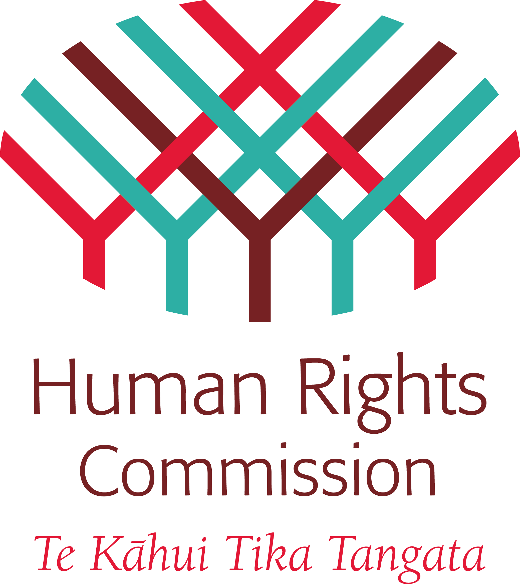
Human Rights Council
Expert Mechanism on the
Rights of Indigenous Peoples

EIGHTH SESSION, 20-24 JULY 2015, GENEVA

Agenda Item 7: Study and advice on the promotion and protection of the rights of indigenous peoples with respect to their cultural heritage

E ngā mana, e ngā reo, e ngā maunga, e ngā awaawa, e nga pātaka o ngā taonga tuku iho, tēnā koutou katoa. [Translation: to all expert colleagues, all voices, the mountains, the rivers, the treasure houses, greetings to all of you.]

Mr. Chairman, thank you for this opportunity to speak as the Commissioner representative of the New Zealand Human Rights Commission. My name is Karen Johansen. The following comments are made further to the Commission’s submission to the Expert Mechanism’s study earlier this year.

In Aotearoa New Zealand, alongside the Declaration, the Treaty of Waitangi frames how indigenous rights are to be realised, and cultural heritage protected. In summary, the 1840 Treaty:
- Gave the Crown an authority to govern, based on the obligation of partnership;
- Affirmed Māori rangatiratanga (self-determination) and rights to land and other treasured possessions (taonga), and an obligation of Crown protection; and
- Guaranteed equality and full participation for Māori.

Within this framework, the promotion and protection of Māori cultural heritage has been comprehensively examined through a major, long-running inquiry by the Waitangi Tribunal. The claim, known as Wai 262, concerned the place of mātauranga Māori (Māori knowledge and cultural values) in contemporary New Zealand law, policy and practice. The Tribunal’s final report, Ko Aotearoa Tēnei, was released in 2011. The lack of comprehensive government response to the report to date highlights challenges in implementation of indigenous rights.

As with the Expert Mechanism’s report and Advice No. 8 on Cultural Heritage, similarly, the Tribunal’s report highlights the interrelatedness of rights to cultural heritage and other rights, such as self-determination, participation and rights to lands, territories and resources.

The Waitangi Tribunal also highlighted the crucial importance of the Treaty partnership between Māori and the state, and obligations to act cooperatively and with good faith. The Tribunal emphasised that “there is no area of Crown–Māori relations that requires partnership more than the future of the Māori language”.

Next week (27 July – 2 August) is Māori Language Week – a national week, marked each year for the celebration and promotion of our indigenous language. It is coordinated by the Māori Language Commission. The New Zealand Human Rights Commission is a sponsor of this work. This year’s Māori Language Week theme highlights the crucial role of parents in nurturing te reo for their children.

Despite the challenges that continue to constrain language revitalisation efforts – particularly lack of resourcing and support – there are rich and innovative things happening in communities.

One example is Wairoa Reo Rua 2040 – where the community has developed a strategy to set their community on the path to becoming bilingual by the year 2040 (the 200th anniversary of the Treaty of Waitangi). Activities to celebrate Māori Language Week in Wairoa this year include Māori language speech competitions, haka (performing arts) and other competitions and events.

One of the features of these events is that they locate te reo (the language) in context – places where people gather to celebrate and live their culture, and where as such, the language can thrive – ka rere te reo (the language flows / takes flight). These events are particularly important as they are community-driven and reflective of indigenous values and self-determination.

To conclude, the New Zealand Human Rights Commission welcomes the Expert Mechanism’s study and Advice No. 8 on indigenous peoples’ rights to cultural heritage. The advice provides valuable guidance and the Commission welcomes in particular the affirmation of cultural heritage as an “expression of [indigenous peoples’] self-determination and their spiritual and physical relationships with their lands, territories and resources”.

The publication of the Expert Mechanism’s report and Advice provide a fresh opportunity and a useful supporting framework for the New Zealand government to re-examine the Waitangi Tribunal’s Wai 262 report and commit to a timetabled plan for implementing the Tribunal’s recommendations.

Nō reira, tēnā koutou, tēnā koutou, tēnā koutou katoa [And finally, greetings to you all]

Commissioner Karen Johansen
New Zealand Human Rights Commission
July 2015

